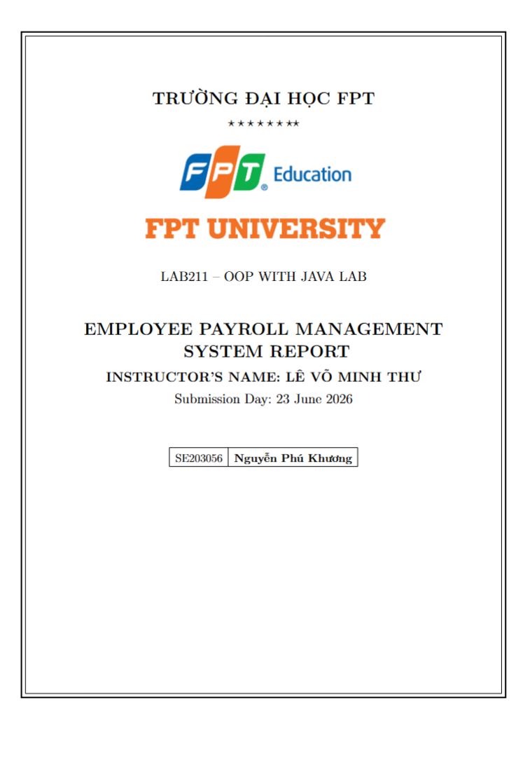

1. Project Overview
The "Employee Payroll Management System" project (J1.L.P0037) is a console-based application developed in Java following the Object-Oriented Programming (OOP) approach. It manages employee information and calculates the monthly payroll. The system also includes a role-based authorization layer: users must log in, and each role (Admin or Staff) is granted access to a specific set of functions. Employee records are stored in a text file (employees.txt), and the system supports loading, adding, updating, removing, searching, payroll calculation, displaying and saving data safely.

Main Features:
# | Feature | Target | Access
- | Login (role-based authentication) | Security | All users
1 | Load employee data from file | System / File | Admin, Staff
2 | Add a new employee | Employee | Admin
3 | Update employee information | Employee | Admin
4 | Remove an employee by ID | Employee | Admin
5 | Search employees by attribute | Employee | Admin, Staff
6 | Calculate monthly payroll (active only) | Payroll | Admin, Staff
7 | Display employee list | Employee | Admin, Staff
8 | Save data to file | System / File | Admin
9 | Quit program (confirm saving) | System | Admin, Staff

Access Control (Authorization):
Each role is mapped to a set of allowed features. The check is polymorphic: the menu asks the account object whether it can access a feature, without any if-else on the role.
Role | Allowed Features | Description
Admin | 1, 2, 3, 4, 5, 6, 7, 8, 9 | Full access (all functions)
Staff | 1, 5, 6, 7, 9 | Read-only (load, search, payroll, display, quit)

Data Constraints:
Attribute | Constraint | Valid example
id | Format ^E\d{3}$ (E001..E999), non-empty, unique | E001
name | Non-empty | David Miller
role | One of: Developer / Tester / Manager / HR | Developer
baseSalary | Positive double ( > 0 ) | 1300
workingDays | Integer in range 0 - 26 | 21
bonus | Double >= 0 | 250
status | active or inactive | active

Salary formula (not given by the assignment - self-defined and justified):
salary = baseSalary / 26 * workingDays (salary by working days)
+ bonus
+ roleAllowance() (role-based allowance - polymorphic)
roleAllowance: Developer 10%*base | Tester 5%*base
Manager 20%*base + 200 | HR 8%*base
Note: 26 is the standard maximum working days defined in the assignment. The monthly payroll (Feature 6) only sums salaries of employees whose status is active.

2. Class Diagram & UML

2.1. Class Diagram
The Class Diagram below illustrates the relationships between all classes in the system (employee model + authorization model).
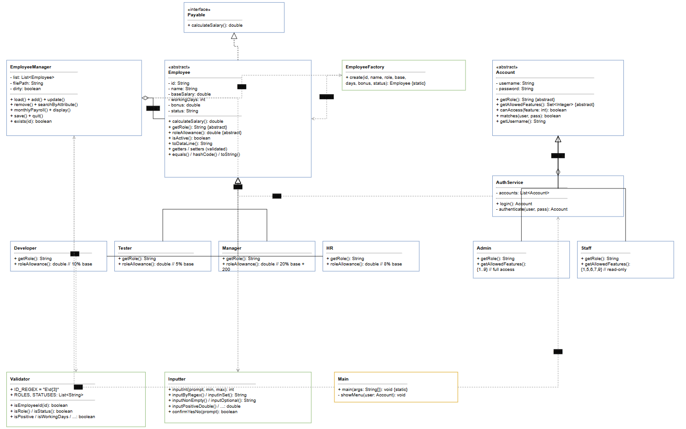

Class Relationships:
Relationship | From | To | Type
Implementation | Employee | Payable | implements
Inheritance | Developer / Tester / Manager / HR | Employee | extends
Inheritance | Admin / Staff | Account | extends
Association | EmployeeManager | List<Employee> | has-a
Association | AuthService | List<Account> | has-a
Dependency | EmployeeManager | EmployeeFactory | uses
Dependency | Main | EmployeeManager / AuthService | uses

2.2. Use Case Diagram
The Use Case Diagram shows all system functions from the user's perspective, including login and role-based access.
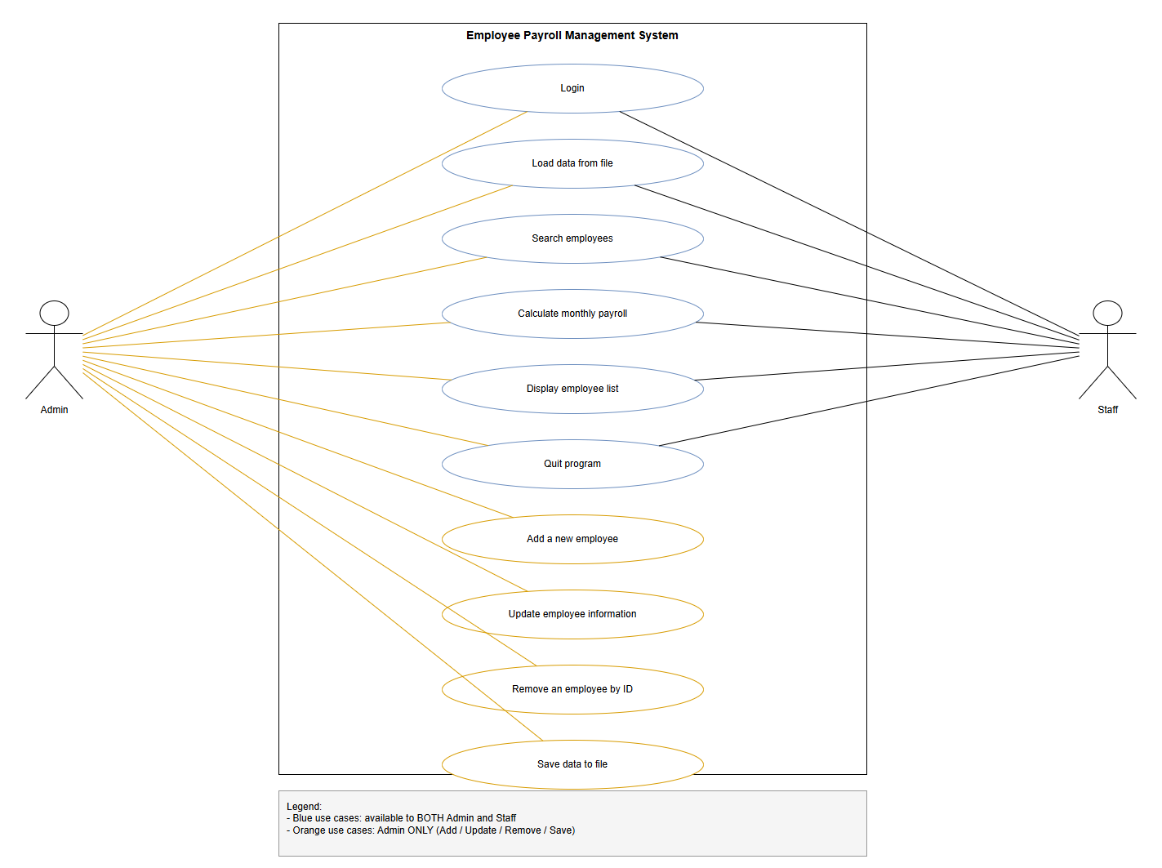

3. Project Structure
The project follows a layered architecture (Decomposition by class):
EmployeePayrollManagementSystem/
|-- src/
| |-- model/ <-- Data Layer
| | |-- Payable.java (interface - calculateSalary)
| | |-- Employee.java (abstract base class)
| | |-- Developer.java (extends Employee)
| | |-- Tester.java (extends Employee)
| | |-- Manager.java (extends Employee)
| | |-- HR.java (extends Employee)
| | |-- Account.java (abstract - authorization)
| | |-- Admin.java (extends Account)
| | +-- Staff.java (extends Account)
| |-- factory/ <-- Object Creation
| | +-- EmployeeFactory.java (role -> correct subclass)
| |-- tools/ <-- Utility
| | |-- Validator.java (regex + constraint rules)
| | +-- Inputter.java (input validation helper)
| |-- business/ <-- Business Layer
| | |-- EmployeeManager.java (9 features + file I/O)
| | +-- AuthService.java (login + account list)
| +-- main/ <-- Presentation Layer
| +-- Main.java (login + menu loop + access check)
+-- employees.txt (employee data file)

4. Class Descriptions

4.1. Model Layer
Payable.java (Interface)
Declares the calculateSalary() contract, demonstrating polymorphism: clients depend on Payable, not concrete classes.
Employee.java (Abstract Class)
Abstract base class holding the common state and defining the abstract methods getRole() and roleAllowance() for subclass-specific behaviour (Abstraction).
Member | Type | Description
-id | String (private) | Unique identifier (E\d{3})
-name / -status | String | Name; active/inactive
-baseSalary / -bonus | double | Base salary ( > 0 ); bonus ( >= 0 )
-workingDays | int | Working days (0-26)
+getRole() | abstract String | Role name - Polymorphism
+roleAllowance() | abstract double | Role allowance - Polymorphism
+calculateSalary() | double | Template salary formula (uses roleAllowance)
+isActive() | boolean | True if status is active
+toDataLine() / toString() | String | File format / table display
+equals() / hashCode() | boolean / int | Compare by employee ID
Developer / Tester / Manager / HR (extends Employee)
Four subclasses that inherit Employee and override roleAllowance() and getRole() (Inheritance + Polymorphism).
Subclass | roleAllowance()
Developer | 0.10 * baseSalary
Tester | 0.05 * baseSalary
Manager | 0.20 * baseSalary + 200
HR | 0.08 * baseSalary
Account.java (Abstract Class) - Authorization
Abstract base class representing a user account. Holds username/password and defines the abstract methods getRole() and getAllowedFeatures(). The canAccess(feature) method is polymorphic, so the menu never needs an if-else on the role.
Member | Type | Description
-username / -password | String (private) | Login credentials (Encapsulation)
+getRole() | abstract String | Role name - Polymorphism
+getAllowedFeatures() | abstract Set<Integer> | Allowed feature numbers - Polymorphism
+canAccess(feature) | boolean | True if the feature is allowed for this role
+matches(user, pass) | boolean | Credential check for login
Admin / Staff (extends Account)
Subclass | getAllowedFeatures()
Admin | {1,2,3,4,5,6,7,8,9} - full access
Staff | {1,5,6,7,9} - read-only

4.2. Factory Layer
EmployeeFactory.java
Centralizes object creation: maps a role string to the correct Employee subclass. Adding a new role only requires one new subclass and one factory branch (Open/Closed Principle).

4.3. Tools Layer
Validator.java
Centralizes all validation rules in one place (Pattern Recognition): ID_REGEX (E\d{3}), ROLES, STATUSES, and range checks.
Inputter.java
Utility class for keyboard input with built-in validation loops:
Method | Description
inputInt(prompt, min, max) | Input integer within [min, max]
inputByRegex(prompt, regex, err) | Input string matching a regex
inputInSet(prompt, allowed) | Input a value within an allowed set
inputNonEmpty / inputPositiveDouble / inputNonNegativeDouble | Constrained inputs
inputOptional(prompt) | Optional input (Enter to keep current value)
confirmYesNo(prompt) | Y/N confirmation

4.4. Business Layer
EmployeeManager.java
Manages the List<Employee> and all 9 features. Uses a dirty flag to track unsaved changes.
Method | Function
load() | Read employees.txt; skip & count invalid lines safely
add() / update() / remove() | CRUD with validation; confirm before remove
searchByAttribute() | Search by ID / Name / Role / Status (substring)
monthlyPayroll() | Sum salary of active employees (polymorphic)
display() / save() | Table display / write back to file
quit() | Confirm saving before exit (dirty flag)
AuthService.java
Manages the List<Account> and the login process (max 3 attempts).
Method | Function
login() | Prompt credentials, authenticate, return the Account or null
authenticate(user, pass) | Find a matching account in the list

4.5. Presentation Layer
Main.java
Main entry point. Requires login first; then runs the 9-feature menu loop and checks currentUser.canAccess(choice) before executing each feature. Sets Locale.US for consistent number formatting.

5. How to Run the Program

5.1. System Requirements
- JDK 1.8 or higher (installed and JAVA_HOME configured)
- IDE: IntelliJ IDEA / Eclipse / NetBeans (IntelliJ recommended)
- OS: Windows / macOS / Linux

5.2. Running with IDE (IntelliJ IDEA)
- Open Netbean -> File -> Open -> select the EmployeePayrollManagementSystem folder
- Wait for the IDE to finish indexing all Java files
- Open file src/main/Main.java
- Right-click on Main.java -> select "Run 'Main.main()'"
- The program will run in the IDE's Console window
[ảnh] Screenshot of IntelliJ IDEA right-clicking Main.java and selecting Run 'Main.main()'.

5.3. Running with Command Line
Step 1: Open Terminal and navigate to the project directory.
Step 2: Compile all Java files:
javac -encoding UTF-8 -d out -sourcepath src src/main/Main.java
Step 3: Run the program:
java -cp out main.Main

5.4. Default Accounts
Username | Password | Role
admin | admin123 | Admin (full access)
staff | staff123 | Staff (read-only)

5.5. Startup / Login Screen
On startup the system asks the user to log in, then displays the menu. Functions outside the current role are marked [locked].
===== LOGIN =====
Username: admin
Password: admin123
Login successful. Welcome admin (Admin).
===== EMPLOYEE PAYROLL MANAGEMENT SYSTEM =====
Logged in as: admin (Admin)
----------------------------------------------
==============================================
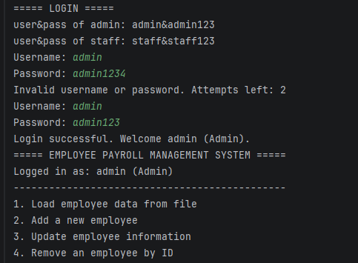

6. Feature Usage Guide

6.0. Login & Authorization
On startup, enter a username and password. After 3 failed attempts the program exits. Once logged in, the menu shows all 9 features but marks the ones outside your role as [locked]; selecting a locked feature shows "Access denied".

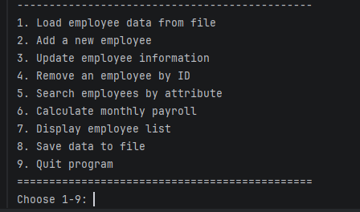

6.1. Feature 1: Load employee data from file
Enter 1 -> Reads employees.txt line by line. Invalid lines (wrong field count, bad number, failed validation, or duplicate ID) are skipped safely and counted. Example: "Loaded 11 record(s), skipped 3 invalid line(s)."

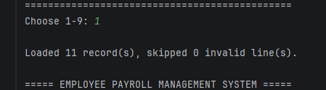

6.2. Feature 2: Add a new employee (Admin only)
Enter 2 -> Input the following fields (each validated; invalid input is re-prompted):
- Employee ID (Exxx) - format validated, duplicates rejected
- Name - non-empty
- Role - Developer/Tester/Manager/HR
- Base salary - must be positive
- Working days - 0 to 26
- Bonus - >= 0
- Status - active/inactive
If all fields are valid -> "Employee added successfully."

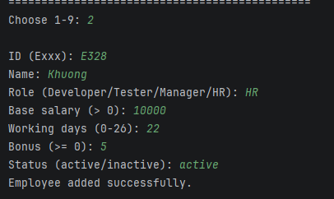

6.3. Feature 3: Update employee information (Admin only)
Enter 3 -> Input Employee ID -> Update role, salary, working days, bonus, status. Press Enter to keep the current value. Changing the role re-creates the object as the correct subclass via the factory.

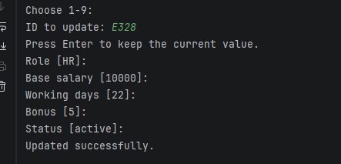 6.4. Feature 4: Remove an employee by ID (Admin only)
Enter 4 -> Input Employee ID -> Confirm (Y/N). Employee removed, or "This employee does not exist!" / "Cancelled.".

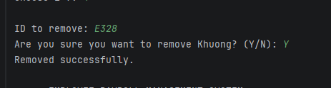 6.5. Feature 5: Search employees by attribute
Enter 5 -> Choose attribute (1.ID 2.Name 3.Role 4.Status) -> Input keyword -> Displays all matching employees (case-insensitive substring match).
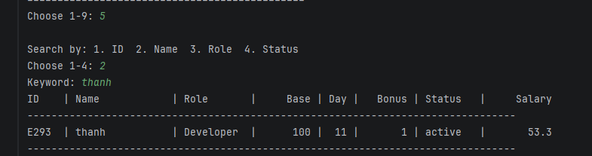

6.6. Feature 6: Calculate monthly payroll
Enter 6 -> Displays each active employee with their computed salary (polymorphic calculateSalary()), then the TOTAL payroll. Inactive employees are skipped.
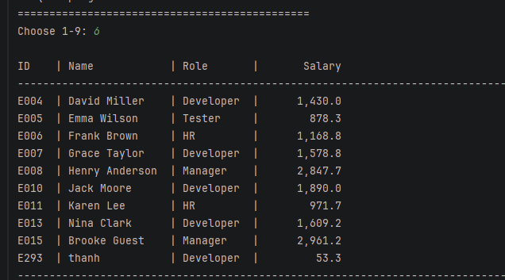

6.7. Feature 7: Display employee list
Enter 7 -> Displays all employees in a formatted table (ID | Name | Role | Base | Day | Bonus | Status | Salary).
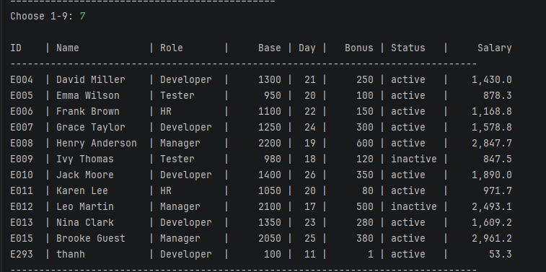

6.8. Feature 8: Save data to file (Admin only)
Enter 8 -> Writes all employees back to employees.txt in the 7-field format. Example: "Data saved to 'employees.txt' (N record(s))."
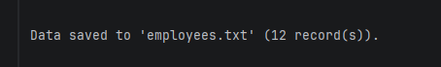

6.9. Feature 9: Quit program
Enter 9 -> If unsaved changes are detected (dirty flag), prompts "Save before exit? (Y/N)". Then exits with "Goodbye!".
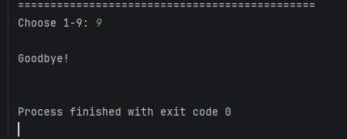

7. OOP Concepts Applied
OOP Concept | Application | Specific Example
Abstraction | Abstract base classes define common interfaces | Employee.roleAllowance(); Account.getAllowedFeatures(); interface Payable
Inheritance | Subclasses reuse base state and behaviour | Developer extends Employee; Admin extends Account
Polymorphism | Overridden methods drive behaviour without if-else | calculateSalary() uses roleAllowance(); menu uses canAccess()
Encapsulation | Private fields with controlled access | Employee.setWorkingDays() (0-26); Account hides password
Open/Closed | Extend without modifying existing logic | Add a new role/account = one new subclass only

8. Conclusion

8.1. Achievements
- Implemented all 9 features for employee management and payroll.
- Added a role-based authorization layer (login + Admin/Staff permissions).
- Applied OOP principles to both the employee model and the authorization model.
- Strict validation: regex (ID), value ranges, role/status sets, unique ID.
- Polymorphic salary calculation and polymorphic access control (no if-else on role).
- Monthly payroll counts active employees only.
- Safe file loading: malformed lines are skipped and reported, never crashing.

8.2. Challenges & Solutions
Challenge | Solution
Different allowance per role without if-else | Abstract Employee + roleAllowance() overridden in each subclass
Role-based access without if-else on role | Abstract Account + getAllowedFeatures() overridden; menu calls canAccess()
Salary formula not provided by the assignment | Self-defined a transparent formula and justified it
Reading a file that may contain erroneous data | try-catch + field-count + per-field validation; skip & count invalid lines
Inconsistent number formatting across locales | Locale.setDefault(Locale.US)

