Practical Exam Answer Sheet
Subject Code | SWE202c
Subject name | Introduction Software Engineering
Page no | 2
Topic | Smart Parking Management System
Time | 120’
Tools | MS Word, Draw.io for desktop, MS Visio, Astah, Visual paradigm, Start UML
Student ID | SE203056
Student Name | Nguyễn Phú Khương
Date | 22/08/2026
Notes: Students must fill in all fields in the table above and in footer. The submission will not be accepted if the table and footer are incomplete or contains incorrect information.

Question 1. Software development model (2.0)

1.1
Chosen model: Agile (Scrum based iterative and incremental development).
- Requirements are not fully known or stable at project inception. The case states that requirements may continue to evolve from customer feedback, so a rigid up front plan would create rework.
- Scrum supports iterative delivery in short sprints, frequent demonstrations, backlog refinement, and regular feedback from drivers, parking lot owners, attendants, and administrators. This allows the team to validate high value flows early, such as search, reservation, payment, and parking entry.
- SPMS contains significant technical and business risks: two drivers may try to reserve the same slot concurrently; occupancy sensors and barrier hardware from different vendors may be unreliable or inconsistent; and licence plate/personal data creates privacy and security risks. Agile allows early technical spikes, prototypes, integration tests, and performance/security tests before the final release.
- A team of about ten software engineers is suitable for one cross functional Scrum team. With a one-year target for the first production release, the team can deliver an MVP first and then add or refine features incrementally.
- Because UrbanPark is a start up, the ability to reprioritize the backlog when customer or operational feedback changes is more valuable than locking the scope at the beginning.
Alternative model: Waterfall.
Agile/Scrum advantages in SPMS: (1) accommodates changing requirements through backlog reprioritization; (2) provides frequent working increments and stakeholder feedback; (3) exposes integration, concurrency, performance, and privacy risks early.
Agile/Scrum disadvantages: (1) requires continuous stakeholder participation and disciplined Product Owner decisions; (2) scope/cost forecasting is less fixed because priorities can change and integration with several hardware vendors may create sprint uncertainty.
Waterfall advantages in SPMS: (1) clear sequential phases, milestones, documentation, and management visibility; (2) easier initial cost/schedule planning when requirements are stable.
Waterfall disadvantages: (1) SPMS requirements are explicitly expected to evolve, so late changes are expensive; (2) hardware, payment, concurrency, and privacy risks may be discovered late if integration/testing occurs after long analysis and implementation phases; (3) stakeholders wait longer to validate real user workflows.
Conclusion: Waterfall is less appropriate for this case; Agile/Scrum provides the flexibility and early risk reduction that UrbanPark needs.

Question 2. UC Modeling (1.5)
2.1 List of actors

Actor | Primary goal Description | Primary/secondary
Driver | Find a suitable parking lot/slot, reserve it, pay, enter the lot, and review reservation history. | Primary
Parking Lot Owner | Register and manage parking lots, zones, slot types, pricing rules, occupancy, and revenue information. | Primary
Parking Attendant | Handle on-site operations such as walk-in vehicles, cash payments, manual barrier opening, and equipment issue reporting. | Primary
System Administrator | Manage users/roles, configure payment services, monitor the platform, and perform system maintenance. | Primary

2.2 List of usecases

Usecase name | Initial actor | Goal description
Search Parking Lots | Driver | Search partner parking lots by location and price.
View Available Parking Slots | Driver | View currently available slots for a selected parking lot and time period.
Check Slot Availability | Driver | Verify that the selected slot is still free for the requested time interval before reservation is committed.
Reserve Parking Slot | Driver | Create a reservation for one available slot during a selected time period without double booking.
Pay Online | Driver | Pay the reservation fee electronically through the configured payment service.
Enter Parking Lot | Driver | Enter the parking lot using a valid QR code or licence plate recognition.
View Reservation History | Driver | Review previous and current parking reservations.
Manage Parking Lot | Parking Lot Owner | Register/update parking lots and maintain zones and slot types.
Configure Pricing Rules | Parking Lot Owner | Define and update pricing rules used to calculate parking fees.
Admit Walk-in Vehicle | Parking Attendant | Admit a vehicle without a prior reservation and record the on site parking entry.
Manage Users and Roles | System Administrator | Create/update user access and assign permissions according to RBAC.

2.3 Usecase diagram
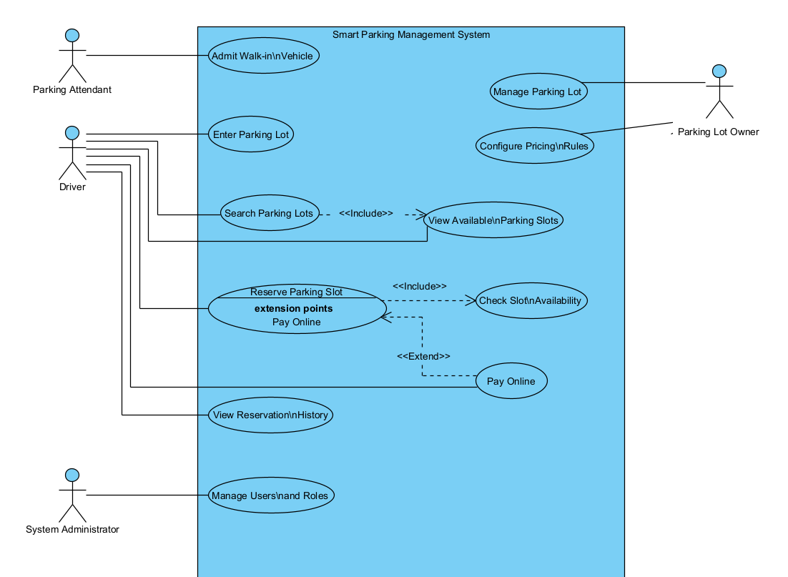Written rationale for UML relationships:
- <<include>>: Reserve Parking Slot <<include>> Check Slot Availability, because every reservation must re-check availability before the reservation is committed.
- <<extend>>: Pay Online <<extend>> Reserve Parking Slot, because online payment occurs only when the driver chooses “pay online”; the case also allows payment at exit.

Question 3. UC Specification (1.5)

UC SPECIFICATION TEMPLATE
Use Case Name | Reserve Parking Slot
Use Case ID | UC-03
Actor(s) | Primary actor: Driver. Supporting actor: Payment Gateway (only when online payment is selected).
Preconditions | 1. The Driver is authenticated.  2. A vehicle is selected/registered.  3. The selected parking lot is active and pricing information is available.  4. The Driver has selected a desired parking slot and time period.
Post conditions | Success: exactly one valid reservation is stored for the selected slot/time period; the slot is unavailable to overlapping reservations; payment status is recorded; a unique QR confirmation code is generated.  Failure: no confirmed reservation is created, no unintended charge is recorded, and any temporary slot hold is released.
Main Flow (Basic Path) | 1. Driver selects a parking lot, parking slot, vehicle, start time, and end time.  2. System validates the request and the Driver’s access.  3. System atomically rechecks that the slot is available for the entire requested time period.  4. System calculates the parking fee using the active pricing rule.  5. System displays the reservation summary and available payment options.  6. Driver confirms the reservation and chooses a payment option.  7. If “pay at exit” is selected, the system records the payment status as pending.  8. System creates the reservation in a transaction and commits the slot/time allocation.  9. System generates a unique QR confirmation code.  10. System displays reservation confirmation and details to the Driver.
Alternative Flow A | A1 – Online payment selected:  A1.1 Driver chooses “Pay Online”.  A1.2 System sends the amount and transaction reference to the Payment Gateway.  A1.3 Gateway approves the transaction.  A1.4 System records the payment as PAID and continues at Main Flow step 8.  If the gateway declines payment, follow Exception Flow E1.
Alternative Flow B | B1 – Slot is no longer available:  B1.1 At Main Flow step 3, another reservation has already taken the same slot/time period.  B1.2 System does not create the reservation.  B1.3 System informs the Driver that the slot is unavailable and refreshes/displays alternative available slots.  B1.4 Driver may select another slot and restart the reservation request.
Exception Flow | E1 – Payment declined/unavailable: System shows a payment failure message, does not confirm the reservation, does not issue a valid QR code, and releases any temporary slot hold.  E2 – Database/system failure while committing: System rolls back the transaction, keeps data consistent, shows an error, and allows the Driver to retry later.
Business Rules | BR1. A parking slot must never have overlapping confirmed reservations for the same time period.  BR2. Only an authenticated Driver may create a reservation.  BR3. The fee is calculated from the active pricing rule for the selected lot/zone/slot and time period.  BR4. A reservation has a unique identifier and QR code.  BR5. A declined online payment must not result in a confirmed reservation; any temporary hold must be released.
Non-Functional Requirements | Performance: reservation confirmation pages must load within 2 seconds under normal conditions; the platform must process at least 600 reservations per minute.  Security: personal/payment data must be encrypted in transit and at rest; authorization must follow RBAC.  Availability: platform availability must be at least 99.9% per month.  Data integrity: the reservation operation must be atomic so the same slot cannot be reserved twice for an overlapping period.

Question 4. Non-functional requirements (1.0)
4.1 Non-functional requirements
Non-functional requirements (NFRs) into appropriate quality categories described in the table below.
Category | NFR Description | Acceptance criterion
Performance | The home page, parking search, parking details, and reservation confirmation pages must load within 2 seconds under normal operating conditions. | For each listed page, response time is ≤ 2 seconds during the agreed normal-load performance test.
Performance / Capacity | The system must process at least 600 parking reservations per minute while preventing double booking of a slot for the same time period. | A load test sustains ≥ 600 reservation requests/minute and produces zero overlapping confirmed reservations for the same slot/time period.
Security | All personal information and payment data must be encrypted during transmission and storage. | Security verification finds no personal/payment data transmitted or stored in plaintext in the tested system paths.
Security / Access Control | Access to system functions must be controlled using Role-Based Access Control (RBAC). | Authorization tests confirm that each protected operation is allowed only to roles granted that permission and denied to unauthorized roles.
Availability | The platform must provide at least 99.9% monthly availability. | Production monitoring for each calendar month reports service availability ≥ 99.9%, excluding only formally agreed maintenance if applicable.
Scalability | The system should support future expansion as the number of partner parking lots increases. | A scale test with a materially larger partner lot dataset completes without architectural redesign and the core search/reservation functions continue to meet the stated performance targets.

4.2 Conflict non-functional requirements
NFR1 | NFR2 | Explaination
Security: encryption and RBAC checks | Performance: ≤ 2-second pages and ≥ 600 reservations/minute | Conflict: encryption, authentication, authorization, and security validation add CPU/latency overhead and can reduce throughput. Trade off: keep mandatory security controls, use efficient cryptographic libraries/TLS termination, cache only non sensitive data, optimize authorization lookups, and performance test with all security controls enabled. Scale application instances or database capacity if the 2 second/600 per minute targets are not met; do not disable required security.

Question 5. Class Diagram (1.5)
5.1 Class List and Description
Class name | Attributes | Methods
User | userId: Long  fullName: String  email: String  role: UserRole | authenticate(): boolean  updateProfile(): void
Driver | driverId: Long  phoneNumber: String  accountStatus: String | searchParkingLots(): List<ParkingLot>  reserveSlot(): Reservation
ParkingLotOwner | ownerId: Long  companyName: String  contactPhone: String | registerParkingLot(): ParkingLot  viewRevenueReport(): Report
ParkingLot | lotId: Long  name: String  address: String  status: ParkingLotStatus | addZone(zone): void  getOccupancyRate(): double
ParkingZone | zoneId: Long  name: String  slotType: SlotType  floorLevel: String | addSlot(slot): void  getAvailableSlots(): List<ParkingSlot>
ParkingSlot | slotId: Long  slotNumber: String  type: SlotType  status: SlotStatus | isAvailable(start,end): boolean  markReserved(): void
Vehicle | vehicleId: Long  licensePlate: String  vehicleType: String  color: String | validatePlate(): boolean  updateDetails(): void
Reservation | reservationId: Long  startTime: DateTime  endTime: DateTime  status: ReservationStatus | confirm(): void  cancel(): void
Payment | paymentId: Long  amount: Decimal  method: PaymentMethod  status: PaymentStatus | process(): boolean  refund(): boolean
PricingRule | ruleId: Long  ruleName: String  hourlyRate: Decimal  effectiveFrom: DateTime | calculateFee(start,end): Decimal  isApplicable(at): boolean

Relationships to represent in the diagram: User <|-- Driver; User <|-- ParkingLotOwner; ParkingLotOwner 1 -- 0..* ParkingLot; ParkingLot 1 *-- 1..* ParkingZone; ParkingZone 1 *-- 1..* ParkingSlot; Driver 1 -- 0..* Vehicle; Driver 1 -- 0..* Reservation; ParkingSlot 1 -- 0..* Reservation; Reservation 1 -- 0..1 Payment; ParkingLot 1 -- 0..* PricingRule.
5.2 Class diagram
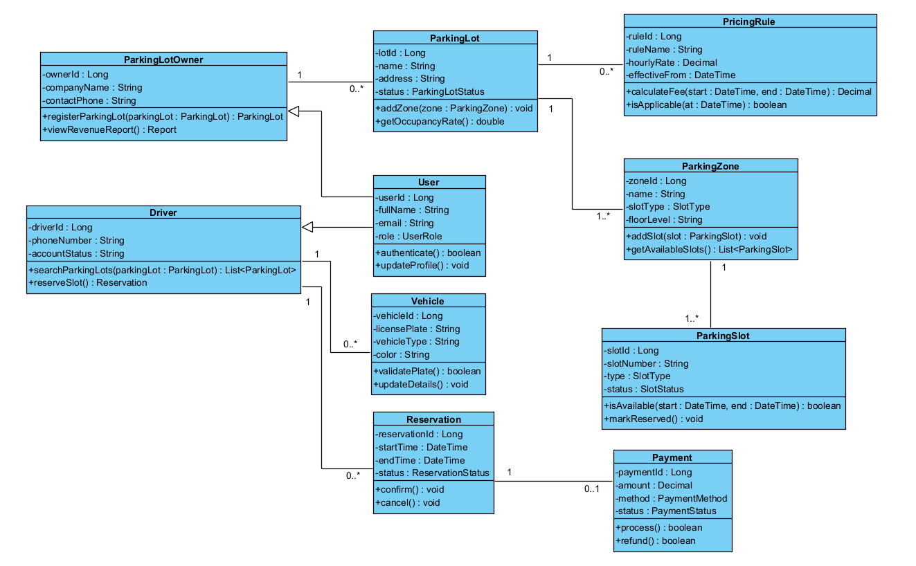

Question 6. AI in Coding (1.0)

Prompt 1:
Act as a senior Java/Jakarta Servlet security and code quality reviewer. Context: this is the legacy Driver Portal of UrbanPark's Smart Parking Management System (SPMS), where a driver reserves a parking slot. The system must prevent double booking and protect personal/payment data. Review the following two files for security vulnerabilities, correctness defects, concurrency/data integrity problems, resource management issues, and Servlet/JSP bad practices.
ReserveSlotServlet.java:
public class ReserveSlotServlet extends HttpServlet {
protected void doGet(HttpServletRequest request,
HttpServletResponse response)
throws ServletException, IOException {
String slotId = request.getParameter("slotId");
Statement st = conn.createStatement();
ResultSet rs = st.executeQuery(
"SELECT * FROM parking_slot WHERE id=" + slotId);
if (rs.next()) {
if (rs.getString("status") == "AVAILABLE") {
st.executeUpdate(
"UPDATE parking_slot SET status='RESERVED' WHERE id=" + slotId);
}
}
request.setAttribute("driver",
request.getParameter("driverName"));
request.getRequestDispatcher("result.jsp")
.forward(request, response);
}
}
result.jsp:
<h3>Reservation for
<%= request.getParameter("driverName") %>
</h3>
Expected output: return a table with columns [# | File/location | Defect | Why it is a problem | Severity | Recommended fix]. Identify at least six defects and prioritize exploitable security/correctness issues.
Expected defects the AI should identify:
1. SQL Injection because slotId is concatenated directly into SQL.
2. No input validation/type checking for slotId.
3. String comparison uses == instead of .equals(), which can produce incorrect status checks.
4. Stored/reflected XSS risk because driverName from the request is rendered by a JSP scriptlet without output escaping.
5. Statement/ResultSet (and possibly Connection) resources are not properly closed.
6. GET is used for a state changing reservation operation; POST is more appropriate.
7. Check then update race condition can allow concurrent double booking; no atomic conditional update/locking/transaction is shown.
8. JDBC/database logic is embedded in the servlet and JSP uses scriptlets, both contrary to separation-of-concerns best practices.
Prompt 2:
Using the code and review findings above, generate corrected versions of ReserveSlotServlet.java and result.jsp for the SPMS Driver Portal. Requirements:
• Prevent SQL Injection and use PreparedStatement for all SQL values.
• Validate slotId and reject missing, malformed, or non positive input.
• Use POST for the reservation state-changing operation.
• Prevent Cross-Site Scripting (XSS); do not print raw request parameters in JSP and do not use JSP scriptlets. Pass trusted display data as request attributes and escape output (for example with JSTL <c:out>).
• Correct String comparison logic.
• Use try-with-resources to close JDBC resources properly.
• Prevent concurrent double booking by making the availability check/reservation update atomic (for example, UPDATE ... WHERE id=? AND status='AVAILABLE' and verify exactly one updated row) and use an appropriate transaction boundary.
• Keep SQL out of result.jsp and follow Servlet/JSP separation of concerns practices.
• Handle database/payment style failures with safe user-facing messages; do not expose stack traces or sensitive data.
Expected output: (1) a complete corrected ReserveSlotServlet.java code block, (2) a complete corrected result.jsp code block, and (3) a short bullet summary explaining each major improvement and how it addresses the identified defect.

Question 7. Testing Stage and Type (1.5)
7.1 Testing Stage and Responsibility
Stage | What is tested? | Who is responsible? | Types of test?
Unit Testing | Individual classes/methods such as reservation validation, pricing calculation, slot availability logic, and authorization helpers. | Developers | Unit, white-box, boundary value, exception testing
Integration Testing | Interactions among reservation service, database, Payment Gateway, occupancy sensors, barrier/QR/licence plate components, and external vendor interfaces. | Developers and QA engineers | Integration, API/contract, database, interface, failure handling testing
System Testing | The complete SPMS end to end for Driver, Parking Lot Owner, Parking Attendant, and System Administrator workflows, including NFRs. | QA/Test team | Functional E2E, regression, performance/load, security, recovery/availability testing
Acceptance Testing | Business workflows and acceptance criteria in a production like environment, especially search, reserve, payment, entry, operations, and reports. | Product Owner/business representatives and selected end users | User Acceptance Testing (UAT), business process, operational acceptance testing

7.2 Test Cases
TCID | Test Case Name | Precondition | Test steps | Expected result | Test type
TC1 | Successful reservation with QR confirmation | Driver is authenticated; a vehicle is registered; selected slot is available for the requested period; online payment service is available. | 1. Search/select a parking lot and available slot.  2. Choose start/end time and vehicle.  3. Click Reserve.  4. Choose online payment and use an approved e-wallet transaction.  5. Confirm the reservation.  6. Open the confirmation page. | One confirmed reservation is created; payment is recorded as successful; the slot is unavailable for overlapping reservations; a unique valid QR confirmation code and reservation details are displayed. | Happy path
TC2 | Reserve the very last free slot | For the selected parking lot/time period, free slots = 1; Driver is authenticated; the last slot is available. | 1. View availability and verify free slots = 1.  2. Reserve the last available slot.  3. Refresh availability.  4. Attempt another reservation for the same slot/time period. | First reservation succeeds; free slots becomes 0; the same slot cannot be reserved again for the overlapping period; no double booking is created. | Boundary / edge case
TC3 | E-wallet payment is declined | Driver is authenticated; selected slot is available; Payment Gateway/e-wallet is configured to return DECLINED. | 1. Select an available slot and time period.  2. Start Reserve Parking Slot.  3. Choose e-wallet/online payment.  4. Submit payment and receive DECLINED from the gateway.  5. Return to reservation/availability. | A clear payment-declined message is shown; no confirmed reservation and no valid QR code are created; no payment is recorded as successful; any temporary hold is released so the slot remains available. | Negative / error

