
APT3010A Introduction to Artificial Intelligence
Group Assignment 3
Surveillance Robot Navigation
Group 3
Dev Patel • 670820 | Juliet Karakacha • 671759
Harshni Beed • 674078 | Megan Surmat • 673644
Shreyas Dodhia • 673432 | Muriuki Lenny • 670597
Steve Kyoni • 673382

Overview
The building map contains 12 scan points (nodes 0–11) where the surveillance robot can position itself. The energy cost of moving between any two connected nodes equals the absolute difference of their node values. A single Python program was written to handle all four navigation tasks, with the agent selecting the desired mode at runtime.

GitHub Repo with the full code:

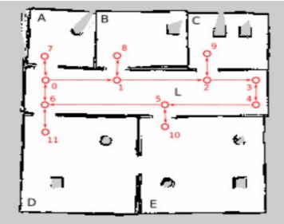

Task | Algorithm Used
i) Fewest stopovers | BFS — Breadth-First Search
ii) All paths | DFS — Depth-First Search (full traversal)
iii) Cheapest path | UCS — Uniform Cost Search
iv) Cheapest + distance heuristic | A* Search

i) Fewest Stopovers — BFS (Breadth-First Search)
Explanation
When the agent needs to respond quickly to a security concern, the priority is reaching the target with as few intermediate stops as possible — not necessarily the cheapest route. BFS is ideal for this because it explores the graph level by level (one hop, then two hops, then three, and so on). The first time BFS reaches the goal node, it guarantees that path uses the minimum number of steps.

- BFS uses a queue (FIFO — first in, first out).
- Each level of the queue represents nodes reachable in exactly N steps.
- The first path to reach the goal has the fewest nodes visited.
- It does NOT consider edge costs — only the number of hops matters.

Code
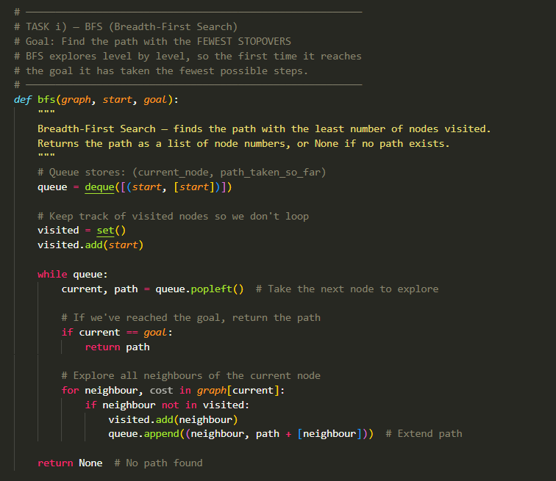

Key Code Snippet
queue = deque([(start, [start])])
visited = set([start])

while queue:
current, path = queue.popleft()
if current == goal:
return path
for neighbour, cost in graph[current]:
if neighbour not in visited:
visited.add(neighbour)
queue.append((neighbour, path + [neighbour]))

Sample Output
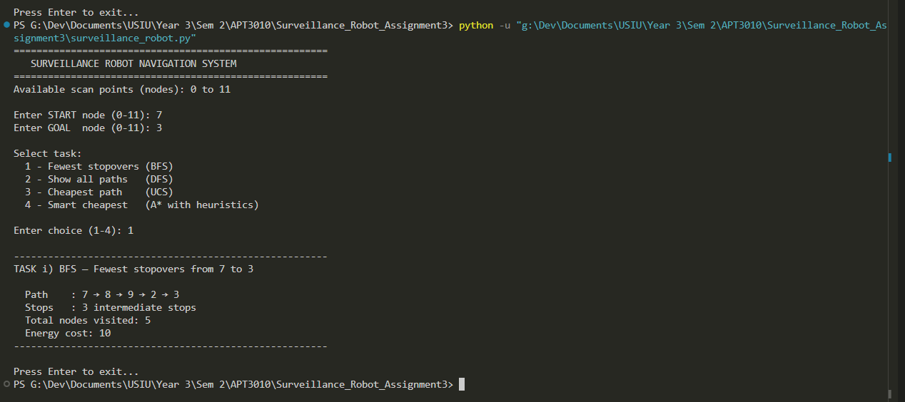

The output shows the path taken, number of intermediate stops, and total energy cost. BFS finds the path with the fewest nodes, even if it is not the cheapest.

ii) All Available Paths — DFS (Depth-First Search)
Explanation
When the agent needs a complete picture of all possible routes — perhaps to choose manually or to assess risks — DFS is used to enumerate every valid path. Unlike standard DFS (which stops at the first goal found), this version continues exploring after reaching the goal to collect all paths.

- DFS uses a stack (LIFO — last in, first out).
- It dives deep into one route before backtracking and trying another.
- Each path tracks its own visited set to prevent cycles within that path.
- Every time the goal is reached, the path is saved and exploration continues.

Code
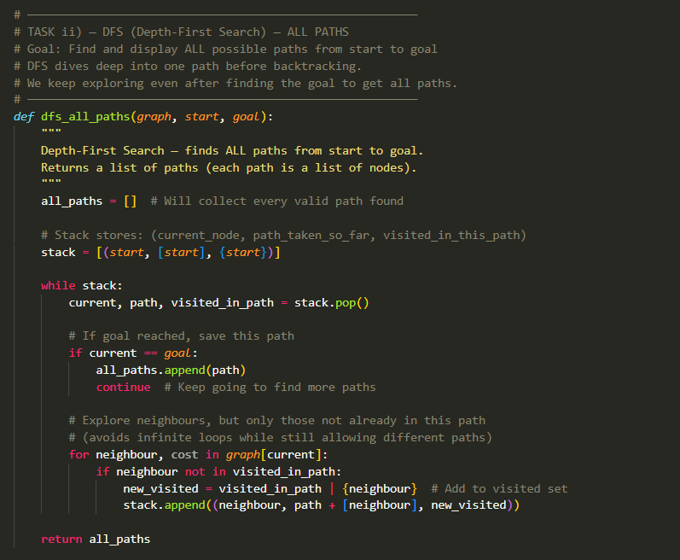

Key Code Snippet
stack = [(start, [start], {start})]
all_paths = []

while stack:
current, path, visited_in_path = stack.pop()
if current == goal:
all_paths.append(path)
continue
for neighbour, cost in graph[current]:
if neighbour not in visited_in_path:
new_visited = visited_in_path | {neighbour}
stack.append((neighbour, path + [neighbour], new_visited))

Sample Output
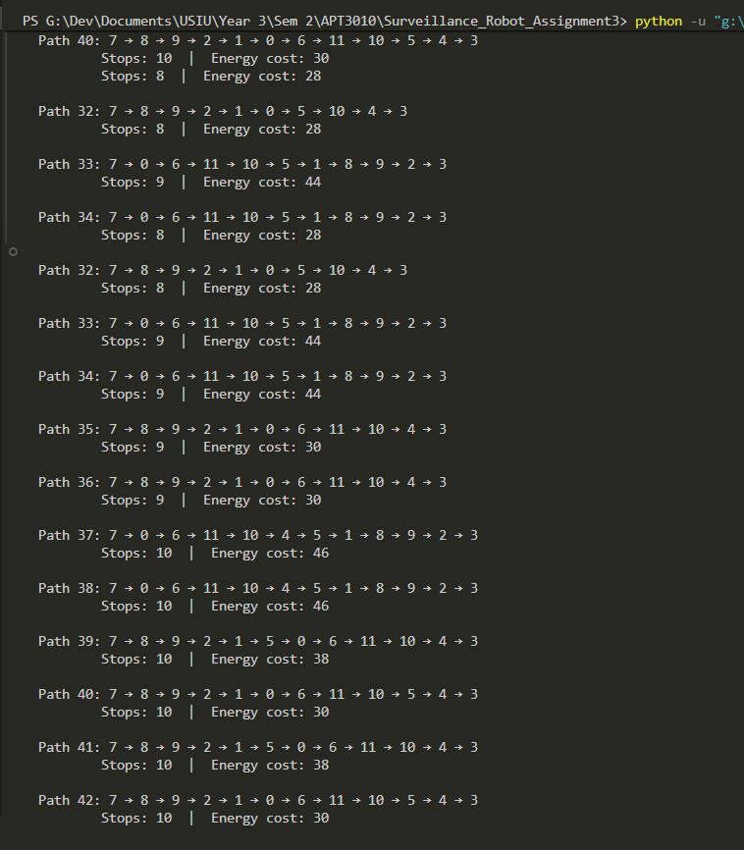

The output lists every discovered path with its stop count and energy cost, sorted from shortest to longest. This gives the agent a full view of available routes.
iii) Cheapest Path — UCS (Uniform Cost Search)
Explanation
When the robot's battery is low, minimising energy use is critical. UCS guarantees finding the path with the lowest total energy cost by always expanding the cheapest unexplored node first. It uses a min-heap priority queue, so the path with the lowest cumulative cost is always processed next.

- UCS uses a priority queue ordered by total cost so far (g).
- It never expands a node through a path more expensive than a known cheaper route.
- When the goal is first popped from the priority queue, that is guaranteed to be the optimal path.
- Edge costs = |node_value_A − node_value_B|, so adjacent nodes with similar values are cheap to traverse.

Code
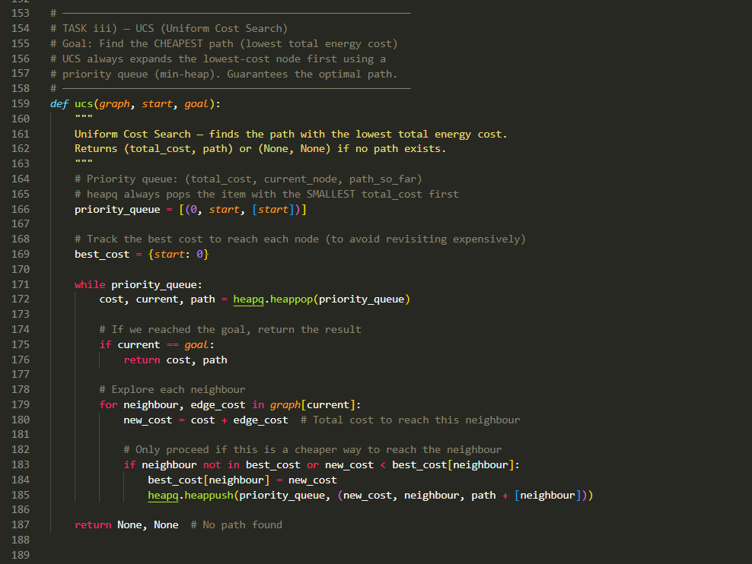

Key Code Snippet
priority_queue = [(0, start, [start])]
best_cost = {start: 0}

while priority_queue:
cost, current, path = heapq.heappop(priority_queue)
if current == goal:
return cost, path
for neighbour, edge_cost in graph[current]:
new_cost = cost + edge_cost
if neighbour not in best_cost or new_cost < best_cost[neighbour]:
best_cost[neighbour] = new_cost
heapq.heappush(priority_queue, (new_cost, neighbour, path + [neighbour]))

Sample Output
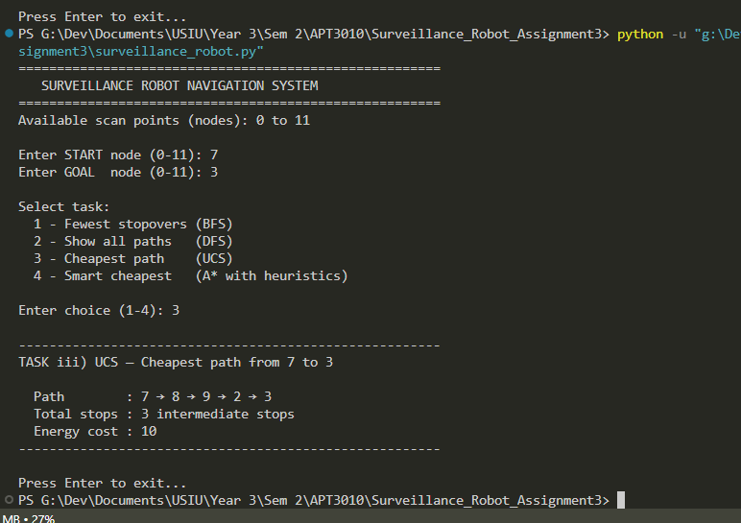

The output shows the cheapest path found and its total energy cost. This may have more stops than the BFS result but will always have an equal or lower energy cost.

iv) A* Search with Heuristics
Explanation
A* improves on UCS by adding a heuristic — an estimate of the remaining cost to the goal. This allows the search to prioritise nodes that are not only cheap to reach but also appear close to the goal, making it more efficient than UCS while still guaranteeing the optimal path (provided the heuristic is admissible — never overestimates).

The Heuristic
The heuristic used is the absolute difference between the current node's value and the goal node's value:

h(n) = |node_value(n) − node_value(goal)|

This works as a distance proxy because node values increase roughly with their position in the building. Nodes whose values are closer to the goal's value are treated as being geographically closer. This heuristic is admissible — it never overestimates the true cost — because the minimum cost of any single edge is 1 (adjacent node values differ by at least 1).

- f(n) = g(n) + h(n)
- g(n) = actual energy cost from start to node n
- h(n) = estimated remaining cost from n to goal
- A* expands the node with the lowest f(n) first

Code
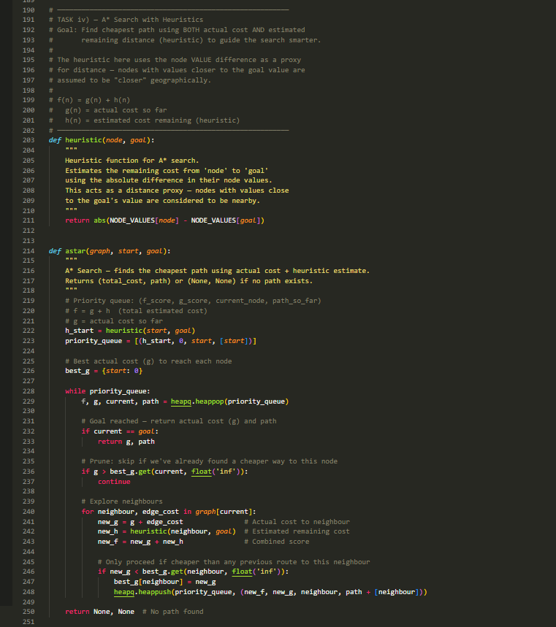

Key Code Snippet
def heuristic(node, goal):
return abs(NODE_VALUES[node] - NODE_VALUES[goal])

priority_queue = [(h_start, 0, start, [start])]
best_g = {start: 0}

while priority_queue:
f, g, current, path = heapq.heappop(priority_queue)
if current == goal:
return g, path
for neighbour, edge_cost in graph[current]:
new_g = g + edge_cost
new_h = heuristic(neighbour, goal)
new_f = new_g + new_h
if new_g < best_g.get(neighbour, float('inf')):
best_g[neighbour] = new_g
heapq.heappush(priority_queue, (new_f, new_g, neighbour, path + [neighbour]))

Sample Output
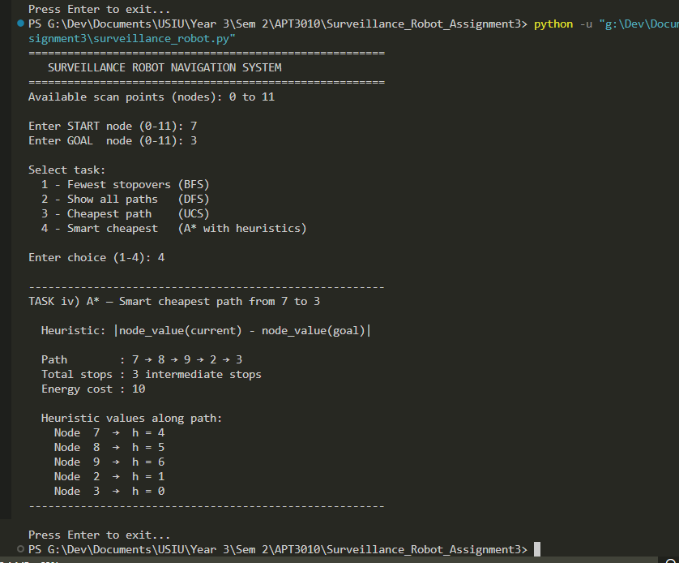

The output shows the optimal path, total energy cost, and the heuristic value at each node along the path. The heuristic values decrease as the robot approaches the goal, confirming the heuristic is guiding the search in the right direction.

A* vs UCS Comparison
Property | UCS vs A*
Optimality | Both guarantee the cheapest path
Speed | A* is generally faster — heuristic reduces explored nodes
Heuristic | UCS uses none; A* uses h(n) = |value(n) − value(goal)|
Best for | UCS: small graphs. A*: larger graphs where direction matters

Conclusion
All four navigation tasks were implemented in a single Python program using well-established search algorithms. The agent selects the appropriate mode at runtime depending on the situation: BFS for speed, DFS for full exploration, UCS for battery conservation, and A* for intelligent battery-saving with distance awareness. No external libraries are required — only Python's built-in heapq and collections modules.

