
APT3010A: Introduction to Artificial Intelligence
Assignment 2 Mars Rover Simulation

GROUP 3
Dev Patel 670820
Juliet karakacha 671759
Harshni Beed 674078
Megan Surmat 673644
Shreyas Dodhia 673432
Muriuki lenny 670597
Steve Kyoni 673382

1. Introduction
This assignment required us to simulate a Mars Rover performing two exploration ventures across four Mars locations (A, B, C, D) while sampling rocks. The environment changes randomly between explorations to simulate wind uncovering or covering rocks. The rover is not allowed to sample a location it has already visited in a previous venture.
The program was implemented in Python using object-oriented programming (OOP), with three classes: RoverPerformance, MarsEnvironment, and RoverAgent.

2. How to Run the Program
Requirements
The program uses only Python's built-in random module — no additional installations are needed. You only need:
Python 3.x installed on your computer
Visual Studio Code (VS Code) with the Python extension

Steps to Run
1. Open VS Code and open the folder containing mars_rover.py.
2. Open a terminal in VS Code: Terminal > New Terminal.
3. Type the following command and press Enter:
python mars_rover.py
4. The simulation will run and display output in the terminal.
5. Press Enter when prompted to close the program.

3. Program Structure & Classes
The program follows an object-oriented design with three classes, each handling a specific responsibility.

Class 1: RoverPerformance
This class tracks everything the rover has done across both explorations. It stores how many times each location was sampled, counts total actions and successful samples, and calculates the rover's performance percentage

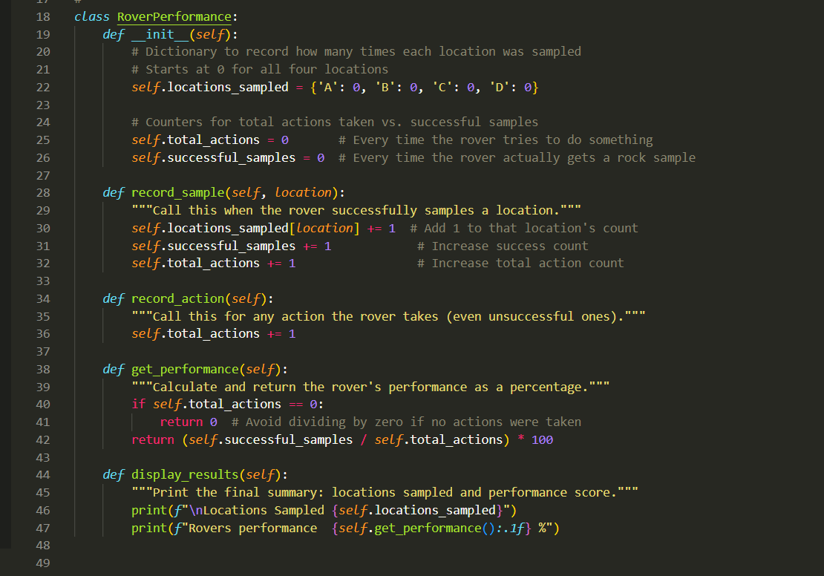

Class 2: MarsEnvironment
This class represents the four Mars locations and whether each one currently has rocks. It randomly assigns rocks (1) or no rocks (0) to each location when created. The randomize() method is called between explorations to simulate wind changing the environment.
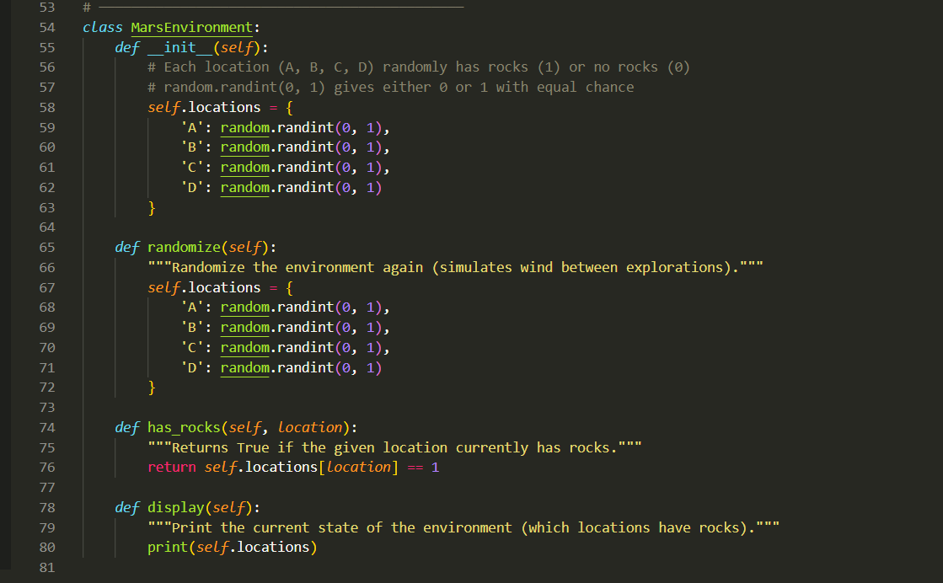

Class 3: RoverAgent
This class represents the rover itself. It holds a reference to the environment and the performance tracker. The explore() method runs a single exploration venture — visiting all four locations, checking for rocks, and sampling where possible. It skips any location already sampled in a previous venture.

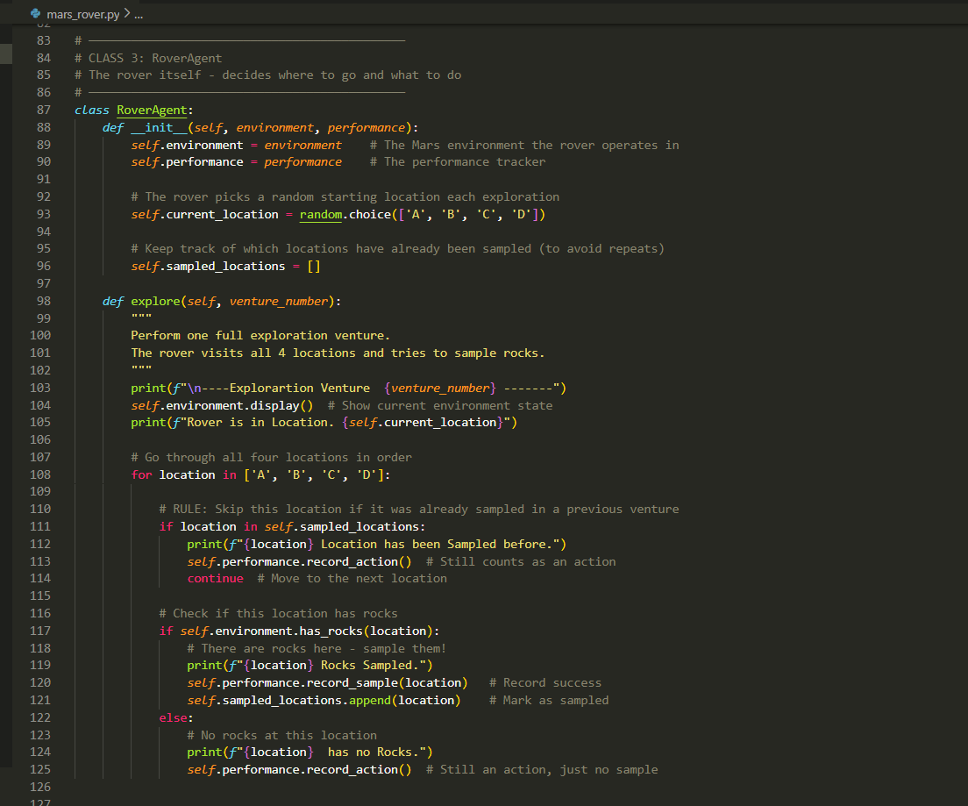

4. How the Simulation Works
Below is a step-by-step walkthrough of what happens when the program runs:

A RoverPerformance object is created to track the rover's history.
A MarsEnvironment object is created, randomly assigning rocks to each location.
A RoverAgent is created and placed at a random starting location.
Exploration Venture 0 begins: the rover visits all four locations in order (A, B, C, D). If a location has rocks, it samples them and records a success. If not, it records an action (no sample).
Between ventures, the environment is randomized again (wind simulation).
Exploration Venture 1 begins: the rover repeats the process, but skips any location it already sampled in Venture 0.
After both ventures, the final sampled locations and performance percentage are displayed.

Performance is calculated as:
Performance (%) = (Successful Samples / Total Actions) x 100

5. Expected Output
Because the environment is randomized each time, the output will vary between runs. Below is an example of what you might see:

----Explorartion Venture 0 -------
{'A': 1, 'B': 1, 'C': 0, 'D': 0}
Rover is in Location. C
C has no Rocks.
D has no Rocks.
A Rocks Sampled.
B Rocks Sampled.
----Explorartion Venture 1 -------
{'A': 1, 'B': 1, 'C': 1, 'D': 0}
Rover is in Location. A
A Location has been Sampled before.
B Location has been Sampled before.
C Rocks Sampled.
D has no Rocks.
Locations Sampled {'A': 1, 'B': 1, 'C': 1, 'D': 0}
Rovers performance 75.0 %
Press any key to continue . . .

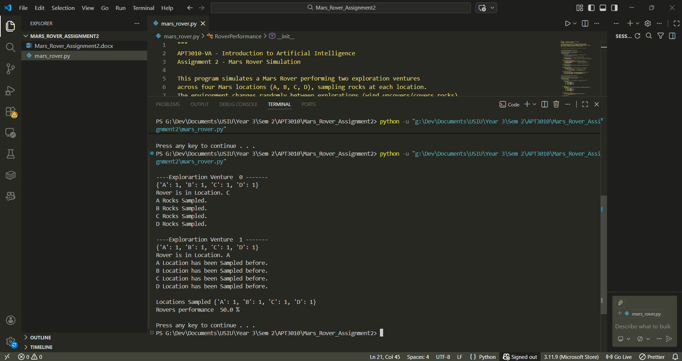

6. Conclusion
This simulation demonstrates how an AI agent (the rover) can make decisions based on its environment. The key concepts applied include:
Object-Oriented Programming — separating concerns into three distinct classes.
Randomization — using Python's random module to model an unpredictable environment.
Agent memory — the rover remembers which locations it has sampled and avoids repeating them.
Performance measurement — tracking success rate across multiple actions.

The program successfully replicates the expected output shown in the assignment and demonstrates basic AI agent behaviour in a simple simulated environment.

