Andrés Gómez Emilsson
Psych 209 final project report
Jay McClelland

Illusory Contour – a neural network model

######################################
Structure of the paper:
Introduction (1, 2)
Methods (3, 4)
Results (5)
Discussion (6)

#####################################
Introduction (1, 2)

Issues and questions addressed
Interesting, previously done and not yet done

Methods (3, 4)

The approach to modeling the illusory contour used in this paper is to use an network that recognizes squares in an input layer by combining low and high level features. This is in a way approximately analogous to the integration of information between the features detected by layers V1 and V2. The layers in our network are specifically tuned to identify rows and columns of a given length, by combining those detected lines then squares of a given size are detected. The network's connections are pre-established and their weights do not change over time. The network architecture is designed in such a way that each possible square -of the appropriate size- in the input layer is has a corresponding unit in the highest layer. At a high level, we associate activity in the intermediate layers to activity in V1 neurons, while activity in the square-recognizing layer is associated to activity in V2 neurons.

Specifics of the network:

Units in the network are organized as four layers. The format of the following list provides the dimensions each layer followed by the weighted sum of excitation (ex function) received by other units.

Input layer: NxN lattice.
No excitatory connections to I units.

Row layer is: (N–L+1)xN lattice.
ex(R_{i,j}) = sw(S_{i,j} + S_{i-l+1,j}) + ∑_{j-1<x<j+l} I_{i,x}

Column layer is: Nx(N-L+1) lattice.
ex(C_{i,j}) = sw(S_{i,j} + S_{i,j-l+1}) + ∑_{i-1<x<i+l} I_{x,j}

Square layer: (N-L+1)x(N-L+1) lattice.
ex(S_{i,j}) = C_{i,j} + C_{i,j+l} + R_{i,j} + R_{i+l,j}

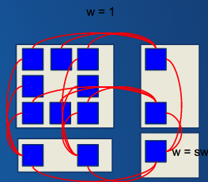
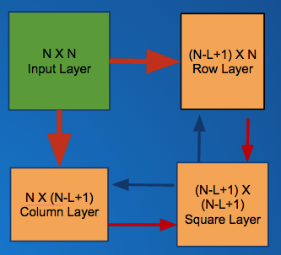
Figure 1 & 2: 1 Depicts the broad network architecture in terms of layers and connectivity. 2 depicts an example connectivity where l = 3. Typically the units in Row and Column layers excite two units in the the Square layer, but near-edge units excite only one.

In the description above sw is a scalar (“square weights”) that represents the connection weights from the Square layer to the Row and Column layers. The ex function is a way to pool the excitation of the units directed to each unit. However, the net input (net) on a given unit is not immediately equal to the ex function. Instead, the net input from the previous epoch is taken into account in order to avoid sudden loss of information or wild swings in the net input units receive. For this reason, for the net activation of unit u in a given epoch we use instead a lambda parameter in the following way:
net(u)_{epoch} = (1 – λ)net(u)_{epoch-1} + λex(u)

The activation for each unit is then determined using either a whole-layer divisive normalization (D), or a local divisive normalization with a Gaussian kernel (GD).
In the first case, D, the activation of unit u in layer L is computed by:
act(u) = e^{net(u)} / (α + β ∑_{v in L}e^{net(v)})

In the second case, GD, instead we have:
act(u) = e^{net(u)} / (α + β ∑_{v in L} (e^{net(v)} k(d(u, v), sd)))
Where d(u, v) is the euclidean distance between unit u and v: ((u_{x} - v_{x})² + (u_{y} + v_{y})²)^{0.5} and k(d) is the Gaussian kernel with standard deviation sd.
k(d, sd) = e^{(-d^2/ (2sd^2))}

With the network above we see that there are multiple parameters that can be tuned for various purposes. First, we have the top-down connection weights, sw.

Inputs Used

First, the input that is used will Simulating the classic Kanizca shape in a pixalated domain, we take off the center segments of a square. Additionally, we also use inputs

Complete Square (CS) | Missing Piece (MP) | Missing Side (MS) | Kanizsa Shape (KS)

Additionally, the input has a noise component that masks the relevant part of the stimuli. For a given proportion of noise P, the program does the following: For each unit in the input layer, with probability P erase the value at that unit and replace it by either 1 or 0 with equal probability. In this way, P is equal to the proportion of units whose information is lost.

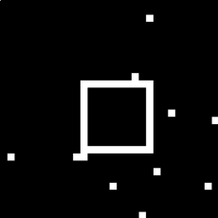 | 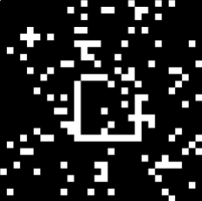 | 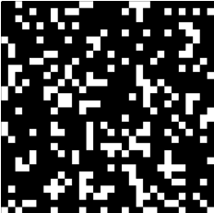 | 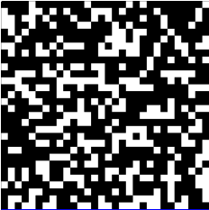
5% information loss | 25% information loss | 45% information loss | 65% information loss

Pattern of results to replicate:

There are four behaviors we want the network to display. First, (1) it must be able to recognize squares in the input layer. Without this objective being met the rest of the task would not be very meaningful. Ideally, the network should be able to recognize squares under noisy conditions too.

(2) Second the network should show the illusory contour phenomena. We are defining the location of the illusory contour to correspond to activation in the units that recognize line segments. When we present the network with an incomplete square, the unit that recognizes the incomplete (or absent) line should then show activity even though there is less (or no) direct stimulation coming from the input layer.

(3) Third, delay of activation of illusory contour versus square layer. The main finding in the Lee & Nguyen (2001) paper is described as follows: “The population averaged response to illusory contours emerged 100 msec after stimulus onset in the superficial layers of V1, and around 120–190 msec in the deep layers. The illusory contour response in V2 began earlier, occurring at 70 msec in the superficial layers and at 95 msec in the deep layers.” Given the structure of our network, we do not differentiate between superficial and deep layers within each layer. Since both the deep and superficial layers show the same respective time lag between V2 and V1, the qualitative behavior we intend to see when the network is properly parametrized can simply be described as a delay in the activation of the line segment units respect to the square unit. This behavior, more so, should happen with the illusory contour but not with a whole square.

(4) Fourth, another important result in Lee & Nguyen (2001) is a characteristic delay of activation of V1 neurons to the illusory contour versus real contours (either actual individual lines, or the edge of grey and white squares).

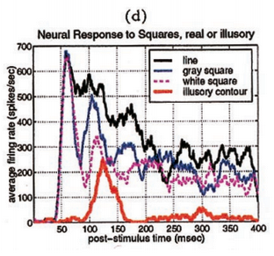
To replicate this result in our network we will compare the onset of activation of units that recognize segments when the segments themselves are missing but they still correspond to an outline of a square with a missing piece or side. An aspect of the results of the paper that we will not attempt to replicate is the decay in activation after it reaches its peak. Presumably there are neural adaptation processes that explain the decay, but our network will settle on the activation of only a few units which will stay active for as long as the simulation is ran.

Results

(1) We found a set of parameters that enable a faithful recognition of a unique square in an input. For simplicity we are focusing on the whole-layer divisive normalization (D), which runs much faster than the GD normalization. We define a “successful trial” to be a run when the square unit that matches the correct input square is the single most active unit in the entire layer.

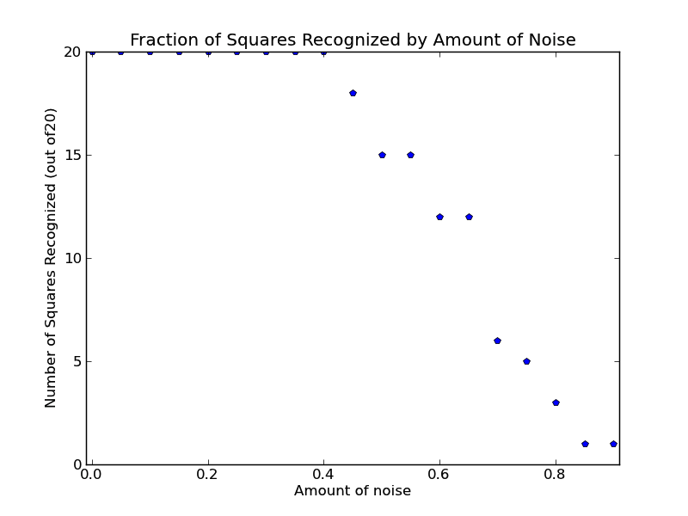

Figure 3: Number of successful trials under different amounts of noise (out of 20 trials in each condition). With 0.05 noise proportion interval ranging from 0 to .9.

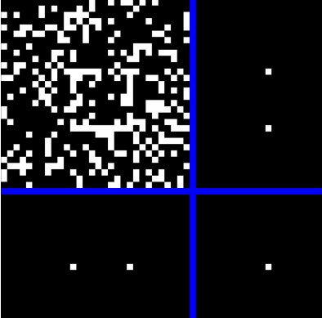

Figure 4: Example of the final state of a successful trial with 50% noise.

We see that up to a level of noise of 40% the network always identifies the correct square unit. The network is not sensitive to parameter changes in beta, alpha, or sw for this result.

(2) To show conclusively that there is an illusory contour effect we contrast the activation of the unit corresponding to the Missing Side in the MS input type, to the activation of the same unit with CS as input. As we can see, in the Missing Side trials we

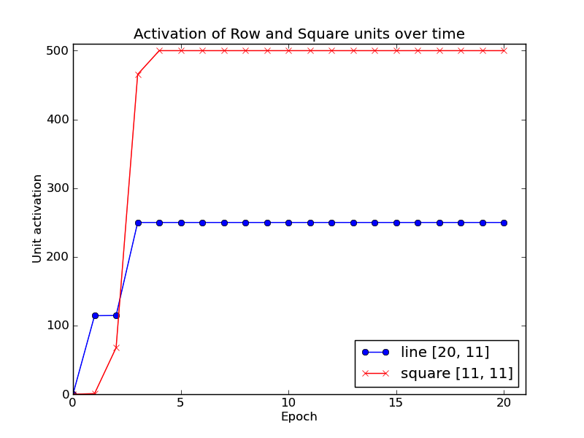  0% noise |  | 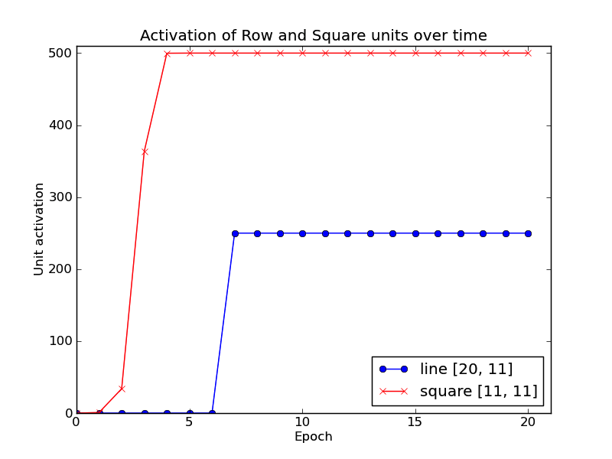
20% noise | 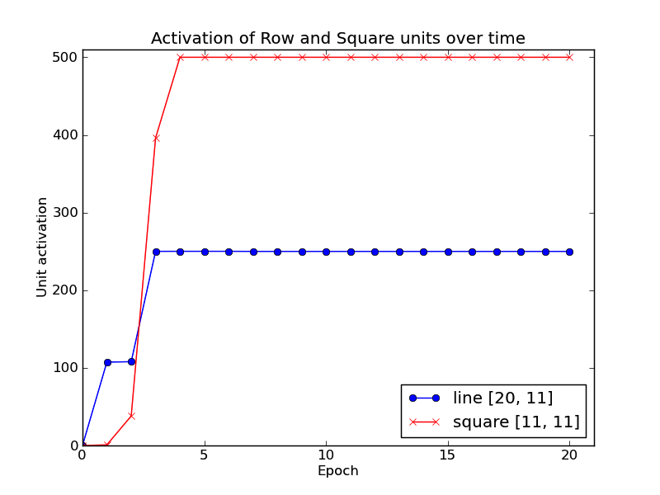 | 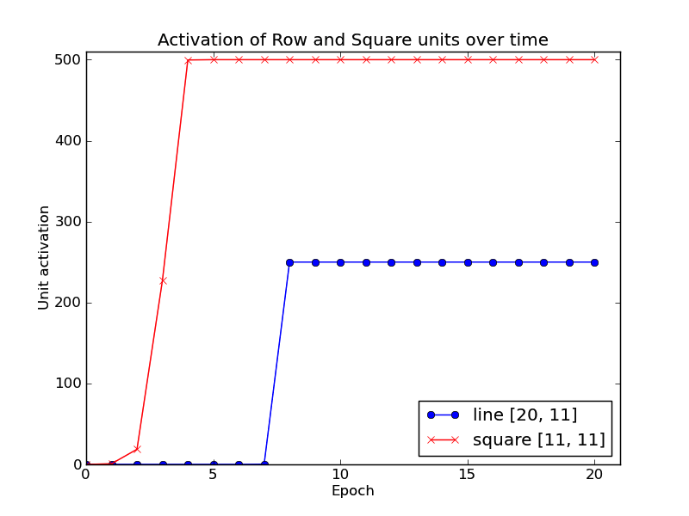
 | Complete Square (D) | Missing Side (D)
The use of MS above is to show unequivocally that the activation of the line unit is being driven by the interaction between the C, R and S layers rather than any kind of direct stimulation from the input layer. Similar results are also found when we use the Gaussian normalization:

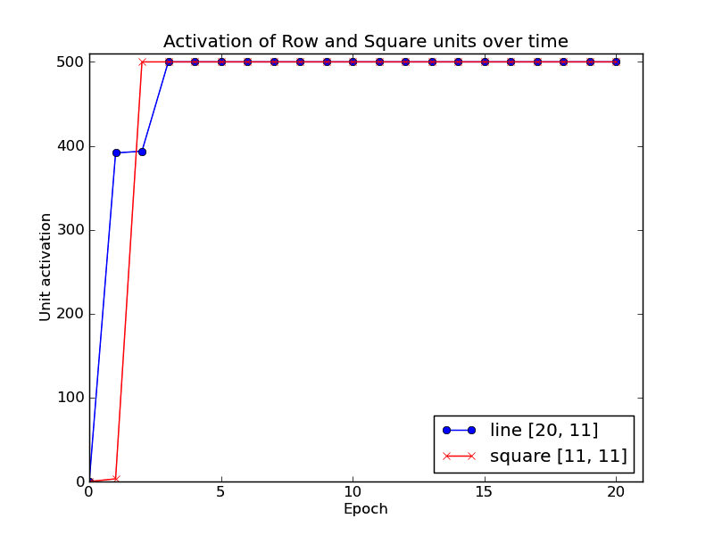 | 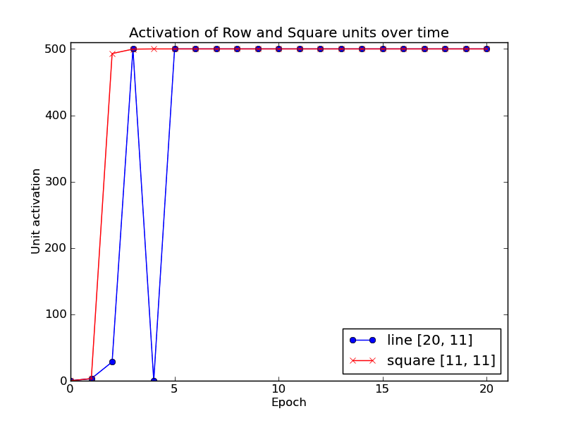
Complete Square (DG)

(3) The delayed activation of unit encoding an illusory contour line compared to the activation between versus square layer.

(4) Delay of activation of illusory contour versus full contour.

Discussion (6)

1. Issue or question addressed

2. Interesting, previously done and not yet done

3. What approach will you be taking to address it? (at a big picture level; novel and/or otherwise noteworthy aspects)

4. Details of approach:

Specific target phenomenon or phenomena you will be addressing: e.g., pattern of data you intend to try to fit.

Model network task setting, architecture, processing and learning algorithm, training environment (corpus used for training, knowledge base built in to network),

5. Results and Analysis

First present your primary findings that bear directly on the target phenomena. A strong paper will, in addition, present an analysis of why the results came out the way they did, especially in cases where results did not come out as expected. It can be useful to discuss results you obtain with one of us to get suggestions as to how to fully understand your findings. Analysis not only of network outputs but also of the structure of the information present in the materials you use to train your network (when relevant) and / or the hidden unit activations, network weights, or learning trajectory can help illuminate why and how your network has performed the way it did.

6. Discussion

Summarize your goals, your approach, and your main findings, and state a conclusion indicating how well, overall, your goals have been met. Then, discuss shortcomings or limitations of your effort and indicate how these might be overcome in future work. Also, indicate broader implications and potential future applications of the ideas and approach. End with a brief final summary.

Citations: We will not be sticklers for details of citation styles but do provide citations to literature you draw on in your paper, using the following format.

[Hint: in Google Scholar, if you click on 'cite', then select the APA example, you'll get citations in this format]

Smith, R. B., Jones, F, L., & Green, D. E. (2010). Title of Article. Journal Name, V#, sp#-ep#.

(V# stands for Volume number, sp#-ep# stand for start and end page numbers).

the article's doi can be provided instead of the volume and page numbers.

For conference proceedings, the volume and page numbers may be omitted. Conference names can be abbreviated.

For articles in books:

Smith, R. B., Jones, F, L., & Green, D. E. (2010). Title of Article. In Brown, D. E. and Baker, A. R, (Eds) Book Title, #sp-#ep, Publisher.

For whole books:

Smith, R. B., Jones, F, L., & Green, D. E. (2010). Book Title. Publisher.

Parameters of images:

layer_divisive_0_to_-9_complete_square_n30_l10_sl10_prob0-9_sou20-0a_lmda-1_sw5-0_alpha0-31_beta0-002_scaling5_expo0-3_t1-0_dnorm0_amp11_sd10-7_amp20-5_sd22

complete_square_n30_l10_sl10_prob0-5_sou11-11a_lmda-1_sw1-1_alpha0-31_beta0-002_scaling5_expo0-3_t1-0_dnorm0_amp11_sd10-7_amp20-5_sd22

(2) contrasts: complete_square_n30_l10_sl10_prob0-2_sou11-11a_lmda-01_sw40-1_alpha0-31_beta0-002_scaling5_expo0-3_t1-0_dnorm0_amp11_sd10-7_amp20-5_sd22

