NEERAJ PANWAR- Batch7 (CEQ545)

# Create a lambda function which will invoke another lambda function

Steps are as follows:

* Create a lambda function.
* Then create another lambda function which will call the first lambda function using Boto3.
* When we run the 2nd lambda function, it will show that the execution is successful under the execution results tab.

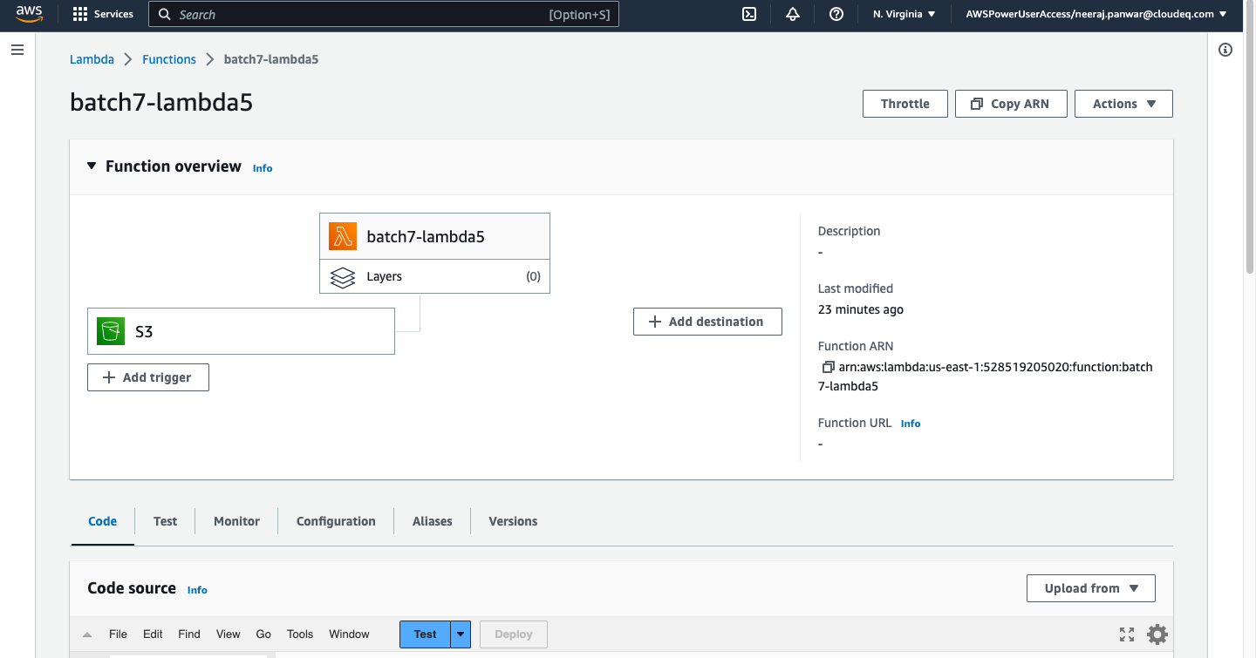

Invoking ‘batch7-lambda3’ function in ‘batch7-lambda5’ function using boto3 code.

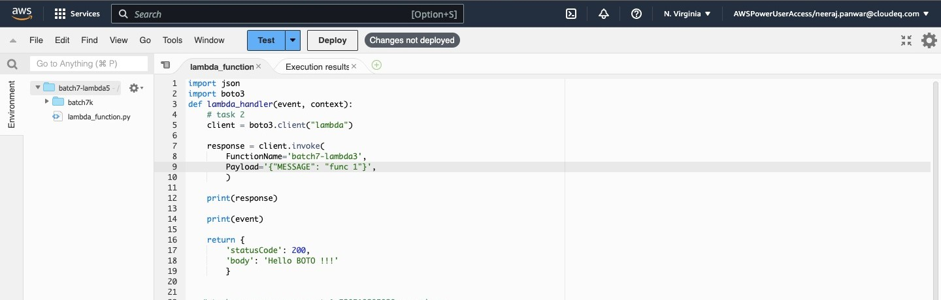

Cloud watch page: Payload message in Logs, passed from ‘lambda5’ to ‘lambda3’

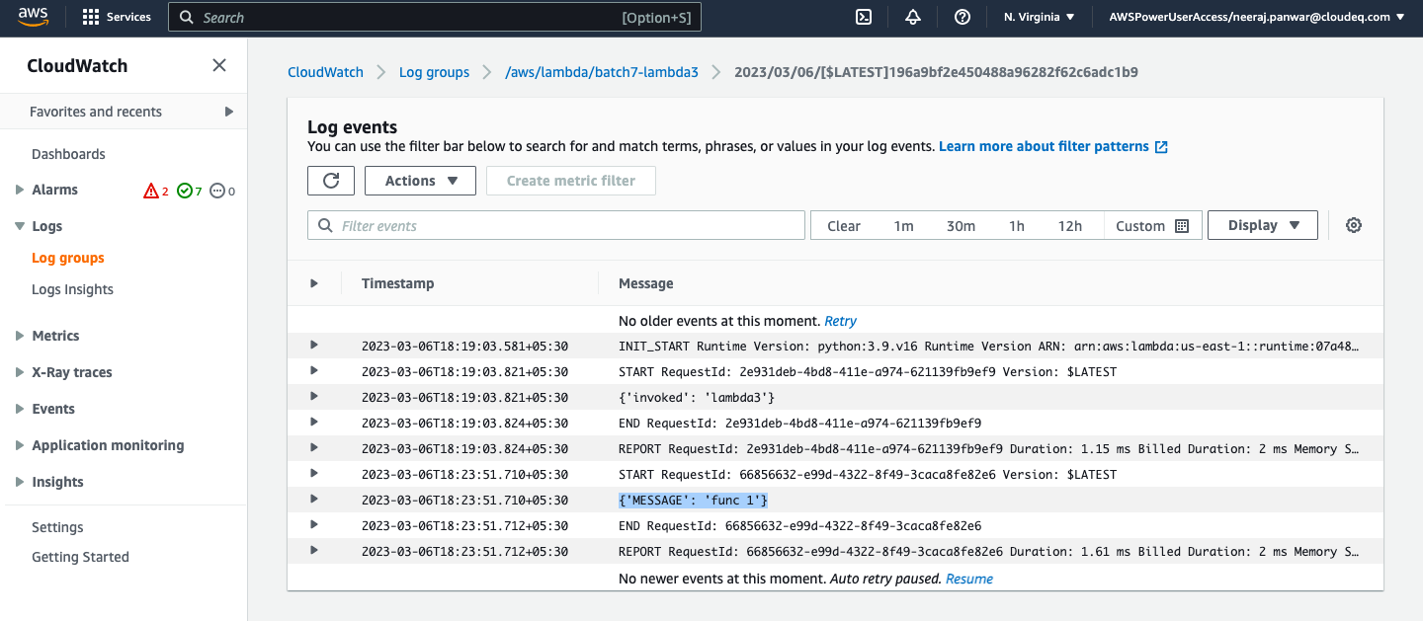

# Create a lambda that will have 2 triggers -i) when object is uploaded in s3 bucket and ii) when object is deleted from s3 bucket. And have SNS as destination and the result should display only the bucket name.

STEPS:

* + adding 2 triggers, one for uploading object in s3 bucket and another one is for deleted object from s3 bucket

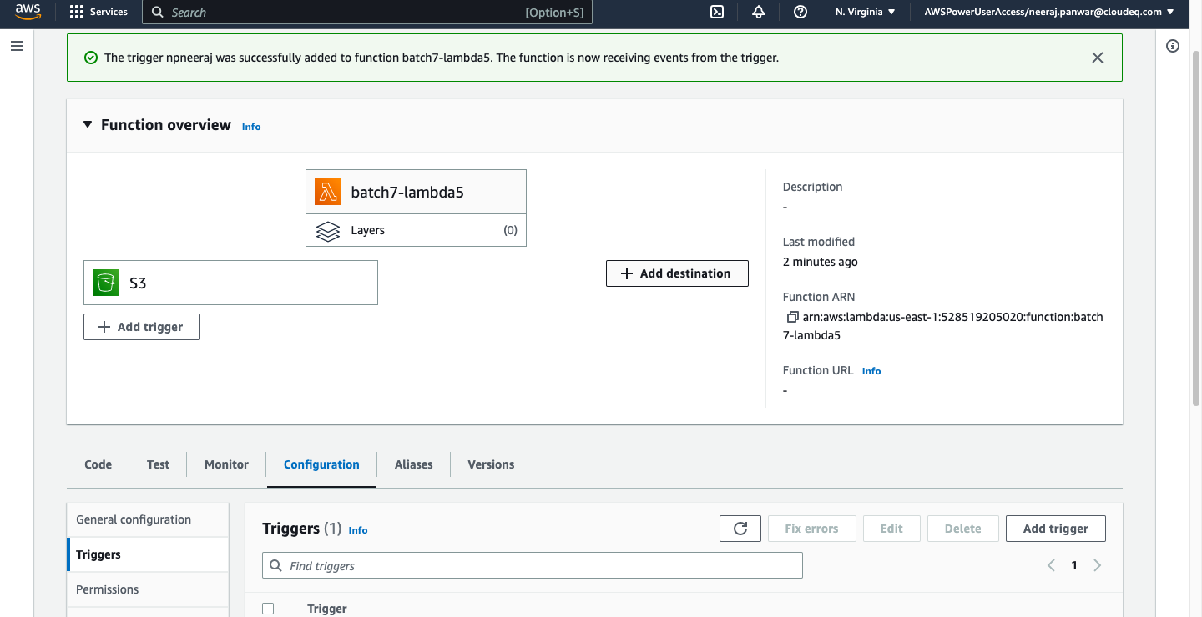

* + when object is uploaded in s3 bucket

Cloud watch page:

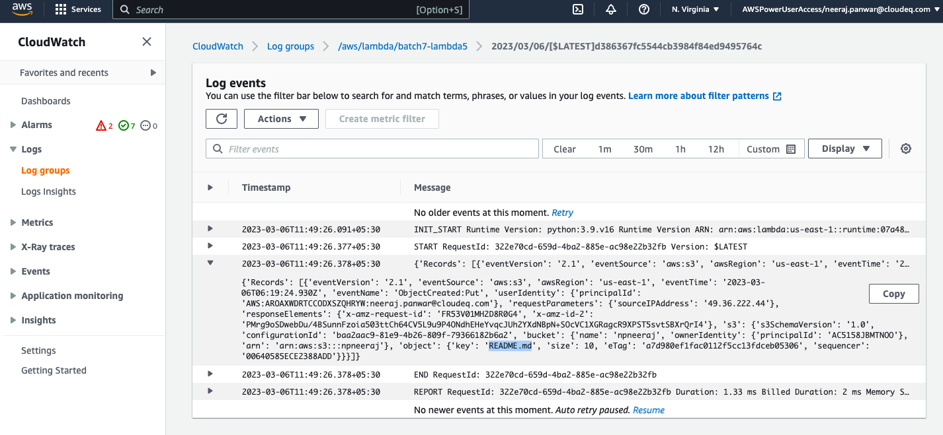

* + when the object in s3 bucket is deleted

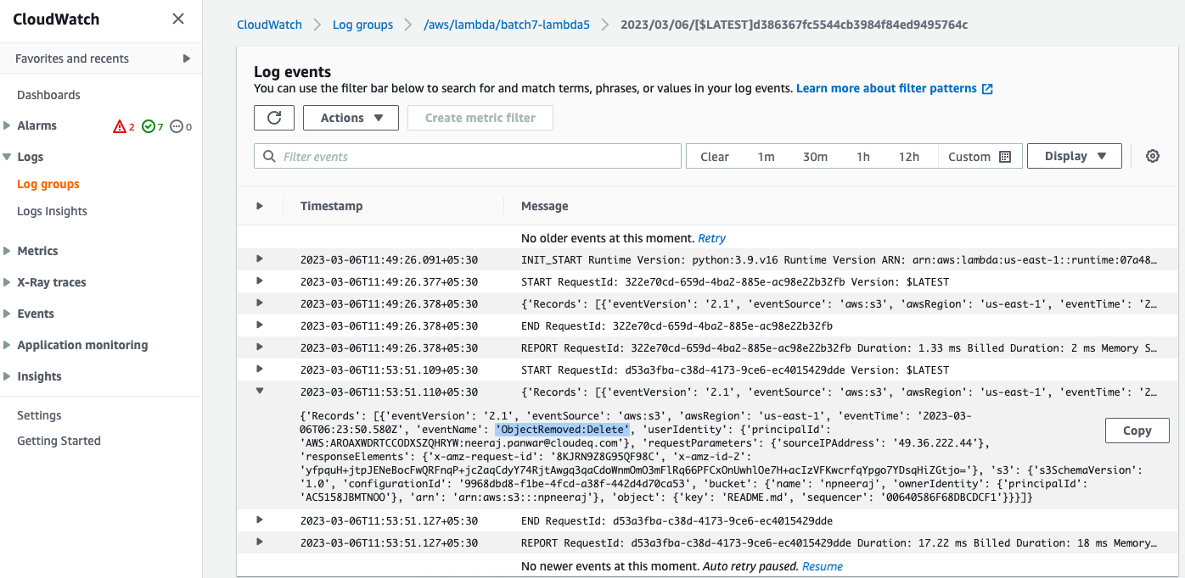

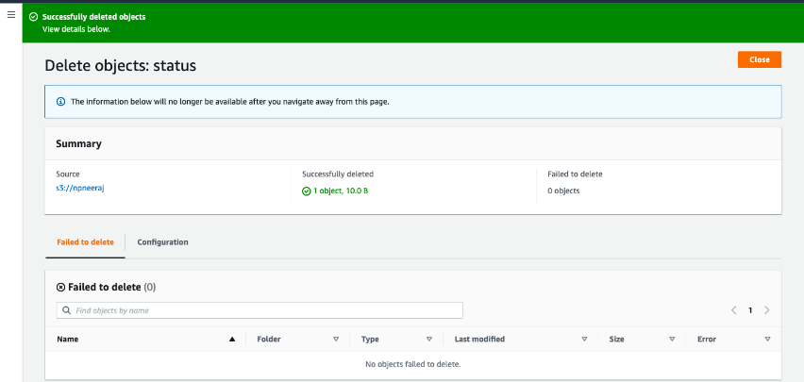

Creating SNS-

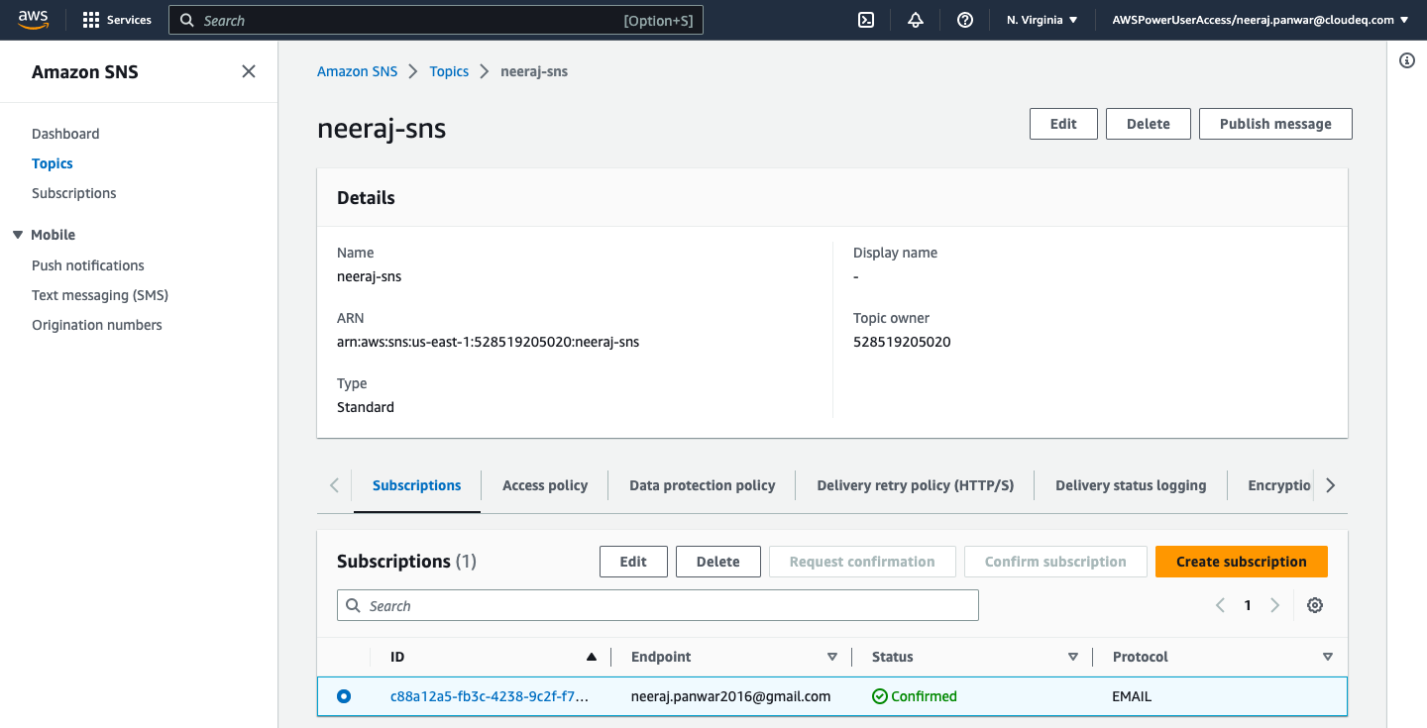

Receiving an email for confirm subscription.

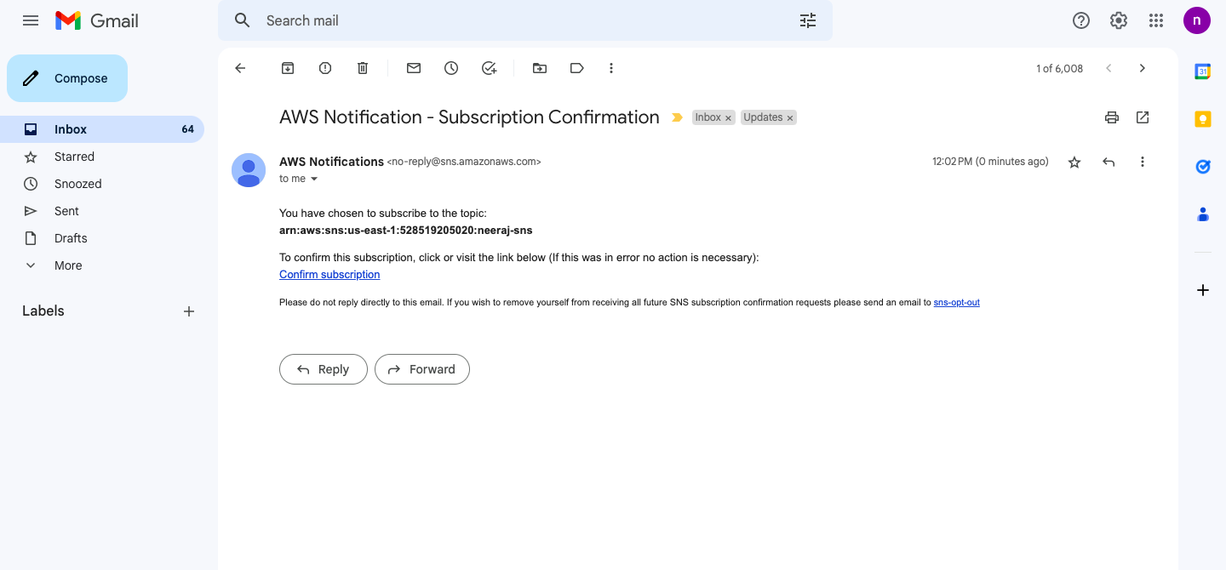

Add destination

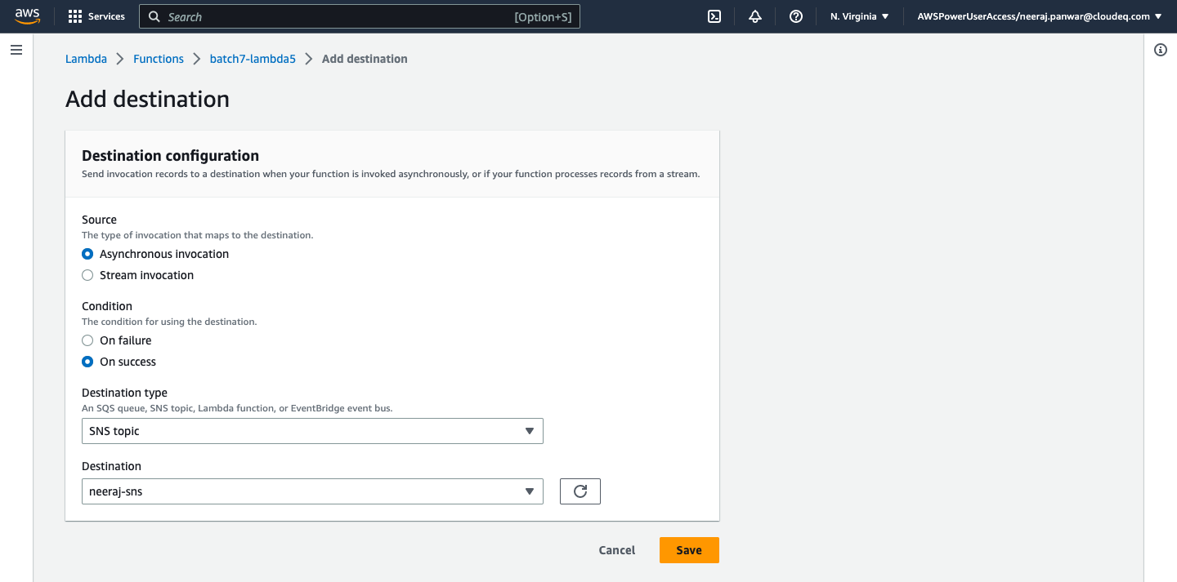

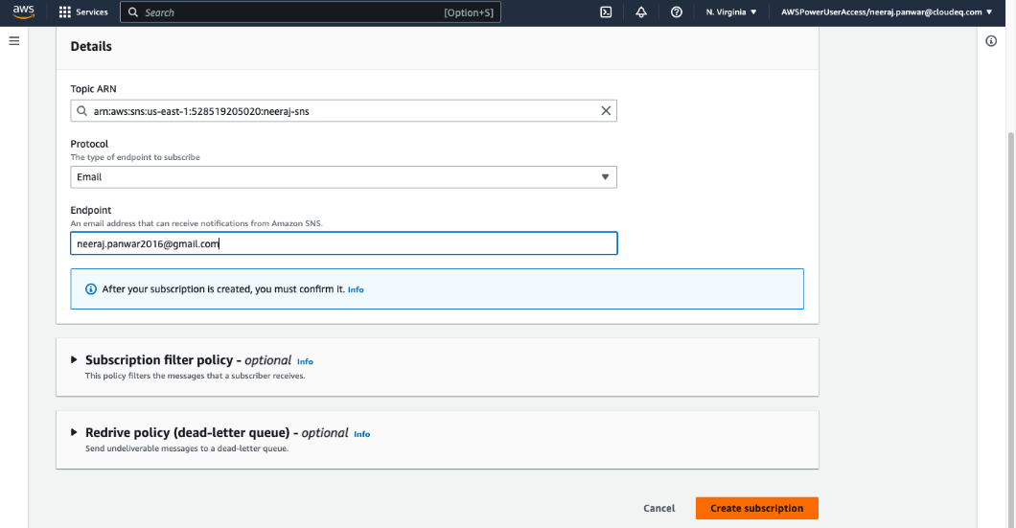

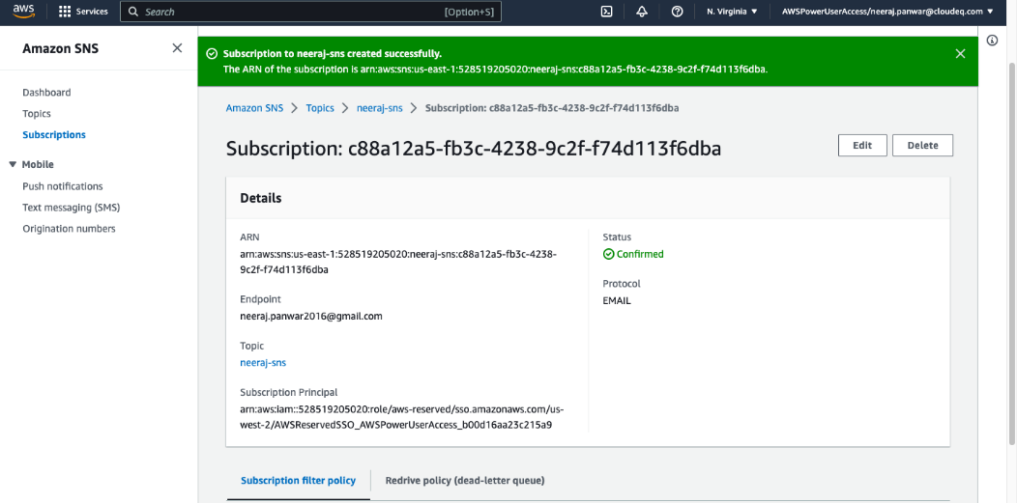

# Create lambda function that will trigger when an object is uploaded in s3 bucket. Create a new bucket and upload the same object (used for triggering) in new bucket using boto3.

1. Lambda function that will trigger when an object is uploaded in s3 bucket

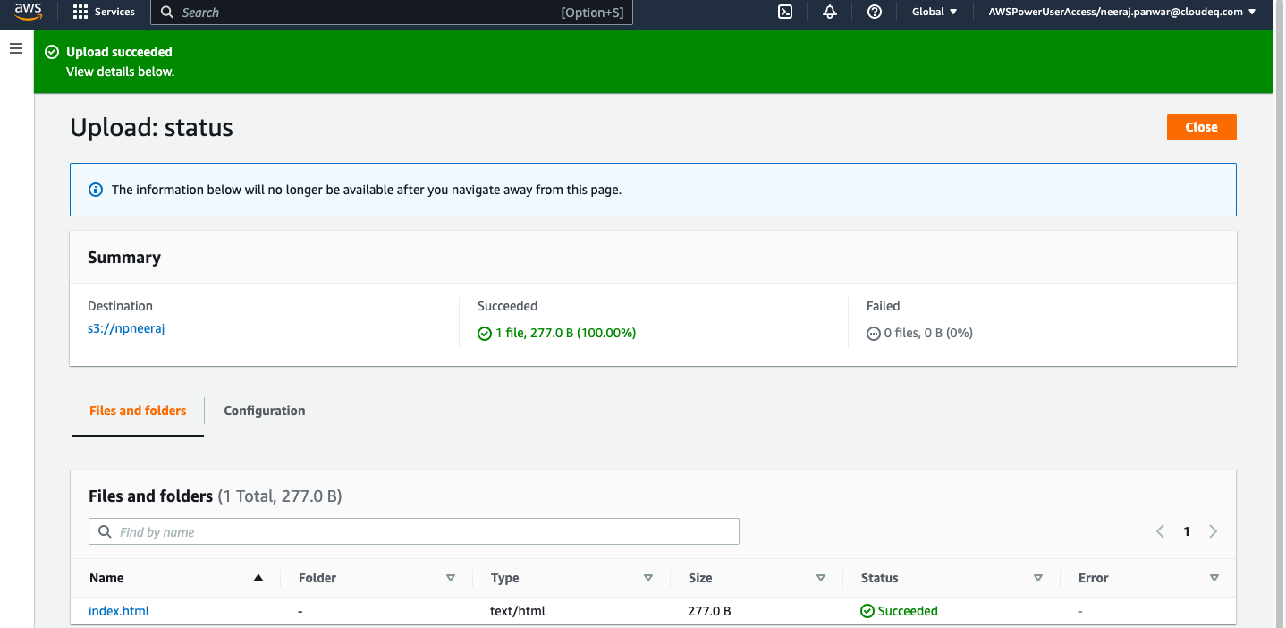

Cloud Watch page:

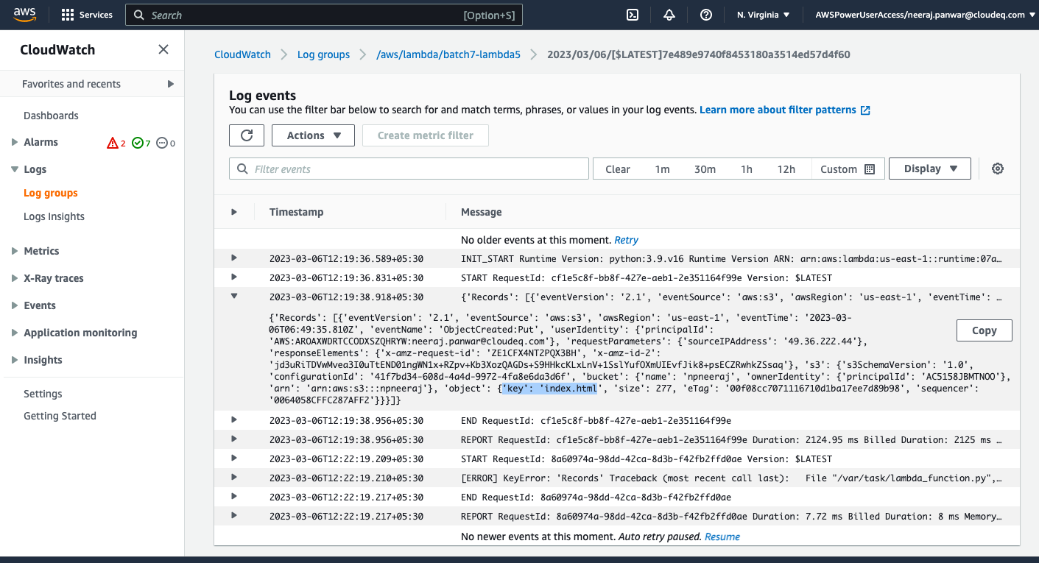

ii- Now create a new bucket and upload same object using boto3

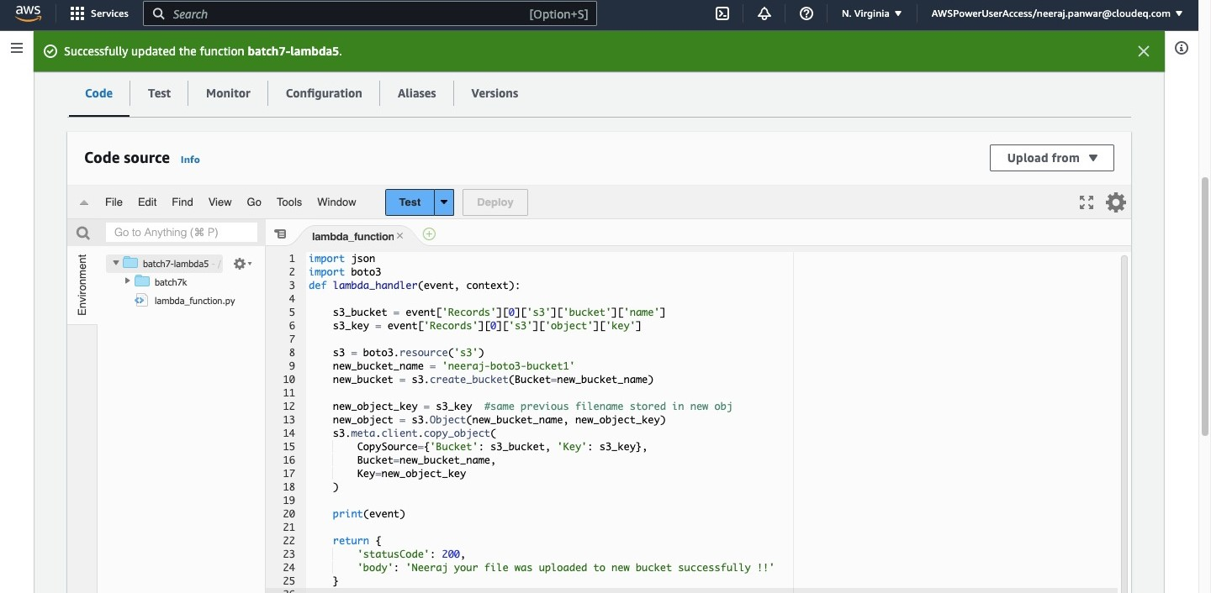

Bucket Created!

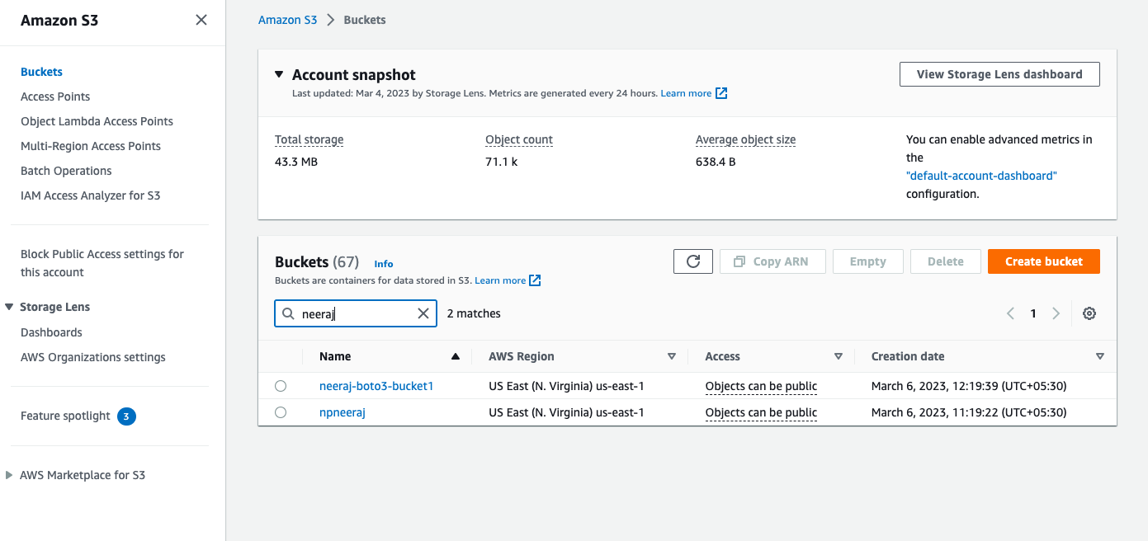

With same object -

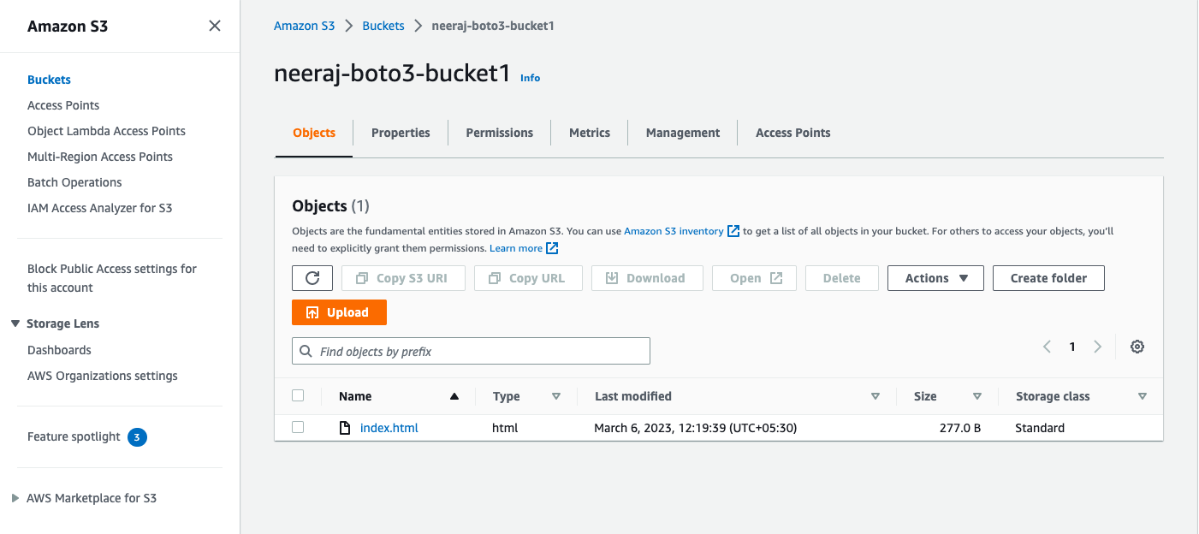

Cloud Watch page:



Thank You!