# P11的PL和LK提取方法

# PL提取

1. 拷贝vendor/mediatek/proprietary/bootable/bootloader/preloader到boot目录
2. build.sh根据实际修改：

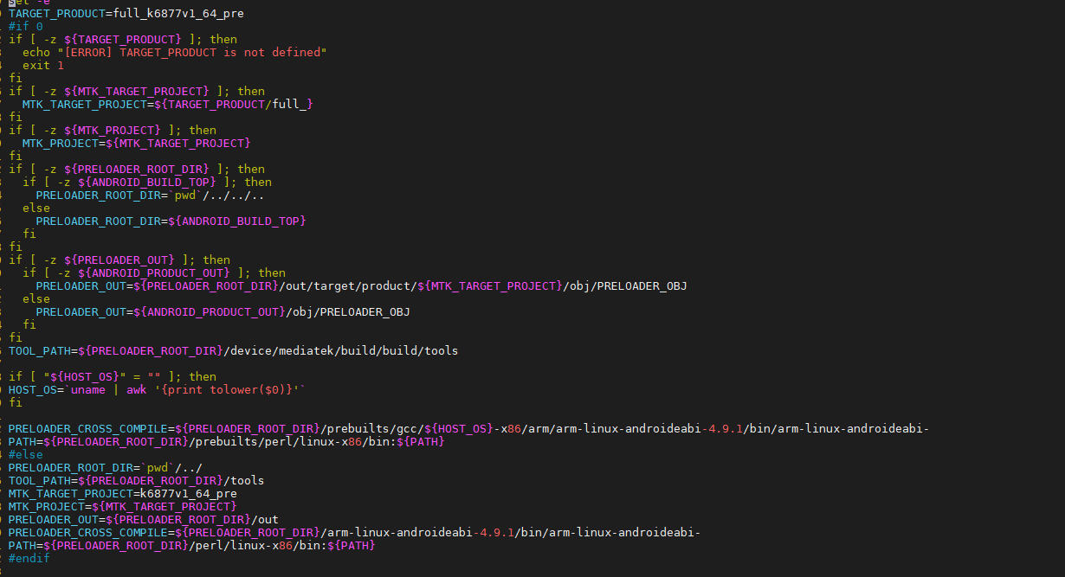

1. custom/k6877v1_64_pre/k6877v1_64_pre.mk添加TARGET_BUILD_VARIANT = userdebug
2. 拷贝如下几个工具：

/MT6877_Demophone_EVB_Android_R_20210713/alps/device/mediatek/build/build/tools

MT6877_Demophone_EVB_Android_R_20210713/alps/prebuilts/perl

MT6877_Demophone_EVB_Android_R_20210713/alps/prebuilts/gcc/linux-x86/arm/arm-linux-androideabi-4.9.1

编译就是执行./build.sh

## LK提取

1 拷贝vendor/mediatek/proprietary/bootable/bootloader/lk/ 源代码到boot目录。

2 sdk中单独编译lk，查看编译log:out/ verbose.log.1.gz：

PYTHONDONTWRITEBYTECODE=True PRODUCT_OUT=out/target/product/k6877v1_64_pre BOARD_AVB_ENABLE=true python vendor/mediatek/proprietary/scripts/sign-image_v2/sign_flow.py -target logo.bin -env_cfg vendor/mediatek/proprietary/scripts/sign-image_v2/env.cfg mt6853 k6877v1_64_pre

vendor/mediatek/proprietary/scripts/sign-image_v2/../../custom/mt6853/security

按log单独拷贝sign-image_v2和security目录到boot目录中。

拷贝main_dtb_header.bin到lk目录下

3.修改/sign-image_v2/env.cfg：

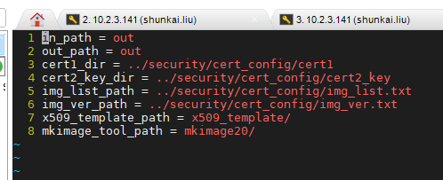

配置arch/arm/rules.mk：

TOOLCHAIN_PREFIX ?= ./../arm-linux-androideabi-4.9.1/bin/arm-linux-androideabi-

4，lk/makefile添加项目名

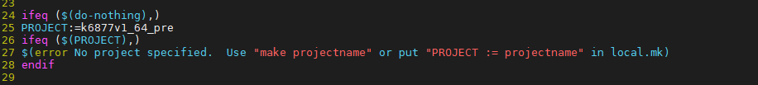

1. lk目录下准备：build.sh:

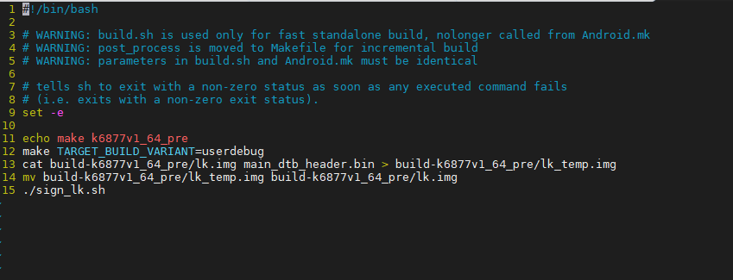

Sigh_lk.sh

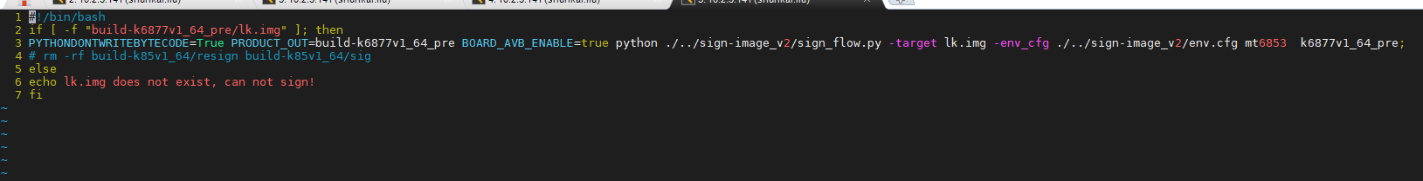

内容实际就是根据编译的log来的

执行build.sh编译