1.What are the two values of the Boolean data type? How do you write them?

Ans: True and False

2. What are the three different types of Boolean operators?

Ans: “AND”, ”OR”,”NOT”

3. Make a list of each Boolean operator's truth tables (i.e. every possible combination of Boolean values for the operator and what it evaluate ).

Ans:

AND TABLE

|  |  |  |
| --- | --- | --- |
| True | False | Evaluation |
| T | T | True |
| T | F | False |
| F | T | False |
| F | F | False |

OR TABLE

|  |  |  |
| --- | --- | --- |
| True | False | Evaluation |
| T | T | True |
| T | F | True |
| F | T | True |
| F | F | False |

NOT TABLE

|  |  |
| --- | --- |
| True | NOT True |
| T | F |
| F | T |

4. What are the values of the following expressions?

(5 > 4) and (3 == 5) 🡪 False

not (5 > 4) 🡪 False

(5 > 4) or (3 == 5) 🡪 True

not ((5 > 4) or (3 == 5)) 🡪 False

(True and True) and (True == False) 🡪 False

(not False) or (not True) 🡪 True

5. What are the six comparison operators?

|  |  |  |  |
| --- | --- | --- | --- |
| Operator | Meaning | Example | Result |
| **<** | Less than | 5 < 6 | True |
| **>** | Greater than | 6 > 5 | True |
| **<=** | Less than or Equal to | 5 < = 6 | True |
| **>=** | Greater than or Equal to | 5 > = 6 | False |
| **==** | Equal to | 5 == 6 | False |
| **!=** | Not Equal to | 5 != 6 | True |

6. How do you tell the difference between the equal to and assignment operators? Describe a condition and when you would use one.

Ans: Equal to operator will compare two values & give a result in the form of True or False while assignment operators will perform function & assign result to the variable.

5 == 6

a = 5

a +=1 (We can use assignment operators in while and for loop)

a = 5 + 1 = 6

7. Identify the three blocks in this code:

spam = 0

if spam == 10:

print('eggs')

if spam > 5:

print('bacon')

else:

print('ham')

print('spam')

print('spam')

Ans:-

spam = 0

if spam == 10:

print('eggs')

elif spam > 5:

print('bacon')

else:

print('ham')

print('spam')

print('spam')

8. Write code that prints Hello if 1 is stored in spam, prints Howdy if 2 is stored in spam, and prints Greetings! if anything else is stored in spam.

a = int(input("Spam = "))

if a == 1 :

print("Hello")

elif a == 2 :

print("Howdy")

else :

print("Grettings")

9.If your programme is stuck in an endless loop, what keys you’ll press?

Ans : I will press interrupt the kernel key.

10. How can you tell the difference between break and continue?

Ans: Break will terminate loop once given condition will become true while continue will continuously run the loop until given condition become true.

11. In a for loop, what is the difference between range(10), range(0, 10), and range(0, 10, 1)?

Ans: There is no difference between range(10), range(0, 10), and range(0, 10, 1) as we will get same extracted data set from all three ranges i.e. (0,1,2,3,4,5,6,7,8,9)

12. Write a short program that prints the numbers 1 to 10 using a for loop. Then write an equivalent program that prints the numbers 1 to 10 using a while loop.

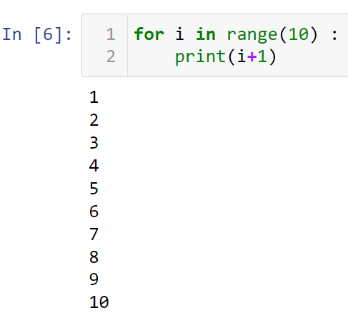

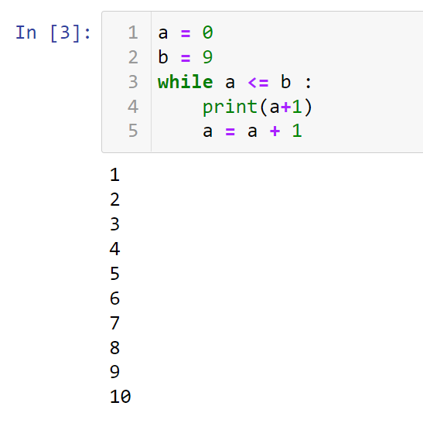

13. If you had a function named bacon() inside a module named spam, how would you call it after importing spam?

Ans: bacon() + (shift+enter)