1. What exactly is []?

Ans: It is a syntax used to create and declare a list.

2. In a list of values stored in a variable called spam, how would you assign the value 'hello' as the third value? (Assume [2, 4, 6, 8, 10] are in spam.)

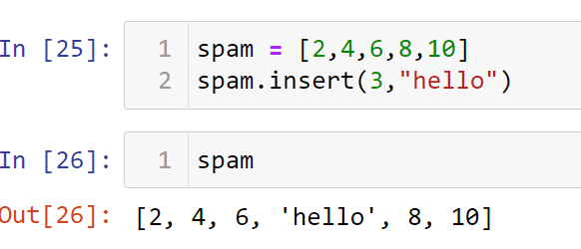

Let's pretend the spam includes the list ['a', 'b', 'c', 'd'] for the next three queries.

3. What is the value of spam[int(int('3' * 2) / 11)]?

4. What is the value of spam[-1]?

Ans: - ‘d’

5. What is the value of spam[:2]?

Ans:- [‘a’,’b’]

Let's pretend bacon has the list [3.14, 'cat,' 11, 'cat,' True] for the next three questions.

6. What is the value of bacon.index('cat')?

Ans:- 1

7. How does bacon.append(99) change the look of the list value in bacon?

Ans:- [3.14, 'cat', 11, 'cat', True, 99]

8. How does bacon.remove('cat') change the look of the list in bacon?

Ans:- [3.14, 11, 'cat', True, 99]

9. What are the list concatenation and list replication operators?

Ans: list concatenation operators : ‘**+**’

list replication operators : ‘**\***’

10. What is difference between the list methods append() and insert()?

Append operation will add given data at the end of the list while insert operation will insert data at given index in a list.

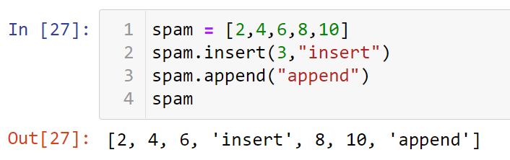

11. What are the two methods for removing items from a list?

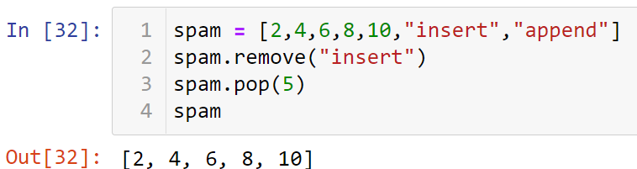

12. Describe how list values and string values are identical.

Ans: List & string values contain some data.

13. What's the difference between tuples and lists?

Ans: Tuples are immutable while lists are mutable.

14. How do you type a tuple value that only contains the integer 42?

Ans: t = (42)

15. How do you get a list value's tuple form? How do you get a tuple value's list form?

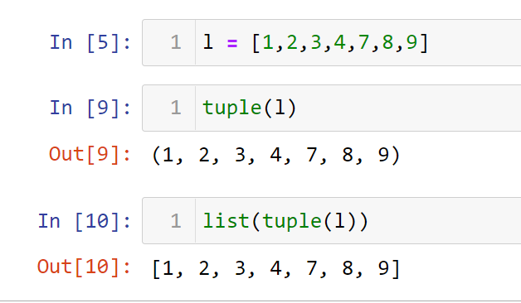

16. Variables that "contain" list values are not necessarily lists themselves. Instead, what do they contain?

Ans: Variables will contain references to list values rather than list values themselves.

17. How do you distinguish between copy.copy() and copy.deepcopy()?

Ans: No Idea