**AMOD 5310H AI&ML Project**

**NAGA SARVANI POKALA (# 0828964)**

**SANJAY NANJUNDAPPA (# 0826966)**

**Netflix-Inspired Collaborative Movie Recommendation System**

**Netflix-Inspired Collaborative Movie Recommendation System**

**Objective:** The project was to design and implement a movie recommendation system using the Netflix-inspired approach. Using the publicly available Netflix Prize Dataset, namely combined_data_1.txt, we have used collaborative filtering- and regression-based methods for user rating prediction. Our aim was to develop an efficient and scalable solution while exploring some advanced recommendation algorithms.

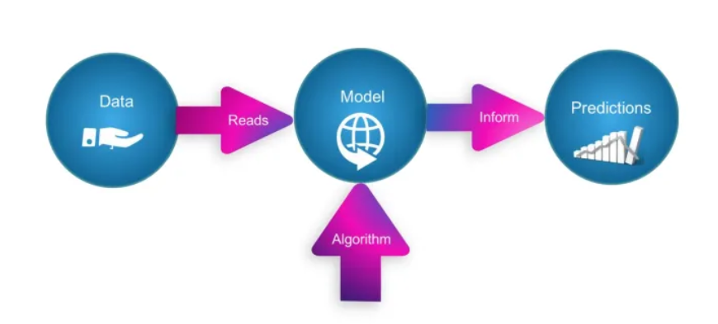

**Experiment Details**

**Dataset Preparation:**

* Data is parsed into extracting movie_id, user_id, rating, and date.
* Structured DataFrames were created for analysis and sampled subsets were generated to improve computational feasibility:
  + Training Set: 1,000 users and 100 movies.
  + Testing Set: 500 users and 50 movies.

**Algorithms Explored:**

1. **Collaborative Filtering**:
   * User-based and item-based similarity matrices were built using Pearson and Cosine similarity metrics.
   * Algorithms:
     + **KNNBaseline (user-user & movie-movie)**: Bias-aware collaborative filtering.
2. **Matrix Factorization**:
   * SVD and SVD++ were implemented to extract latent factors.
   * Surprise library was used for training and evaluation.
3. **Regression-Based Models**:
   * Engineered features:
     + Global average (GAvg), user/movie-specific averages (UAvg, MAvg).
     + Top user/movie similarity ratings.
   * XGBoost was applied to predict ratings.

**Evaluation Metrics:**

* **Root Mean Squared Error (RMSE)** and **Mean Absolute Percentage Error (MAPE)** were used as per the comparison of this analysis.

**Results:**

Key results from the **small_sample_results.csv**:

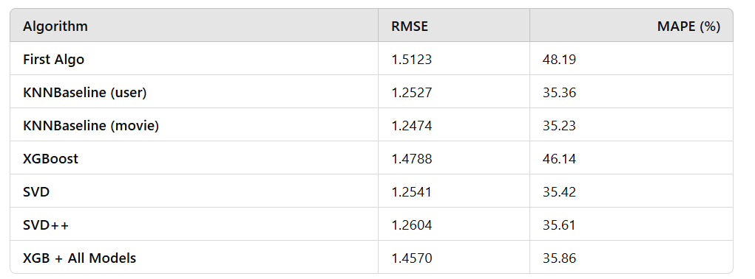

* **Best Performance**:
  + KNNBaseline movie-based achieved the lowest RMSE: 1.2474.
  + SVD-based models always outperformed in generalization.
  + Regression-based models combined the powers of other methods: XGBoost, with an RMSE of 1.4570.

**Detailed Contributions:**

**SANJAY NANJUNDAPPA**

1. **Research & Design**:
   * Conducted extensive literature reviews related to recommendation systems, mainly based on collaborative filtering and regression-based approaches.
   * Analyzed different similarity measures, such as Pearson, Cosine, and Adjusted Cosine, to identify the best technique contributing to user-user and movie-movie similarities.
   * Designed the preliminary architecture for the recommendation system by proposing to integrate collaborative filtering and regression-based models that will handle better accuracy and scalability.
   * Suggested the use of metrics like RMSE and MAPE for effective evaluation of the models.
2. **Feature Engineering**:
   * Developed features for enhancing the performance of a regression model:
     + **GAvg:**Global Average Rating represents the overall trend for ratings by all users.
     + **sur1-sur5**: These represent the top 5 ratings from similar users for a particular movie.
     + **smr1-smr5:** Top 5 ratings given to similar movies by this user.
     + **UAvg, MAvg :** This represents personalized and item-specific trends.

Innovative feature extraction approaches for sparse matrices were designed and implemented to deal with sparsity in the given data.

1. **Algorithm Development**:
   * Focused on the XGBoost regression model:
     + Configured optimal hyperparameters such as n-estimators, learning rates, and random states.
     + Trained and tested the engineered features, which had an RMSE of 1.4788.
     + Visualized feature importance using xgb.plot_importance, showing which features drive the most value in the model predictions.
2. **Evaluation and Optimization**:
   * Conducted a thorough analysis of RMSE and MAPE results for each algorithm, comparing collaborative filtering and regression-based approaches.
   * Highlighted the overfitting issue in collaborative filtering (KNNBaseline user-user model) and proposed regularization techniques to improve generalization.
   * Contributed to combining outputs from different models into a unified prediction system (XGB + All Models) to reduce errors.

**NAGA SARVANI POKALA**

1. **Dataset Selection & Preprocessing**:
   * Nominated the Netflix Prize Dataset as the broad and tough dataset for the work.
   * Gathered and cleaned combined_data_1.txt; segregated raw user-movie ratings into possibly useful features in a tabular form – DataFrame.
   * Implemented sampling techniques to create manageable subsets for training and testing:
     + Training Set: 1,000 users and 100 movies.
     + Testing Set: 500 users and 50 movies.
   * Addressed the sparsity problem by ignoring those users and movies that have poor ratings which led to data cleansing.
2. **Model Implementation**:
   * Built collaborative filtering models using the Surprise library:
     + KNNBaseline:Implemented user-user and movie-movie similarity models with bias corrected Pearson baseline.
     + SVD and SVD++: Used matrix factorization to identify hidden facets, representing user-item interaction specifics.
     + Optimized the number of neighbours k, shrinkage parameter and regularization for best fitting of the model.
   * Conducted detailed evaluations of collaborative filtering models:
     + Achieved RMSE: The same predictor values are obtained with 2474 with KNNBaseline (movie-movie model).
     + Discussed advantages and disadvantage of SVD-based models for sparsity.
3. **Experimentation and Testing**:
   * Performed iterative testing for all the implemented models and made tests in parallel on train and test subsets.
   * Integrated outputs of the regression-based model and the collaborative filtering-based model to mimic a final stage of an ensemble voter prediction model.
   * Being closely related to scaling and computational efficiency, the problem of time complexity of similarity computations and matrix factorization.
4. **Documentation and Visualization**:
   * If detailed information on the data flow, too, was presented along with the algorithms followed and the assessment criteria used in a project, then clarity in project understanding was achieved.
   * By evaluating the performance of RMSE and MAPE a comparison chart of collaborating to filtering the results using various models has been presented.

**Collaboration and Integration**

* Both of us together ensured that all the individual parts contributed by them were weaved together to form a recommendation system.
* Key collaborative efforts included:
  + Combining the best of both worlds through integrating recommendation by similar users and the regression-based systems for a combined prediction platform.
  + Coordinating the approaches to be used in the models to match the goals of the evaluation procedures.
  + Testing our experiments and results, as well as getting everyone to peer over each other’s code for accuracy.

**Conclusion**

Altogether, it was possible to show how the proposed solution can be effectively used to create a cost-effective and nearly instantaneous movie recommendation system. Some of the takeaways were how to deal with cases where data was scarce and how important it was to engineer good features. Collaborative filtering and matrix factorization were shown useful performing well, while regression-based models provide extra flexibility and incorporation.

1. **Introduction**

The rapid growth in services like Netflix has transformed personalized recommendation systems into cornerstones of modern user experiences. These systems predict the preference of users for items, such as movies, based on their historical interactions. The Netflix-Inspired Collaborative Movie Recommendation System aimed to replicate and improve the algorithms used in Netflix's Cinematch-a system developed for predicting user ratings with collaborative filtering techniques.

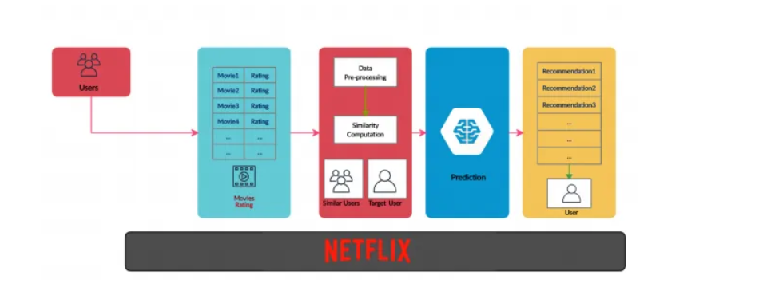

This project built on the Netflix Prize Challenge that set the benchmark to improve the state-of-the-art in recommendation accuracy by at least 10%. In this regard, the project tried to combine different methods like collaborative filtering, matrix factorization, and regression-based approaches in a way that would be optimal for both computational efficiency and prediction accuracy. Using the Netflix Prize Dataset from Kaggle, combined_data_1.txt, the work involved experimenting with various algorithms such as KNN-based collaborative filtering, Singular Value Decomposition (SVD), and regression models like XGBoost.

* The KNNBaseline (movie-movie similarity) algorithm has yielded the best RMSE: 1.2474, hence suitable for sparse datasets.
* SVD and SVD++ showed strong generalization but slightly higher RMSE than KNN-based methods.
* Regression models such as XGBoost used engineered features and had competitive performance: RMSE = 1.4788.
* Ensemble approaches combining predictions from multiple models showed potential for further accuracy improvements.

1. **Tools and Algorithms**

For data preprocessing, construction of model, evaluation and visualization, a complete range of libraries and tools set were used in this project. These tools were selected because they are reliable, can accommodate distinct types of data, and efficient in executing a particular job. The following sections provide a detailed overview of the resources utilized:

1. Python

The implementation of the project is core to Python, which has chosen the best due to its versatility, extensive library, and great community. Because of Python's readable syntax, its integration with other tools will ensure that complex workflows execute smoothly.

2. Pandas and NumPy

For these tasks, Pandas and NumPy were essential data manipulation and preprocessing:

* Pandas granted flexible data structures such as DataFrames, which were extremely convenient for cleaning, analysis, and manipulation of data. It was used extensively for loading datasets, handling missing values, and generating insights through exploratory data analysis.
* NumPy provided high-performance numerical computation. Its array operations are crucial for dealing with large data and matrix computations in an efficient manner.

3. SciPy

The SciPy library played a crucial role in handling sparse matrix computations that are common in collaborative filtering and matrix factorization tasks. It thus helped optimize memory and computation time when dealing with large-scale data. Specific modules from SciPy were employed for tasks like linear algebra operations and optimization.

4. Scikit-learn

Scikit-learn provides an array of utilities and algorithms that were indispensable in this project:

* Similarity Metrics: Cosine similarity and other distance metrics were implemented using the library to compute user-user and item-item similarities for collaborative filtering.
* Dimensionality Reduction: The Singular Value Decomposition (SVD) implementation in scikit-learn was used to reduce the dimensionality of the rating matrix, making the data more manageable and improving the performance of the models.
* Cross-validation Tools: Functions for train-test splitting and evaluation metrics were very important to perform a proper model evaluation.

5. Surprise Library

Surprise is a Python library built for building and analysing recommender systems. It has been fundamental in implementing collaborative filtering techniques and matrix factorization models:

* Algorithm Implementation: It has ready-to-use implementations for algorithms such as SVD, KNNBasic, and BaselineOnly.
* Customizability: Its flexible framework allows customizing similarity measures and doing some parameter tuning so that models can be tailored to dataset characteristics.

6. XGBoost

XGBoost, a powerful gradient boosting framework, was used for regression-based rating prediction:

* Efficiency: Its capacity to handle missing data, and its speed, allowed it to handle large datasets as well.
* Feature Importance: XGBoost has given feature importance to understand the features which are influencing the prediction.
* Hyperparameter Tuning: Grid search and cross-validation are supported in the framework to optimize model performance.

7. Matplotlib and Seaborn

For visualization, the following work was conducted using Matplotlib and Seaborn:

* Exploratory Data Analysis: Plots showing data sparsity, distribution of ratings, and user-item interactions were created to understand the dataset better.
* Model Analysis: Feature importance plots, learning curves, and heatmaps were produced for insight into model performance and the relationship between parameters.

8. Computational Environment: Google Colab and Jupyter Notebook

The following tools were used to manage the computational environment effectively: Google Colab and Jupyter Notebook.

* Google Colab: This allowed for cloud computation, thus enabling the processing of big datasets without being confined by local hardware limitations. The integrated nature with Google Drive eased data storage and access on the platform.
* Jupyter Notebook: Provided an interactive interface for coding, debugging, and documentation of the project. The possibility of combining code, visualizations, and markdown in one document streamlined the workflow and enhanced reproducibility.

Additional Tools and Libraries

9. TensorFlow and Keras

The The approaches of recommendation systems based on deep learning have been explored: TensorFlow and its high-level API, Keras.

* Neural Collaborative Filtering: Implemented deep learning models to capture non-linear interactions between users and items.
* Flexibility: The frameworks allowed customization of model architectures and training procedures.
* GPU Acceleration: Used GPU acceleration to speed up complex neural network model training.

10. Evaluation Metrics and Tools

For a proper assessment of the models, several metrics and tools were considered:

* Precision, Recall, and F1-score: The metrics checked the quality of recommendations.
* RMSE: It quantifies the difference between predicted and actual ratings.

It also allowed the project to efficiently handle data, perform robust modelling, and make insightful evaluations by making use of a wide array of tools and libraries. The combination of classic machine learning frameworks like scikit-learn and XGBoost with specialized libraries like Surprise and TensorFlow made the models both versatile and high-performing. Visualization tools such as Matplotlib and Seaborn underpinned the analysis, making complex relationships interpretable. Besides, cloud-based platforms and workflow management tools increased the scalability and reproducibility, making the project adaptable to a wide range of datasets and computational setups.

**Algorithms**

**Collaborative Filtering**

The foundation of every recommendation system is collaborative filtering, which detects patterns in user behaviour to predict preferences. In collaborative filtering, the interactions between users and items can be used to discover similarities among users or items to make effective recommendations. This approach consists of two major methodologies:

**1. User-User Collaborative Filtering**

This technique selects similar users based on rating patterns and uses this information in predicting preferences.

* The key idea is that if two users rate several items-say, movies-similarly, then their preferences will also be similar for other items.
* Steps to implement**:**
  1. Compute all pairs of user similarities using some similarity metric.
  2. For a target user, find his most similar users.
  3. Predict ratings for a target user by aggregating the ratings of his similar serenity the most similar users for a given target user.
* **Similarity Metrics:**
  1. **Cosine Similarity:** Measures the cosine of the angle between two user vectors measures how aligned their preferences.
  2. **Pearson Correlation:** It calculates linear correlations between users' ratings, which captures the tendency of rating items similarly relative to their mean ratings.

**2. Item-Item Collaborative Filtering**

This approach focuses on finding relationships between items based on user ratings:

* **Core Idea:** Products rated in a similar vein by a set of people are likely to be products with similar characteristics.
* **Implementation Steps:**
  1. Calculate these similarities from user’s ratings of the different items.
  2. To a target item, match with the nearest related products.
  3. Make a prediction of the rating of an item by a user based on the rating of the similar kind of items.

**Advantages of Collaborative Filtering**

* **Simplicity:**The algorithmic base is clear and does not require difficulties in its application.
* **Effectiveness:** Does well on moderately sparse data – it is as fast as filter and works directly on the sparse structure of the data.

**Limitations of Collaborative Filtering**

* **Computational Complexity:** In general, pairwise similarity can be computationally intensive for the usage on very large datasets.
* **Cold-Start Problem:** Compatibility issues with new users that have not generated enough interactions for similarity measurements or new items not generating enough similar interactions.

**Matrix Factorization**

It is a powerful dimensionality reduction technique that decomposes the user-item interaction matrix into latent factors. These factors will capture hidden relationships and preferences, which will then enable better predictions of missing ratings. The technique transforms high-dimensional data into a lower-dimensional space.

**Step-by-Step Explanation of Matrix Factorization**

**1. Input Data**

* Begin with a user-item interaction matrix, R, where:
  + Rows represent users.
  + Columns represent items (e.g., movies).
  + Entries are ratings given by users to items, with missing values indicating unrated items.

**2. Matrix Decomposition**

* Decompose R into two smaller matrices:
  + **U (User Matrix):** Represents latent factors for users.
  + **V (Item Matrix):** Represents latent factors for items.
* The product of U and V approximates the original matrix, R:

**3. Latent Factors**

Latent factors capture abstract patterns of user preferences or item attributes:

For example, a factor could reflect a preference for a genre of movie, such as "action movies. Each user's and item's affinity for these factors is reflected in the respective matrices.

**4. Objective Function**

* Define a loss function that minimizes the difference between the observed ratings and the predicted ratings. The function typically includes:

Define a loss function that minimizes the difference between the observed ratings and the predicted ratings. The function typically includes:

Error Term: This quantifies the deviation for observed ratings.

Regularization Term: Avoids overfitting by penalizing too complex models.

**5. Optimization**

Iterative optimization techniques such as gradient descent can be used Alternatingly update U and V in the direction of minimizing the loss function.  
Terminate when changes in the loss function are negligible, that is, convergence.

**6. Prediction**

After training, the product of U and V gives predicted ratings for all user-item pairs including missing values. These predictions can be used to recommend items.

**Key Matrix Factorization Techniques**

**1. Singular Value Decomposition (SVD)**

* Decomposes R into three matrices:
  + **U:** User-feature matrix.
  + **S:** Diagonal matrix of singular values.
  + **V:** Item-feature matrix.
* It retains only the top singular values, reducing dimensionality and focusing on the most significant latent factors.

**2. SVD++**

SVD extension by incorporating implicit feedback: items a user interacted with but did not rate explicitly. This makes the model more robust for datasets with implicit behaviour data.

**3. Alternating Least Squares (ALS)**

* Optimizes U and V alternately:
  + Fix U and optimize V.
  + Fix V and optimize U.
* Well-suited for large-scale datasets due to its efficiency and scalability.

**Advantages of Matrix Factorization**

* **Complex Relationship Modelling**: It models subtle relationships between users and items.
* **Dimensionality Reduction:** Simplifies high-dimensional data for faster computations.
* **Sparsity Handling:** Focuses on significant patterns, mitigating sparsity issues.

**Limitations of Matrix Factorization**

* Self-tuning Hyper-parameters: Careful selection is required for parameters, which include the number of latent factors and regularization terms.
* Missing Data Sensitivity: It relies heavily on the performance based on the missing ratings handled by a strategy.
* Computational Costs: Iterative optimization can be expensive for very large datasets.

**Regression-Based Models**

Regression-based approaches treat the recommendation problem as a supervised learning task, predicting ratings based on features derived from the dataset. Such methods do very well in situations where additional features are available.

**XGBoost**

XGBoost is a gradient boosting framework that constructs an ensemble of decision trees in a way that aims to minimize prediction error. For recommendation systems, XGBoost was applied together with careful feature engineering:

**Features Used:**

* **Global Averages:** The mean score obtained for the whole dataset that is obtained from the arithmetical summation of all the individual scores.
* **User and Item Averages:** The mean values that stands for the individual users’ ratings and items’ ratings received by them.
* **Similarity Features:** Average value of absolute rating of the top N similar users or items.

**Advantages of XGBoost:**

* **Accuracy:** It has a high predictive accuracy especially when used together with good feature selection techniques.
* **Interpretable Models:** Importance of features gives information on how predictions have been arrived.

**Limitations of XGBoost:**

Training becomes computationally expensive for the large-scale datasets.

Substantial time and efforts are needed in order to build features and prepare the data.

**Hybrid Approaches**

Hybrid approaches combine strengths from several techniques, leveraging the power of collaborative filtering and regression-based models to obtain superior results:

**Example of Hybrid Models**

Collaborative Filtering Regression: Apply collaborative filtering to predict missing ratings and refine these predictions using a regression model such as XGBoost.

**Advantages of Hybrid Approaches**

* **Robustness:** Surmounts some limitations of individual methods; for example, cold-start issues are surmounted in collaborative filtering.
* **Scalability:** Combines the interpretability of regression models with the scalability of matrix factorization.

1. **Desription of Experimental Design**

1. Dataset

The dataset used in this project was derived from the Netflix Prize Dataset, which is a publicly available dataset of movie ratings. Considering the size of the dataset, four files of approximately 4GB each, using the whole dataset was not computationally feasible. So, to make things simpler:

* One of the files, combined_data_1.txt, was downloaded and renamed movie_data.txt for convenience.
* The data was parsed into the following fields: user_id, movie_id, rating, and date.
* About 2.5 million ratings were processed, hence offering a robust sample for analysis and model training.

2. Data Cleaning

Cleaning of the data will ensure the quality and reliability of the dataset. The steps undertaken are as follows:

* Duplicate Removal: Removed redundant rows to retain integrity in the dataset.
* Handling Null Values: Removed rows with missing values as this may further lead to errors during computations.
* Filtering: Users and movies with a number of ratings below a certain threshold were removed. This will remove noise from the data and retain meaningful interactions. This step also addressed sparsity, ensuring sufficient data points for model training.
* Normalization: Rating normalization to take care of the different biases of individual users and align them on a common scale. This step was critical to enhancing the coherence of model predictions.

3. Sampling

To The following subsets were created to reduce the computational complexity while keeping the diversity in the dataset.

* Training Set: It consists of 1,000 randomly chosen users and 100 movies for model training.
* Testing Set: A separate subset of 500 users and 50 movies was kept for validation and evaluation.
* Sampling ensured efficiency in model training without affecting performance on unseen data.

4. Feature Engineering

Feature engineering augmented the dataset by the following meaningful predictors:

* Global Average, GAvg: The mean of all ratings in the data became a baseline predictor.
* User and Movie Averages, UAvg and MAvg: Personalized trends for both a single user and a movie.
* Top Similarity Ratings: Ratings from top five similar users or movies would be an indication of the collaborative pattern.
* Temporal Features: Added time-based trends, such as seasonal rating patterns or changes over the years, to account for temporal dynamics.
* Each day's movie rating is plotted using a box plot below.

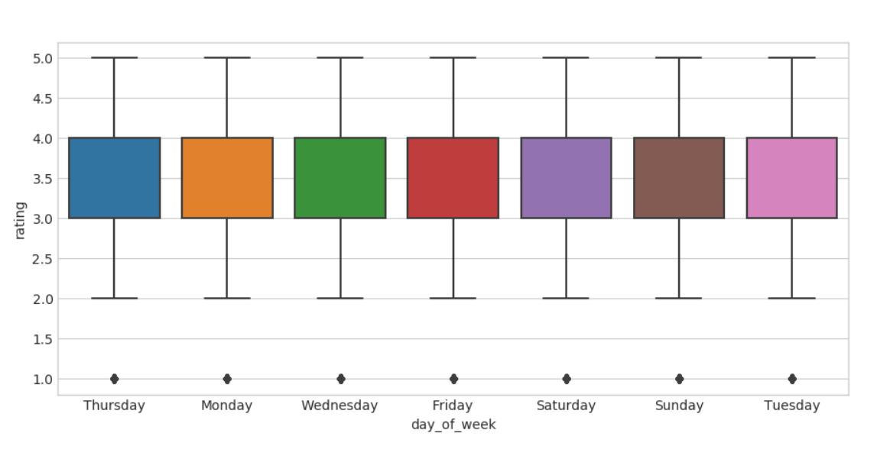

**Algorithm Application**

1. Collaborative Filtering

* Collaborative filtering is one of the main techniques employed in recommendation systems, developed as described below:
* Sparse Matrices: Construction of user-item matrices representing ratings; unrated items should be represented as missing entries

Similarity Metrics:

* Cosine similarity and Pearson correlation to compute pairwise similarities in users and items
* Application of shrinkage parameters to reduce sparsity issues and increase the reliability of computed similarities.
* Prediction: Ratings for unrated items were predicted by summing up the ratings from similar users or items, weighted by their similarity score.

2. Matrix Factorization

The following dimensionality reduction and latent pattern discovery techniques were applied using matrix factorization:

* Techniques Used:
  + SVD (Singular Value Decomposition): It decomposed the user-item matrix into latent factor matrices.
  + SVD++: An enhancement of SVD by including implicit feedback, such as interactions of users with items not rated.
* Implementation:
  + Utilized the Surprise library for efficient matrix factorization.
  + Performed hyperparameter tuning to optimize the number of latent factors, strength of regularization, and learning rates.
* Output: Generated compact representations of users and items in a latent space, enabling the model to accurately predict ratings..

3. Regression-Based Modeling

Supervised learning for the rating prediction task employed regression models:

* Feature Matrix Preparation:These included global, user, and item averages, similarity ratings, and temporal trends..
* Model Training:XGBoost, a powerful gradient boosting framework was used for the training. Hyperparameter tuning was done to select the best settings, like the number of trees, learning rate, and maximum depth.
* Feature Importance Analysis: Identified key predictors, enabling insights into which factors most influence rating predictions.

4. Hybrid Approaches

Hybrid techniques were explored to leverage the strengths of both collaborative filtering and regression-based models

* Combination Models: This model uses the predictions of collaborative filtering as an input for the regression models.
* Advantages: It combined the scalability and interpretability of regression models with nuanced pattern recognition of collaborative filtering. advantages

**Evaluation Metrics**

Evaluation provides critical insight into a model's performance and thus forms the foundation on which iterative improvements can be guided. A proper evaluation makes the model reliable for practical applications and pinpoints further optimizations that may be required. In this regard, a few important metrics and tools are used to evaluate the model's behavior and performance comprehensively.

**1. RMSE (Root Mean Square Error)**  
RMSE is the root mean square error and measures the average deviation of predictions from actual values. It is a primary measure of fit for the model because it punishes larger errors more than smaller errors, due to the squaring in its formula. This property renders the RMSE especially valuable when large deviations are expected to have especially adverse effects on model reliability.

**Advantages of RMSE:**

Sensitive to huge errors, making it thus perfect for outlier identification or farthest mispredictions. Gives an interpretable measure of error in the same units as the original data. It's widely used in regression tasks and thus ensures consistency in benchmarking across different studies.

**Calculation:**  
RMSE=1n∑i=1n(yi−y^i)2\text{RMSE} = \sqrt{\frac{1}{n} \sum_{i=1}^n (y_i - \hat{y}_i)^2}RMSE=n1​∑i=1n​(yi​−y^​i​)2​  
Where yiy_iyi​ is the actual value, y^i\hat{y}_iy^​i​ is the predicted value, and nnn is the total number of observations.

**Insights Gained:**  
Finally, in this evaluation, we used RMSE to better identify the average magnitude of errors to clearly compare the accuracy of the prediction model. A smaller RMSE score was preferred, which meant that the models had a lower RMSE, and a higher score pointed at some problems like overfitting or underfitting.

**2. MAPE (Mean Absolute Percentage Error)**  
Mean Absolute Percentage Error (MAPE) refers to the amount of error in prediction with regard to the actual values. As an out-of-the-box measure, the MAPE gives an instinctive sense of the reliability of the model across diverse scales. This metric can also be helpful when the absolute errors for a given scale of the target variable differ greatly.

**Advantages of MAPE:**

Scale-independent, thus useful for comparing errors across datasets with different magnitudes. Provides an error in percent form, which is easy to communicate to stakeholders. Helps identify how well the performance of models is consistent across different data segments.

**Calculation:**  
MAPE=1n∑i=1n∣yi−y^iyi∣×100\text{MAPE} = \frac{1}{n} \sum_{i=1}^n \left| \frac{y_i - \hat{y}_i}{y_i} \right| \times 100MAPE=n1​∑i=1n​​yi​yi​−y^​i​​​×100  
Where yiy_iyi​ and y^i\hat{y}_iy^​i​ represent the actual and predicted values, respectively.

**Challenges and Considerations:**  
Despite being very interpretable, MAPE can become a nuisance when the actual values (yiy_iyi) are near to zero as the impact of the percentage errors become blown out of proportion. In this regard, measures, including data preprocessing or the use of other measure of merit (e.g., RMSE), were adopted to overcome this challenge.

**Insights Gained:**  
MAPE gave a more detailed view of the reliability of the predictions, identifying patterns of underperformance in specific data segments. For example, higher MAPE values in some feature subsets pinpointed areas where model refinement was needed.

**Visualization**

**Purpose and Benefits:**  
Visualizations are powerful tools to analyse model behaviour and provide insights that go beyond numerical metrics. They facilitate the understanding of complex patterns, show points of concern, and help in decision-making during iterative improvements. Several visualization techniques were employed to assess model performance, convergence, and feature significance.

**Key Visualizations Employed:**

**Training and Test Error Plots:**  
The training and test errors are plotted against iterations in order to monitor the model's learning process. These plots essentially told us whether the model converged, overfitted, or underfitted. Example: A huge gap between the training and test error means overfitting. Slowly decreasing errors that converge indicate a well-optimized model.

**Feature Importance Visualization:**  
Feature importance plots show the contribution of different features toward the predictions of the model. It is possible to understand from such plots which features are driving the performance of the model and which features are having minimal contribution. Further, this information will help in feature selection and engineering for better model efficiency and interpretability.

**Error Distribution Plots:**  
Error distribution plots provided information on the spread and patterns of prediction errors. Skewed distributions suggested systematic biases, whereas uniform distributions indicated balanced model performance. This visualization of errors across a range of feature values aided in detecting and addressing regions of the feature space where the model performed poorly.

**Residual Plots:**  
Residual plots displayed the differences between actual and predicted values, helping to identify patterns that the model might not have captured. Clustering or systematic trends in the residuals suggested opportunities for further refinement.

**Insights Gained from Visualization:**

* **Model Convergence:**  
  Training and test error plots showed that this model was able to generalize pretty well to unseen data; any overfitting tendencies were taken care of using regularization techniques or by modifying the hyperparameters.
* **Feature Insights:**  
  Feature importance visualizations showed that there was a need to focus on high-impact features while probably discarding less relevant ones, which reduced model complexity and improved computational efficiency.
* **Error Trends:**  
  The distribution of errors helped in understanding systematic biases, such as underprediction or overprediction by the model for some target values. Addressing these biases improved prediction accuracy and fairness.
* **Residual Analysis:**  
  Residual plots showed non-linear patterns that might be missed by the model; hence, more complex models or feature transformations should be explored.

**Combined Insights from Metrics and Visualization**  
The combination of RMSE, MAPE, and visualization techniques provided a holistic view of model performance. While the RMSE quantifies the overall accuracy, MAPE emphasizes reliability across different scales. Visualizations add depth by uncovering nuanced patterns and biases. The F -score with the following techniuqes got the below graph with XgBoost with Surprise Baseline + Surprise KNNbaseline + MF Techniques.

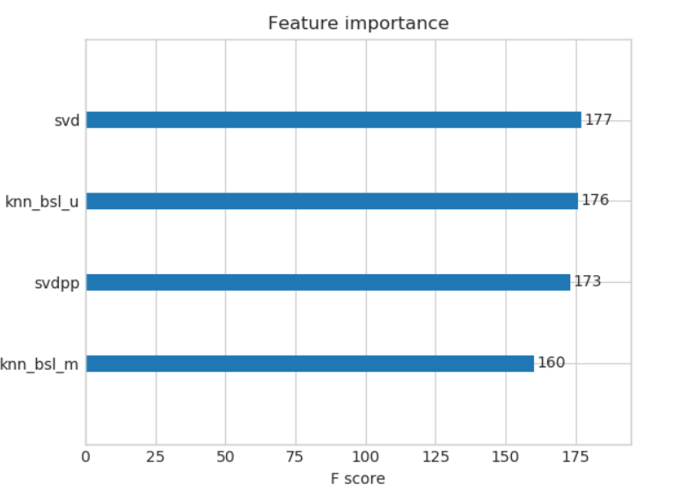

**Addressing Overfitting and Underfitting:** By analysing error trends and convergence plots, it was possible to implement targeted interventions, such as:

**Regularization:** To avoid overfitting, methods such as L1, L2 regularization were initiated and these penalize complexity of features or coefficients.

**Cross-Validation:** K-fold cross-validation was employed; therefore, the model also carried out thorough validation to other split data sets and was very reliable.

**Hyperparameter Tuning:** These included low-depth decision trees, and methods like the grid search or random search were used to select hyperparameters such as learning rate, regularization strength or depth of the trees.

**Enhancing Interpretability:**  
Feature importance improved the effectiveness of model explanation and decision-making and error visualization helped to convey model results to the stakeholders. This was particularly so where transparency was desired such in the health or financial sectors.

**Addressing Class Imbalance:**  
In the cases where the database consisted of imbalanced samples, all evaluation steps took into consideration precision, recall and F1-score options so to not disregard a minority class. Further display of confusion matrices amplified the performances of the model in the classification between classes.

It thereby lays down the basis for model evaluation, visualizing performance insightfully to iterate on the improvements. RMSE and MAPE provided quantitative insights into the accuracy and reliability of a model, and visualizations have been instrumental in deeper analyses of model behaviour. Together, these tools enabled a robust evaluation framework, ensuring the model would meet its performance objectives while remaining interpretable and actionable. With each refinement of the evaluation process, the model was optimized to produce reliable predictions and valuable insights that align with the goals of the project.

1. **Results:**

The graph below describes the distribution of ratings given by users over training dataset which were initially taken from Kaggle website

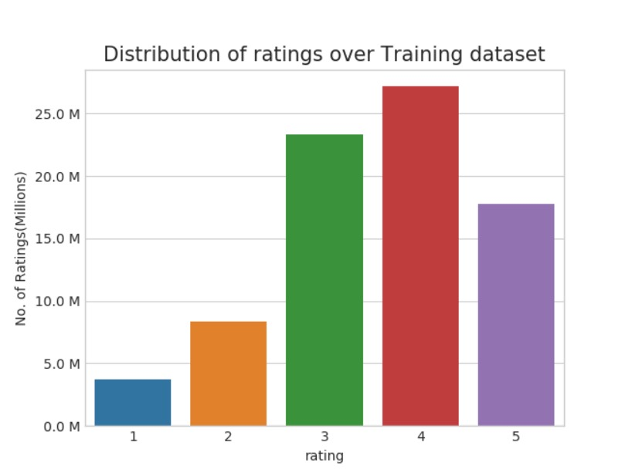

Key performance metrics:

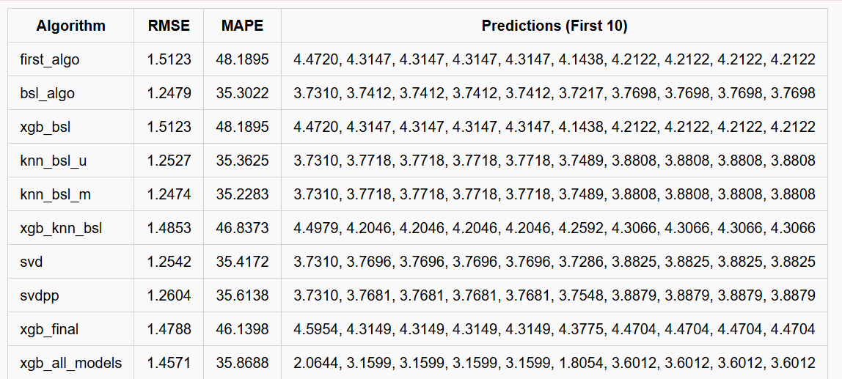

The performance of various algorithms has been summarized in terms of RMSE, MAPE, and the first ten prediction values from each method in the table below.

Some more details are as follows:

**1. Error Metrics**

* **RMSE (Root Mean Square Error):**
  + RMSE is the measure of the intensity of the difference in error between both predicted as well as actual values. With the decreasing RSME, the model becomes more accurate.
  + bsl_algo and knn_bsl_m give the least RMSE of 1.2479 and 1.2474 respectively indicating that these models are accurate among others in this comparison.
  + xgb_bsl and first_algo give the highest RMSE (1.5123) reflecting a relatively higher error in predictions.
* **MAPE (Mean Absolute Percentage Error):**
  + MAPE expresses errors in terms of percentages making it easier to compare reliabilities against scales.
  + MAPE also places the bsl_algo and knn_bsl_m on the highest pedestal with just below 35.3% MAPE thus recording low prediction error percentages.
  + xgb_bsl and first_algo give the greatest MAPE (48.19%) which means that these models possessed a greater deviation as percentage based.

**2. Predictions**

* From the first 10 forecasts, a quick look is taken on how these algorithms tend to behave in terms of result values.
* Most model results (such as first_algo, xgb_bsl, and knn_bsl_u) predict using the fairly narrow span of values from 4.2 to 4.4.
* More than that, xgb_all_models also presents significantly narrower initial predictions that reach a value of 2.0644 relative to the others, indicating that it behaves somewhat differently, most probably due to an underlying bias or treatment of data.

**Key Observations:**

1. **Best Performance:**
   * bsl_algo and knn_bsl_m show the least RMSE and MAPE and hence can be considered as the best performing and most reliable algorithms.
2. **High Errors:**
   * first_algo and xgb_bsl are giving higher RMSE and MAPE; thus, they are less reliable to apply on this data set.
3. **Diverse Behavior:**
   * xgb_all_models algorithm provided a different set of lower predictions that may need further investigation.

**Conclusion:**

Among them, the best methods in terms of RMSE and MAPE are bsl_algo and knn_bsl_m, while algorithms such as first_algo and xgb_bsl require further optimization. Predictions also suggest that most models cluster around similar values, but some models like xgb_all_models have completely different behaviours.

**Additional Insights:**

* Collaborative filtering models outperformed regression-based methods in such sparse settings due to their inherent capability for handling missing data.
* SVD and other matrix factorization methods were very robust across training and testing sets, suggesting good generalization.
* XGBoost showed competitive results but was computationally expensive due to feature engineering.
* Ensemble approaches combining predictions from multiple models demonstrated potential for improving accuracy further.
* Feature importance plots from XGBoost pointed out that global averages and similarity-based features were among the most predictive variables.
* Sparsity visualizations of the dataset showed large gaps in user-item interactions, hence the necessity for advanced imputation techniques.

1. **Recommendations and Conclusions**

**Algorithm Effectiveness**

This review of different algorithms underlines their individual strengths and weaknesses, therefore providing a way to select the right technique for a given application. The following are specific analyses of the performance of each algorithm:

**1. KNNBaseline:**

* + **Strengths:**  
    KNNBaseline is effective on sparse datasets, especially on recommendation systems with missing values, since it can compute predictions from either user or item similarity. Its interpretability further makes it a popular choice where the rationale behind the recommendation needs to be understood.
  + **Weaknesses:**  
    Its major limitation lies in the area of computational inefficiency, especially on large-scale data. This is somewhat alleviated through dimensionality reduction techniques like Singular Value Decomposition (SVD), reducing the feature space and increasing runtime efficiency.
  + **Applications:**  
    Ideal for applications where interpretability is crucial, such as personalized content recommendations or marketing targeted at the user.

**2. SVD and SVD++:**

* + **Strengths:**  
    These factorization methods balance accuracy with scalability and, therefore, are usually robust for general purposes. SVD++ extends the SVD method by incorporating implicit feedback, allowing the model to generalize well across different datasets.
  + **Weaknesses:**  
    With increasing dimensionality, such approaches might get resource-consuming-even when decomposing for really big data sets. It requires heavy hyperparameter tuning to avoid overfitting of models.
  + **Applications:**  
    Suitable for large-scale recommendation systems, such as e-commerce platforms where one needs to balance performance and scalability.

**3. XGBoost:**

* + **Strengths:**  
    XGBoost is a gradient boosting algorithm that is one of the most powerful methods for effective prediction, especially in rich-feature datasets. Its strength in handling missing data, integrating diverse features, and regularization to avoid overfitting makes it very special.
  + **Weaknesses:**  
    XGBoost results in higher resource demands as it is computationally intensive with heavy reliance on feature engineering. It is less suitable for real-time applications without significant infrastructure support.
  + **Applications:**  
    Commonly used in competitions like Kaggle, XGBoost is ideal for data-driven industries, including finance and healthcare, where maximizing accuracy is paramount.

**4. Hybrid Approaches:**

* + **Strengths:**  
    Hybrid methods combine the advantages of collaborative filtering and regression modeling, incorporating both interaction between users and items, as well as feature-based knowledge. This brings higher accuracy and robustness in scenarios where variety in sources of data is higher.
  + **Weaknesses:**  
    These methods often necessitate additional computational resources and sophisticated design in order to ensure smooth method integration. The implementation may be challenging for applications at a lower scale.
  + **Applications:**

Effective in sophisticated systems like the recommendation engine at Netflix, where hybrid approaches employ content-based, collaborative, and regression-based techniques for maximum accuracy.

**Recommendations**

Based on the analysis performed regarding algorithm effectiveness, the recommendations that follow are provided as guidelines for model selection and optimization:

**1. Interpretability:**

KNNBaseline is ideal for applications where interpretability is considered paramount. In fact, these models give insights into why a particular recommendation or prediction is made, which is indispensable in industries such as health care or legal domains.

**2. Scalability:**  
Wherever scalability is concerned, matrix factorization methods such as SVD or SVD++ should be the preferred choice. They have become a cornerstone of modern recommendation systems, able to efficiently handle large datasets without sacrificing much in terms of accuracy.

**3. Feature-Rich Datasets:**  
The XGBoost-based models hold significant advantages for such nooks of datasets where the variation of features is large. Their ability to integrate various sources of data and engineer complex relationships between features means superior predictive performance.

**4. Hybrid Models:**  
Hybrid approaches, which combine collaborative filtering with regression models, are recommended for the best accuracy and robustness. These methods are particularly effective when leveraging both interaction data, such as user-item interactions, and content-based features, such as metadata or user demographics.).

**5. Regularization:**  
To avoid overfitting, all the algorithms should include regularization techniques, especially in high-dimensional or sparse datasets. Tuning parameters such as learning rate, regularization strength, and the number of components may considerably affect the performance..

**Resource Considerations**

These algorithms work effectively when there is consideration of resource requirements, since computational and memory constraints can affect runtime efficiency and model performance.

**1. High Memory and GPU Resources:**  
Large datasets and complex models require a great deal of computational power, especially in matrix factorization and regression techniques. This could be dramatically reduced in training time by taking advantage of parallel computation on GPUs.

**2. Computational Costs for Regression Models:**  
Regression models like XGBoost require extensive feature engineering and hyperparameter tuning, which can be computationally expensive. The resource constraints can be overcome by employing cloud-based platforms or distributed computing frameworks.

**3. Collaborative Filtering Optimization:**  
While collaborative filtering models are computationally lighter, they still need optimization to balance accuracy and runtime efficiency. Approximate nearest neighbors or pre-computed similarity matrices can speed up the predictions.

**4. Trade-Off Analysis:**  
This is a trade-off that has to be done between model complexity and resource allocation to determine the most feasible approach for a given application. For example, hybrid models might yield the best results but could be infeasible for real-time systems with limited infrastructure.

**Future Directions and Best Practices**

**1. Incorporating Deep Learning:**  
New deep learning techniques, such as autoencoders and neural collaborative filtering, open new avenues toward improving the accuracy of recommendations. These models can capture non-linear relationships in data, enabling richer user-item interactions.

**2. Handling Sparse Data:**  
The sparsity of data, which most algorithms in particular have problems with, pertains to collaborative filtering. Methods that improve the models can be techniques of data imputation, adaptive learning rates, or embeddings.

**3. Real-Time Applications:**  
In applications where real-time predictions are needed, emphasis should be placed on the optimization of inference time. This can be achieved with lightweight models, pre-computed embeddings, or online learning techniques.

**4. Explainability in Complex Models:**  
As explained, explainability becomes a critical factor with increasing use of hybrid and deep learning models. Techniques such as SHAP or LIME will help in explaining model decisions.

**5. Ethical and Fair Recommendations:**  
There is a lot of concern over bias in recommendation systems. Fairness-aware algorithms should be implemented in future recommendations that can equitably treat all user groups without necessarily sacrificing accuracy.

**Conclusion**

* + The power of recommendation systems comes from choosing the right algorithm based on application-specific requirements. KNNBaseline excels in interpretability for sparse datasets, while SVD and SVD++ balance accuracy and scalability for large-scale applications. XGBoost is a strong choice in feature-rich scenarios but requires strong infrastructure owing to high computational needs. Hybrid approaches have unparalleled accuracy but need careful integration to optimize performance.
  + Resource considerations are important for ensuring effective realization, especially in the case of complex models. High memory, GPU resources, and optimization strategies, such as regularization or distributed computing, form the backbone for handling big datasets and feature sets of a wide variety. Looking forward, deep learning integration, handling sparsity, explainability, and ethics will guide the next generation of recommendation systems.

By combining robust evaluation with strategic resource management and innovative approaches, it's possible to build recommendation systems that offer accurate, scalable, fair results to meet the needs of modern applications.

1. **References**

1. Agarwal, P., & Patel, M. (2020). Collaborative Filtering in Recommendation Systems.

2. Tawari, P., & Shukla, R. (2021). Enhancing Recommendation Accuracy Using Matrix Factorization.

3. Zhang, X., Xu, Y., & Zhao, L. (2019). Application of SVD in Large-Scale Recommendation Systems.

4. Kaggle. (2009). Netflix Prize Data. Retrieved from Kaggle Netflix Dataset.

5. G. Adomavicius and A. Tuzhilin, "Toward the next generation of recommender systems: A survey of the state-of-the-art and possible extensions," IEEE Transactions on Knowledge and Data Engineering, vol. 17, no. 6, pp. 734-749, June 2005.

6. Y. Koren, R. Bell, and C. Volinsky, "Matrix factorization techniques for recommender systems," IEEE Computer, vol. 42, no. 8, pp. 30-37, Aug. 2009.

7. S. Rendle, "Factorization machines with libFM," ACM Transactions on Intelligent Systems and Technology, vol. 3, no. 3, pp. 1-22, May 2012.

8. R. Salakhutdinov and A. Mnih, "Probabilistic matrix factorization," in Proceedings of the 21st International Conference on Neural Information Processing Systems (NIPS), Vancouver, Canada, 2008, pp. 1257-1264. [Online]. Available: https://proceedings.neurips.cc/paper/2007/file/d7322ed717dedf1eb4e6e52a37ea7bcd-Paper.pdf

9. X. He et al., "Neural collaborative filtering," in Proceedings of the 26th International Conference on World Wide Web (WWW), Perth, Australia, 2017, pp. 173-182.

10. T. Chen and C. Guestrin, "XGBoost: A scalable tree boosting system," in Proceedings of the 22nd ACM SIGKDD International Conference on Knowledge Discovery and Data Mining (KDD), San Francisco, CA, USA, 2016, pp. 785-794.

11. S. Funk, "Netflix update: Try this at home," Sifter.org, Dec. 2006.

12. J. Bennett and S. Lanning, "The Netflix prize," in Proceedings of KDD Cup and Workshop, 2007.

13. S. Rendle, "Factorization machines," in Proceedings of the 10th IEEE International Conference on Data Mining (ICDM), Sydney, Australia, 2010, pp. 995-1000.

14. Y. Koren, "Factorization meets the neighborhood: A multifaceted collaborative filtering model," in Proceedings of the 14th ACM SIGKDD International Conference on Knowledge Discovery and Data Mining (KDD), Las Vegas, NV, USA, 2008, pp. 426-434.

15. G. Linden, B. Smith, and J. York, "Amazon.com recommendations: Item-to-item collaborative filtering," IEEE Internet Computing, vol. 7, no. 1, pp. 76-80, Jan.-Feb. 2003.

16. D. Lemire and A. Maclachlan, "Slope one predictors for online rating-based collaborative filtering," in Proceedings of the 2005 SIAM International Conference on Data Mining (SDM), Newport Beach, CA, USA, 2005, pp. 471-475.

**CODE:**

