TP1: 3.3V from regulator

TP2: GND reference

TP3: 0-3.3V 125kHz square wave

TP4: 3-9V 125kHz square wave

TP5: 3-9V 125kHz square wave

TP6: 3-9V skewed square wave

TP7: 125kHz sine wave, at least 20Vpp

TP8: Rectified sine wave

TP9: Demodulated sine wave

TP10: MCU compatible output

TP11: Input for 3.3V sine wave for tuning

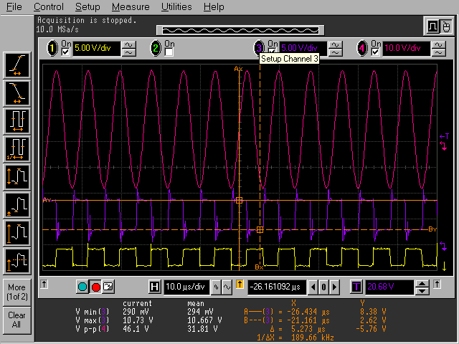

1: TP3

2: TP4

3: TP7

125kHz gate transmit, high 30/63

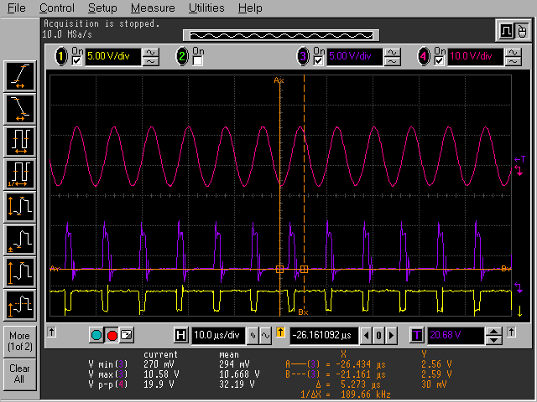

1: TP3

2: TP4

3: TP7

125kHz gate transmit, low 10/63

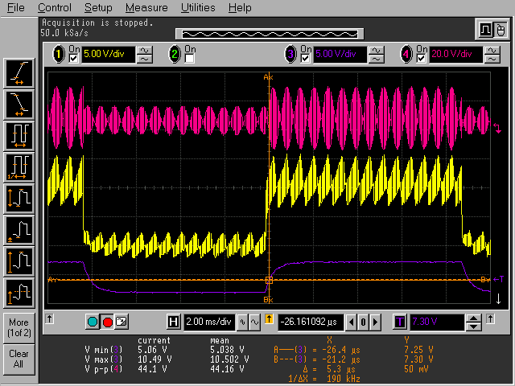

1: TP8: Demodulated wave

3: TP9: Rectified wave

4: TP7: Sine wave

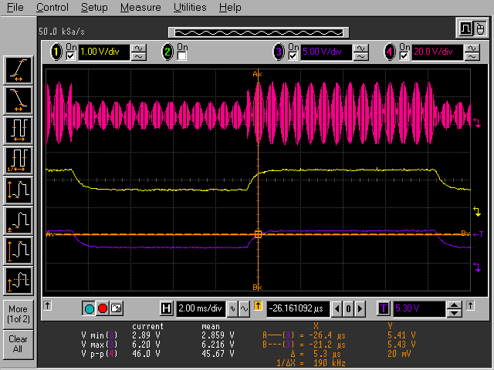

1: TP10

3: TP9

4: TP7