TP1: 12V battery

TP2: 6V battery tap

TP3: BBB 5V output

TP4: Switch node

TP5: Tuning sine wave input

TP6: LC sense

TP7:

TP8: Rectified sine wave

TP9: Demodulated sine wave

TP10: MCU compatible output

TP11: Input for 3.3V sine wave for tuning

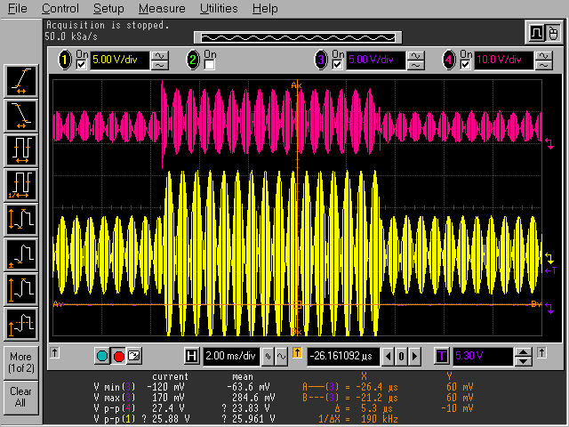

1: TP6 tag LC

4: TP7 gate output

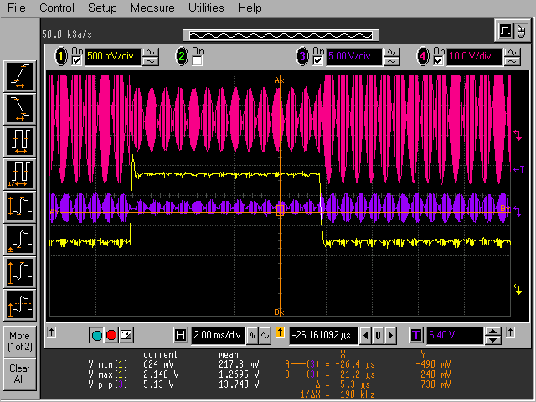

1: Pmos source follower output, with tag angle close to minimum

3: LC tank

4: scanner TP7

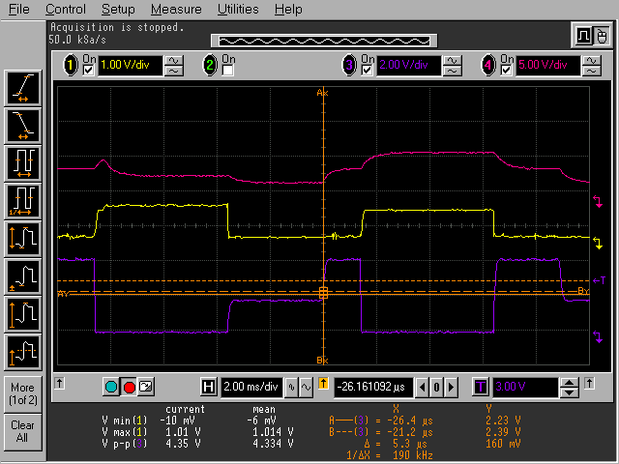

1: TP10

3: TP11

4: scanner TP9

100Hz square wave on robot tx, with gate transmitting square wave as well.

TP10: (PMOS Source Follower)

Maximally coupled: 0V

60-180 degrees: square wave appears, first low is stable, then both move, then high is stable

Minimally coupled: 1.4V

TP11: standard peak detector

Maximally coupled: 1.8V to 4.4V square wave

0-180 degrees: square wave decreases in both high and low

Minimally coupled: close to 0V