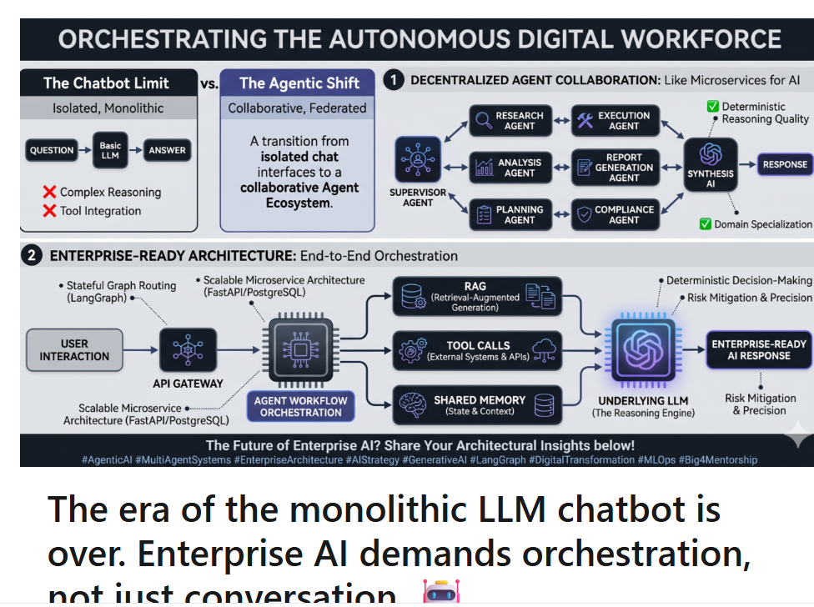
The era of the monolithic LLM chatbot is over. Enterprise AI demands orchestration, not just conversation. 🤖

Arpita Jaiswal

Enterprise AI Engineer | Architecting Multi-Agent Systems & GenAI Solutions | SAP-Certified in Autonomous Enterprise | LangGraph, RAG, AWS
June 29, 2026
Traditional chatbots are hitting a hard ceiling. The standard pipeline—Question → LLM → Answer—is sufficient for basic customer service, but it shatters under the weight of complex, multi-layered enterprise workflows.
When deploying single-model architectures at scale, Fortune 500 organizations consistently run into operational bottlenecks:
❌ Cognitive Overload: Degradation in complex, multi-step reasoning.
❌ Integration Friction: Inability to seamlessly execute across legacy corporate APIs.
❌ Governance Risks: Lack of deterministic decision-making and domain specialization.
The Architectural Solution
The paradigm is shifting toward Multi-Agent Architectures (Agentic AI).
Just as software engineering evolved from fragile monoliths to highly scalable microservices, AI is transitioning from isolated models to federated agent ecosystems.
Instead of forcing one model to do everything poorly, we orchestrate specialized agents to collaborate flawlessly under a central supervisor:
🔍 Research Agent: Ingests and sanitizes massive unstructured datasets.
📊 Analysis Agent: Processes quantitative data against business logic.
⚙️ Execution Agent: Safely interfaces with ERPs and external APIs via strict tool calls.
🛡️ Compliance Agent: Enforces corporate guardrails and guarantees zero hallucination on policy.
The ROI & Business Impact
By adopting a multi-agent framework (leveraging tools like LangGraph or CrewAI), enterprises immediately unlock:
✅ Deterministic Quality: Superior reasoning through isolated agent responsibilities.
✅ Limitless Scalability: Parallel processing of heavy corporate workflows.
✅ Auditability: Transparent memory and routing layers for compliance tracking.
We are moving away from building "chat interfaces" and towards engineering autonomous digital workforces.
What is your take on this architectural shift? Will Multi-Agent Systems become the mandatory baseline for enterprise AI within the next 12 months? Let’s debate the architecture below. 👇
#AgenticAI #MultiAgentSystems #EnterpriseArchitecture #AIStrategy #GenerativeAI #LangGraph #DigitalTransformation #MLOps

