RESEARCH REPORT
Digital Twin Technology
Introduction · Architecture · Use Cases · Advantages & Disadvantages
Comparisons · Alternatives · Sample Code · Real-Time Projects
A Comprehensive Technical Reference
July 2026

Table of Contents

1. Introduction to Digital Twin
A digital twin is a virtual, dynamic representation of a physical object, process, or system that is kept synchronized with its real-world counterpart through continuous data exchange. Unlike a static 3D model or a one-time simulation, a digital twin evolves over its entire lifecycle — reflecting the real asset's current condition, behavior, and history, and in many cases feeding insights or control signals back into the physical world.
The concept was first articulated by Michael Grieves at the University of Michigan around 2002 in the context of Product Lifecycle Management, and later popularized by NASA and the U.S. Air Force Research Laboratory for simulating the health of spacecraft and airframes. The term gained mainstream industrial traction after 2010 as IoT sensors, cloud computing, and simulation software became affordable enough to model entire factories, cities, and supply chains in near real time.

1.1 Core Idea
Every digital twin rests on three pillars that must all be present for a system to genuinely qualify as a digital twin rather than a simulation or a 3D model:
- Physical Entity: The real machine, building, vehicle, human body, or process being modeled.
- Virtual Entity: A software model (physics-based, data-driven, or hybrid) that represents structure and behavior.
- Data Connection: A continuous, bidirectional flow of data linking the two — sensor data flowing in, insights or commands flowing back out.

1.2 Digital Twin vs Digital Model vs Digital Shadow
These three terms are often used loosely, but they describe distinctly different levels of data connectivity:
Term | Data Flow | Description
Digital Model | None (manual) | A digital representation with no automated data exchange with the physical object (e.g. a CAD design).
Digital Shadow | One-way (Physical → Virtual) | The virtual model updates automatically from sensor data, but changes in the model do not affect the physical object.
Digital Twin | Two-way (Physical ⇄ Virtual) | Data flows automatically in both directions — the virtual model can trigger real changes in the physical asset.

2. Digital Twin Architecture
A production-grade digital twin is built as a layered system spanning the physical asset all the way up to end-user applications. The diagram below shows the reference architecture used across most industrial digital twin platforms.
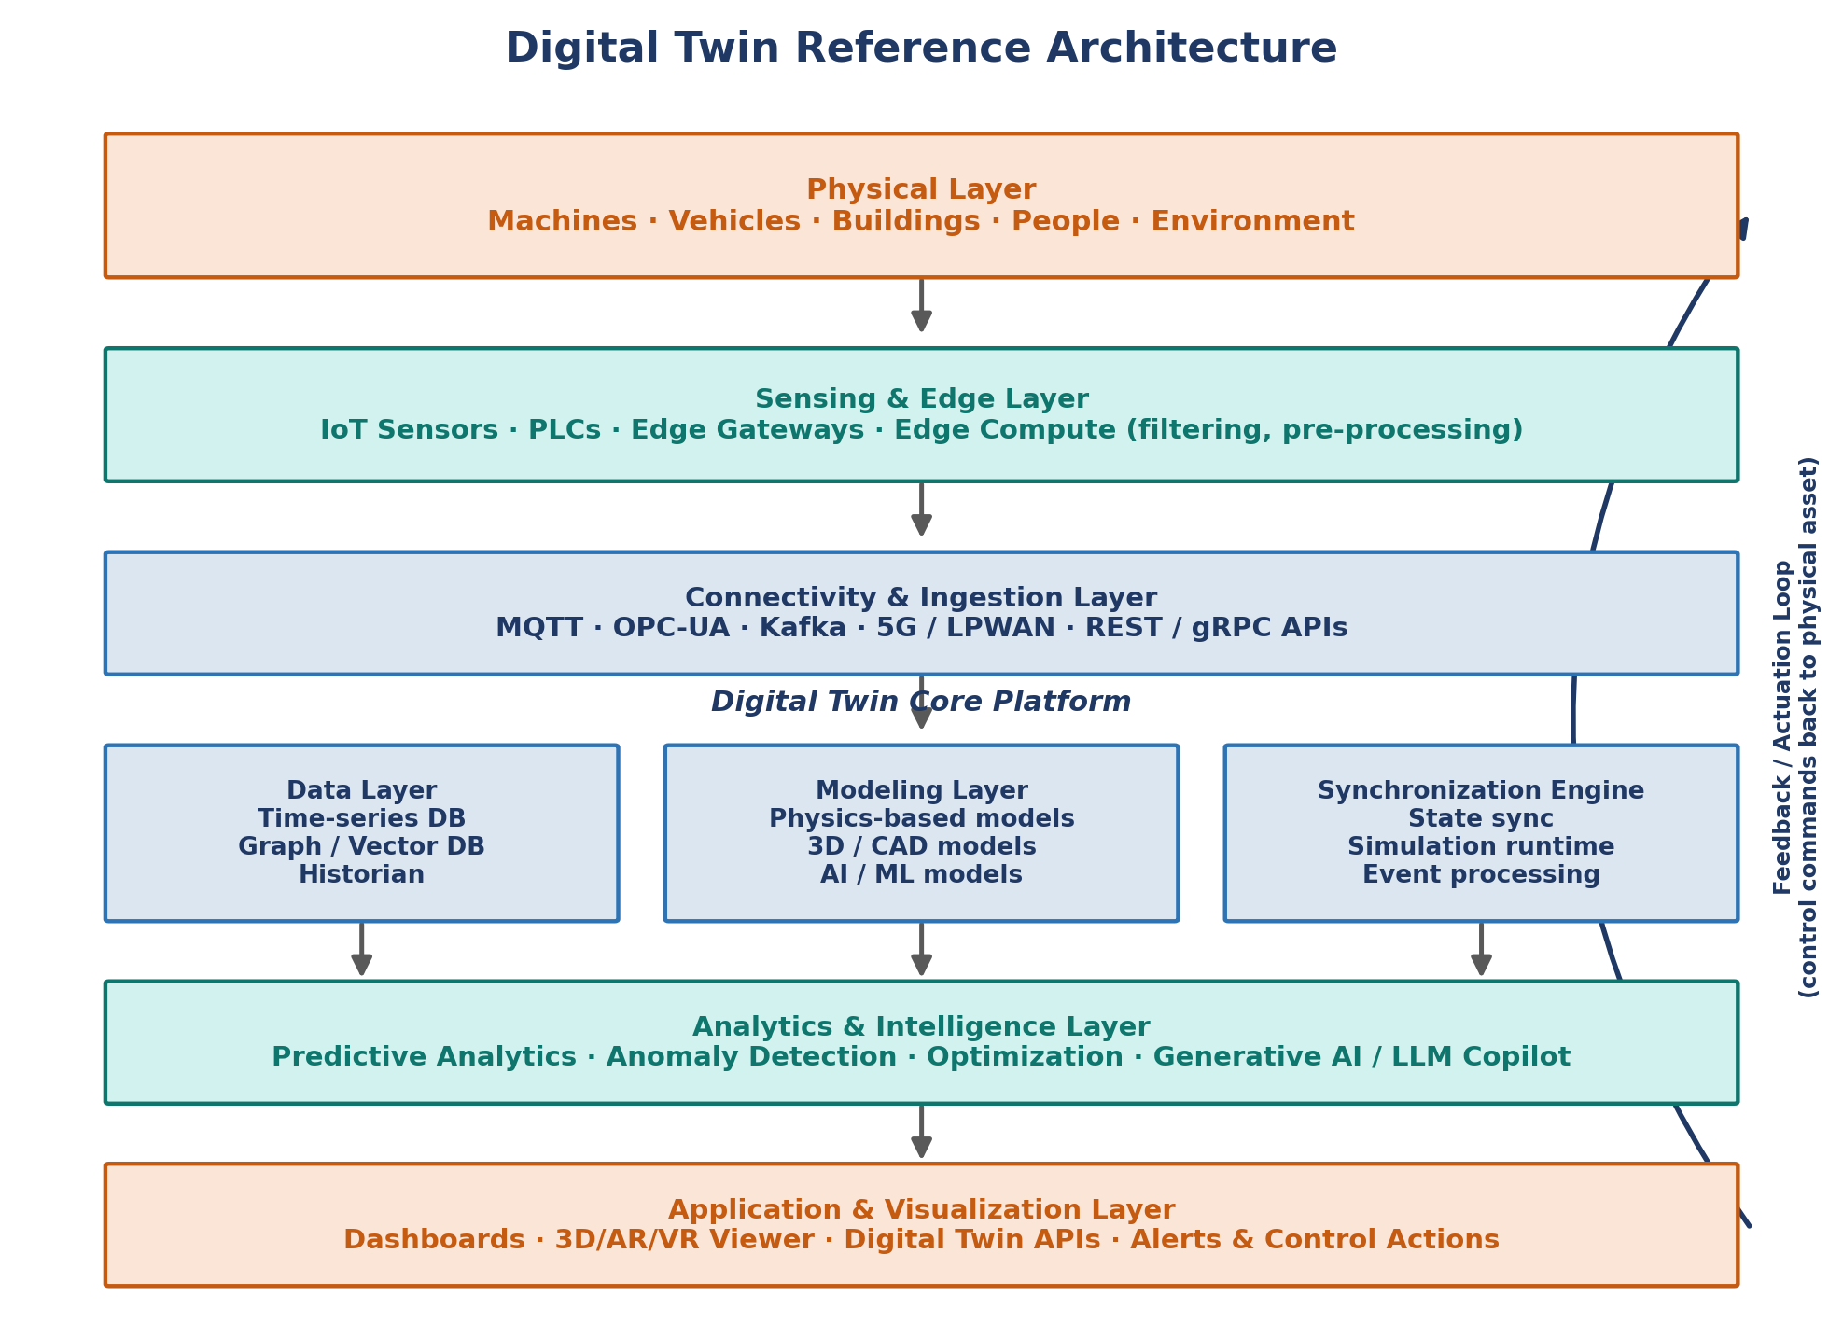
Figure 1: Layered reference architecture of a digital twin platform

2.1 Layer Breakdown
- Physical Layer: The real-world asset — a machine, vehicle, building, or environment — that is the ultimate source of truth.
- Sensing & Edge Layer: IoT sensors, PLCs, and edge gateways capture raw signals (temperature, vibration, GPS, images) and perform local filtering or pre-processing to reduce bandwidth and latency.
- Connectivity & Ingestion Layer: Protocols such as MQTT, OPC-UA, AMQP, and streaming platforms like Apache Kafka move data reliably from the edge to the cloud or on-prem data center.
- Digital Twin Core Platform: Composed of a data layer (time-series/graph/vector databases), a modeling layer (physics-based, geometric, or ML models), and a synchronization engine that keeps virtual state aligned with physical state.
- Analytics & Intelligence Layer: Predictive analytics, anomaly detection, optimization algorithms, and increasingly generative AI / LLM copilots that let users query the twin in natural language.
- Application & Visualization Layer: Dashboards, 3D/AR/VR viewers, and APIs that expose the twin to operators, engineers, and other systems — completing the loop with feedback or control commands sent back to the physical asset.

2.2 The Synchronization Loop
At the heart of every digital twin is a continuous synchronization loop: the physical twin emits telemetry, the digital twin ingests and updates its internal state, runs simulations or ML inference on that state, and returns insights, alerts, or direct control commands back to the physical asset.
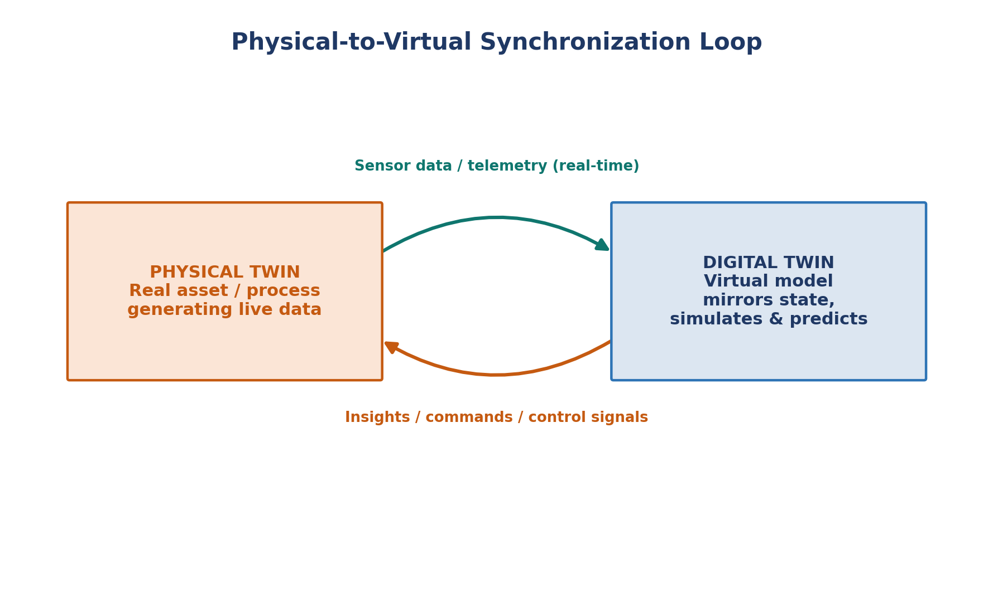
Figure 2: Bidirectional synchronization between physical and digital twin

2.3 Common Technology Stack
Layer | Typical Technologies
Edge / IoT | Raspberry Pi, NVIDIA Jetson, AWS IoT Greengrass, Azure IoT Edge
Messaging / Streaming | MQTT, Kafka, RabbitMQ, AWS Kinesis
Time-series storage | InfluxDB, TimescaleDB, OpenTSDB
3D / Geometry | Unity, Unreal Engine, NVIDIA Omniverse, CesiumJS
Simulation | MATLAB/Simulink, ANSYS Twin Builder, Modelica
ML / AI | PyTorch, TensorFlow, scikit-learn, LangGraph agents
Backend / Orchestration | FastAPI, Node.js, Kubernetes, Apache Airflow
Visualization | Grafana, Power BI, React/Three.js dashboards

3. Types of Digital Twins
Digital twins are commonly classified by the scale of what they represent:
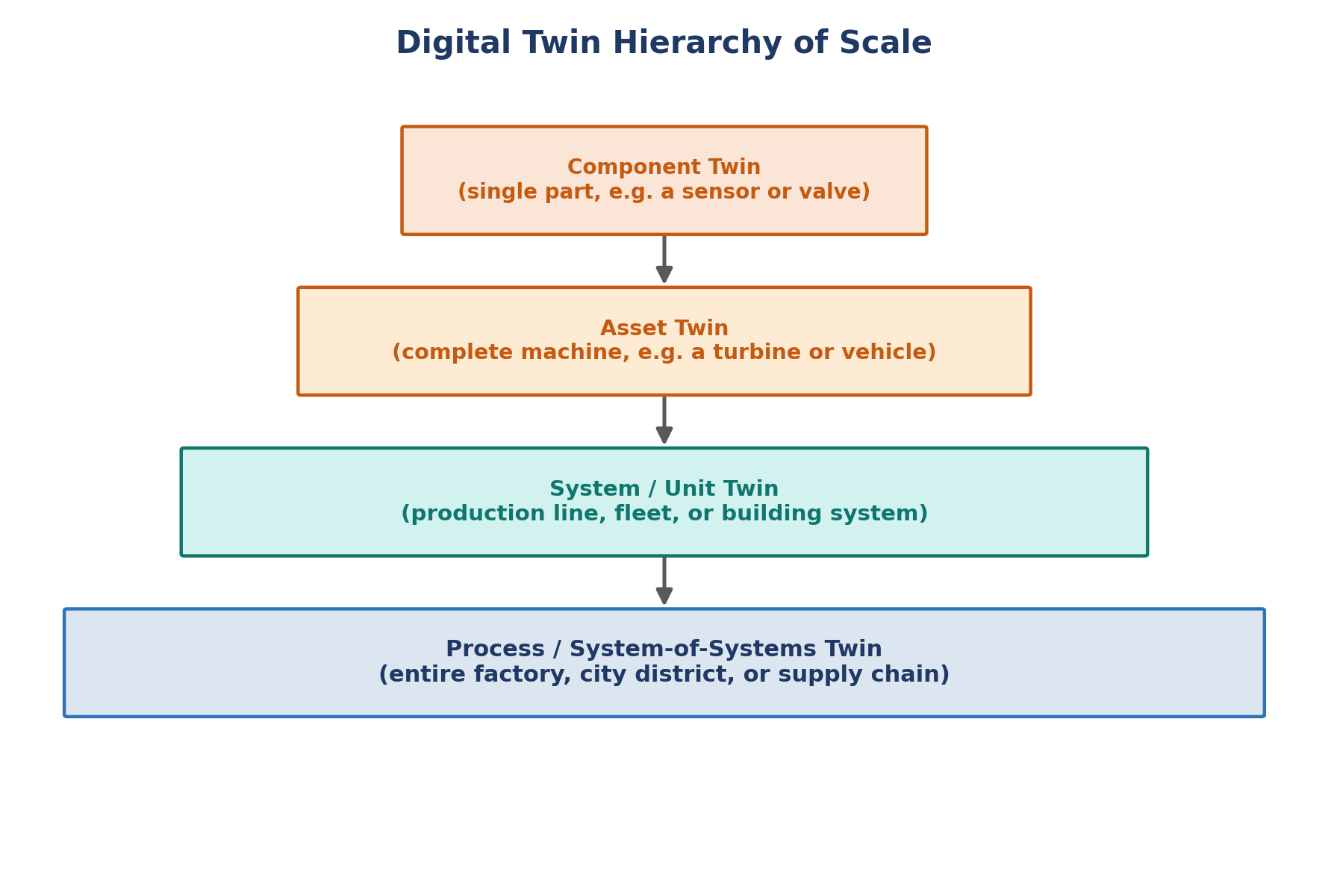
Figure 3: Digital twin hierarchy of scale
- Component Twin: Models a single part, such as a bearing, sensor, or valve.
- Asset Twin: Models a complete piece of equipment, such as a wind turbine, engine, or vehicle, combining multiple component twins.
- System / Unit Twin: Models how multiple assets interact, such as a production line, a building's HVAC system, or a fleet of vehicles.
- Process / System-of-Systems Twin: The broadest scope — an entire factory, supply chain, or city district, integrating many system twins together.

3.1 Classification by Purpose
Category | Focus | Example
Discrete Twin | A specific physical item | A single CNC machine on a shop floor
Composite Twin | A group of assets working together | An assembly line of ten robots
Predictive Twin | Forecasting future states | Remaining-useful-life estimation for a jet engine
Prescriptive Twin | Recommending or automating actions | Auto-adjusting HVAC setpoints for energy savings

4. Why We Use Digital Twins
Organizations adopt digital twins to close the gap between design-time assumptions and real-world operating conditions. Key motivations include:
- Risk-free experimentation: Test 'what-if' scenarios (overload, failure, extreme weather) on the virtual twin without endangering the physical asset.
- Predictive maintenance: Detect early signs of wear or failure days or weeks before a breakdown, reducing unplanned downtime.
- Faster product development: Validate designs virtually before committing to expensive physical prototypes.
- Operational optimization: Continuously tune throughput, energy consumption, or resource allocation based on live data.
- Lifecycle visibility: Maintain a single evolving record of an asset from design through decommissioning.
- Remote monitoring & training: Operate, inspect, or train on assets that are hazardous, remote, or expensive to access physically.

5. Where Digital Twins Are Used
Digital twins have moved well beyond manufacturing and now touch nearly every capital-intensive industry:
Industry | Typical Application
Manufacturing | Virtual commissioning of production lines, throughput optimization, quality prediction
Aerospace | Engine health monitoring, airframe fatigue analysis, flight simulation
Automotive | Vehicle design validation, battery degradation modeling, autonomous driving simulation
Energy & Utilities | Wind turbine performance, power grid load balancing, solar farm yield forecasting
Healthcare | Patient-specific organ models, hospital operations simulation, personalized treatment planning
Smart Buildings | HVAC and energy optimization, space utilization, fire/safety simulation
Retail & Supply Chain | Warehouse layout optimization, inventory flow simulation, logistics network modeling
Agriculture | Crop yield modeling, irrigation optimization, livestock health monitoring
Construction | Building Information Modeling (BIM)-linked twins for progress tracking and clash detection

6. Advantages and Disadvantages

6.1 Advantages
- Reduces unplanned downtime through early failure detection
- Shortens design and testing cycles by validating changes virtually first
- Improves decision-making with real-time, data-driven insight
- Enables safe experimentation with extreme or hazardous scenarios
- Supports sustainability goals by optimizing energy and resource use
- Creates a persistent institutional record of an asset's full lifecycle
- Facilitates remote operations, training, and collaboration

6.2 Disadvantages
- High upfront cost of sensors, integration, and platform engineering
- Requires clean, reliable, high-frequency data — poor data quality undermines the twin's accuracy
- Model drift: virtual models can diverge from physical reality if not continuously recalibrated
- Integration complexity across legacy OT systems, IT systems, and multiple vendors
- Cybersecurity risk — a compromised twin could issue harmful commands to physical equipment
- Requires multidisciplinary skills spanning domain engineering, data science, and software
- Unclear or hard-to-quantify ROI in the early stages of adoption

7. Comparisons

7.1 Digital Twin vs Traditional Simulation
Aspect | Traditional Simulation | Digital Twin
Data source | Assumed / historical inputs | Live sensor data from the real asset
Update frequency | Run once or periodically, offline | Continuously synchronized in near real time
Scope | Models a scenario or design | Models the actual, current state of a specific asset
Feedback to physical world | None | Can trigger real actions/control
Lifetime | Single study or project | Persists across the asset's entire lifecycle

7.2 Digital Twin vs IoT Dashboard
An IoT dashboard visualizes live sensor readings but does not contain a behavioral or physics-based model of the asset. A digital twin goes further: it can simulate what would happen under conditions that have not yet occurred, and can reason about cause and effect — not just display current values.

7.3 Platform Comparison
Platform | Strength | Best Fit
Azure Digital Twins | Strong graph-based twin modeling (DTDL), deep Azure IoT integration | Enterprises already on Microsoft Azure
AWS IoT TwinMaker | Connects existing data sources without duplicating them; good 3D scene composition | AWS-centric industrial IoT deployments
NVIDIA Omniverse | Photorealistic, physically accurate 3D simulation with USD format | Robotics, autonomous vehicles, high-fidelity visual twins
Siemens Xcelerator (Mindsphere/Teamcenter) | Deep CAD/PLM integration, strong in discrete manufacturing | Manufacturers already using Siemens PLM tools
Open-source (Eclipse Ditto, ThingsBoard) | No vendor lock-in, customizable, lower cost | Startups, research, and cost-sensitive projects

8. Alternatives and Related Technologies
- Digital Shadow: A lighter-weight, one-way version of a digital twin — useful when two-way control is not needed or is too risky.
- Building Information Modeling (BIM): A design-time digital model of a building; can become the geometric foundation of a facility digital twin once live sensors are added.
- Classical Discrete-Event Simulation (DES): A cheaper alternative for process-level 'what-if' analysis when real-time synchronization is not required.
- SCADA / Historian Systems: Traditional industrial monitoring systems — a digital twin can be seen as SCADA plus a live behavioral/predictive model layered on top.
- Metaverse / Pure 3D Environments: Visually rich virtual worlds without a mandatory live data link back to a specific real object — a digital twin is a stricter, data-grounded subset of this idea.

9. Key Concepts and Terminology
Term | Meaning
DTDL | Digital Twin Definition Language — a JSON-LD-based schema (used by Azure Digital Twins) for describing twin models
USD | Universal Scene Description — Pixar-originated 3D interchange format used heavily by NVIDIA Omniverse
OPC-UA | An industrial communication protocol for secure, reliable data exchange between machines
RUL | Remaining Useful Life — a predictive maintenance metric estimating time until failure
Model Drift | Divergence between a digital twin's predictions and real-world behavior over time
Edge Computing | Processing data close to its source (on the machine or gateway) rather than in the cloud, to cut latency
Sim2Real | Techniques for transferring models trained in simulation to work correctly on real physical systems

10. Demo Code Examples
The examples below illustrate the core building blocks of a digital twin system: a simple state-sync model, an MQTT-based ingestion listener, a time-series anomaly detector, and a FastAPI service exposing the twin over a REST API.

10.1 A Minimal Digital Twin Class (Python)
This example shows the simplest possible digital twin: an in-memory object that mirrors sensor readings and exposes a simulate() method to predict future state.
digital_twin.py
from dataclasses import dataclass, field
from datetime import datetime
from collections import deque

@dataclass
class MachineDigitalTwin:
asset_id: str
temperature: float = 0.0
vibration: float = 0.0
rpm: float = 0.0
history: deque = field(default_factory=lambda: deque(maxlen=500))

def update_from_sensor(self, reading: dict):
"""Ingest a new sensor reading and update virtual state."""
self.temperature = reading.get("temperature", self.temperature)
self.vibration = reading.get("vibration", self.vibration)
self.rpm = reading.get("rpm", self.rpm)
self.history.append({**reading, "ts": datetime.utcnow().isoformat()})

def predict_failure_risk(self) -> float:
"""Very simple heuristic risk score (0-1). Replace with an ML model."""
risk = 0.0
if self.temperature > 85:
risk += 0.4
if self.vibration > 5.0:
risk += 0.4
if self.rpm > 3000:
risk += 0.2
return min(risk, 1.0)

def recommend_action(self) -> str:
risk = self.predict_failure_risk()
if risk >= 0.7:
return "STOP: Schedule immediate maintenance"
if risk >= 0.4:
return "WARN: Plan maintenance within 48 hours"
return "OK: Continue normal operation"

if __name__ == "__main__":
twin = MachineDigitalTwin(asset_id="PUMP-101")
twin.update_from_sensor({"temperature": 91, "vibration": 6.2, "rpm": 3100})
print(f"Risk: {twin.predict_failure_risk():.2f}")
print(f"Action: {twin.recommend_action()}")

10.2 MQTT Ingestion Listener (Python, paho-mqtt)
Real digital twins receive data continuously from field devices. This example subscribes to an MQTT broker and updates the twin's state on every message.
mqtt_listener.py
import json
import paho.mqtt.client as mqtt
from digital_twin import MachineDigitalTwin

twin = MachineDigitalTwin(asset_id="PUMP-101")

def on_connect(client, userdata, flags, rc):
print(f"Connected with result code {rc}")
client.subscribe("factory/pump101/telemetry")

def on_message(client, userdata, msg):
reading = json.loads(msg.payload.decode())
twin.update_from_sensor(reading)
risk = twin.predict_failure_risk()
if risk >= 0.4:
print(f"[ALERT] {twin.asset_id} risk={risk:.2f} -> {twin.recommend_action()}")

client = mqtt.Client()
client.on_connect = on_connect
client.on_message = on_message
client.connect("broker.local", 1883, 60)
client.loop_forever()

10.3 FastAPI Service Exposing the Twin
Digital twin platforms typically expose state and predictions through an API layer so dashboards, mobile apps, and other services can consume them.
main.py — FastAPI Digital Twin Service
from fastapi import FastAPI
from pydantic import BaseModel
from digital_twin import MachineDigitalTwin

app = FastAPI(title="Digital Twin API")
twins: dict[str, MachineDigitalTwin] = {}

class SensorReading(BaseModel):
temperature: float
vibration: float
rpm: float

@app.post("/twins/{asset_id}/telemetry")
def ingest_telemetry(asset_id: str, reading: SensorReading):
twin = twins.setdefault(asset_id, MachineDigitalTwin(asset_id=asset_id))
twin.update_from_sensor(reading.dict())
return {
"asset_id": asset_id,
"risk": twin.predict_failure_risk(),
"action": twin.recommend_action(),
}

@app.get("/twins/{asset_id}/state")
def get_state(asset_id: str):
twin = twins.get(asset_id)
if not twin:
return {"error": "twin not found"}
return {
"temperature": twin.temperature,
"vibration": twin.vibration,
"rpm": twin.rpm,
"risk": twin.predict_failure_risk(),
}

# Run with: uvicorn main:app --reload --port 8000

10.4 3D Visualization Snippet (Three.js)
Digital twins are commonly rendered as 3D scenes so operators can visually inspect asset condition. This snippet shows a bare-bones Three.js viewer that changes a model's color based on live risk data fetched from the API above.
viewer.js
import * as THREE from "three";

const scene = new THREE.Scene();
const camera = new THREE.PerspectiveCamera(60, window.innerWidth / window.innerHeight, 0.1, 1000);
const renderer = new THREE.WebGLRenderer({ antialias: true });
renderer.setSize(window.innerWidth, window.innerHeight);
document.body.appendChild(renderer.domElement);

const geometry = new THREE.CylinderGeometry(1, 1, 2, 32);
const material = new THREE.MeshStandardMaterial({ color: 0x2e74b5 });
const pumpMesh = new THREE.Mesh(geometry, material);
scene.add(pumpMesh);
scene.add(new THREE.AmbientLight(0xffffff, 0.8));
camera.position.z = 5;

async function refreshTwinColor() {
const res = await fetch("/twins/PUMP-101/state");
const data = await res.json();
if (data.risk >= 0.7) material.color.set(0xc0392b); // red
else if (data.risk >= 0.4) material.color.set(0xf39c12); // amber
else material.color.set(0x27ae60); // green
}

function animate() {
requestAnimationFrame(animate);
pumpMesh.rotation.y += 0.01;
renderer.render(scene, camera);
}
setInterval(refreshTwinColor, 3000);
animate();

11. Real-Time Projects and Use Cases

11.1 Project 1 — Predictive Maintenance for Rotating Equipment
Goal: detect bearing or motor degradation before failure using vibration and temperature sensors, reducing unplanned downtime in a factory setting.
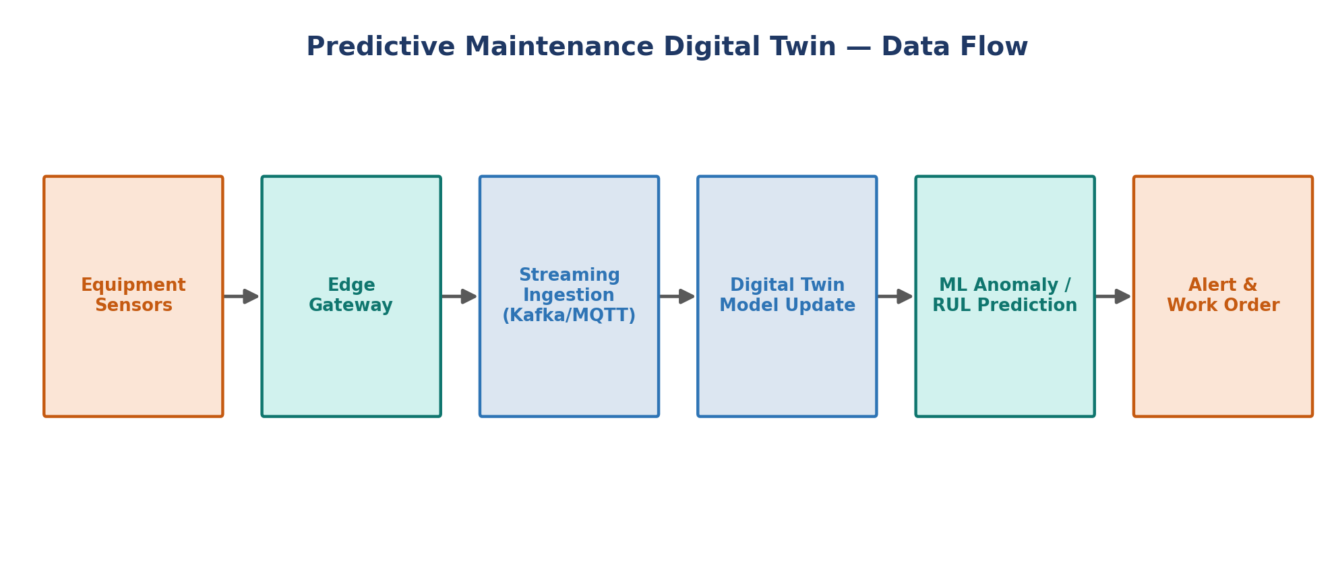
Figure 4: Predictive maintenance digital twin data flow
- Sensors: Accelerometers (vibration), thermocouples (temperature), current clamps
- Pipeline: Edge gateway → Kafka topic → time-series DB (InfluxDB) → digital twin model → ML model (Isolation Forest / LSTM autoencoder) → alerting
- Outcome: Maintenance teams receive a Remaining Useful Life (RUL) estimate instead of relying on fixed maintenance schedules

Sample: Anomaly Detection with an Isolation Forest
anomaly_detector.py
import pandas as pd
from sklearn.ensemble import IsolationForest

# historical sensor readings: temperature, vibration, rpm, current
df = pd.read_csv("sensor_history.csv")

model = IsolationForest(n_estimators=200, contamination=0.02, random_state=42)
model.fit(df[["temperature", "vibration", "rpm", "current"]])

def score_new_reading(reading: dict) -> dict:
X = pd.DataFrame([reading])
anomaly_score = model.decision_function(X)[0] # higher = more normal
is_anomaly = model.predict(X)[0] == -1
return {"anomaly_score": float(anomaly_score), "is_anomaly": bool(is_anomaly)}

print(score_new_reading({"temperature": 96, "vibration": 7.1, "rpm": 3200, "current": 18.4}))

11.2 Project 2 — Smart Building Energy Twin
Goal: model a commercial building's HVAC, lighting, and occupancy systems to cut energy consumption while maintaining comfort.
- Sensors: CO2/occupancy sensors, smart thermostats, energy meters, weather API feed
- Model: A thermal simulation combined with a reinforcement-learning agent that adjusts setpoints
- Outcome: Typical energy savings of 10-25% by pre-cooling/heating zones only when occupancy is predicted

Sample: Simple Rule-Based Energy Optimization Loop
energy_twin.py
def recommend_hvac_setpoint(occupancy_forecast: float, outdoor_temp: float, current_temp: float) -> float:
"""
occupancy_forecast: predicted occupancy in the next 30 min (0-1)
outdoor_temp / current_temp: degrees Celsius
Returns recommended indoor setpoint.
"""
if occupancy_forecast < 0.1:
# Unoccupied: relax setpoint to save energy
return 28.0 if outdoor_temp > 20 else 16.0
# Occupied: maintain comfort band, but pre-condition using outdoor trend
base = 23.0
if outdoor_temp > 32:
base -= 1.0 # pre-cool a bit more on hot days
return base

setpoint = recommend_hvac_setpoint(occupancy_forecast=0.8, outdoor_temp=33.5, current_temp=25.0)
print(f"Recommended setpoint: {setpoint} C")

11.3 Project 3 — Digital Twin of a Delivery Fleet
Goal: maintain a live virtual model of every vehicle in a delivery fleet — location, fuel/battery level, engine health, and route progress — to optimize dispatch and predict maintenance needs.
- Data sources: GPS telemetry, OBD-II diagnostics, weather and traffic APIs
- Architecture: Vehicles publish telemetry over cellular/5G to a cloud ingestion endpoint; a graph-based twin models the fleet as nodes and routes as edges

Sample: Fleet State Aggregation (Python)
fleet_twin.py
from dataclasses import dataclass
from typing import Dict

@dataclass
class VehicleTwin:
vehicle_id: str
lat: float
lon: float
fuel_pct: float
engine_temp: float
speed_kmh: float

class FleetDigitalTwin:
def __init__(self):
self.vehicles: Dict[str, VehicleTwin] = {}

def update(self, telemetry: dict):
v = VehicleTwin(**telemetry)
self.vehicles[v.vehicle_id] = v

def vehicles_needing_fuel(self, threshold=15.0):
return [v.vehicle_id for v in self.vehicles.values() if v.fuel_pct < threshold]

def vehicles_overheating(self, threshold=105.0):
return [v.vehicle_id for v in self.vehicles.values() if v.engine_temp > threshold]

fleet = FleetDigitalTwin()
fleet.update({"vehicle_id": "VAN-07", "lat": 1.29, "lon": 103.85, "fuel_pct": 12.0, "engine_temp": 92, "speed_kmh": 40})
print("Needs fuel:", fleet.vehicles_needing_fuel())

12. Best Practices for Building Digital Twins
- Start with a narrow, high-value pilot (a single asset or line) before scaling to a whole plant or fleet
- Invest in data quality and sensor calibration before investing in advanced AI models
- Design the data schema (ontology) early — inconsistent naming across sites is a common failure mode
- Continuously validate and recalibrate models against real outcomes to prevent model drift
- Treat the twin as a product with an owner, not a one-off engineering project
- Secure the feedback/control channel carefully — it is the highest-risk part of the architecture
- Choose open standards (OPC-UA, DTDL, USD) where possible to avoid vendor lock-in

13. Challenges and Future Trends

13.1 Remaining Challenges
- Interoperability between vendor-specific twin platforms remains limited
- Scaling from one asset to thousands (city-scale or fleet-scale twins) strains compute and data pipelines
- Talent shortage — few engineers combine domain expertise, simulation, and AI/ML skills

13.2 Emerging Directions
- Generative AI Copilots: Natural-language interfaces (LLM agents) that let engineers ask a twin questions like 'why is turbine 3 vibrating more than usual?' and get grounded answers.
- Autonomous/Self-Healing Twins: Twins that not only detect anomalies but automatically trigger corrective actions with minimal human intervention.
- City-Scale and Climate Twins: Digital twins of entire urban areas or ecosystems for climate resilience and infrastructure planning.
- Twin-to-Twin Federation: Interconnected twins across supply chain partners sharing state to optimize end-to-end logistics.

14. Conclusion
Digital twin technology has matured from a niche aerospace concept into a mainstream engineering discipline spanning manufacturing, energy, healthcare, buildings, and logistics. Its value comes from the discipline of maintaining a live, two-way link between the physical and virtual worlds — enabling organizations to predict, experiment, and optimize with far less risk and cost than working on the physical asset alone. Success depends less on any single technology choice and more on data quality, a well-designed architecture, and starting with focused, high-value pilots before scaling.

References and Further Reading
- Grieves, M. (2014). Digital Twin: Manufacturing Excellence through Virtual Factory Replication.
- NASA & U.S. Air Force Research Laboratory — early digital twin concepts for aerospace vehicle health management
- Microsoft Azure Digital Twins documentation
- AWS IoT TwinMaker documentation
- NVIDIA Omniverse and Universal Scene Description (USD) documentation
- Digital Twin Consortium — industry definitions and reference architectures

