**Final Report**

**SOFTWARE ENGINEERING**

TOPIC: SUPPLEMENT FACTS PRODUCTS

Lecturer: **Mr. PHAM THAI KI TRING**

Students: **Ho Vinh Tuong - 520K0091**

**Nguyen Pham Phu Thinh - 520V0012**

**Final Report**

**SOFTWARE ENGINEERING**

TOPIC: SUPPLEMENT FACTS PRODUCTS

Lecturer: **Mr. PHAM THAI KI TRING**

Students: **Ho Vinh Tuong - 520K0091**

**Nguyen Pham Phu Thinh - 520V0012**

Course: **24**

# ACKNOWLEDGEMENT

We send our most sincere thanks to Mr. Pham Thai Ki Trung for always supporting and accompanying us to complete the mid-term report of Software Engineering in the best way. We always hope that you will always be the teacher that accompanies and gives our students the best knowledge so that they can go out and have the most solid knowledge. Once again, thank you very much for your time.

The team would also like to thank the Faculty of Information Technology and the school for creating conditions both physically and mentally so that the group could complete the mid-term report in the best way.

We would like to thank all the teachers who have supported us in the best way. We sincerely thank you!

# THE REPORT IS COMPLETED AT TDT UNIVERSITY

I hereby declare that this is the product of our own project and under the guidance of Mr. Pham Thai Ki Trung. The research contents and results in this topic are honest and have not been published in any form before. The data in the tables for analysis, comments and evaluation are collected by the author himself from different sources, clearly stated in the reference section.

In addition, the project also uses a number of comments, assessments as well as data from other authors, other agencies and organizations, with citations and source annotations.

If I find any fraud, I will take full responsibility for the content of my project. Ton Duc Thang University is not related to copyright and copyright violations caused by me during the implementation process (if any).

*HCMC, December 3rd 2022*

*Authors*

*Ho Vinh Tuong*

*Nguyen Pham Phu Thinh*

# CONFIRMATION AND ASSESSMENT SECTION

**The evaluation of lecturer**

HCMC, December 3rd, 2022

**The evaluation of examiner**

HCMC, December 3rd, 2022

Contents

ACKNOWLEDGEMENT 1

THE REPORT IS COMPLETED AT TDT UNIVERSITY 2

CONFIRMATION AND ASSESSMENT SECTION 3

A. INTRODUCTION 37

1. Purpose and Scope 37

2. Product Overview (including capabilities, scenarios for using the product, etc.) 37

3. Structure of the Document 37

4. Terms, Acronyms, and Abbreviations 37

B. PROJECT MANAGEMENT PLAN 37

1. Project Organization 37

2. Lifecycle Model Used 37

3. Risk Analysis 37

4. Hardware and Software Resource Requirements 37

5. Deliverables and Schedule 37

6. Monitoring, Reporting, and Controlling Mechanisms 37

7. Professional Standards 37

8. Evidence all the artifacts have been placed under configuration management 37

9. Impact of the project on individuals and organizations 37

C. REQUIREMENT SPECIFICATIONS 37

1. Stakeholders for the system 37

2. Use case model 38

2.1. Graphical use case model 38

2.2. Textual Description for each use case 38

3. Functional requirements 42

4. Non-functional requirements 42

D. ARCHITECTURE 42

1. Architectural style(s) used 42

2. Architectural model 42

3. Technology, software, and hardware used 42

4. Rationale for your architectural style and model 42

E. DESIGN 42

1. Database design 42

2. Static model – class diagrams 42

3. Dynamic model – sequence diagrams 42

4. Rationale for your detailed design model 42

5. Traceability from requirements to detailed design model 42

F. TEST PLAN 42

1. Requirements/specifications-based system level test cases 42

2. Traceability of test cases to use cases 42

3. Techniques used for test generation 42

4. Assessment of the goodness of your test suite 42

G. DEMO 42

1. Database 42

2. Source code 42

3. Testing 42

H. REFERENCES 42

# INTRODUCTION

## Purpose and Scope

## Product Overview (including capabilities, scenarios for using the product, etc.)

## Structure of the Document

## Terms, Acronyms, and Abbreviations

# PROJECT MANAGEMENT PLAN

## Project Organization

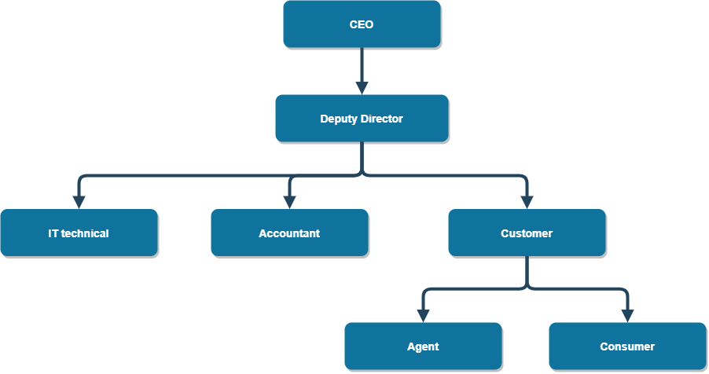

## Lifecycle Model Used

## Risk Analysis

## Hardware and Software Resource Requirements

## Deliverables and Schedule

## Monitoring, Reporting, and Controlling Mechanisms

## Professional Standards

## Evidence all the artifacts have been placed under configuration management

## Impact of the project on individuals and organizations

# REQUIREMENT SPECIFICATIONS

## Stakeholders for the system

|  |  |  |
| --- | --- | --- |
| Stakeholder | | Role |
| Project Manager | | Planning and managing the whole progress from beginning to the end. |
| Developer Team | | Do implementation, testing and maintaining |
| User | Accountant |  |
| Agent |  |
| Consumer |  |

## Use case model

## Graphical use case model

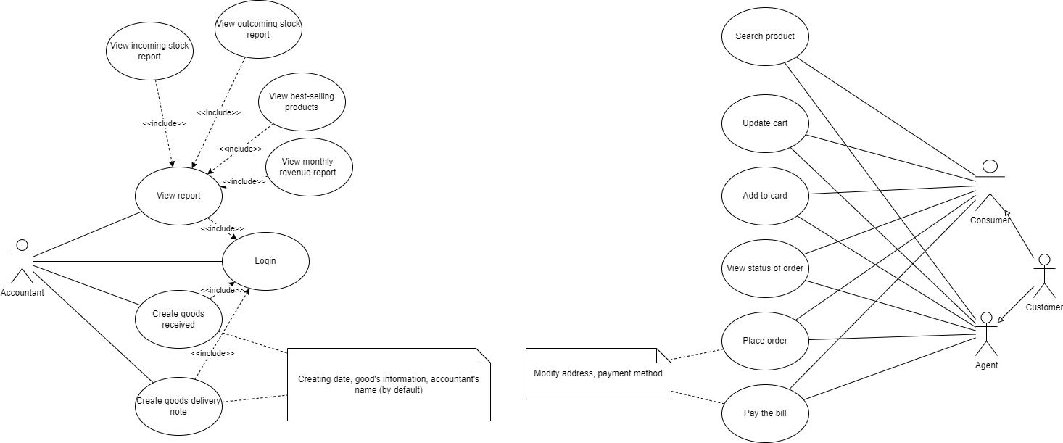

## Textual Description for each use case

|  |  |  |
| --- | --- | --- |
| **Use Case Name** | Create Goods Received | |
| **Scenario** | Display form allow accountant text Goods Received on screen | |
| **Triggering event** | Accountant create Goods Received | |
| **Actors** | Accountant | |
| **Brief description** | Accountant want to create Goods Received to enter their details for system. | |
| **Related use cases** | Might be demanded when accountant receive a message from their manager | |
| **Stakeholders** | Accountant | |
| **Preconditions** | Basic information of goods must be valid. | |
| **Postconditions** | Goods Received must be created and saved. | |
| **Flow of activity** | Actor | System |
| 1.Select Create Goods Received.  2.Accountant input details.  3.Enter save  . | * 1. Display form screen.   2. System prompts for details.   2.1. Check and create temp form.  2.2. System prompts for save.  3.1. Check compatibility and create form.  3.2. System return valid Goods Received details |
| **Exception conditions** | Basic details are uncompleted.  System will display invalid goods Received | |

|  |  |  |
| --- | --- | --- |
| **Use Case Name** | Create Goods Delivery | |
| **Scenario** | Display form allow accountant text Goods Delivery on screen | |
| **Triggering event** | Accountant create Goods Delivery | |
| **Actors** | Accountant | |
| **Brief description** | Accountant want to create Goods Delivery to enter their details for system. | |
| **Related use cases** | Might be demanded when accountant receive a message from their manager | |
| **Stakeholders** | Accountant | |
| **Preconditions** | Basic information of goods must be valid. | |
| **Postconditions** | Goods Delivery must be created and saved. | |
| **Flow of activity** | Actor | System |
| 1.Select Create Delivery Received.  2.Accountant input details.  3.Enter save  . | 1.1.Display form screen.  1.2.System prompts for details.  2.1.Check and create temp form.  2.2.System prompts for save.  3.1.Check compatibility and create form.  3.2.System return valid Goods Delivery details |
| **Exception conditions** | Basic details are uncompleted.  System will display invalid goods Received | |

|  |  |  |
| --- | --- | --- |
| **Use Case Name** | Update the status of orders | |
| **Scenario** | Display form allow accountant update the status of orders on screen | |
| **Triggering event** | Accountant update the status of orders | |
| **Actors** | Accountant | |
| **Brief description** | Accountant want to update the status of orders by enter some details for system. | |
| **Related use cases** | Might be demanded when accountant receive a message from their manager | |
| **Stakeholders** | NgocTimothy Co.,Ltd | |
| **Preconditions** | Basic information of orders must be valid. | |
| **Postconditions** | Orders must be updated and saved. | |
| **Flow of activity** | Actor | System |
| 1.Select update the status of orders  2.Accountant filter out the latest orders details.  3.Enter save  . | 1.1.Display form screen.  1.2.System prompts for details.  2.1.Check and update the temp latest orders form.  2.2.System prompts for save.  3.1.Check compatibility and update form.  3.2.System return valid update the status of orders |
| **Exception conditions** | Update wrong orders | |

|  |  |  |
| --- | --- | --- |
| **Use Case Name** | Update the payment status of agents. | |
| **Scenario** | Display form allow accountant updatethe payment status of agents on screen | |
| **Triggering event** | Accountant update the payment status of agents. | |
| **Actors** | Accountant | |
| **Brief description** | Accountant want to update the payment status of agents by enter some details for system. | |
| **Related use cases** | Might be demanded when accountant receive a message from their manager | |
| **Stakeholders** | Accountant | |
| **Preconditions** | Successful delivery must be valid. | |
| **Postconditions** | Payment must be updated and saved. | |
| **Flow of activity** | Actor | System |
| 1.Select update the payment status of agents  2.Accountant filter out paid and unpaid status details.  3.Enter save  . | 1.1.Display list on screen.  1.2.System prompts for details.  2.1.Check and update the temp filter out paid and unpaid status  2.2.System prompts for save.  3.1.Check compatibility and update form.  3.2.System return valid update the the payment status of agents |
| **Exception conditions** | Update wrong payment status of agents | |

|  |  |  |
| --- | --- | --- |
| **Use Case Name** | View incoming/outgoing stock report | |
| **Scenario** | Display incoming/outgoing stock report, best-selling products and revenue report monthly. | |
| **Triggering event** | Accountant view incoming/outgoing stock report | |
| **Actors** | Accountant | |
| **Brief description** | Accountant want to be able to find report by their IDs and view incoming/outgoing stock report, best-selling products and revenue report monthly. | |
| **Related use cases** | Might be demanded when accountant receive a message from their manager | |
| **Stakeholders** | Accountant | |
| **Preconditions** | List of goods for sale must be existedd | |
| **Postconditions** | Accountant actions must be logged into the database | |
| **Flow of activity** | Actor | System |
| 1. Find report using their accountantID 2. View records | * 1. System display report   2.1 System display report |
| **Exception conditions** | Goods not found.  System will display invalid goods ID | |

|  |  |  |
| --- | --- | --- |
| **Use Case Name** | Order of items | |
| **Scenario** | Display list of goods for agent to buy on screen | |
| **Triggering event** | Agent order of items | |
| **Actors** | Agent | |
| **Brief description** | Agent want to buy some items by enter some details for system. | |
| **Related use cases** |  | |
| **Stakeholders** | Consumer, Agent | |
| **Preconditions** | Basic information of agent must be valid. | |
| **Postconditions** | Items must be bought and associated with information of agent. | |
| **Flow of activity** | Actor | System |
| 1. Find items want to buy 2. Click buy | * 1. Display list of items   Information  2.1Order is created and save into database |
| **Exception conditions** | Details of agent unvalid | |

|  |  |  |
| --- | --- | --- |
| **Use Case Name** | Choose a payment method | |
| **Scenario** | Display list of payment methods for agent to choose on screen | |
| **Triggering event** | Agent choose a payment method | |
| **Actors** | Agent | |
| **Brief description** | Agent want to pay some items by choose a payment method for system. | |
| **Related use cases** |  | |
| **Stakeholders** | Consumer, Agent | |
| **Preconditions** | Items are bought | |
| **Postconditions** | Order is created and associated with information of agent. | |
| **Flow of activity** | Actor | System |
| 1. Find payment method   want to choose   1. Click a payment method | 1.1Display list of payment method  2.1 Payment method  is created |
| **Exception conditions** | Details of agent unvalid | |

|  |  |  |
| --- | --- | --- |
| **Use Case Name** | See the status of their orders | |
| **Scenario** | Display information and the status of their orders | |
| **Triggering event** | Agent want to see the status of their orders | |
| **Actors** | Agent | |
| **Brief description** | Agent want to be able to find a their orders with their IDs and view their current orders | |
| **Related use cases** |  | |
| **Stakeholders** | Accountant | |
| **Preconditions** | List of orderrs must be existed | |
| **Postconditions** | Agent actions must be logged into their account | |
| **Flow of activity** | Actor | System |
| 1. Find orders using agentID 2. View their order | * 1. System display information orders   2.1 System display information orders |
| **Exception conditions** | Orders not found.  System will display invalid information of orders | |

## Functional requirements

## Non-functional requirements

# ARCHITECTURE

## Architectural style(s) used

## Architectural model

## Technology, software, and hardware used

## Rationale for your architectural style and model

# DESIGN

## Database design

## Static model – class diagrams

## Dynamic model – sequence diagrams

## Rationale for your detailed design model

## Traceability from requirements to detailed design model

# TEST PLAN

## Requirements/specifications-based system level test cases

## Traceability of test cases to use cases

## Techniques used for test generation

## Assessment of the goodness of your test suite

# DEMO

## Database

## Source code

## Testing

# REFERENCES