Implementing Aprior algorithm for parallel action rules discovery using Hadoop map-reduce

Naga Poorna Pujitha Perakalapudi | Anusha Sama | Sai Krishna Nadella
nperakal@uncc.edu | asama2@uncc.edu | snadella1@uncc.edu

Abstract- Extracting of action rules is used mainly for profiting business organizations. Discovering action rules on huge data sets has been a challenging task today. In this paper we propose a parallel Action Rule discovery algorithm based on MapReduce paradigm through count distribution. We use Hadoop distributed file system for faster performance. The experiment compares the discovery of action rules in a distributed environment to a single cluster and we can see much faster computational time.

Keywords- Action Rules; MapReduce; Apriori; Count Distribution

I. INTRODUCTION

An action rule is a rule extracted from a decision system that describes a possible transition of objects from one state to another with respect to a distinguished attribute called a decision attribute [1]. We assume that attributes used to describe objects in a decision system are partitioned into stable and flexible. Values of flexible attributes can be changed. This change can be influenced and controlled by users.
An action rule was defined as a
term [(ω)∧(α→β)]⇒(ϕ→ψ) [2], where ω is a

conjunction of fixed condition features shared by both groups, (α→β) represents proposed changes in values of flexible features, and (ϕ→ψ) is a desired effect of the action. Action rules are mainly useful in business area. With the help of these rules, decisions such as discounts on goods etc. are taken to attract consumers and improve their profits.

However, the action rules extraction is a tedious process and is not practical when there are huge data sets. Practical applications usually involve very large data sets and hence becomes a challenging task to find action rules on these huge data sets. This can be achieved. In this project we propose an approach for adapting the Apriori Action Rules mining algorithm to processing in a distributed environment

where the Action Rules generation is done parallelly on several clustered nodes in a distributed processing environment. For processing the Action Rules mining in a distributed environment we are using the MapReduce framework on an Apache Hadoop platform. This will speed up the processing of huge data sets.

III. RELATED WORK

The action rules idea was at first proposed with the thought of part the properties into stable attributes, flexible attributes and a decision attribute. In the prior research, be that as it may the activity rules were created utilizing a few of the classification rules. Ras and Wyrzykowska [8] afterward gave a LERS [9] sort of algorithm that considers as it were checked certain rules to build the activity rules. A new algorithm named ARoGS was proposed by Ras and Wyrzykowska [10] which combines each activity run the show created from single classification run the show with the remaining steady traits to offer more activity rules. This makes a difference find more activity rules that were missed out in the past algorithms.

IV. METHODOLOGY

The concepts of Action Sets and frequent Action Sets are used in this algorithm. These are best explained by an example information system as shown in Table 1.

 | a | b | c | d
X1 | a1 | b1 | c1 | d1
X2 | a2 | b1 | c1 | d1
X3 | a2 | b2 | c1 | d2
X4 | a2 | b2 | c2 | d2
X5 | a2 | b1 | c1 | d1
X6 | a2 | b2 | c1 | d2

X7 | a2 |  | b1 | c2 | d2
X8 | a1 |  | b2 | c2 | d1
 |  | Table 1

From the table, S has a set of objects X = {x1, x2, x3, x4, x5, x6, x7, x8}, set of attributes A = {a, b, c, d} and set of values V = {a1, a2, b1, b2, c1, c2, d1, d2}. Consider attribute {b} to be flexible, attributes {a, c} to be stable, and attribute {d} to be the decision attribute in S. We can compose Action Rules from these Action Sets which include the decision attribute, decision_from and decision_to values. An Action Rule composed from the above action set is (a, a1 → a2).(b, b1 → b2) → (d, d1 → d2). For constructing all Action Rules from a particular dataset, we need to find all possible combinations of Action Sets which involve the decision attributes and required values (decision_from and decision_to) of the decision attribute. Apriori algorithm is the most widely used algorithm for identifying association rules. It uses an iterative method to generate (k+1) item-sets from k item-sets. Constructing Action Sets is very similar to generating item-sets in association rules. Hence we use an Apriori based strategy for building Action Rules in this method. Standard interpretation NS of action sets in S is defined as follows [8]

- If (a, a1 → a2) is an Atomic Action Set, then NS ((a, a1 → a2)) = [{x ∈ X: a(x) = a1}, {x ∈ X: a(x) = a2}].

- If t1 = (a, a1 → a2) · t and NS (t) = [Y1, Y2], then NS (t1) = [Y1 ∩ {x ∈ X: a(x) = a1}, Y2 ∩ {x ∈ X: a(x) = a2}].

Let us define [Y1, Y2] ∩ [Z1, Z2] as [Y1 ∩ Z1, Y2 ∩ Z2] and

assume that NS (t1) = [Y1, Y2] and NS (t2) = [Z1, Z2].

Then, NS (t1 ·t2) = NS (t1) ∩ NS (t2).

If t is an Action Set and NS (t) = {Y1, Y2}, then the support of t in S is defined as:

Sup (t) = min {card (Y1), card (Y2)}.

Now, let r = [t1 → t2] be an action rule, where NS (t1) = [Y1, Y2],

NS (t2) = [Z1, Z2]. Support and confidence of ‘r’ are defined as follows [7] :

Sup(r) = min {card (Y1 ∩ Z1), card (Y2 ∩ Z2)}

Conf(r)= [ card(Y1∩Z1) card(Y1) ] · [ card(Y2∩Z2) card(Y2)]

Figure 1. Support and Confidence of Action Rules.

We build Association Action Rules by constructing all possible Action Sets which involve the decision attribute and required decision values. For constructing all possible combination of Action Sets, we initially start with Atomic Action Sets and find their support and confidence using the steps mentioned above. Once all Atomic Action Sets are generated, we combine possible combinations of Action Sets to generate larger Action Sets and look for those sets which contains the required decision change ((decision_from and decision_to) of the decision attribute).

In the example from Table I., d is the decision attribute. If Action Rule specifies a decision change from d1 to d2, we look for all Action Sets which contains (d, d1 → d2), and compute the support and confidence of those action sets. If the support and confidence are greater than the user specified threshold, then Action Sets are considered frequent, and we retain them. Otherwise, we remove them. An example Action Set from Table I. is shown below:

(a, a2) · (b, b1→ b2) · (c, c1) · (d, d1→ d2) -support 2.

Finding all such possible Action Sets iteratively requires a lot of memory and time, and hence we propose the use of distributed computing environment, in order to provide scalability of the Apriori Action Rules algorithm to today’s increasingly large datasets.

- MR-Apriori Count Distribution Algorithm for Parallel Action Rules Discovery [5]:

In this method, Action Rules based on Apriori are transformed to work in a distributed setup using MapReduce. Apriori algorithm finds all possible Action Set combinations by scanning the database time after time, which consume a lot of time and memory space for massive data. Hence researchers have been exploring ways to apply the MapReduce model in this field. With Count Distribution stated as the best way to parallelize the Apriori algorithm, we propose an implementation of MR-Apriori Count

Distribution Algorithmfor Parallel Action Rules discovery in this paper. We use Hadoop framework to run the Apriori algorithm parallel in distributed cluster. Hadoop is a free, Java-based programming framework that supports the processing of large data sets in a distributed computing environment. The core of Apache Hadoop consists of a storage part, known as Hadoop Distributed File System (HDFS), and a processing part called MapReduce. Hadoop splits files into large blocks and distributes them across nodes in a cluster. To process data, Hadoop transfers packaged code for nodes to process in parallel based on the data that needs to be processed. Count Distribution algorithm uses a simple principle of allowing redundant computations in parallel [6]. Computations here involves the construction of action rules and finding their support and confidence. We use the same techniques described in Association Action Rules section for building action rules with their support and confidence. But in MR-Apriori Count Distribution method, data is distributed as blocks across different nodes. Same functions for building action rules, computing support and confidence are executed parallel across nodes for all blocks of locally distributed data. These are included in the Map task in MR-Apriori algorithm. Output from all map nodes are synchronized to construct the final action rules with global support and confidence, which is included in the Reducer class. Fig 2 gives a high level overview of the implementation of MR-Apriori Count Distribution Algorithm for parallel action rules discovery. Before moving to the implementation of MR-Apriori, we briefly review the MapReduce programming paradigm and the methods in Mapper and Reducer classes. MapReduce is a programming model and an associated implementation for processing and generating large data sets with a parallel, distributed algorithm on a cluster. A MapReduce program is composed of a Map task that performs filtering, sorting, etc. and a Reduce task that performs a summary operation as shown on Figure 2. Map task is coded in Mapper class which has methods like setup, map, cleanup and run. For the map task, framework calls setup once, then map for each record and finally cleanup once at the end of task. Similarly, Reduce task is written in Reducer class which has methods like setup, reduce, cleanup and run and executes similar to map. Both map and reduce operate over key-value pairs. The proposed MR-Apriori Count Distribution Algorithm for Parallel Action Rules Discovery is shown on Figure 3. and involves the following steps: a) First the dataset for which action rules are to be

discovered is stored in HDFS. A text file which contains the name of attributes of dataset and another text file which contains user parameters like stable attributes, decision attribute, decision_from, decision_to, minimum support and confidence, are stored in the Distributed cache. These two text files are read by every node before the execution of map functions. We name the first file as 'attributes.txt' and the other text file as 'parameters.txt'.
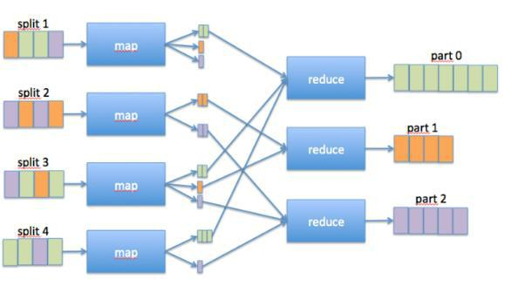

Fig 2: Map reduce architecture.

Mapper<Text, Text, Text, Text> Hashmap data;

setup(context)

- read „attribute.txt‟ from Distributed

Cache and store it globally.

- read„parameters.txt‟from
Distributed Cache and store it
globally
map(key,
value, context):

- line = read value

- data.put(line)

cleanup(context)

- find atomic action sets using Apriori

- combine atomic action sets to form required action rules using decision

values from

„parameters.txt‟

- form action rules using action sets

- compute support and confidence for action rules formed in above step

Reducer<Text, Text, Text, Text> reduce(key, value, context)

- read <key, list(value)

- Parse value to support and confidence

- Add all support values and average confidence values from the list
Output “action rule [support = s, confidence = c]”

Figure 3. MR-Apriori Count Distribution Algorithm for Parallel Action Rules Discovery

  - The dataset is divided horizontally into m blocks and are distributed to m nodes for processing. The default block size is 64MB. However, this size can be configured manually as well.

  - In the MapReduce phase, initially Map tasks executes for all input splits across different nodes in the cluster. For the Map task, setup(), map() and cleanup() methods are overridden. First setup() is called once during execution. It reads the text files from Distributed Cache and stores the attribute names and user parameters. Then map() function is called for each record. Map() reads each record as key-value pair and stores each record in a data structure which is defined globally in Mapper class. Data structure we use is a hashmap. For the first record in Table I, map() function produces output in the following format:
{ [ a_a1, b_b1, c_c1, d_d1 ] , count }

The output of map() is a key-value pair and count variable just counts the number of occurrences of same rows. Once map() function reads all the records in that split and stores these records in a hashmap, cleanup() function is called. Cleanup() contains the methods to build action rules from the data stored in hashmap using Apriori strategy and compute their supports and confidence as described in Association Action Rule section. Output from cleanup() is the output of the map task, which are the locally found Action Rules for the input splits. An example output of data from Table I is shown below.

{ [ (a, a2) ^ (b, b1 → b2) ^ (c, c1) → (d, d1 → d2) ]

,

[ 2, 44.44] }

- After the completion of map tasks for all splits across all nodes, output from these nodes is sorted and shuffled. This is the shuffle phase and is taken care of by the framework itself. Output from the shuffle phase if given as the input to the reduce phase.

- Reduce phase gets the input as [Action has reduce() these records are read initially and the final support and confidence are aggregated for every unique action rules. Supports for same Action Rules are added to get the final support in reduce() function. Output from reduce() is the reduce task output and an example format is shown below:

{ [ (a, a2 → a1) ^ (b, b1 → b2) → (d, d1 → d2) ] [ Support = 6, Confidence = 84.4% ] }

IV. EXPERIMENT

To test our program, we used car evaluation dataset from UCI machine learning repository. The data set has 1728 instances. We multiplied the records by 10 to test a total of 17280 instances. The data set contains
Attributes | values
buying | v-high, high, med, low
maint | v-high, high, med, low
doors | 2, 3, 4, 5-more
persons | 2, 4, more
lug_boot | small, med, big
safety | low, med, high
class | Unacc, acc, good, v-
 | good

We considered class as decision attribute and action rules are discovered based on change of class from ‘unacc’ to ‘acc’. These rules can be used further by management to take critical decisions.

We generate the rules using single machine, i.e. local cluster and using Hadoop cluster having many nodes. Then, we compared the time taken to compute the algorithm in both the ways. The results are displayed in the table below.

Method |  | Time
Single | node | 13 | mins | 26
cluster |  | seconds
Hadoop cluster |  | 5 | mins | 20
 |  | seconds

This shows the MR- count distribution algorithm for parallel action rules discovery, speeds up the process and improves the performance of the algorithm significantly. The association action rules generated are:
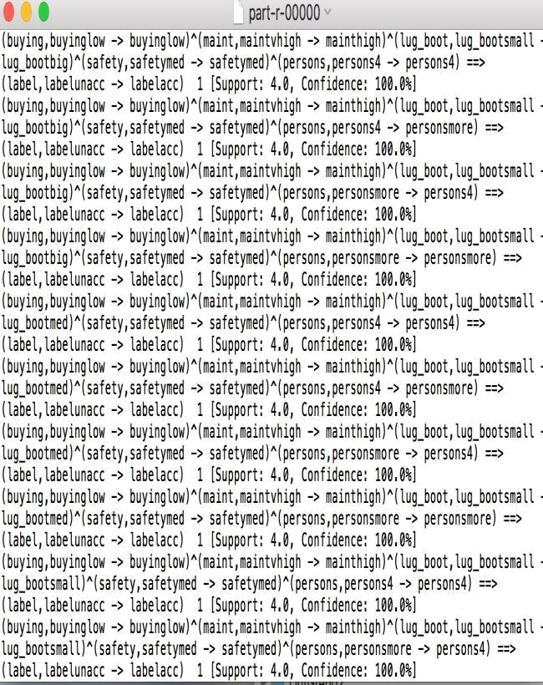

V. CONCLUSION

In this project, we implemented Map Reduce Count distribution algorithm for parallel action rules discovery. We use Apriori strategy for Action Rules extraction and Count Distribution Algorithm for implementing the parallel processing. We ran the program on cloud era single node cluster and on Hadoop distributed file system. The performance is very fast on cluster when compared to single node cluster. Map reduce on Hadoop really helps to take critical decisions on business data.

The above process can be applied to any type of data such as industrial, medical, retail etc. for example on what products the retailer should give a discount and also to know what products specific customers prefer.

V. REFERENCES

1.webpages.uncc.edu/ras/KBS-Class/2-AssocRules.ppt
2. https://webpages.uncc.edu/ras/Papers/50-Im.pdf

3.Dr. Agnieszka Dardzinska (2013) “Action Rules Mining” published by Springer.

4.https://en.wikipedia.org/wiki/Apriori_algorithm

5.https://webpages.uncc.edu/ras/Papers/Tzacheva-Ras.pdf

- Z.W. Ras and A. Wieczorkowska, “Action-Rules:
How to increase profit of a company”, in Principles of

Data Mining and Knowledge Discovery, Proceedings of PKDD 2000, Lyon, France, LNAI, No. 1910, Springer, 2000, pp. 587-592.

7.https://static.googleusercontent.com/media/researc h.google.com/en//archive/mapreduce-osdi04.pdf

- Ras ́Z, Gupta S. Global action rules in distributed knowledge systems. Fundamenta Informaticae J 2002;51:175–184.

- J. W. Grzymała-Busse, S. R. Marepally, Y. Yao (2013), An Empirical

Comparison of Rule Sets Induced by LERS and Probabilistic Rough Classification , in Rough Sets and
Intelligent Systems, Vol. 1, Springer, pp.
261-276.

- M. Lichman (2013), UCI Machine Learning Repository[http://archive.ics.uci.edu/ml]. Irvine, CA: University of California, School of Information and Computer Science.

