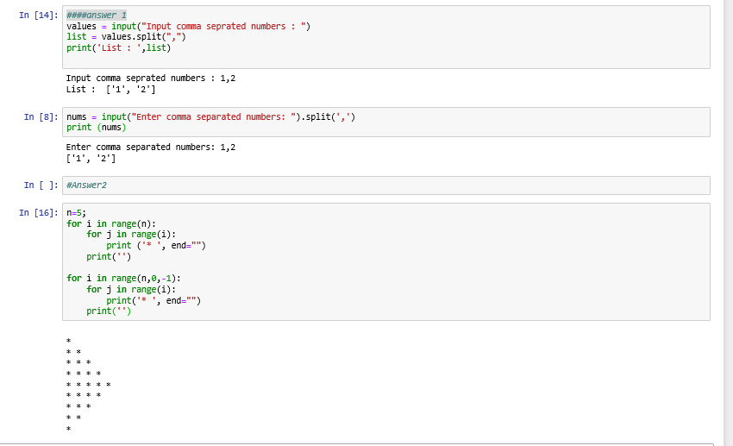

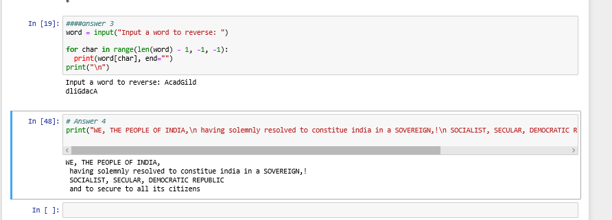

**Code for Answer 4**

**print("WE, THE PEOPLE OF INDIA,\n having solemnly resolved to constitue india in a SOVEREIGN,!\n SOCIALIST, SECULAR, DEMOCRATIC REPUBLIC\n and to secure to all its citizens")**