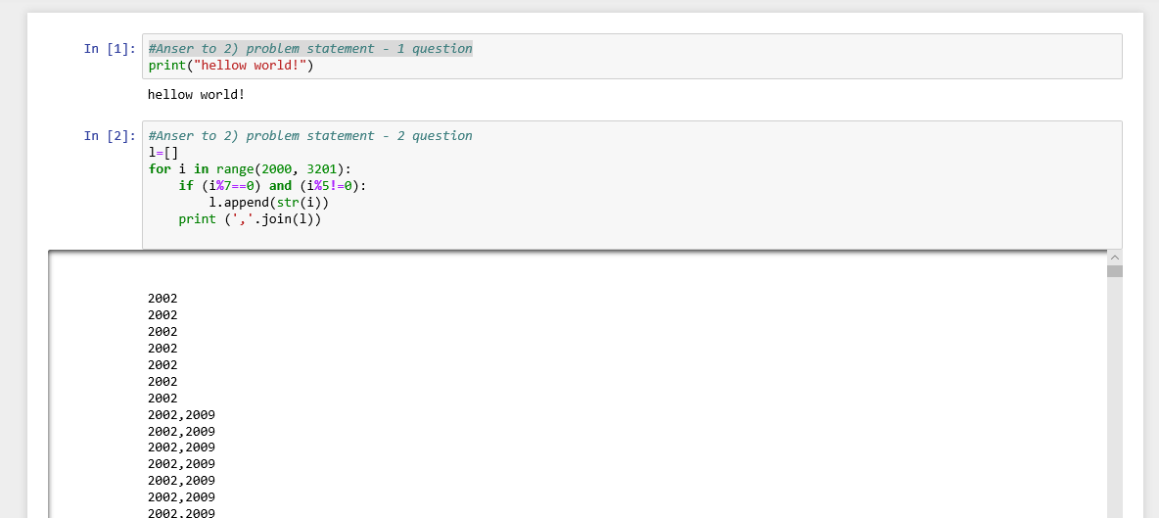

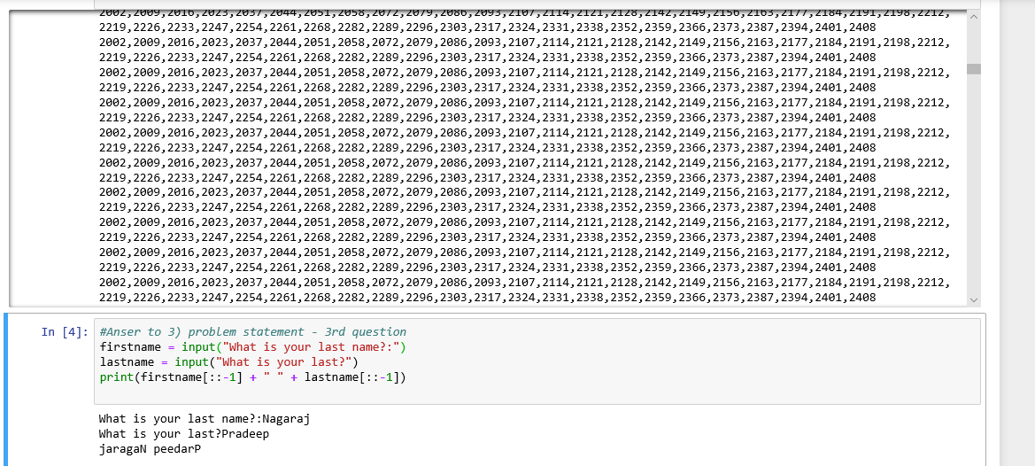

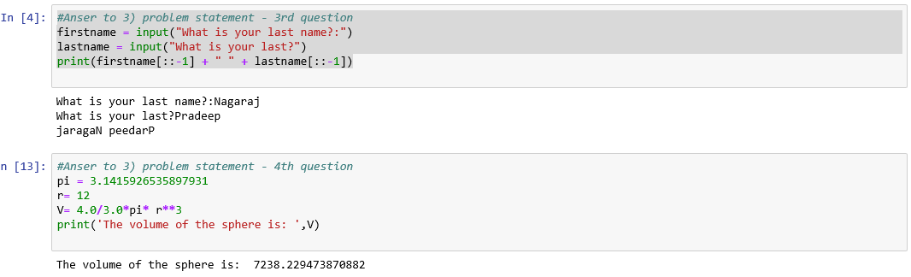

**Please find the souce code below:**

**#Anser to 2) problem statement - 1 question**

print("hellow world!")

**#Anser to 2) problem statement - 2 question**

l=[]

for i in range(2000, 3201):

if (i%7==0) and (i%5!=0):

l.append(str(i))

print (','.join(l))

**#Anser to 3) problem statement - 3rd question**

firstname = input("What is your last name?:")

lastname = input("What is your last?")

print(firstname[::-1] + " " + lastname[::-1])

**#Anser to 3) problem statement - 4th question**

pi = 3.1415926535897931

r= 12

V= 4.0/3.0*pi* r**3

print('The volume of the sphere is: ',V)