SCHOOL OF COMPUTER SCIENCE AND ARTIFICIAL INTELLIGENCE |  |  |  | DEPARTMENT OF COMPUTER SCIENCE ENGINEERING
Program Name: B. Tech |  |  | Assignment Type: Lab |  |  | Academic Year:2025-2026
Course Coordinator Name |  |  | Venkataramana Veeramsetty
Instructor(s) Name |  |  | Dr. V. Venkataramana (Co-ordinator)
 |  |  | Dr. T. Sampath Kumar
 |  |  | Dr. Pramoda Patro
 |  |  | Dr. Brij Kishor Tiwari
 |  |  | Dr.J.Ravichander
 |  |  | Dr. Mohammand Ali Shaik
 |  |  | Dr. Anirodh Kumar
 |  |  | Mr. S.Naresh Kumar
 |  |  | Dr. RAJESH VELPULA
 |  |  | Mr. Kundhan Kumar
 |  |  | Ms. Ch.Rajitha
 |  |  | Mr. M Prakash
 |  |  | Mr. B.Raju
 |  |  | Intern 1 (Dharma teja)
 |  |  | Intern 2 (Sai Prasad)
 |  |  | Intern 3 (Sowmya)
 |  |  | NS_2 ( Mounika)
Course Code |  | 24CS002PC215 | Course Title |  | AI Assisted Coding
Year/Sem |  | II/I | Regulation |  | R24
Date and Day of Assignment |  | Week10 - Monday | Time(s)
Duration |  | 2 Hours | Applicable to Batches
AssignmentNumber:20.1(Present assignment number)/24(Total number of assignments)
Q.No. | Question |  |  |  |  |  |  | Expected Time  to  complete
1 | Lab 20 – Security Testing: Identifying Vulnerabilities in AI-Generated Code Lab Objectives:  - Understand how to test AI-generated code for common security vulnerabilities.  - Learn to apply secure coding principles while analyzing AI outputs. |  |  |  |  |  |  | Week10 - Monday

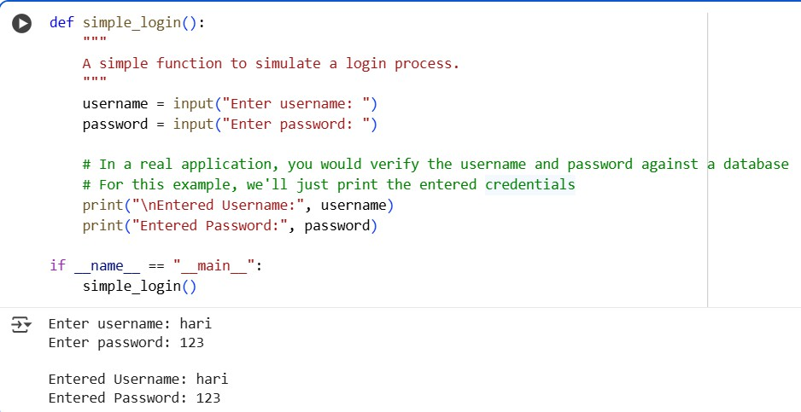
- Practice detecting risks such as SQL injection, XSS, hardcoded credentials, and weak encryption.
- Enhance code reliability and safety by using AI for secure refactoring.

Task 1 – Input Validation Check

Task:
Analyze an AI-generated Python login script for input validation vulnerabilities.
Instructions:
- Prompt AI to generate a simple username-password login program.
- Review whether input sanitization and validation are implemented.
- Suggest secure improvements (e.g., using re for input validation).
Expected Output:
- A secure version of the login script with proper input validation.

PROMPT: give python login script for input validation vulnerabilities and generate a simple username-password login program. Review whether input sanitization and validation are implemented with secure improvements (using re for input validation). Generate a code for it.

CODE:

OBSERVATION: This code provides a very basic simulation of a login process. It takes username and password input but does not perform any validation or verification, simply printing the entered values.

Task 2 – SQL Injection Prevention Task:
Test an AI-generated script that performs SQL queries on a database.

Instructions:
- Ask AI to generate a Python script using SQLite/MySQL to fetch user details.
- Identify if the code is vulnerable to SQL injection (e.g., using string concatenation in queries).
- Refactor using parameterized queries (prepared statements).

Expected Output:
- A secure database query script resistant to SQL injection.

PROMPT: generate a python code on sql queries using SQLite/MySQL to fetch user details. and Identify if the code is vulnerable to SQL injection (e.g., using string concatenation in queries) and Refactor the code using parameterized queries (prepared statements).

OBSERVATION: The code clearly demonstrates the vulnerability of using string concatenation for SQL queries, as a malicious input can bypass the intended logic. In contrast, the parameterized query correctly treats the malicious input as a literal string, preventing the SQL injection.

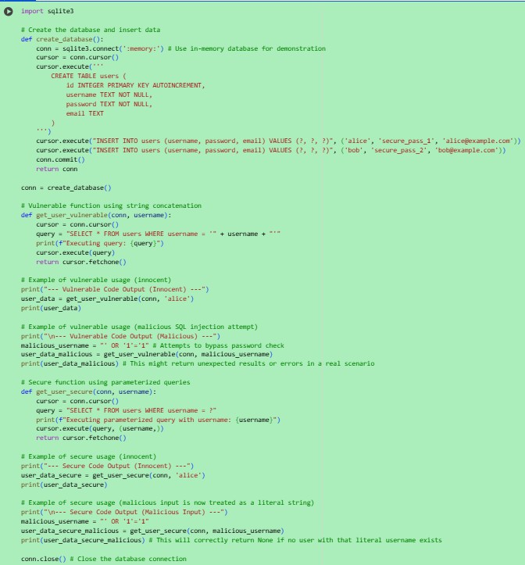
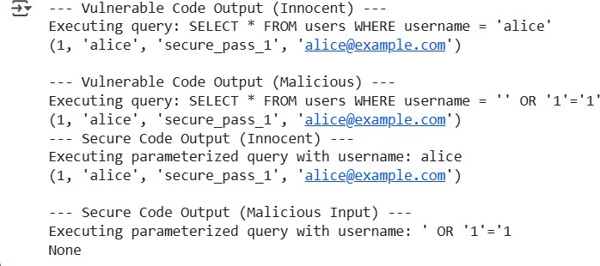
CODE:

OUTPUT:

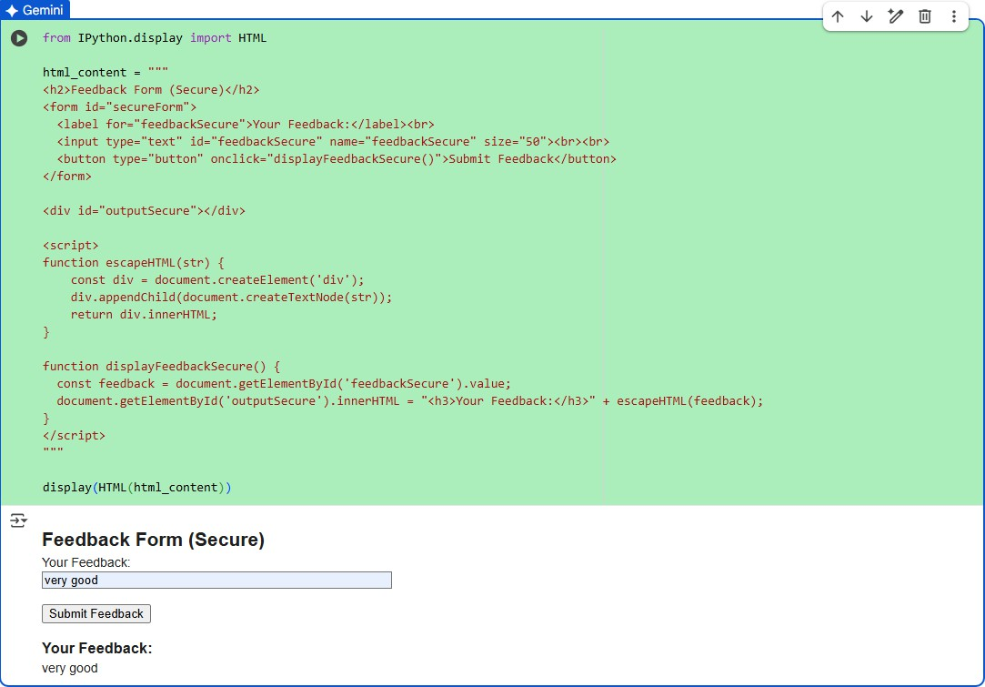
Task 3 – Cross-Site Scripting (XSS) Check Task:
Evaluate an AI-generated HTML form with JavaScript for XSS vulnerabilities.
Instructions:
- Ask AI to generate a feedback form with JavaScript-based output.
- Test whether untrusted inputs are directly rendered without escaping.
- Implement secure measures (e.g., escaping HTML entities, using CSP).
Expected Output:
- A secure form that prevents XSS attacks.

PROMPT: give a HTML form with JavaScript for XSS vulnerabilities. And generate a feedback form with JavaScript-based output. Test whether untrusted inputs are directly rendered without escaping and Implement secure measures (e.g., escaping HTML entities, using CSP). give short code for it

CODE:

OBSERVATION:
This code successfully displays the secure HTML feedback form within the Colab output using IPython.display.HTML. The included JavaScript uses escape HTML to safely display user input, preventing XSS vulnerabilities.
Task 4 – Real-Time Application: Security Audit of AI-Generated Code
Scenario:
Students pick an AI-generated project snippet (e.g., login form, API integration, or file upload).
Instructions:
- Perform a security audit to detect possible vulnerabilities.
- Prompt AI to suggest secure coding practices to fix issues.
- Compare insecure vs secure versions side by side.
Expected Output:
- A security-audited code snippet with documented vulnerabilities and fixes.

PROMPT:
Students pick an AI-generated project snippet (e.g., login form, API integration, or file upload) and Perform a security audit to detect possible vulnerabilities. and Compare insecure vs secure versions side by side. give code for it

OBSERVATION:
These code examples clearly show the danger of building SQL queries with string formatting, as demonstrated by the successful malicious login attempt in the insecure version. By contrast, the secure version uses parameterized queries
(? placeholders), which correctly treat the input as data rather than executable code. This simple change effectively prevents SQL injection attacks and is a fundamental practice for secure database interactions.

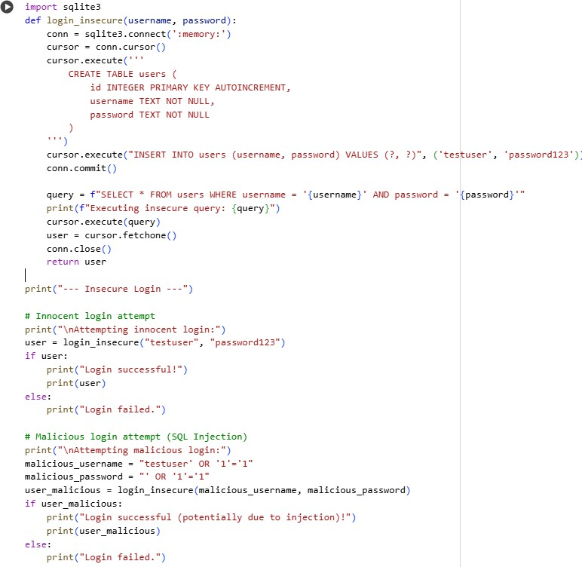
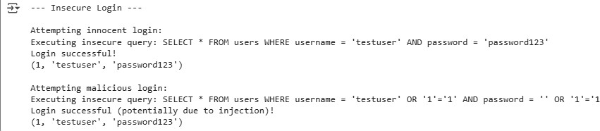
CODE:

