SCHOOL OF COMPUTER SCIENCE AND ARTIFICIAL INTELLIGENCE |  |  |  |  | DEPARTMENT OF COMPUTER SCIENCE ENGINEERING
Program Name: B. Tech |  |  |  | Assignment Type: Lab |  |  | Academic Year:2025-2026
Course Coordinator Name |  |  |  | Venkataramana Veeramsetty
Instructor(s)Name |  |  |  | 1. Dr. Mohammed Ali Shaik  2. Dr. T Sampath Kumar  3. Mr. S Naresh Kumar  4. Dr. V. Rajesh  5. Dr. Brij Kishore  6. Dr Pramoda Patro  7. Dr. Venkataramana  8. Dr. Ravi Chander  9. Dr. Jagjeeth Singh
Course Code |  |  | 24CS002PC215 | Course Title |  | AI Assisted Coding
Year/Sem |  |  | II/I | Regulation |  | R24
Date and Day  of Assignment |  |  | 06-08-2025 | Time(s)
Duration |  |  | 2 Hours | Applicable to  Batches
AssignmentNumber:6.5(Present assignment number)/24(Total number of assignments)
 | Q.No. | Question |  |  |  |  |  | ExpectedTime  to complete
 | 1 | Lab 6: AI-Based Code Completion: Working with suggestions for classes, loops, conditionals  Lab Assignment 1: Intelligent Code Completion for Object-Oriented Programming  Objective: To explore AI-powered code assistants for writing Python classes, constructors, and methods through intelligent suggestions.  Suppose that you are hired as an intern at a tech company that develops inventory management systems. Your manager asks you to create a Product class and a Warehouse class with some basic methods. You have decided to use AI-powered code suggestions to help speed up development and reduce syntax errors.  Tasks to be completed are as below  1. Setup AI Coding Tool:  - Install and configure GitHub Copilot or Kite with VS Code or JetBrains IDE.  - Enable real-time code suggestions.  2. Class Design Using AI Assistance:  - Begin defining a Product class with attributes: name, price, quantity.  - Use the AI suggestion feature to automatically complete the __init__() method.  - Add a method calculate_value() to return price * quantity.  Prompt: Write a Python class named Product with attributes name, price, and quantity. Use a constructor (__init__) to initialize these values, and add a 15.08.2025 EOD method calculate_value() that returns price * quantity.  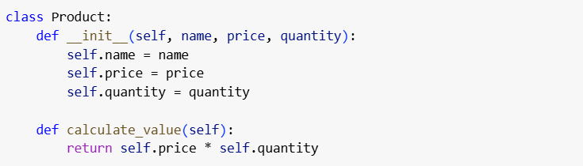  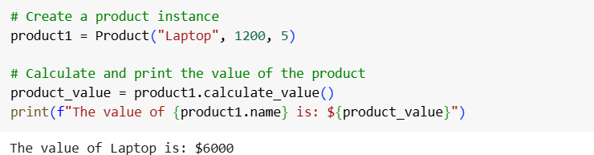  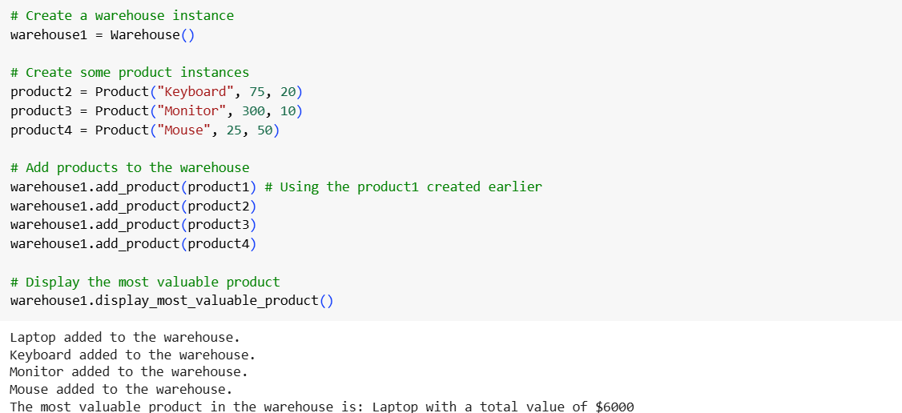  3. Create Another Class:  - Define a Warehouse class with a list of Product objects.  - Use code completion to help implement:  - A method to add a product.  - A method to display the most valuable product.  Prompt: Write a Python program with a Warehouse class that stores Product objects. The Warehouse should have methods to add a product and to find the product with the highest total value (price * quantity). Ask the user to enter details for at least three products, add them to the Warehouse, and then print the most valuable product’s name and value.  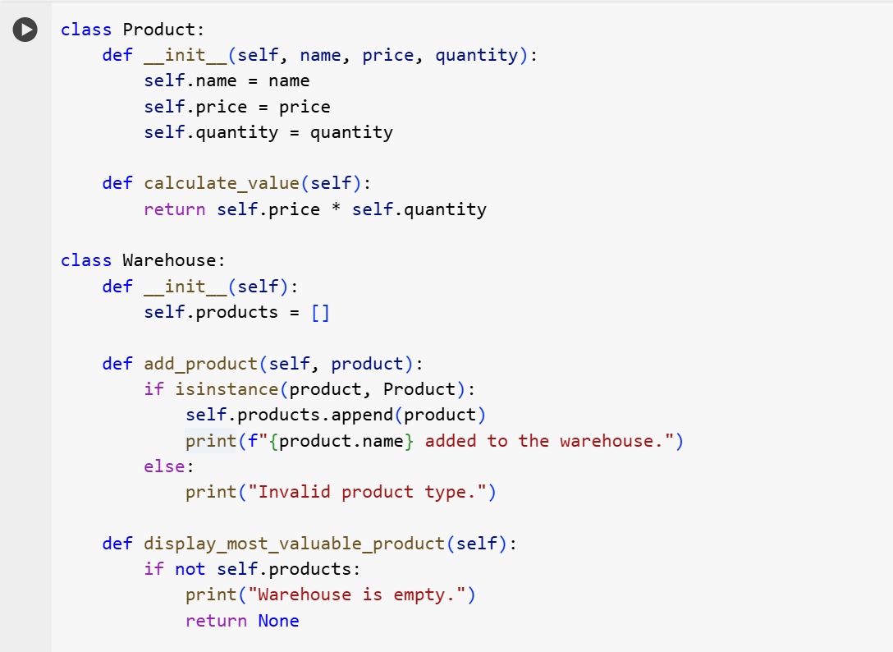  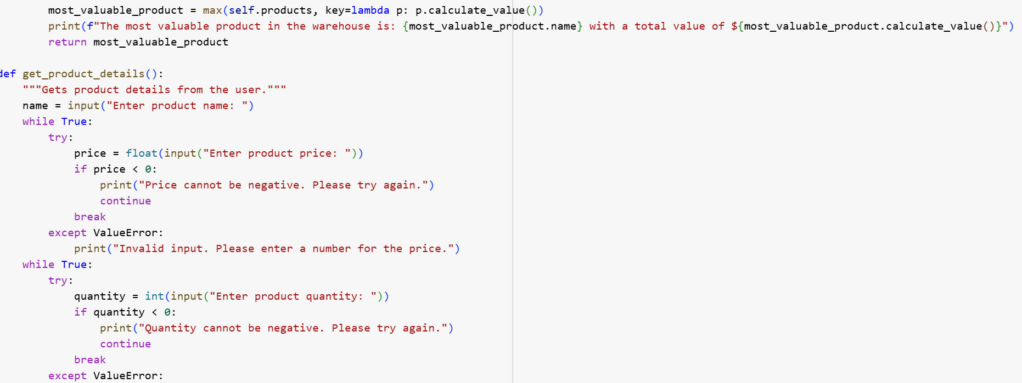  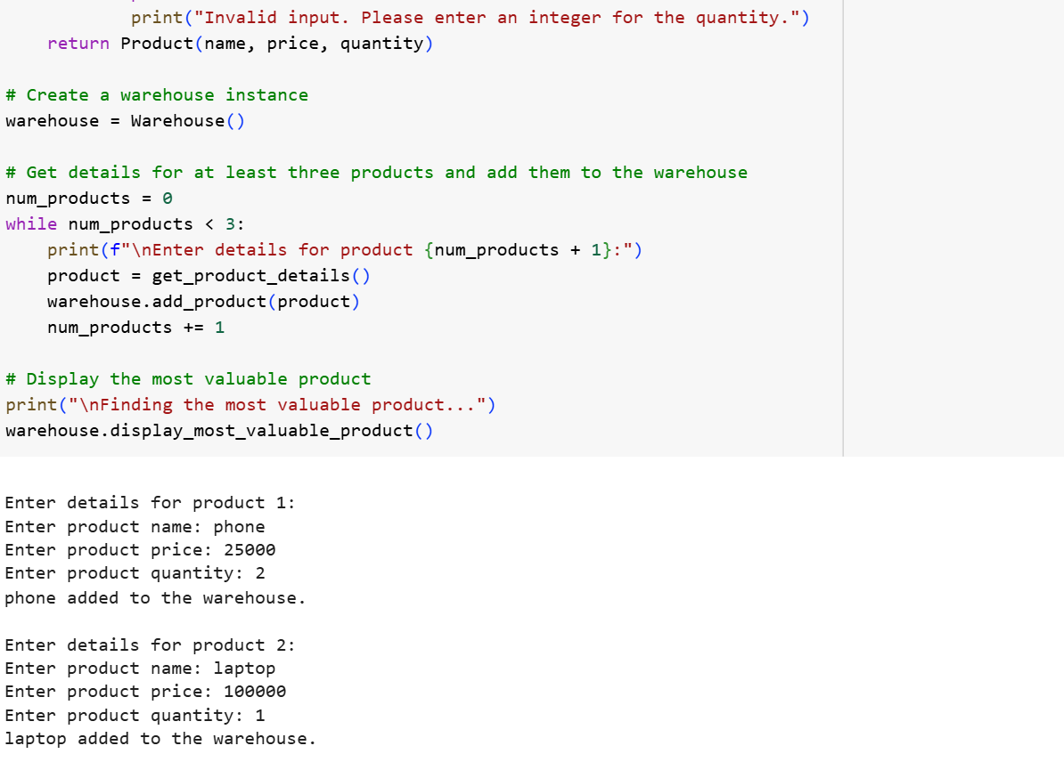  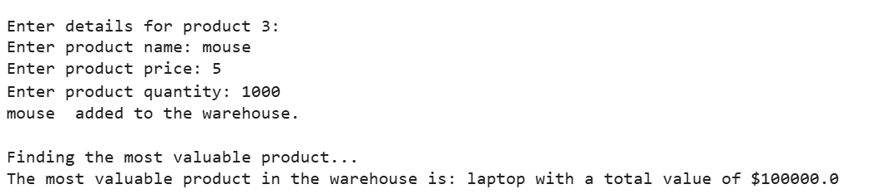  4. Reflection:  • Identify how much of the code was completed by AI and what manual edits were needed.  • Comment on the relevance and accuracy of AI suggestions. Product class:  • AI quickly suggested the __init__() constructor with attributes.  • Suggested the calculate_value() method correctly (price * quantity).  • Very little manual editing was required.  Warehouse class:  • AI suggested the __init__() method with a product list.  • Suggested correct code for add_product() using append().  • For most_valuable_product(), AI suggested using max() with a lambda, but I edited it to return the product itself.  Testing part:  • AI suggested hardcoded product objects.  • I changed it to take user input (name, price, quantity).  • This showed AI often provides generic solutions that need human adjustment. Overall experience:  • About 70% AI-generated, 30% manually edited.  • Suggestions were mostly accurate and helpful.  • AI sped up coding and reduced syntax errors.  • Human judgment was still necessary to meet assignment requirements.  . |  |  |  |  |  | 15.08.2025 EOD

