Admin Screen

1. Show the toaster message after click “Save Preference”

Message : “User preference saved successfully “

Screen image :

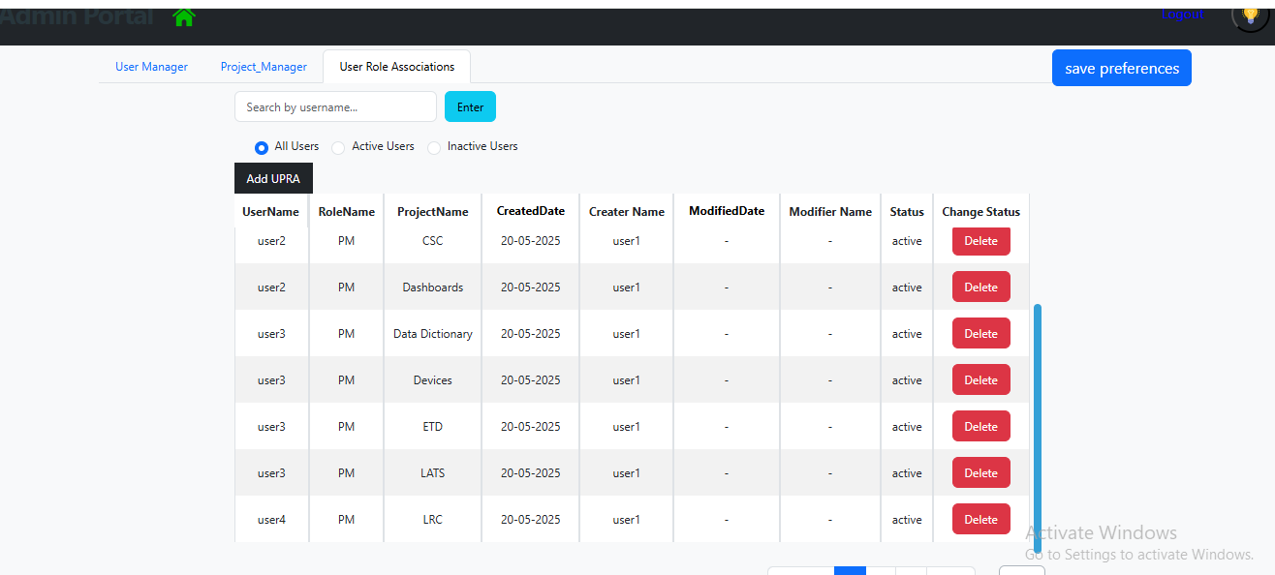

User this code for reference (<https://demos.blazorbootstrap.com/toasts>)

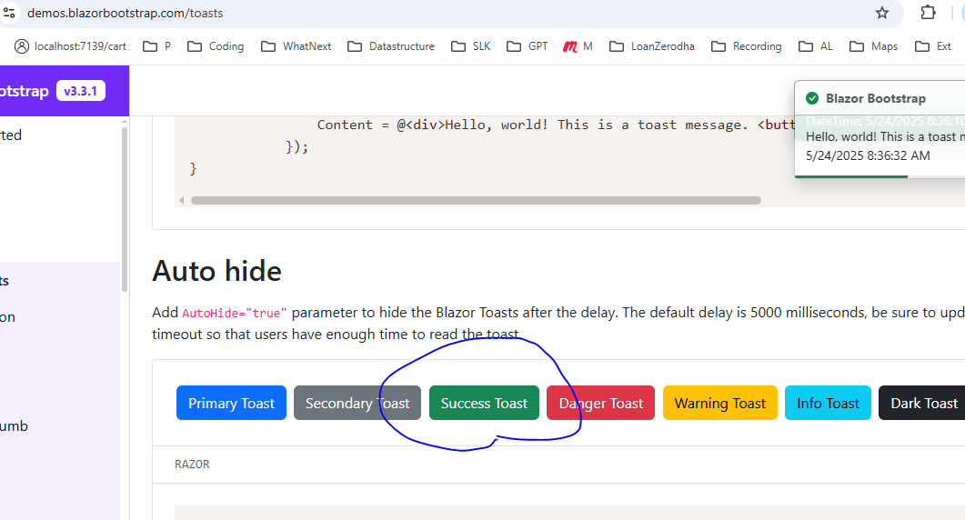

1. Give margin at bottom of the screen



1. Point
2. Remove this icon

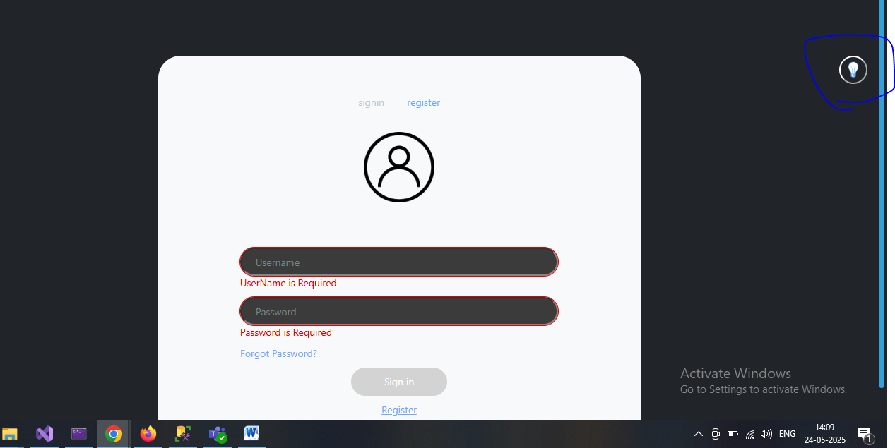

1. On click on Register button its giving error
2. Remove