Lengthy address

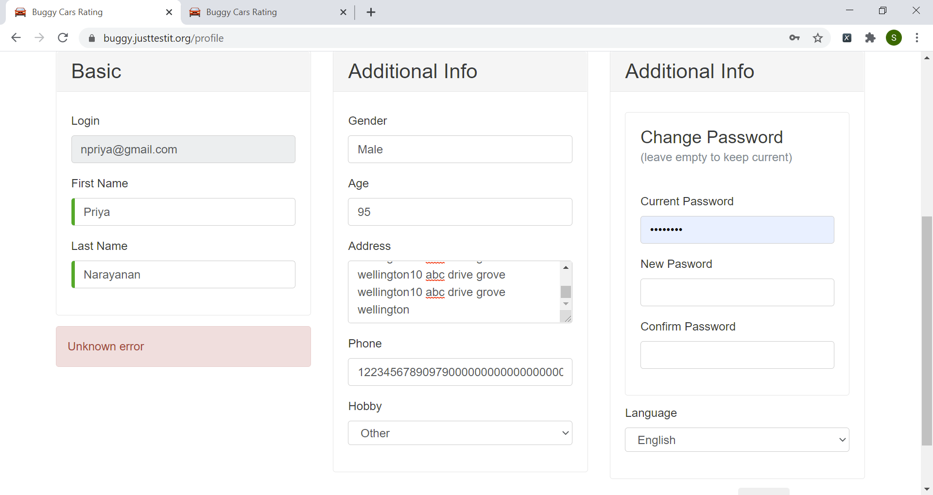

Address entered was:

10 abc drive grove wellington10 abc drive grove wellington10 abc drive grove wellington10 abc drive grove wellington10 abc drive grove wellington10 abc drive grove wellington10 abc drive grove wellington10 abc drive grove wellington10 abc drive grove wellington10 abc drive grove wellington10 abc drive grove wellington10 abc drive grove wellington10 abc drive grove wellington10 abc drive grove wellington10 abc drive grove wellington10 abc drive grove wellington10 abc drive grove wellington10 abc drive grove wellington10 abc drive grove wellington10 abc drive grove wellington10 abc drive grove wellington10 abc drive grove wellington10 abc drive grove wellington10 abc drive grove wellington10 abc drive grove wellington10 abc drive grove wellington10 abc drive grove wellington10 abc drive grove wellington10 abc drive grove wellington10 abc drive grove wellington10 abc drive grove wellington10 abc drive grove wellington10 abc drive grove wellington10 abc drive grove wellington10 abc drive grove wellington10 abc drive grove wellington10 abc drive grove wellington10 abc drive grove wellington10 abc drive grove wellington10 abc drive grove wellington10 abc drive grove wellington10 abc drive grove wellington10 abc drive grove wellington10 abc drive grove wellington10 abc drive grove wellington10 abc drive grove wellington10 abc drive grove wellington10 abc drive grove wellington10 abc drive grove wellington10 abc drive grove wellington10 abc drive grove wellington10 abc drive grove wellington10 abc drive grove wellington10 abc drive grove wellington10 abc drive grove wellington10 abc drive grove wellington10 abc drive grove wellington10 abc drive grove wellington10 abc drive grove wellington10 abc drive grove wellington10 abc drive grove wellington10 abc drive grove wellington10 abc drive grove wellington10 abc drive grove wellington10 abc drive grove wellington10 abc drive grove wellington10 abc drive grove wellington10 abc drive grove wellington10 abc drive grove wellington10 abc drive grove wellington10 abc drive grove wellington10 abc drive grove wellington10 abc drive grove wellington10 abc drive grove wellington10 abc drive grove wellington10 abc drive grove wellington10 abc drive grove wellington10 abc drive grove wellington10 abc drive grove wellington10 abc drive grove wellington10 abc drive grove wellington10 abc drive grove wellington10 abc drive grove wellington10 abc drive grove wellington10 abc drive grove wellington10 abc drive grove wellington10 abc drive grove wellington10 abc drive grove wellington10 abc drive grove wellington

Delete address and try with valid values – still throws error

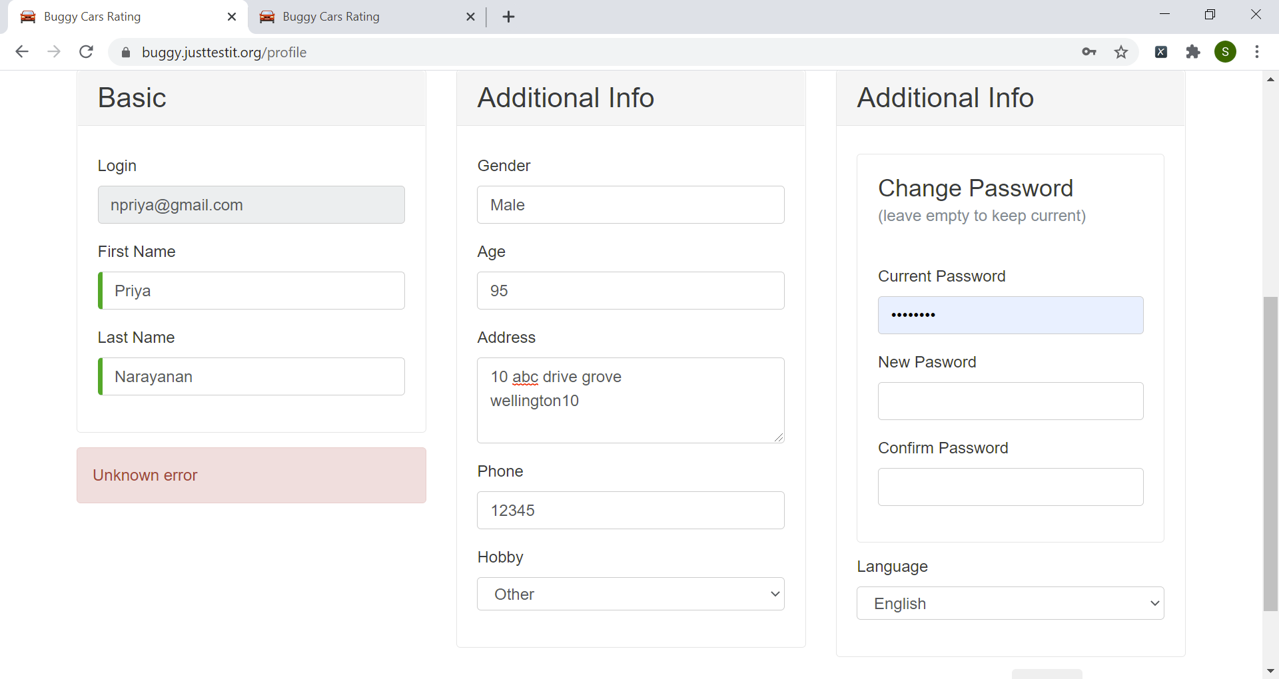

Press cancel and return to home page – not working

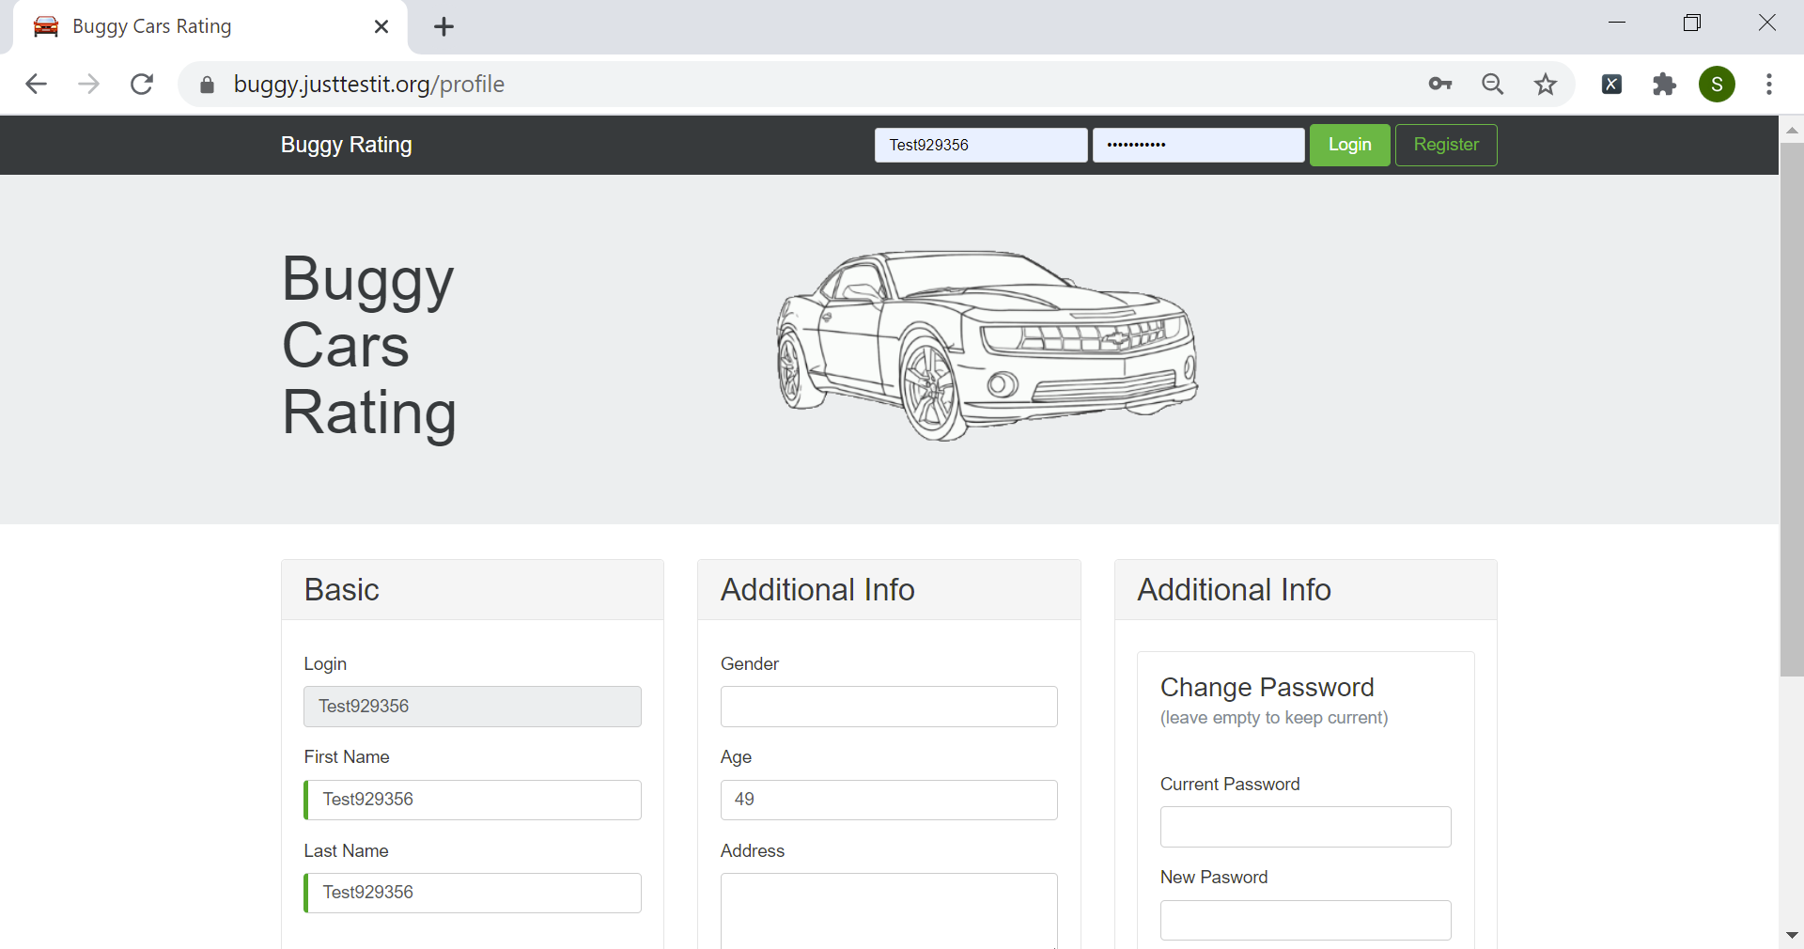

Return to home page also displays profile underneath

