Project K.I.L.O.S. — Website Revisions
Grouped by page/section, based on the client's revisions doc.

Home
No content revisions requested. (The earlier reported "crash" — Vercel 404: DEPLOYMENT_NOT_FOUND — was a false alarm; the site simply hadn't been deployed yet.)

About
- Add "Myths about Hypertension" section [Pending]New content block addressing common misconceptions.
- Tagalog translations throughout [Pending]Shown in parentheses ( ) or italicized, alongside existing English copy.
- Expanded Tagalog FAQ list [Pending]11 new Q&As covering symptoms, medication adherence, sleep, stress, diet, exercise, and check-up frequency.
- References / studies icon [Pending]Placed at the end of the About page content (no footer exists in the current shell — confirmed via mobile screenshot that the bottom nav leaves no room for one). Links to the NHLBI DASH Eating Plan and Living with the DASH Eating Plan pages.

Tracker
- Include low BP (hypotension) on tracker [Pending]Two new tiers added to getBpStatus(): "Low" (systolic <90 or diastolic <60) and "Severe Low" (systolic <70 or diastolic <40). Low reuses the DASH-modal layout with new hypotension content; Severe Low mirrors the Crisis modal + urgent card, styled with the tertiary color role. Draft code written for tracker.js and tracker.html. Note: client's doc has a bare "HYPOTENSION" heading with no guidance copy yet, so current do's/don'ts/meal content is placeholder pending official wording.
- DASH diet serving sizes [Pending]Add a daily/weekly servings table by food group, based on the reference 2,000-cal/day plan, plus calorie-tier variants (1,200 / 1,400–1,600 / 1,800–2,000 / 2,600 cal/day). Reference table from client's doc shown below.
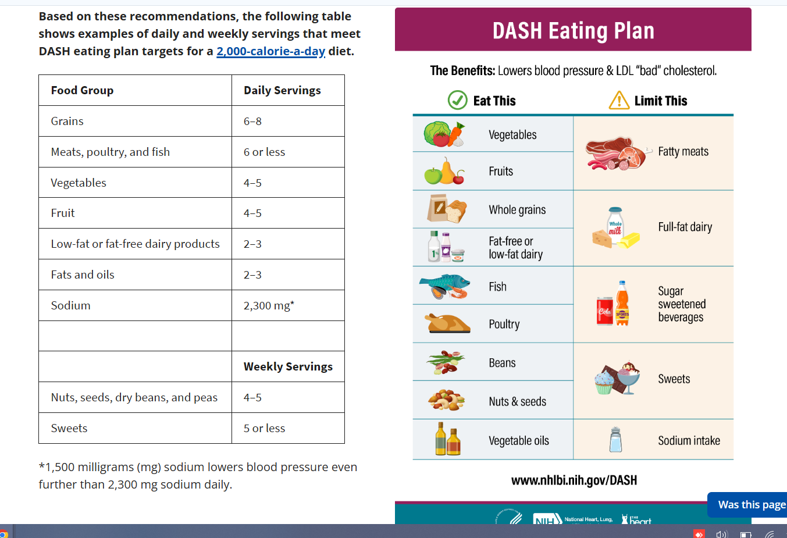
Reference: DASH eating plan servings table (client-provided, NHLBI)
- Sodium limits on diet [Pending]State both the standard limit (2,300 mg/day) and the lower target for greater BP reduction (1,500 mg/day).
- Pictures on the downloadable DASH PDF [Pending]Add plate-serving visuals and a shopping/cooking/eating-out sodium-reduction tip table to dash-elevated.pdf and dash-high.pdf. Reference images from client's doc shown below.
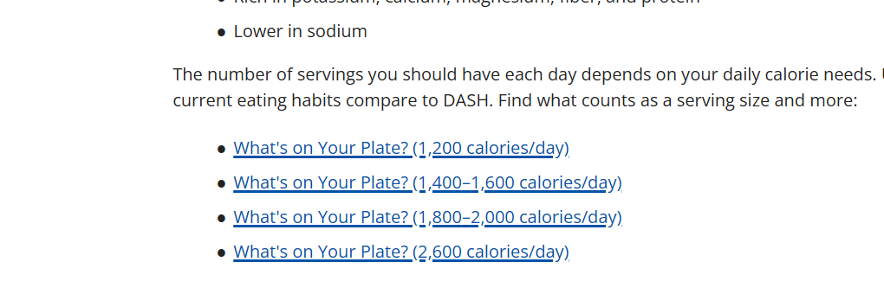
Reference: "What's on Your Plate?" serving guides by calorie level
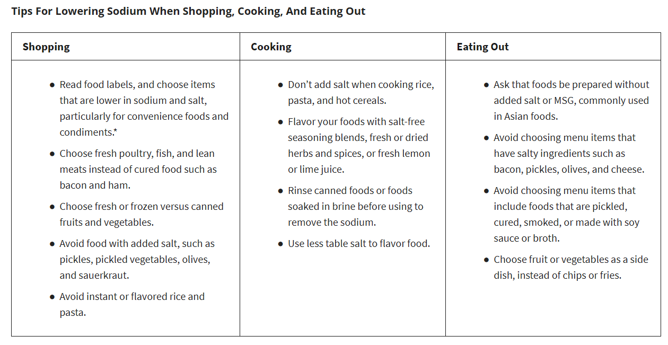
Reference: Tips for lowering sodium — shopping, cooking, eating out

Emergency
No content revisions requested.

Site-Wide / Needs Clarification
- Tagalog translation — full site or About only? [Pending]Client's doc concentrates Tagalog additions in About/FAQ content. Confirm whether Home, Tracker, and Emergency copy also need parenthetical/italicized Tagalog.

Reference Sources (for item 4)
- NHLBI — DASH Eating Plan (nhlbi.nih.gov/education/dash-eating-plan)
- NHLBI — Living with the DASH Eating Plan

