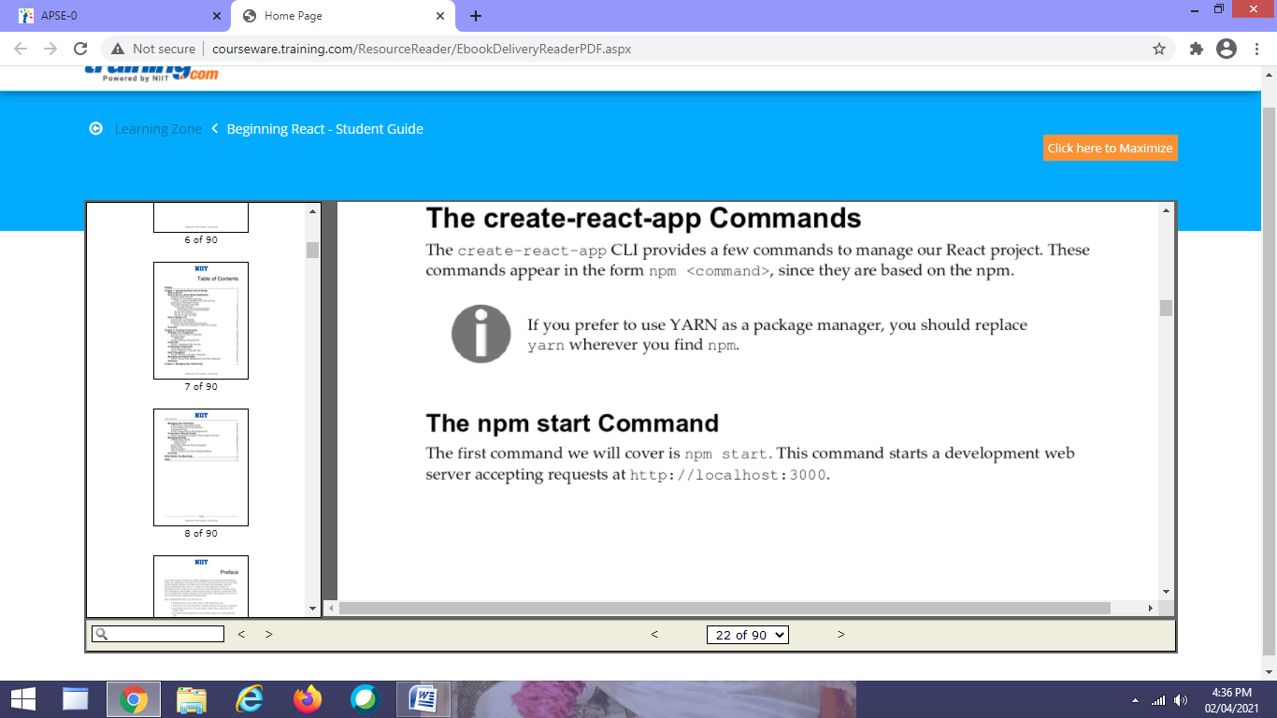

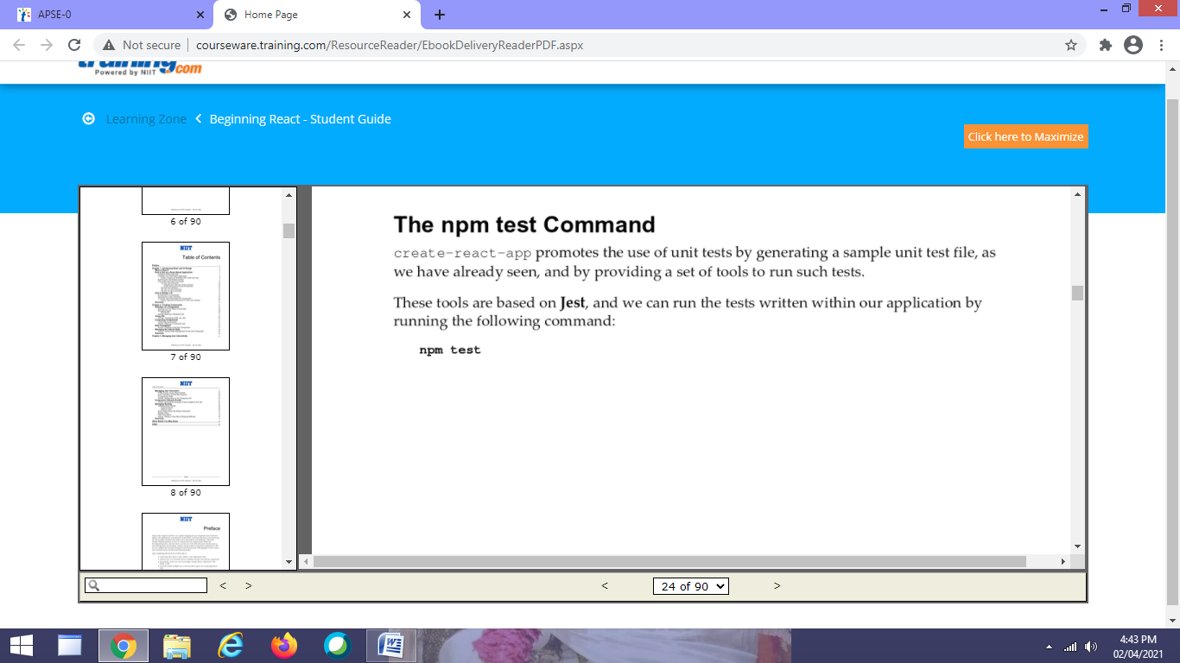

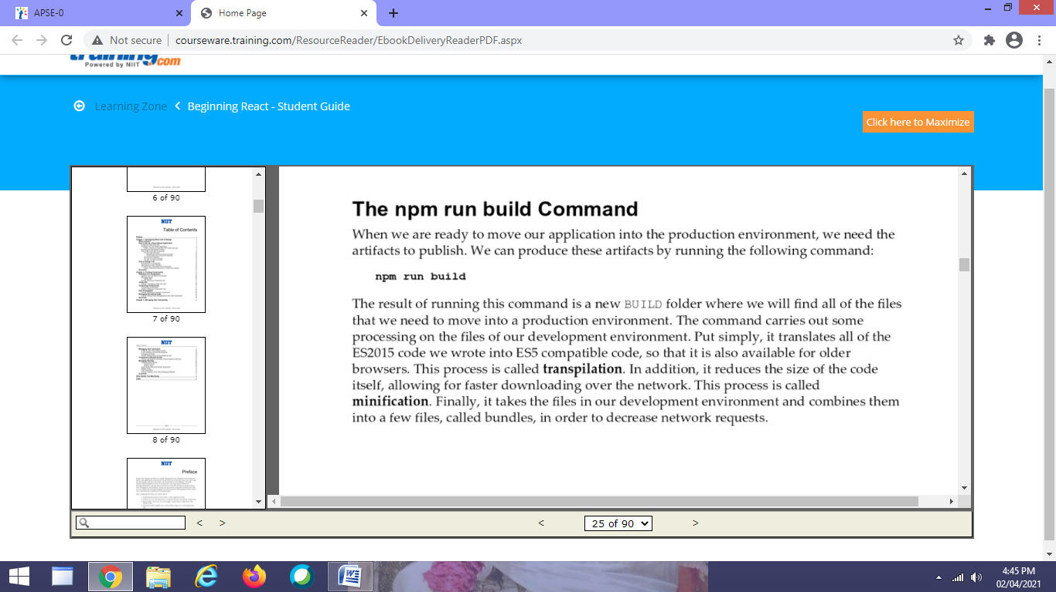

How to Design a UI

Now, we are going to see how we can design our application so that it fits well when implemented with React.

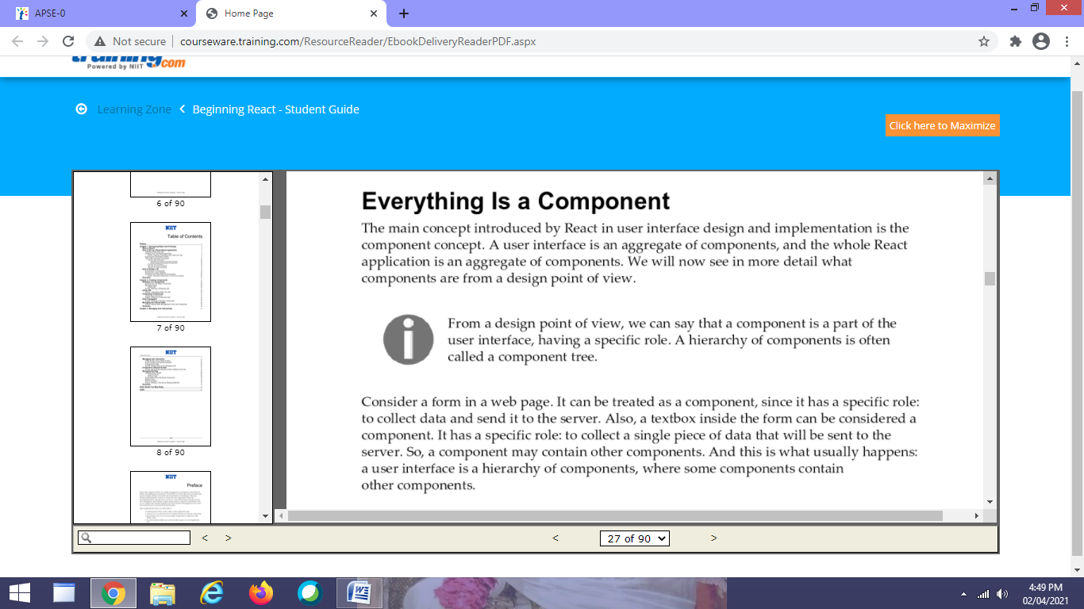

Decomposing a UI

Decomposition process allows us to focus on the specific role of each item in an interface, so that we can try to isolate each functionality and create reusable components, that is, components with just the dependencies that really matter.

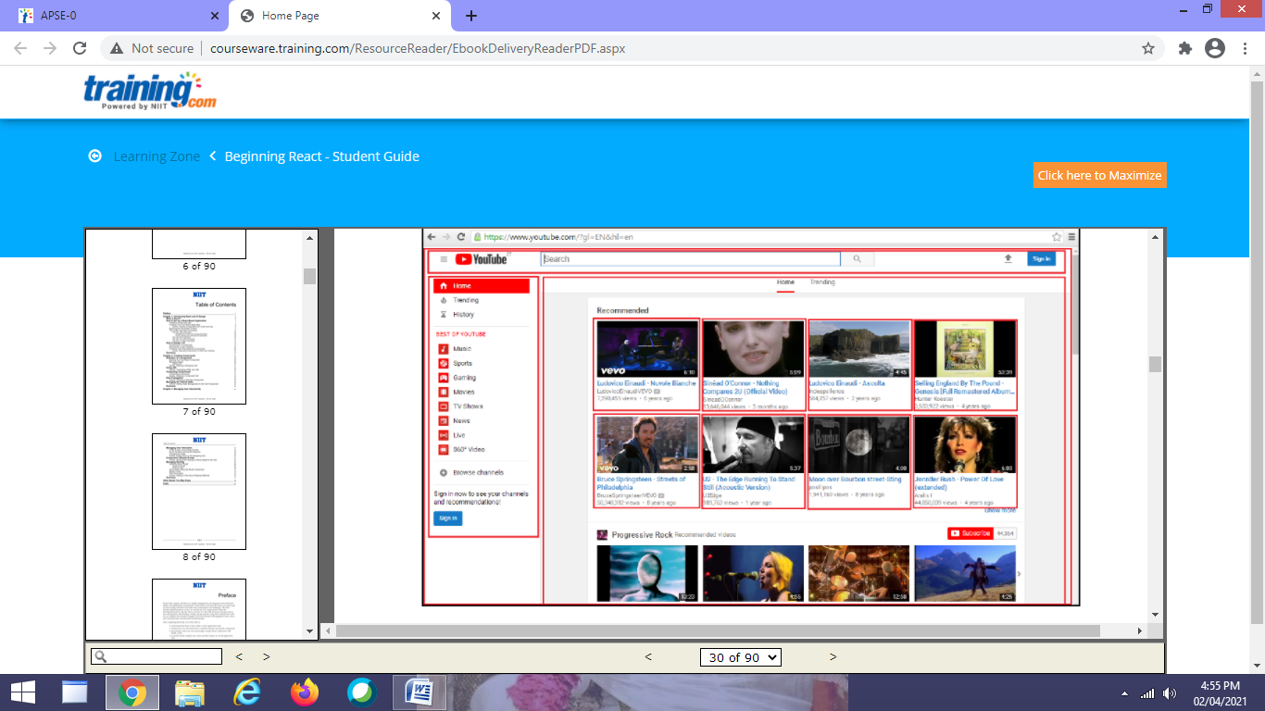

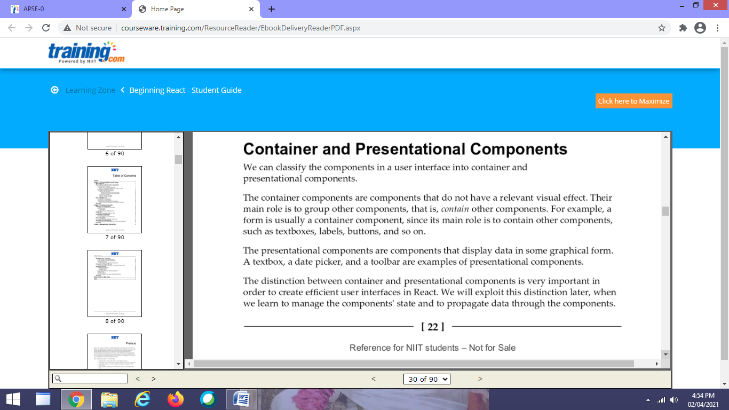

Creating Components

We are going to learn how to implement React components, how to assemble multiple components into one, and how to manage their internal states. We will explore React component implementation by building a simple application.

Definition of a Component

Components are the fundamental building blocks of React. Virtually any visual item in a user interface can be a component. From a formal point of view, we would say that a React component is a piece of JavaScript code defining a portion of a user interface.