Error: Error class is the subclass of Throwable class and a superclass of all the runtime error classes. It terminates the program if there is a problem related to a system or resources (JVM).

Throwable class is the parent class of all exception types. It is an immediate subclass of the Object class. Below Throwable class, there are two subclasses (two child objects) Error and Exception.
Exception: An exception is an abnormal condition that is caused by runtime error in the program. It is the superclass of all exceptions in Java. It is further divided into checked and unchecked (runtime) exceptions.
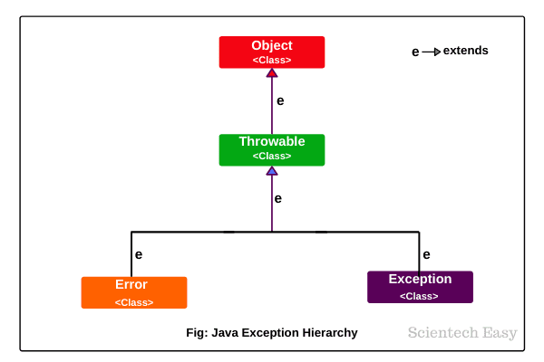

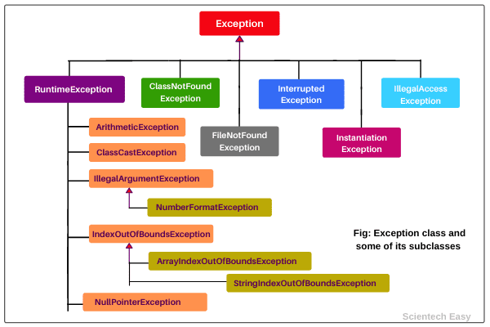

Exception Handling :- Handling the uncertain things at run time.
What is an Error :- That doesn't executes our code.
That interrupts the execution of our code, halts the program while executing by displaying appropriate error message.
Types of Error :-
a. Syntax Error / Compilation Error / Design time Error
Ex :- java convention rules (case sensitivity, " ", {} , misspelled elseif .....
program doen't compiles , fails the compilation process.
b. Logical Error :- Our code is syntatical correct, but doesn't returns expected output.
if.else... , Logical operator ( && / ||) >= / >
c. Exception :- It is something unexpected occuring at run time, which abruptly / abnormally terminates your code.
Exception Handling :- Handling the uncertain things at run time.
Categories of Exceptions
Checked exceptions are those exceptions that are checked by Java compiler at compilation. A list of some important checked exceptions are given below:
- ClassNotFoundException
- InterruptedException
- InstantiationException
- IOException
- SQLException
- IllegalAccessException
- FileNotFoundException, etc
Runtime exceptions are those exceptions that are checked by JVM at runtime. Some important examples of runtime exceptions are given below:
- ArithmeticException
- ClassCastException
- NullPointerException
- ArrayIndexOutOfBoundsException
- NegativeArraySizeException
- ArrayStoreException
- IllegalThreadStateException
- SecurityException, etc.

UnChecked Exception :- subclass of Runtime Exception
Checked Exception:- Any UserDefined class which extends Exception Class
throw :- is used to explicitly throw an exception or custom exception from a method or any block of code.
class myDivisionException extends Exception{
}
class division{
// method (){
throw new myDivisionException();
}

P s v main(…) throws ArithmeticException, FileNotFoundException,…
Two ways of handling exception
- Try catch
- throws keyword
Exception Handling Technique by implementing
try {
}catch(Exception ex) {}
try :- where normal flow of code to execute is enclosed inside this block.
The Root class :-
Exception
System Exception
ArithmeticException
ArrayIndexOutOfBoundsException
FileNotFoundException
IOExpection
InputMisMatchException
Application Exception (USer defined exception)

=========== Rule 1
There must be catch() block immediately following try block
=========== Rule 2
Every try block must have atleast one catch block.
=========== Rule 3
Any try block can have multiple catch blocks.
========== Rule 4
Finally block is not a mandatory block, but if defined it will execute regardless of exception

/*
* To change this license header, choose License Headers in Project Properties.
* To change this template file, choose Tools | Templates
* and open the template in the editor.
*/
package exceptionhandlingdemo;

import java.util.InputMismatchException;
import java.util.Scanner;

public class ExceptionHandlingDemo {

public static void main(String[] args) {
int num1, num2,sum,res;
Scanner sc=new Scanner(System.in);
System.out.println("Enter two numbers");
num1=num2=0;
sum=res=0;

try
{
num1=sc.nextInt();
num2=sc.nextInt();
sum=num1+num2;
res=num1/num2;

}
catch(ArithmeticException ae)
{
System.out.println("Cannot divide by zero");
System.out.println(ae.getMessage());
}
catch(InputMismatchException ie)
{
System.out.println("Please enter correct details");
}
finally
{
System.out.println("Sum of two numbers = "+sum);
System.out.println("Division = "+res);
}
}
}
========================= Task
ArrayIndexOutofBoundsException()
Assertion is a statement which ensure the correctness of your assumptions
3+2=5
// java -ea applicationname
int age=19;
assert age>=18 : "Can Vote";
System.out.println("the age is "+age);

