Name:

ID:

M1 Assignment 03

**Submit completed assignment here:** <https://docs.google.com/forms/d/e/1FAIpQLSds9eCRFNJvsJfotdndpaL3A5gng9XFma-OseHMnrFGujfWTg/viewform>

**Part 1: Google**

1. Use [Google Sites](https://sites.google.com/new) to create a simple website for a restaurant. Paste the link to your website or a screenshot of your website below:
2. Use [Google Forms](https://docs.google.com/forms/u/0/) to create a 5 question multiple choice quiz about video games. Paste the link to your quiz or a screenshot below:

**Part 2: Programming**

Node.js: <https://repl.it/repls/LovingPersonalNetwork#index.js>

1. Consider the following:

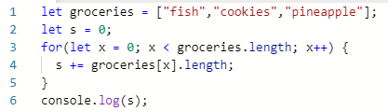

* What is the output?

|  |  |
| --- | --- |
| “fishcookiespineaplle” | 20 |
| 0 | 9 |
| “groceries.length” | 12 |

* What could you add to the groceries list to make the output 34?

1. Consider the following:



* What is a + b?
* What is c + c?

1. Consider the following:

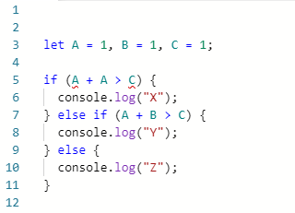

* What values of A, B, and C give an output of Z?

**Part 3: Design**

<https://www.w3schools.com/colors/colors_psychology.asp>

1. Which color will most likely attract attention:

|  |  |
| --- | --- |
| Red | Blue |
| Green | Purple |
| Yellow | Brown |

1. All of the following are true of color except what?

|  |  |
| --- | --- |
| Influence taste of food | Influence attractiveness |
| Influence human behavior | Influence human height |

1. Which color should a spa use as the background color of their website? They want their users to feel *safe*, *calm*, and *fresh*.

|  |  |
| --- | --- |
| Black | Gray |
| Yellow | Green |
| Blue | Pink |

1. Use the color mixer: <https://www.w3schools.com/colors/colors_mixer.asp> to find out what color results from mixing #003300 with #3333FF:

|  |  |
| --- | --- |
| #cf9e05 | #47d1f0 |
| #f7f057 | #7adec9 |
| #bfe64c | #8f8fba |

1. Convert the rgb color: rgb(255,100,0) into hex using the [color converter](https://www.w3schools.com/colors/colors_converter.asp):

|  |  |
| --- | --- |
| #ff6400 | #47d1f0 |
| #64ff64 | #643264 |
| #ffff00 | #8f8fba |

<https://www.w3schools.com/colors/colors_theory.asp>

1. Newton said colors are mixtures of which 3 kinds of light?

|  |  |
| --- | --- |
| Blue, orange, purple | Cyan, magenta, yellow |
| Black, white, gray | Green, blue, red |
| Red, blue, yellow | Blue, yellow, black |

1. Consider the following:

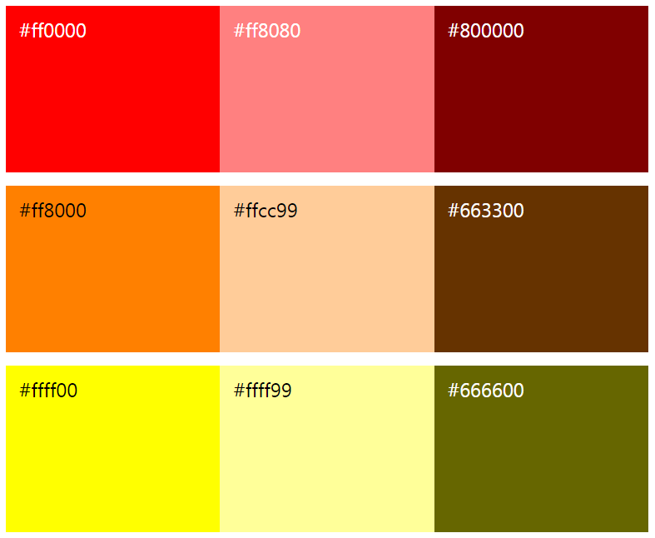

Which of the following has the same **hue** but different **darkness** than #ff0000?

|  |  |
| --- | --- |
| #ff8000 | #666600 |
| #800000 | #ff8080 |
| #ffcc99 | #663300 |

Part 4: Research

1. Create a Google Slides presentation about a programming language. There should be 5 slide. paste link below:
   1. History of the language (when it was created, who created it, why was it created)
   2. What kind of things can be built with this language?
   3. How do you write code and install the programming language?
   4. Give an example of a program?
   5. Additional interesting information