Name:

ID:

M1 Assignment 05

**Part 1:**

1. Which of these restaurants is closest to the State Tower (use Google Maps):

|  |  |
| --- | --- |
| Mazzaro | Jok prince |
| kfc | mcdonalds |
| Pizza hut | Prachak |
| Tien Sin | Jing Jing |

**Part 2:**

1. Consider the following:

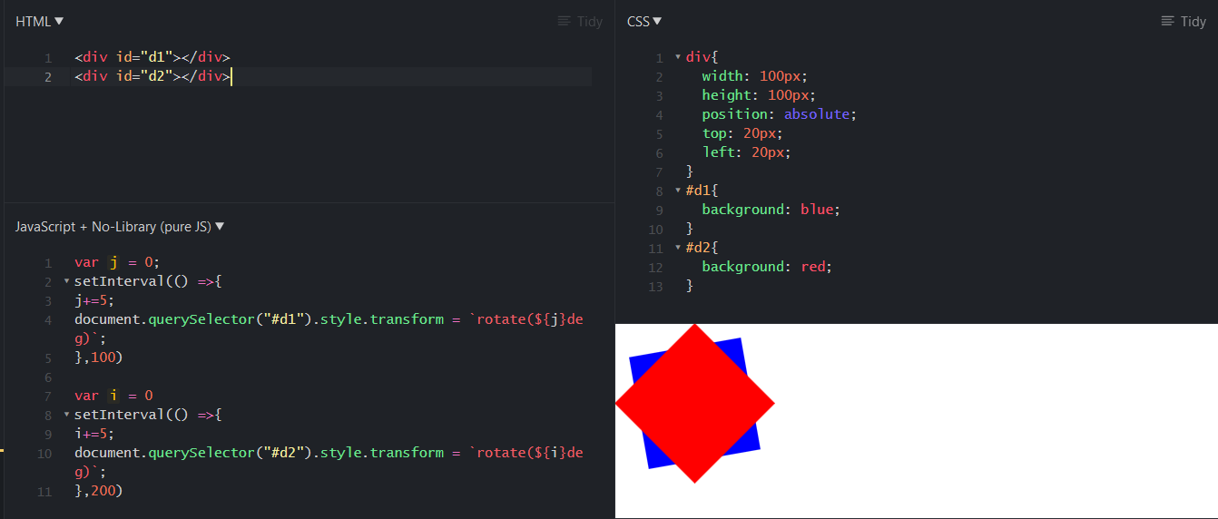

* Make d1 twice as big as d2 (paste screenshot below):
* Make d1 a green color (paste screenshot below):
* Make d2 spin 4 times faster than d1 (paste screenshot below):