Name:

ID:

**M1 Assignment 06A**

Submit completed assignment here: <https://docs.google.com/forms/d/e/1FAIpQLScb7hyvGXlrEfREGrFlNyhmM2bvFbDUQnhULbW8YvJnzUEiSg/viewform>

**Part 1:** Morse code

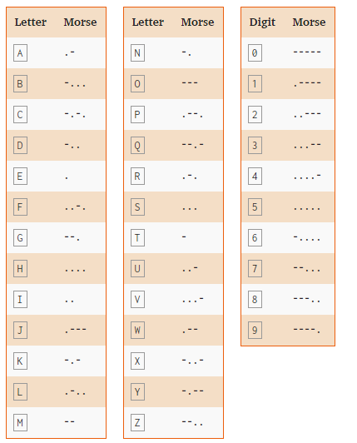

1. **You see a strange code that has been engraved on your desk. Translate the code into English:**

|  |  |
| --- | --- |
| **Code** | **English** |
| **- .... . .-. . .. ... .- -... --- -- -...** |  |

1. **Morse code can be used by flashing lights or creating sounds. This can be particularly useful in a survival situation in which you are unable to speak or move. Imagine a hiker that has been buried under a thick layer of snow and ice that is impermeable to light after an avalanche. There is no cellular service or wifi available and the hiker has broken his jaw disabling his ability to speak. Which of the following would be a viable method of communicating with a rescue team via Morse code?**

|  |  |
| --- | --- |
| **Flash a flashlight in short and long intervals** | **Tap a large hollow metal pipe in short and long intervals** |
| **Send a text message in Morse code** | **Scream for help in Morse code** |
| **Light a torch and use your hand to dim the light for short and long periods of time** | **Make a phone call and use Morse code** |

**Part 2: Biometrics**

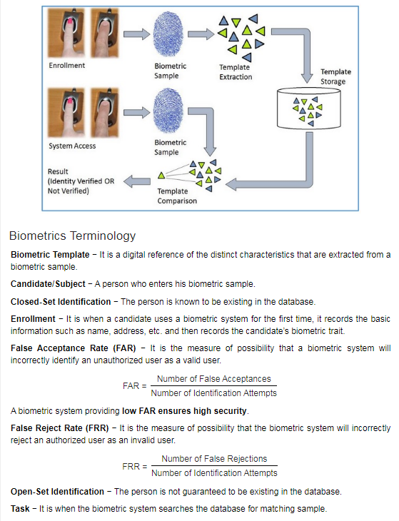

1. **Which of the following is biometric data:**

|  |  |
| --- | --- |
| **A scan of the iris** | **A prime number** |
| **A rock** | **A page of a biology book** |
| **An iphone** | **A SQL database** |

1. **What is the false acceptance rate if a thumb print scanner produces 30 false acceptances out of 40 identification attempts?**

|  |  |
| --- | --- |
| **10%** | **30%** |
| **40%** | **70%** |
| **75%** | **85%** |

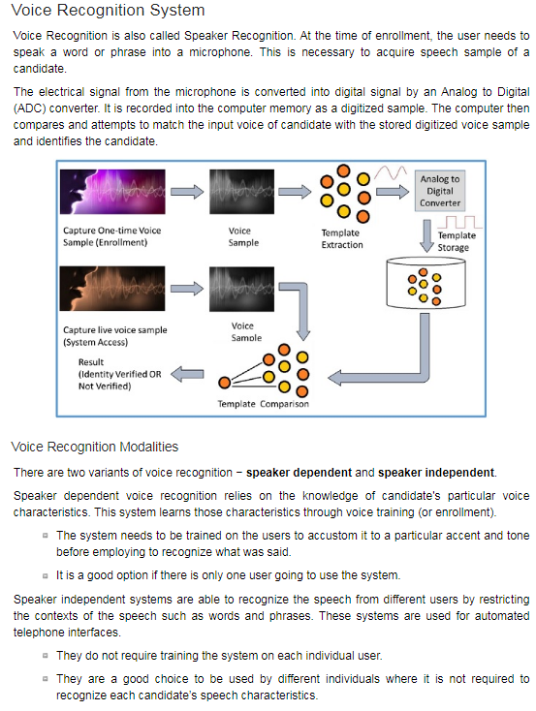

1. **Which of the following is an analog signal?**

|  |  |
| --- | --- |
| **A device that emits 4 possible values** | **A device that emits 1 possible values** |
| **A device that emits 100 possible values** | **A device that emits 100 possible values** |
| **A device that emits nothing** | **A device that emits an infinite number of possible values** |

1. **A company needs two voice recognition devices; device A will be a system that helps people that call the company (needs to understand words and questions). Device B will need to differentiate between different employees voices. Which of the following best describes devices A and B.**

|  |  |
| --- | --- |
| **A is speaker dependent, B is speaker independent** | **A is speaker dependent, A is speaker independent** |
| **B is speaker dependent, A is speaker independent** | **A is neither, B is speaker independent** |
| **B is speaker dependent, B is speaker independent** | **A is neither, B is neither** |