Name:

ID:

M1 Assignment 06B

**Part 2: Social Engineering**

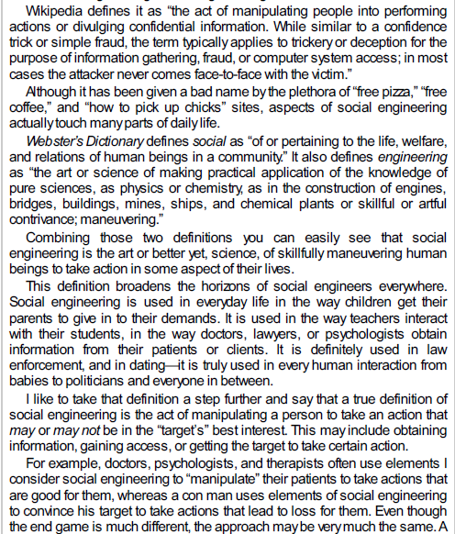

* Which of the following gives an example of social engineering?

|  |  |
| --- | --- |
| Using an algorithm to hack crack someone’s password | Installing a virus on someone’s computer |
| Launching a DDOSS attack | Call someone and pretend to be their bank in order to get their password |
| Carrying out an XSS attack | Removing the power supply to a company’s server |

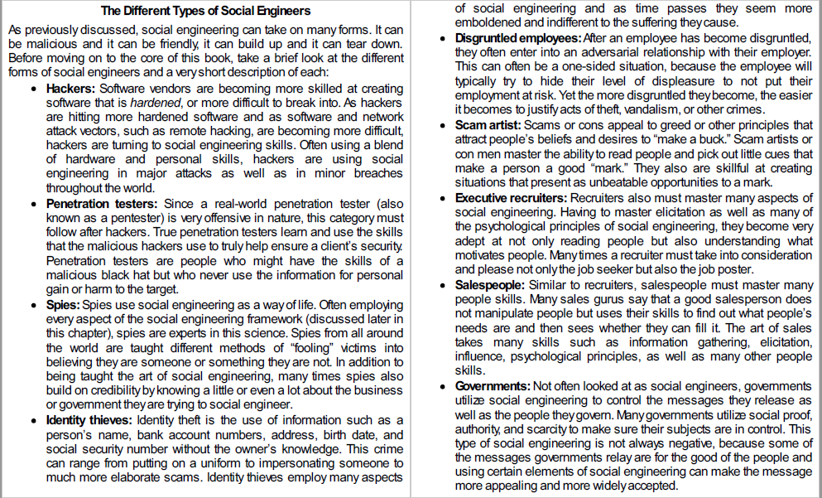

* Which of the following best describes one of the social engineer forms?

|  |  |
| --- | --- |
| A researcher working on finding a vaccine for covid-19, has poor social skills. | The president of the United States watching the news. |
| An employee is fired after being bullied for months, attempts to access the building by posing as a janitor | A passenger on an airplane using the free Wi-Fi, tries to check how much money is in his savings account |
| A thief is stealing a bike from someone’s house, he is later arrested. | A teacher uses gmail to send an email to all of the students. Many of the students do not read the email. |

**Part 4:**

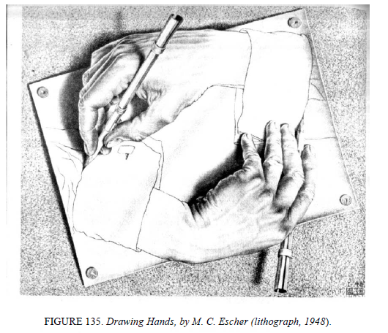

* What would it be like to have a computer that could program itself?