Name:

ID:

**M1 Assignment 07**

Submit completed assignment here: <https://docs.google.com/forms/d/e/1FAIpQLSeoTeIDG9ZI6uwzKdwANSoNFggtAU9Tp25i9DA_lyc7FJhogg/viewform>

**Part 1:** [**Internet Security**](https://www.tutorialspoint.com/internet_security/internet_security_phishing.htm)

1. **Consider the following:**

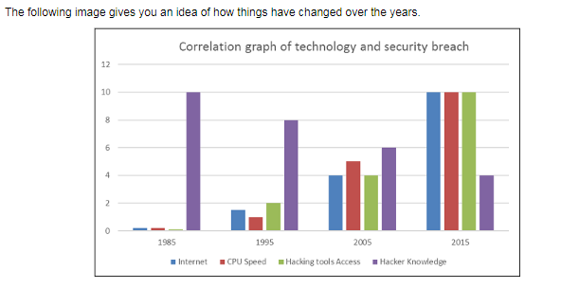

* **Which of the following deductions can be made from this graph?**

|  |  |
| --- | --- |
| **From 1985 to 2015, Hacker’s have had to acquire more knowledge to carry out a security breach** | **In 1995 hacker’s had access to better tools than in 2005 because after the 2001 terrorist attack on the World Trade Center security significantly improved.** |
| **less CPU speed is required for a modern security breach** | **Modern hackers don’t need to know as much as historical hackers** |
| **The internet has become insignificant in modern security breaches, but CPU speed and Hacking tool access is clearly very important** | **Access to hacking tools is not nearly as important as knowing a lot about hacking when carrying out a security breach.** |

1. **Consider the following:**

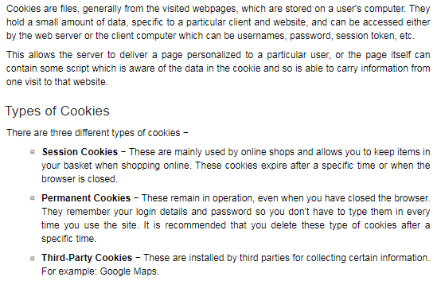

* **Foodpanda remembers all of the food I left in my shopping cart, which kind of cookie are they using to store this information:**

|  |  |
| --- | --- |
| **Double chocolate fudge** | **session** |
| **3rd party** | **permanent** |

* **Which of the following is a good reason to delete cookies from websites that you do not trust?**

|  |  |
| --- | --- |
| **You might eat too many and get fat** | **Cookies can be used to track your behavior online (how long and how many times I visit a certain webpage, gender, interests, location); This information can be used maliciously by advertisers** |
| **Cookies always save your password which can then be stolen by a hacker** | **Cookies are used to mine cryptocurrency like bitcoin. Bitcoin mining requires an enormous amout of computer resources which will be devastating to the computer’s performance** |
| **Cookies will install ransomware on your computer (will encrypt all of your files). A hacker will then demand payment.** | **Having too many cookies will consume all of your computer’s memory. This will destroy the hard drive and you will lose all of your data.** |

1. **Consider the following:**

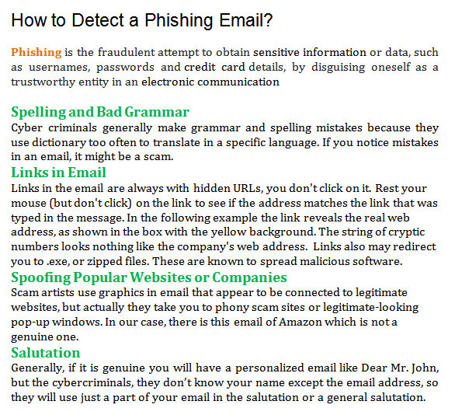

* **Which of the following best describes a phishing attack?**

|  |  |
| --- | --- |
| **Your bank emails you about a ฿10000 withdrawal from your checking account** | **A hacker uses a brute force password cracking algorithm to determine your password** |
| **You get a letter from your 99 year old grandma with a few grammatical errors** | **An email comes from your bank asking to verify your password, the verification link points to a strange Nigerian website** |
| **Your friend uses Photoshop to add a giant egg plant into a picture of you and an old woman** | **A pack of piranhas eat your arm after you fall out a kayak** |

1. **Which of the following is a phishing email?**

|  |
| --- |
| **A)** |
| **B)** |
| **C)** |
| **D)** |

1. **Consider the following:**

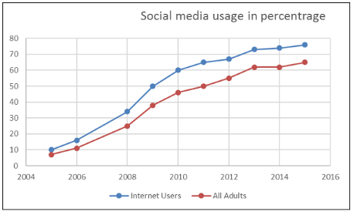

* **Which of the following deductions can be made?**

|  |  |
| --- | --- |
| **Most adults don’t use social media** | **Most kids use social media** |
| **Facebook is used much more than Twitter** | **The majority of social media users are internet users** |
| **Most social media users didn’t use the internet in 2014** | **In 2006 most adults used social media** |

1. **Which of the following is a good reason to use an adblocker?**

|  |  |
| --- | --- |
| **No good reason** | **Messes up the integrity of the web page** |
| **The web page won’t make money from advertising** | **Can speed up the website by blocking resource consuming adverts** |
| **Blocks elements of the web page that are necessary for the page to function** | **Uses up precious memory** |

1. **Consider the guidelines for child safety on the internet:**

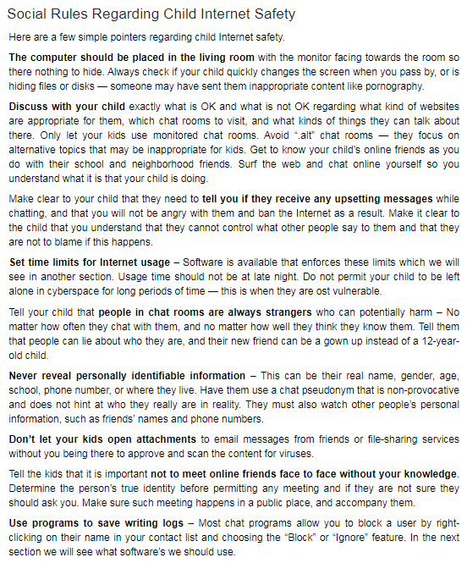

* **A cool older man that you met on an online game asks for your address and wants to buy you an ice-cream. Which of the following bests describes how you should handle this situation?**

|  |  |
| --- | --- |
| **Give him your address but don’t meet him, that could be dangerous.** | **Tell him you would rather talk more and reveal lots of personal information about yourself.** |
| **Give him your phone number or lineID instead** | **Give the address of one of your friends that you don’t really like** |
| **Block this individual and report him immediately** | **You can send him a picture of your house, but don’t give the actual address or meet him.** |
| **Keep chatting with him because he is cool, but tell him you are unavailable.** | **You can meet him; just don’t give up your address.** |

1. **Consider the following types of cybercrime:**

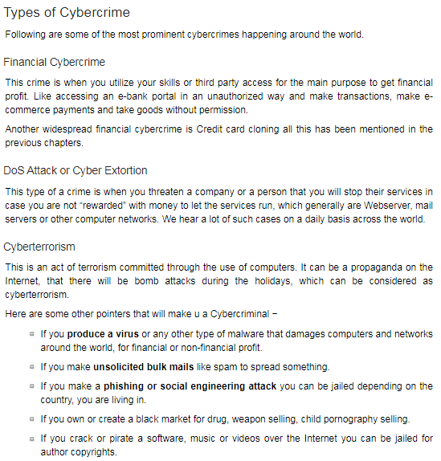

* **A cyberterrorist threatens to send billions of requests to company’s server rendering it disabled unless he is paid ฿30,000,000. What kind of cybercrime is this?**

|  |  |
| --- | --- |
| **Cyberterrorism** | **Financial cybercrime** |
| **DOS attack** | **Phishing** |

1. **Consider the following:**

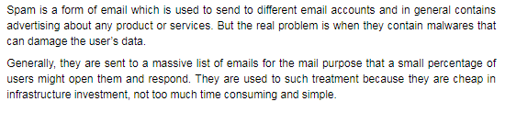

* **Which of the following best describes how spam is effective?**

|  |  |
| --- | --- |
| **I send an email with malware to thousands of people, the probability that at least one person will download the malware is high** | **I send an email with malware to a couple of people, the probability that at least one person will download the malware is high** |
| **I send an email with malware to one people, the probability that at least one person will download the malware is high** | **I send an email with malware to a large group of IT professionals, the probability that at least one person will download the malware is high** |

1. **Go to**  [**https://virustotal.com/**](https://virustotal.com/) **test if the M1_Assignment07.docx file has any viruses. What is the virus detection ratio for this file?**

|  |  |
| --- | --- |
| **0** | **1** |
| **10** | **20** |
| **71** | **72** |

1. **Digital certificates are a way of establishing an encrypted link between a server (computer that hosts a webpage, and send the web page to a user) and a client (computer that a person uses to visit a website). What is the name of the signature algorithm in the following certificate?**

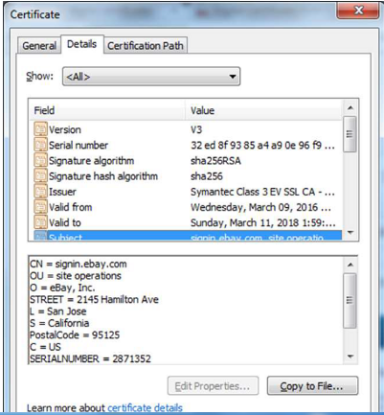

|  |  |
| --- | --- |
| **V3** | **Sha256RSA** |
| **CN** | **symantec** |
| **256** | **32 ed 8f** |

1. **True of false I should use the http: protocol as opposed to the https: protocol when making online payments?**

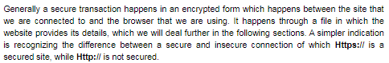

|  |  |
| --- | --- |
| **True** | **False** |

**Part 2:** [**Thailand’s Computer Crime Act**](https://www.samuiforsale.com/law-texts/computer-crime-act.html#:~:text=is%20an%20act%20that%20is,to%20fifteen%20years%20and%20a)

1. **While flying to Phuket you and your friend think it will be funny to post online that there is a bomb on the plane. One of the other passengers sees the post online and tells everyone. Somebody jumps out of the plane and dies. Which of the following sections of the Computer Crime Act best describes your punishment?**

|  |  |
| --- | --- |
| **Section 10** | **Section 12** |
| **Section 11** | **Section 14** |
| **Section 8** | **Section 9** |

1. **You decide to get revenge on a guy that you hate at school by editing a picture of him and his mom. You edit the photo so that it looks like he is grabbing his mom inappropriately and post it online. Which of the following sections of the Computer Crime Act best describes your punishment?**

|  |  |
| --- | --- |
| **Section 10** | **Section 17** |
| **Section 11** | **Section 16** |
| **Section 5** | **Section 6** |

1. **You see the teacher’s mobile phone left out on a desk. You try a random pass code and the phone unlocks. You decide to look through the photos. Which of the following sections of the Computer Crime Act best describes your punishment?**

|  |  |
| --- | --- |
| **Section 10** | **Section 17** |
| **Section 11** | **Section 16** |
| **Section 5** | **Section 6** |

**Part 3: Critical Thinking**

1. **Consider the following:**

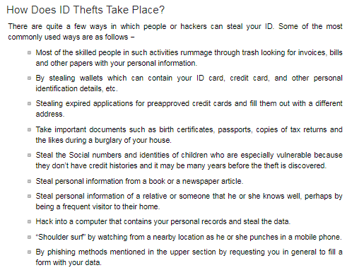

* **Imagine you are a hacker planning on stealing someone’s identity. Write one paragraph, discussing how you would do it.**

1. **Consider the following:**

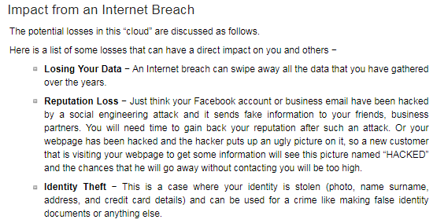

* **Imagine a hacker has access to your personal computer where you keep private information (a secret love letter, medical records stating that you have a disease that you don’t want other people to know about, all of the photographs of your grandfather that passed away). Write two paragraphs explaining how the hacker could damage your reputation or blackmail you.**

**Part 4: Design**

1. **Create a poster of the menu for a new Italian restaurant called: Lenovoes. Paste a screenshot of your menu below:**