Name:

ID:

**M1 Assignment S2_02**

Submit completed assignment here: https://docs.google.com/forms/d/e/1FAIpQLSdDMBHPkETEMZn0UaGjfmh-OpklthveTYtfxjKZNGwBGLbJBg/viewform

**Part 1:** Morse code

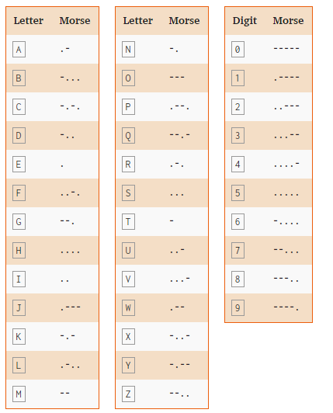

1. **You see a strange code that has been engraved on your desk. Translate the code into English:**

|  |  |
| --- | --- |
| **Code** | **English** |
| **- .... . .-. . .. ... .- -... --- -- -...** |  |

1. **Morse code can be used by flashing lights or creating sounds. This can be particularly useful in a survival situation in which you are unable to speak or move. Imagine a hiker that has been buried under a thick layer of snow and ice that is impermeable to light after an avalanche. There is no cellular service or wifi available and the hiker has broken his jaw disabling his ability to speak. Which of the following would be a viable method of communicating with a rescue team via Morse code?**

|  |  |
| --- | --- |
| **Flash a flashlight in short and long intervals** | **Tap a large hollow metal pipe in short and long intervals** |
| **Send a text message in Morse code** | **Scream for help in Morse code** |
| **Light a torch and use your hand to dim the light for short and long periods of time** | **Make a phone call and use Morse code** |

**Part 2: Biometrics**

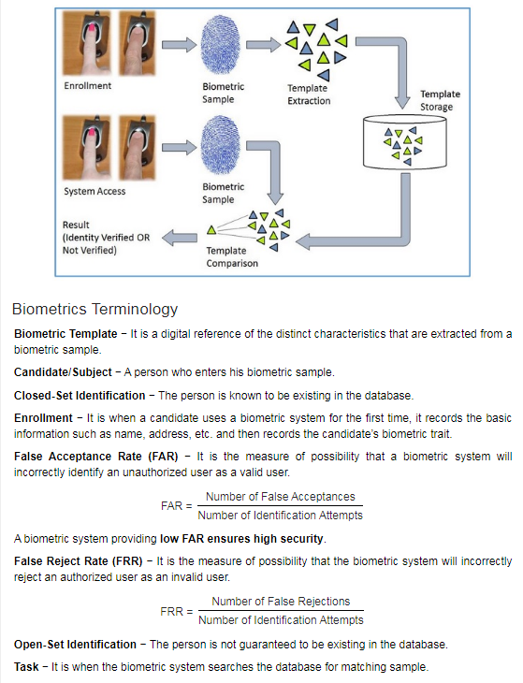

1. **Which of the following is biometric data:**

|  |  |
| --- | --- |
| **A scan of the iris** | **A prime number** |
| **A rock** | **A page of a biology book** |
| **An iphone** | **A SQL database** |

1. **What is the false acceptance rate if a thumb print scanner produces 30 false acceptances out of 40 identification attempts?**

|  |  |
| --- | --- |
| **10%** | **30%** |
| **40%** | **70%** |
| **75%** | **85%** |

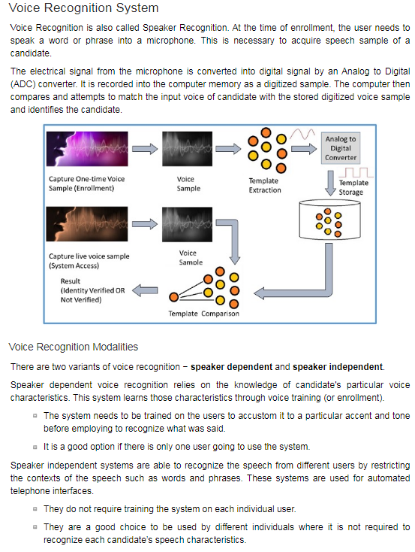

1. **Which of the following is an analog signal?**

|  |  |
| --- | --- |
| **A device that emits 4 possible values** | **A device that emits 1 possible values** |
| **A device that emits 100 possible values** | **A device that emits 100 possible values** |
| **A device that emits nothing** | **A device that emits an infinite number of possible values** |

1. **A company needs two voice recognition devices; device A will be a system that helps people that call the company (needs to understand words and questions). Device B will need to differentiate between different employees voices. Which of the following best describes devices A and B.**

|  |  |
| --- | --- |
| **A is speaker dependent, B is speaker independent** | **A is speaker dependent, A is speaker independent** |
| **B is speaker dependent, A is speaker independent** | **A is neither, B is speaker independent** |
| **B is speaker dependent, B is speaker independent** | **A is neither, B is neither** |

**Part 3: Social Engineering**

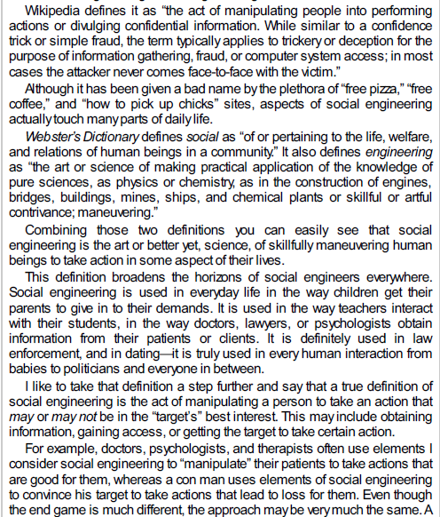

* Which of the following gives an example of social engineering?

|  |  |
| --- | --- |
| Using an algorithm to hack crack someone’s password | Installing a virus on someone’s computer |
| Launching a DDOSS attack | Call someone and pretend to be their bank in order to get their password |
| Carrying out an XSS attack | Removing the power supply to a company’s server |

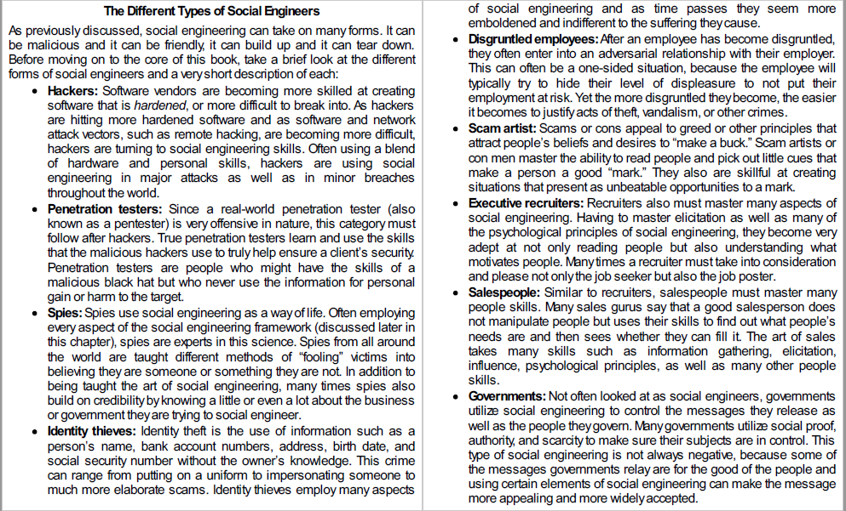

* Which of the following best describes one of the social engineer forms?

|  |  |
| --- | --- |
| A researcher working on finding a vaccine for covid-19, has poor social skills. | The president of the United States watching the news. |
| An employee is fired after being bullied for months, attempts to access the building by posing as a janitor | A passenger on an airplane using the free Wi-Fi, tries to check how much money is in his savings account |
| A thief is stealing a bike from someone’s house, he is later arrested. | A teacher uses gmail to send an email to all of the students. Many of the students do not read the email. |

* Elicitation: In training materials, the National Security Agency of the United States government defines elicitation as “the subtle extraction of information during an apparently normal and innocent conversation.”

Why does elicitation work?

Most people desire to be polite

Most people want to appear intelligent and well informed

Praise leads to divulging more information

Most people do not lie for the sake of lying.  It requires more mental effort to generate a lie.

Heavily reliant on ability to engage in conversation.  Conversation mastery governed by 3 principles:

-Act natural:  the appearance of being uncomfortable, awkward, or displaying socially unacceptable behavior will quickly kill conversation.

-Be well informed: whatever you choose to converse about and whomever with, do research, practice, and be prepared.

Don’t be greedy: if you demand answers and strictly focus on obtaining information, the -target may catch on.  Giving personal information to the target can elicit a feeling of reciprocation.

Elicitation techniques from the [Department of Homeland Security’s elicitation defense training](https://www.social-engineer.org/wiki/archives/BlogPosts/ocso-elicitation-brochure.pdf):

1. Appeal to Ego - you flatter the person with compliments or inflate their status in an effort to get them to open up.
2. Mutual Interest - You bond with the person over a common interest.
3. Deliberate falsehoods - You say something that is blatantly false in order to get a confirmation, denial, or additional information.  People enjoy correcting erroneous information and appearing to be well informed
4. Reciprocation - when someone gives something to you, you feel obligated to give something in return
5. Assumed knowledge - you pretend to know about something already, so that someone feels comfortable discussing it with you.

* Which of the following does not represent an elicitation technique described by the Department of Homeland Security (as described above)?

|  |  |
| --- | --- |
| Wow you seem really smart and intelligent I bet your password is impossible to crack. | All of the Answers |
| You should tell me your password or I will break your legs. | I love basketball too, my username is bigballer. |
| Yea the school uses a dedicated linux server and a SQL database to store the grades, I helped design it. What did you think about the security protocol, I thought it looked a bit weak? | My password is only 5 digits, starts with the first letter of my name and has 2 numbers, but I checked <https://haveibeenpwned.com/> and I haven’t been pwned! |

* Write a paragraph about how a hacker could use elicitation to get personal information from you:

**Part 4:**

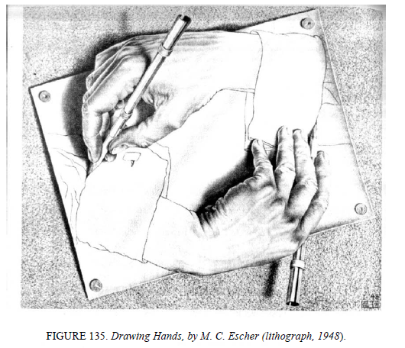

* What would it be like to have a computer that could program itself?