Name:

ID:

M1 Assignment S2_04

Submit completed assignment here: <https://docs.google.com/forms/d/e/1FAIpQLSdygGxiCKScAhWm1V_aNsRY_QEbW3pntClfQuXZrryX9zDdqg/viewform>

**Part 0) Extra Credit Surveys**

Take your time and complete each response thoughtfully.  Mindless, lazy submissions will not be counted.  Giving the same answer for every question or not answering the questions honestly will result in points being deducted from your score.

1. Numbers - <https://docs.google.com/forms/d/e/1FAIpQLSevUWiv6c_6UpoIaSUWgetpIW0GLmBaICqR8hT2JKCBJWF05w/viewform>
2. Morality- <https://docs.google.com/forms/d/e/1FAIpQLScjSwDJhwt36PHLLRs4-SHSJpgfd9GLOfLGJlqHjE7WYGwnEQ/viewform>
3. National -    <https://docs.google.com/forms/d/e/1FAIpQLSc9WMwNLDwZTmIhmOdfHxLzUUGsoGCRp8XLajKQI9E5ccesJw/viewform>
4. IQ1 - <https://docs.google.com/forms/d/e/1FAIpQLSfgg35LVa0lbR-GmY8cNThU8TjvfIHCfiJAUpE3TPyEJri0lw/viewform>

**Part 1:** [Boolean Algebra](https://medium.com/i-math/intro-to-truth-tables-boolean-algebra-73b331dd9b94)

1. Evaluate the following logical expression:

**P = True, X = False**

* What is **P and X**?

1. Evaluate the following logical expression:

**P = True, X = False**

* What is **P or X**?

1. Evaluate the following logical expression:

**P = True, X = False, Z = True**

* What is **P and X or not z**?

1. Complete the following truth table:

|  |  |  |
| --- | --- | --- |
| P | Q | P and Q |
|  |  |  |
|  |  |  |
|  |  |  |

1. Complete the following truth table:

|  |  |  |  |  |
| --- | --- | --- | --- | --- |
| X | Y | X or Y | X and (X or Y) | not (x and (X or Y)) |
|  |  |  |  |  |
|  |  |  |  |  |
|  |  |  |  |  |

Part 2: [The Internet](https://runestone.academy/runestone/books/published/webfundamentals/WWW/toctree.html)

1. Give an example of a web browser:

|  |  |
| --- | --- |
| apple | google |
| maps | opera |
| iphone | windows |

1. What does the “TP” in HTTP stand for? What does it mean?

|  |  |
| --- | --- |
| Tee pee | To protocol |
| Traffic protocol | Total pressure |
| Transfer protocol | Tipping point |

1. What 3 technologies do modern web pages rely on?

|  |  |
| --- | --- |
| Browser,server,bluetooth | Chrome,google,apple |
| Jquery,html,sas | Javascript,html,css |
| Javascript,c++, ruby | Python,html,css |

Part 3: **Information Gathering**

* 1. [Cognitive Biases](https://en.wikipedia.org/wiki/List_of_cognitive_biases)
     1. What is a cognitive bias?
     2. What is the confirmation bias?
     3. What is the survivorship bias?
     4. Discuss a time in your life when you have experienced a cognitive bias:
     5. Why do we need to be aware of cognitive biases when collecting information or building computer programs?
  2. [Chrome Shortcuts](https://support.google.com/chrome/answer/157179?hl=en)
     1. What is the keyboard shortcut to create a new tab?
     2. What is the keyboard shortcut to make everything on the page bigger?
     3. What is the keyboard shortcut to go to the bottom of the page?
     4. What is the keyboard shortcut to add *www.* And *.com* to a website?
  3. [Credible Sources](https://sites.umgc.edu/library/libhow/credibility.cfm)
     1. What checklist should be used to determine if a source is credible?
     2. Name a reliable web domain:
     3. Name two things you should beware of when evaluating a source:
     4. What is a filter bubble?

Part 4: **Computer Speed**

Read the following article on “Speed and Latency”: <https://hpbn.co/primer-on-latency-and-bandwidth/>

* 1. Define latency:
  2. Define bandwidth:
  3. Describe the features of latency and bandwidth:
  4. What is the speed limit of the universe? What does this mean in regards to latency and all physical processes?
  5. Describe methodologies for reducing latency and increasing bandwidth.

Go to <https://www.speedtest.net/> , what is the purpose of this site. Run a speed test.

* 1. What is the download speed?
  2. What is the upload speed?
  3. Can you identify a potential issue with running a speed test from the company that provides your internet?

**Part 5: Color**

[Color Theory](https://www.w3schools.com/colors/colors_theory.asp)

1. Newton said colors are mixtures of which 3 kinds of light?

|  |  |
| --- | --- |
| Blue, orange, purple | Cyan, magenta, yellow |
| Black, white, gray | Green, blue, red |
| Red, blue, yellow | Blue, yellow, black |

1. Consider the following:

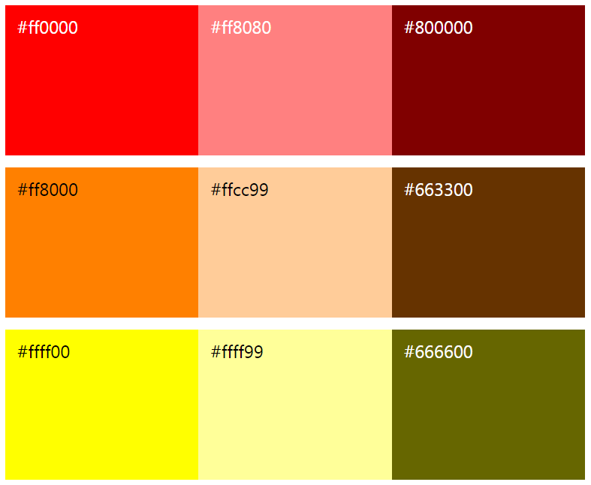

Which of the following has the same **hue** but different **darkness** than #ff0000?

|  |  |
| --- | --- |
| #ff8000 | #666600 |
| #800000 | #ff8080 |
| #ffcc99 | #663300 |

Part 1B: [Color Psychology](https://www.w3schools.com/colors/colors_psychology.asp)

1. Which color will most likely attract attention:

|  |  |
| --- | --- |
| Red | Blue |
| Green | Purple |
| Yellow | Brown |

1. All of the following are true of color except what?

|  |  |
| --- | --- |
| Influence taste of food | Influence attractiveness |
| Influence human behavior | Influence human height |

1. Which color should a spa use as the background color of their website? They want their users to feel *safe*, *calm*, and *fresh*.

|  |  |
| --- | --- |
| Black | Gray |
| Yellow | Green |
| Blue | Pink |