Name:

ID:

**M2 Assignment C1-06**

*Submit completed assignment here:* [*https://docs.google.com/forms/d/e/1FAIpQLSd8ADPgFHNCUX8cyCimo-bs7E_9HptK6X0iLHJ3vBHKt7rhEw/viewform*](https://docs.google.com/forms/d/e/1FAIpQLSd8ADPgFHNCUX8cyCimo-bs7E_9HptK6X0iLHJ3vBHKt7rhEw/viewform)

*Part 1: Google Sites*

1. Use [Google Sites](https://sites.google.com/new) to create a simple website for a restaurant. Paste the link to your website or a screenshot of your website below:

*Part 2: Programming*

Node.js: <https://repl.it/repls/LovingPersonalNetwork#index.js>

1. Consider the following:

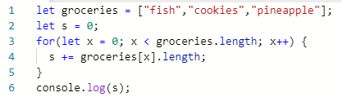

* What is the output?

|  |  |
| --- | --- |
| “fishcookiespineaplle” | 20 |
| 0 | 9 |
| “groceries.length” | 12 |

* What could you add to the groceries list to make the output 34?

1. Consider the following:



* What is a + b?

|  |  |
| --- | --- |
| 2 | 1 |
| 12 | 11 |
| ab | 0 |
| letab | 22 |

* What is c + c?

|  |  |
| --- | --- |
| 1 | 12 |
| 11 | 2 |
| cc | 0 |
| C2 | C1 |

1. Consider the following:

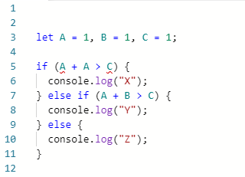

* What values of A, B, and C give an output of X?

|  |  |
| --- | --- |
| A = 1, B =1 , C = 2 | A = -1, B =1 , C = 1 |
| A = 1, B =1 , C = 19 | A = -2, B =1 , C = 1 |
| A = 11, B =1 , C = 1 | A = -3, B =1 , C = 3 |
| A = 1, B =11 , C = 2 | A = 12, B =100 , C = 34 |

*Part 3: Design*

Use the following svg editor to complete the following: <https://www.drawsvg.org/drawsvg.html>

1. Create a logo for a basketball company called “Pro BBX Court”, paste a screen shot below:
2. Create an Image for the homepage of a pizza website, paste a screenshot below:

*Part 4: Web Development*

1. Use HTML, JavaScript and CSS to create the following:



*Hint: create two divs and use the CSS attribute [transform](https://www.w3schools.com/cssref/css3_pr_transform.asp)

1. Use the following JavaScript code to change the background color of the body after 5 seconds:

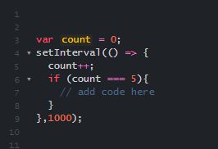

1. Use HTML, JavaScript and CSS to create a timer that counts down from 10 and then changes the font color of an h1 that says “Game Over” from white to red :