Name:

ID:

**M2 Assignment C1-07**

*JSFIDDLE:* [*https://jsfiddle.net/*](https://jsfiddle.net/)

*Submit completed assignment here:* [*https://docs.google.com/forms/d/e/1FAIpQLSdP-Auqj_h_Bi7VO05pI51ncQmqTDO1Z0ZmJD3BwCOgQWP8Lg/viewform*](https://docs.google.com/forms/d/e/1FAIpQLSdP-Auqj_h_Bi7VO05pI51ncQmqTDO1Z0ZmJD3BwCOgQWP8Lg/viewform)

*Part 1:* [*CSS*](https://www.w3schools.com/cssref/default.asp)

1. The css selector **p,div.a** selects which of the following HTML elements?

|  |  |
| --- | --- |
| All **p, div, a** elements | An **p** element with **a** and **div** children |
| An **a** element with **p** and **div** parents | An **a** element with **p** and **div** parents |
| An **a** element with **p** and **div** siblings | All **p** elements and **div** elements with a class=”a” |

1. The css selector **button:hover** will do what?

|  |  |
| --- | --- |
| Style all elements with the class=”button:hover” | Style all button elements when they are hovered |
| Style all elements with the id=”button:hover” | Style all elements with the class button when they are hovered |
| Style all elements with the tag=”button:hover” | Style all elements with the id button when they are hovered |

1. Which of the following is a unit that can be used to specify an **absolute** length**?**

|  |  |
| --- | --- |
| px | cm |
| pt | mm |
| km | in |

1. Which of the following is a unit that can be used to specify a **relative** length**?**

|  |  |
| --- | --- |
| em | pc |
| vh | rem |
| **%** | vmin |

1. Which of the following units refers to a width of fifty percent of the view port width?

|  |  |
| --- | --- |
| 50% | 50vh |
| 50px | 50pt |
| 50rem | 50vw |

1. Describe the following hexadecimal color: #008800

|  |  |
| --- | --- |
| Likely to attract attention | Evokes sense of purity |
| Evokes sense of restfulness and peace | Evokes sense of power |
| Evokes sense of anger and rage | Evokes sense of happiness |

1. Consider the following:

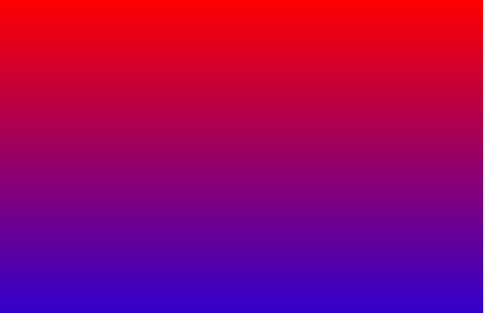

* What CSS code was used to create this?

|  |  |
| --- | --- |
| background: blue to red; | background-color: gradient(red,blue); |
| background-image:gradient(red,blue); | background:linear-gradient(red,blue); |
| background: linear-gradient(blue,red); | background: red to blue; |

1. Consider the following:

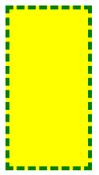

* What CSS code was used to create this?

|  |  |
| --- | --- |
| div{  width: 100px; height: 200px;  border: 5px dashed green;  background: yellow;  }; | div{  width: 100px; height: 100px;  border: 5px dashed green;  background-color: yellow;  }; |
| div{  width: 100px; height: 200px;  border: 1px solid green;  background-color: yellow;  }; | div{  width: 200px; height: 100px;  border: 5px dashed green;  background-color: yellow;  }; |
| div{  width: 200px; height: 200px;  border: 5px dashed green;  background: yellow;  }; | div{  width: 200px; height: 100px;  border: 5px solid green;  background: yellow;  }; |

1. Consider the following:



* What CSS code was used to create this?

|  |  |
| --- | --- |
| div{  width: 100px; height: 200px;  border: 5px solid brown;  background: gray;  box-shadow: 10px 10px black;  }; | div{  width: 100px; height: 100px;  border: 5px solid brown;  background: gray;  box-shadow: 10px 10px black;  }; |
| div{  width: 200px; height: 100px;  border: 5px solid brown;  background: gray;  box-shadow: 10px 10px black;  }; | div{  width: 100px; height: 100px;  border: 1px solid red;  background: gray;  box-shadow: 10px 10px black;  }; |
| div{  width: 100px; height: 200px;  border: 5px solid brown;  background: gray;  box-shadow: 2px 10px black;  }; | div{  width: 100px; height: 100px;  border: 5px solid brown;  background: gray;  box-shadow: 0px 10px black;  }; |

1. Consider the following div, what CSS code was used to create this?

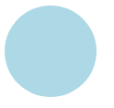

|  |  |
| --- | --- |
| div{  width: 100px; height: 200px;  background: lightblue;  border-radius: 20%;  }; | div{  width: 100px; height: 200px;  background: lightblue;  border-radius: 100%;  }; |
| div{  width: 100px; height: 100px;  background: lightblue;  border-radius: 100%;  }; | div{  width: 100px; height: 100px;  background: lightblue;  border-radius: 20%;  }; |
| div{  width: 200px; height: 200px;  background: blue;  border-radius: 100%;  }; | div{  width: 200px; height: 200px;  background: lightblue; border: 1px solid black;  border-radius: 100%;  }; |

*Part 2 : HTML*

1. Describe the error in the following HTML:

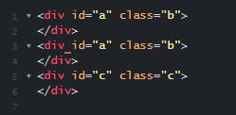

|  |  |
| --- | --- |
| There are two divs with the same class | There are 3 divs |
| The id and class cannot have the same value | Two divs have the same id |
| Divs cannot have classes | Divs cannot have ids |

1. Which of the following correctly creates an image of a giraffe?

|  |  |
| --- | --- |
| **<img>giraffe</img>** | **<img alt=”giraffe”>giraffe</img>** |
| **<img>https://cdn.cnn.com/cnnnext/dam/assets/191117154956-kimba-cincinnati-zoo-giraffe-exlarge-169.jpg</img>** | **<img src="https://cdn.cnn.com/cnnnext/dam/assets/191117154956-kimba-cincinnati-zoo-giraffe-exlarge-169.jpg" alt="">** |
| **<img> https://cdn.cnn.com/cnnnext/dam/assets/191117154956-kimba-cincinnati-zoo-giraffe-exlarge-169.jpg </img>** | **<img src=" " alt=" https://cdn.cnn.com/cnnnext/dam/assets/191117154956-kimba-cincinnati-zoo-giraffe-exlarge-169.jpg ">** |

1. Complete the following HTML so that a row is created with two cells “name” and age:

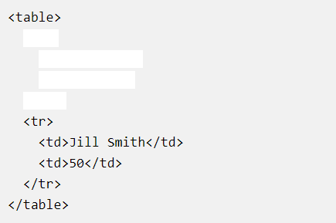

|  |  |
| --- | --- |
| <tr>     <td>name </td>     <td>age </td>   </tr> | <tr>     name  age   </tr> |
| <td>     <td>name </td>     <td>age </td>   </td> | <row>     <cell>name </cell>     <cell>age </cell>   </row> |
| <row>     <td>name </td>     <td>age </td>   </row> | <tbody>  <tr>     <td>name </td>     <td>age </td>  <tr>  </tbody> |

1. Consider the following HTML inputs:



* The type attribute should be set to what value:

|  |  |
| --- | --- |
| text | email |
| checkbox | button |
| submit | radio |

1. What type of HTML element is this?

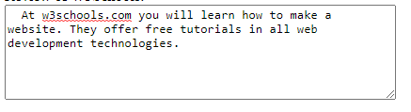

|  |  |
| --- | --- |
| p | div |
| textarea | textbox |
| input | table |

*Part 3:*

1. The following code will change the background color of the body to whatever the user enters into the text input:

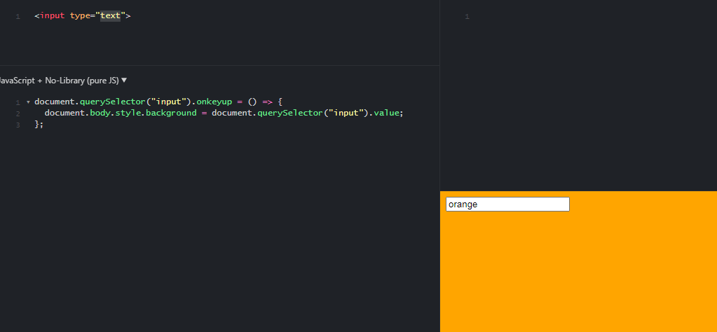

* Change the code so that the font color of an h1 element is changed instead

1. Create a web page that changes the background color to red every time the “R” key is pressed and blue every time the “B” key is pressed:

*Bonus:*

1. Create a web page with a text input. If the user enters an even number the background color of the body should change green. If the user enters an odd number it should turn red.