Name:

ID:

**M2 Assignment C1-08**

*JSFIDDLE:* [*https://jsfiddle.net/*](https://jsfiddle.net/)

*Submit completed assignment here:* [*https://docs.google.com/forms/d/e/1FAIpQLSeJeU6dOXVhMyD3u83GC1fM4uX30-AecTHx7UypjT9SWYJptg/viewform*](https://docs.google.com/forms/d/e/1FAIpQLSeJeU6dOXVhMyD3u83GC1fM4uX30-AecTHx7UypjT9SWYJptg/viewform)

*Part 1: Critical Thinking*

1. If two players get the same score at a certain game, in order to decide a winner, a coin is flipped. Whoever wins the coin toss gets to choose any number. This number will be added to their score and multiplied to their opponents score. Which number should the winner of the coin toss choose so that he can win the game?
2. Win the following game, by getting a water level of exactly 4 in one of the buckets. Take screenshot of screen after you win:

[*https://jsfiddle.net/nps01/30tgLsno/72/*](https://jsfiddle.net/nps01/30tgLsno/72/)

*Part 2: Web Development*

1. Use the HTML, CSS, and JavaScript code of a simulation of two ions to answer the following questions.

Code: <https://jsfiddle.net/y4x57bc2/2/>

* Given that the blue ion is positive and the yellow ion is negative what happens as you drag the ions farther apart from each other?

|  |  |
| --- | --- |
| The distance decreases | The ions get smaller |
| The charge of the blue ion increases | The electrostatic force approaches 0 |
| The charge of both ions increases | The electrostatic force becomes a very large positive number |
| The ions get larger | The electrostatic force becomes a very large negative number |

* Given that the blue ion is positive and the yellow ion is positive (enter a positive number into the text input that says charge) what happens as you drag the ions closer to each other?

|  |  |
| --- | --- |
| The distance decreases | The ions get smaller |
| The charge of the blue ion increases | The electrostatic force approaches 0 |
| The charge of both ions increases | The electrostatic force becomes a very large positive number |
| The ions get larger | The electrostatic force becomes a very large negative number |

* Set the diameter of the blue ion to 2. What effect does this have?

|  |  |
| --- | --- |
| The blue ion gets twice as small as the yellow ion | The yellow ion gets twice as big as the blue ion |
| No effect | Blue ion doubles in size |
| The electrostatic force doubles | Blue ion size is halved |

* Does a really large negative electrostatic force represent an attractive (force that brings close together) or repulsive (force that moves things far apart) force?

|  |  |
| --- | --- |
| Attractive, negative charges are attracted to negative charges | Attractive, negative charges are attracted by positive charges |
| Repulsive, negative charges are repelled by negative charges | Repulsive, negative charges are repelled by positive charges |
| Repulsive, positive charges are repelled by negative charges | None of the above |

* The constant e in the JavaScript code represents the fundamental charge of an electron (-e) or proton (+e). What is the value of e?

|  |  |
| --- | --- |
| 8.99x10^9 | -1 |
| 8.999 | 1.602x10^-19 |
| 1 | -3 |

1. Consider the following:

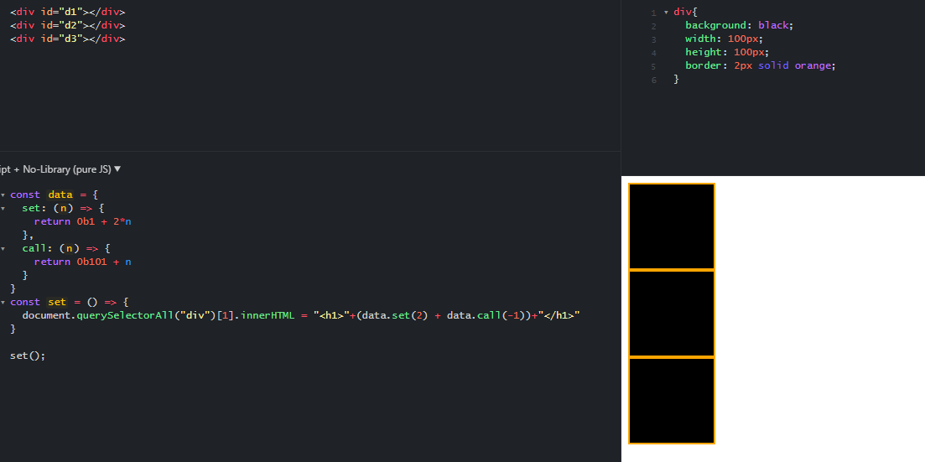

* Change the div background color to white to find a secret number. What is the secret number and which div is it in?

|  |  |
| --- | --- |
| 1, d1 | 1, d2 |
| 9, d1 | Secret, d3 |
| 9, d2 | Secret, d2 |
| Black, d1 | Black, d2 |