Name:

ID:

Web Programming

Chapter 1

Submit here: <https://docs.google.com/forms/d/e/1FAIpQLSdUQkZB7sXgubYv_HXIr0ccufPypFuQVqVh9lPfLwFCzNHYgg/viewform>

Book: <https://runestone.academy/runestone/books/published/webfundamentals/WWW/toctree.html>

1. What protocol is used when the browser and web server talk?
2. Give an example of a web browser:
3. What does the “TP” in HTTP stand for? What does it mean?
4. What 3 technologies do modern web pages rely on?
5. Match the following:
6. Fonts and styles
7. User clicks and interactions
8. Headings and sections and structural components

JavaScript:

CSS:

HTML:

1. Who invented the internet? Where was it invented?
2. What 3 fundamental technologies remain the foundation of the internet?
3. Why was the establishment of the W3C important?
4. Are all locators are also identifies? Explain:
5. Identify and explain the purpose of the 3 components of a URL in the following :

https://lichess.org/@/nick

1. What is returned from the Domain Name Service Server (DNS)?
2. The mechanism in which a browser connects to a server is known as what?
3. Consider the following http request:

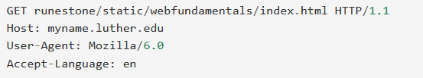

* What command is used and what is its purpose?
* What type of web browser is being used?
* How many headers are used?

1. What does the server send back to the browser through the socket?
2. Give the appropriate HTTP response codes for the following:

* Resource location changed:
* Mistyped URL:
* Server crashed:
* Everything is fine: