Name:

ID:

M3 Assignment 03

Control Flow ([Selection](https://runestone.academy/runestone/books/published/thinkcspy/Selection/toctree.html))

Part 1: [Selection](https://runestone.academy/runestone/books/published/thinkcspy/MoreAboutIteration/toctree.html)

1. WHAT ARE THE TWO BOOLEAN VALUES?
2. How is one equal sign different than two?
3. Discuss 3 comparison operators:
4. Evaluate the following expression:

**3 > 2**

1. Evaluate the following expression:

**20 % 2 ** 3 + 1**

1. Which operator has higher precedence **/** or **\*\*?**
2. Evaluate the following:

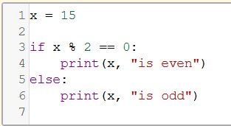

1. Boolean expression after the **if** condition is called what?
2. The more indented statements that follow the **if** statement are called what?
3. Evaluate the following:

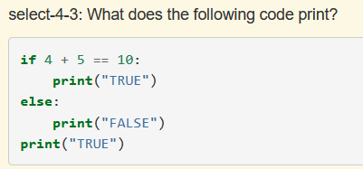

1. Evaluate the following:

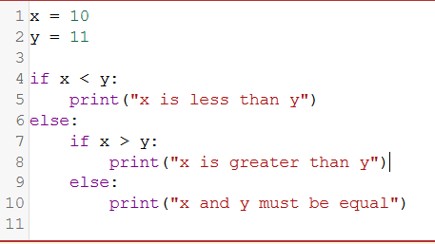

1. How many **elif** statements can there be?
2. Are **elif** statements evaluated in random order or sequentially?
3. Evaluate the following:

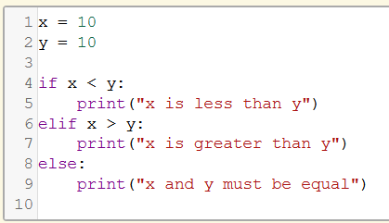

1. Given x = 16, y = -13, and z = 22. Evaluate the following:

