**Name:**

**ID:**

**M3 Assignment 04A**

Submit completed assignment here: <https://docs.google.com/forms/d/e/1FAIpQLScrazOlZaTnCTMe72DgVrIWgwr07TijEK7a_ZMDStwfv1ZNBg/viewform>

Use the following book as a reference to answer the following questions:

<https://runestone.academy/runestone/books/published/thinkcspy/PythonTurtle/toctree.html>

Online Python3 Editor:

<https://repl.it/@enaard/Python-3>

Part 1)

1. What is the turtle module used for (**4.1**):
2. Consider the following code (**4.2**)::

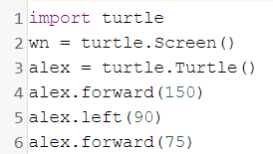

1. Explain the code in line 1?
2. Explain the code in line 2?
3. Explain the code in line 3?
4. Explain the code in line 4?
5. Explain the code in line 5?
6. Consider the following turtle code **(4.2)**:

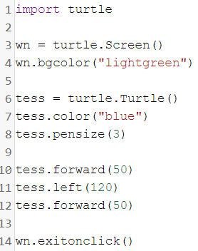

1. Which line changes the background color?
2. Which line will change how thick the line is?
3. Which line will turn Tess left 120 degrees?
4. How can you turn Tess right by 35 degrees?
5. What does line 14 do?
6. Fill in the blank **(4.3)**:

*Each turtle in a program is a _______ of the Turtle type class.*

1. Is the following statement true or false **(4.3)**?

*You can only have one turtle in your program.*

1. A basic idea in computer programming is to repeat some code over and over again, what is this idea called **(4.4)**?
2. Consider the following code **(4.4)**:

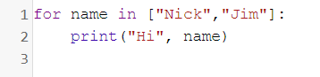

* What are the square brackets on line 1 called?
* What is the name of the loop variable in this code?
* How many different values does the loop variable have?
* What is the output?

1. Consider the following code **(4.4)**:

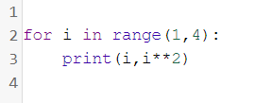

* What is the output?
* Change **range(1,4)** to **range(2,8)**, what is the output?
* What is the difference between **i** and **i**2**?

1. Consider the following code **(4.6)**:

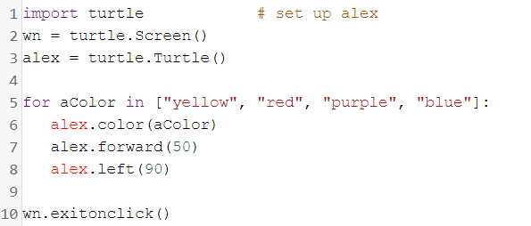

* On line 4 use the .speed() function to change the turtle’s speed to 15, what is the effect
* Every time the turtle change’s color, reduce the distance traveled by 5 units. Paste the output below
* Make the turtle color only blue and pink.

1. Consider the following **(4.7)**:

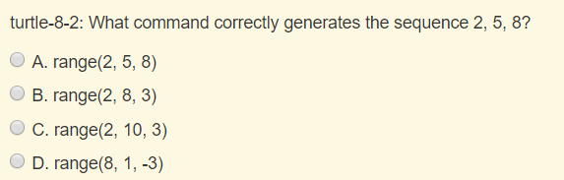

What is the answer?

1. Consider the following:

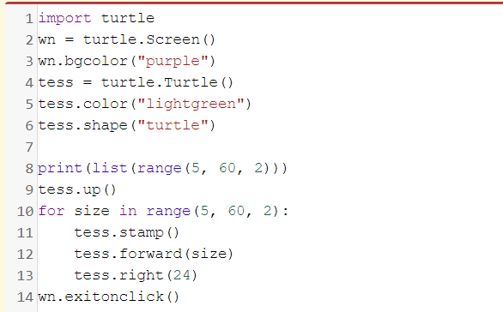

* What does line 9 do?
* What does line 11 do?
* How can you change the shape of the turtle to a square?

Part 2)

1. Draw the first letter of your first name using the turtle module and python3:

Example: “Nick”

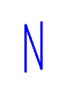

1. Create the following using Python and the Turtle module:

