**Name:**

**ID:**

**M3 Assignment 04B**

Use the following book as a reference to answer the following questions:

<https://runestone.academy/runestone/books/published/thinkcspy/PythonTurtle/toctree.html>

1. What is the turtle module used for (**4.1**):
2. Consider the following code (**4.2**):

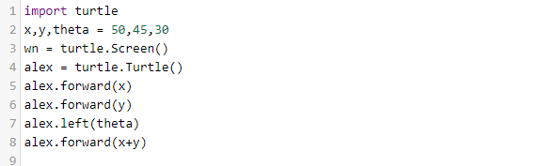

1. Explain the code in line 1?
2. Explain the code in line 2?
3. Which line generates the screen?
4. Which of the following makes alex travel the furthest?

|  |
| --- |
| alex.forward(x*2) |
| alex.forward(x+y) |
| alex.forward(x)  alex.forward(y) |
| alex.forward(theta) |

1. Consider the following turtle code **(4.2)**:

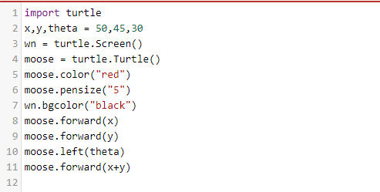

1. Which line changes the background color?
2. Which line will change how thick the line is?
3. Which line will turn Tess left 30 degrees?
4. How can you turn Tess right by 65 degrees?
5. Change the background color to yellow and the color to blue. Paste a screenshot of the result below?
6. Fill in the blank **(4.3)**:

*Each turtle in a program is a _______ of the Turtle type class.*

1. Is the following statement true or false **(4.3)**?

*You can only have one turtle in your program.*

1. A basic idea in computer programming is to repeat some code over and over again, what is this idea called **(4.4)**?
2. Consider the following code **(4.4)**:

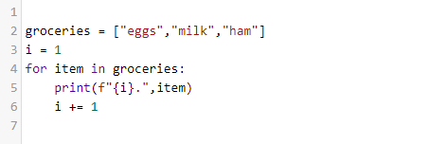

* What are the square brackets on line 2 called?
* What is the name of the loop variable in this code?
* How many different values does the loop variable have?
* What is the output?

1. Consider the following code **(4.4)**:

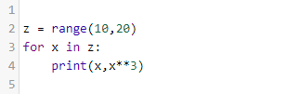

* What is the output?
* Find the greatest difference between **x** and **x**3** in range(10,20)?
* What is the last element of range(10,20)?

1. Consider the following code **(4.6)**:

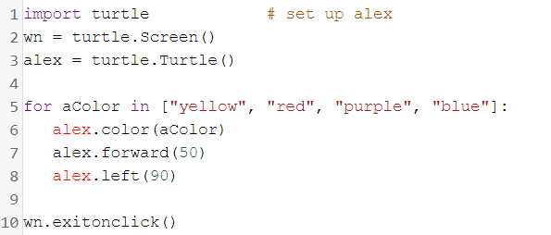

* How many elements are in the list?
* What will happen if you change the name *alex* on line 3 to *tom*?
* Does the **forward** function move the turtle or change the orientation?
* Does the **left** function move the turtle or change the orientation?
* Change the code so the turtle will only be red and purple:

1. Consider the following **(4.7)**:

Which of the following generates the sequence: 17, 19, 21

|  |  |
| --- | --- |
| range(17,21) | range(17,2,21) |
| range(17,20) | range(17,3,22) |
| range(17,22,2) | range(17,21,2) |
| range(17,22,3) | range(17,22) |

What is the answer?

1. Consider the following:

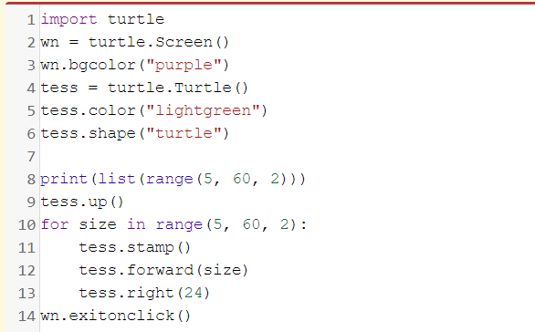

* Change the shape of tess to a circle, paste a screenshot of the output below:
* What does line 9 do?
* What does line 11 do?
* How can you change the shape of the turtle to a rectangle?