Name:

ID:

M3 Assignment 05

Submit completed assignment here: <https://docs.google.com/forms/d/e/1FAIpQLSetbRGxI3BBVOgHnTX3phzLe6DxNIajB3Kgf3tPfHNs_ENY9g/viewform>

Part 1: <http://runestone.academy/runestone/books/published/thinkcspy/SimplePythonData/intro-VariablesExpressionsandStatements.html>

1. How can you determine the type of a variable? (**2.2**):

|  |  |
| --- | --- |
| type() | typeof() |
| typ() | datatype() |
| print() | var() |

1. What are the 3 enclosures for a string? (**2.2**):

|  |  |
| --- | --- |
| “”,’’,() | “”,’’,{} |
| “”,’’,’’’’ | “”,’’,<> |
| “”””””,’’,”” | ‘’’’’’’’,’’,”” |

1. How can I convert the floating point number *143.7* into a string (**2.3**)?

|  |  |
| --- | --- |
| floating(143.7) | string(143.7) |
| str(143.7) | float(143.7) |
| char(143.7) | “143” |

1. What is the data type of 143, how can I convert it into a floating point number (**2.3**)?

|  |  |
| --- | --- |
| Int,float(143) | String,float(143) |
| Float, already a float | Complex, float(143) |

1. What is a variable and what is the operator used to create one (**2.4**)?

|  |  |
| --- | --- |
| It is the name of a string, = | Reserved piece of memory to store a value, = |
| Equality relation, = | Equality relation, == |
| A name, var | A keyword, == |

1. When creating a variable, does the value go on the left hand side or right hand side of the operator (**2.4**)?

|  |  |
| --- | --- |
| It can go on either side | left |
| right | Both sides |

1. List 5 python keywords (**2.5**):
2. Create a valid variable name and assign it a value (**2.5**):
3. What symbol is allowed to appear in variable names (**2.5**)?
4. What is the output of the following: *print(len(“abcde”))* (**2.6**)?
5. What are the operators and operands in the following expression (**2.7**)?

1 + 2 ** 2

|  |  |
| --- | --- |
| operators | operands |
|  |  |

1. What is the output of the following expression? What is the operator called and what is it’s purpose **(2.7)**?

*print( 44 % 2 )*

|  |  |
| --- | --- |
| *Print, display text in console* | *(), evaluate first in an expression* |
| *42 and 2, integers* | *%, remainder form division* |

1. What built in Python function allows the user to input information into a Python program **(2.8)**?

|  |  |
| --- | --- |
| input | enter |
| inp | print |

1. What is the output of the following **(2.9)?**

*print(2+2**3+1)*

1. What is reassignment **(2.10)**?

|  |  |
| --- | --- |
| Updating the value of a variable | Adding a constant to some value |
| Creating a variable that has the same value as another variable | Creating a variable |

Part 2: [Selection](https://runestone.academy/runestone/books/published/thinkcspy/MoreAboutIteration/toctree.html)

1. WHAT ARE THE TWO BOOLEAN VALUES?
2. How is one equal sign different than two?
3. Discuss 3 comparison operators:
4. Evaluate the following expression:

**3 > 2**

1. Evaluate the following expression:

**20 % 2 ** 3 + 1**

1. Which operator has higher precedence **/** or **\*\*?**
2. Evaluate the following:

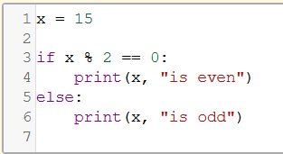

1. Boolean expression after the **if** condition is called what?
2. The more indented statements that follow the **if** statement are called what?
3. Evaluate the following:

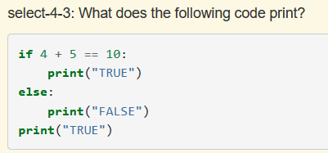

1. Evaluate the following:

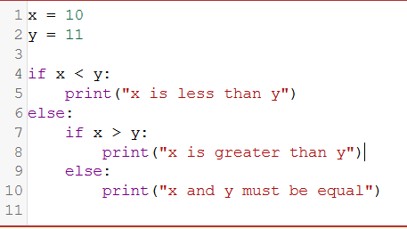

1. How many **elif** statements can there be?
2. Are **elif** statements evaluated in random order or sequentially?
3. Evaluate the following:

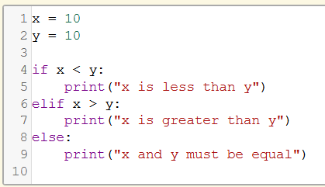

1. Given x = 16, y = -13, and z = 22. Evaluate the following:

