Name:

ID:

Assignment X02

Extra Credit: <https://docs.google.com/forms/d/e/1FAIpQLSfAj9QBN5nElQwi9bKPeIOJ1ATE58jGmHUyzp204gDMkewL6w/viewform>

Python Editor: <https://repl.it/repls/MarriedAustereOctagon#main.py>

Submit Assignment: <https://docs.google.com/forms/d/10UaX0K9R9Xvd2rCrjXt0j1PTG3YTS3loCawH-MP-tks/edit>

Part 1)

1. What is the output of the following?

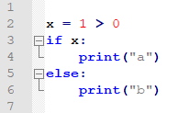

1. What is the output of the following?

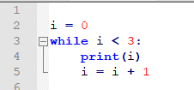

1. What happens if i < 3 is changed to i < 10?
2. What is the output of the following?

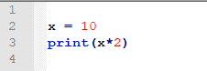

1. Describe line 1 of the following program:



1. Predict the output of the following:

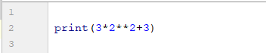

1. Predict the output of the following:

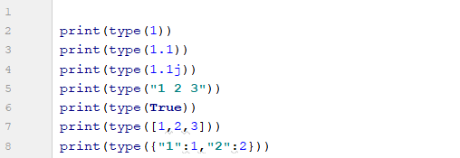

1. Predict the output of the following:

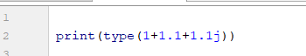

1. Predict the output of the following:



1. Predict the output of the following:

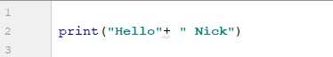

Part 2)

Book: <http://runestone.academy/runestone/books/published/thinkcspy/SimplePythonData/intro-VariablesExpressionsandStatements.html>

1. How can you determine the type of a variable? (**2.2**):
2. What are the 3 enclosures for a string? (**2.2**):
3. How can I convert the floating point number *143.7* into a string (**2.3**)?
4. What is the data type of 143, how can I convert it into a floating point number (**2.3**)?
5. What is the difference between one and two equal signs?
6. What is the output of *print((1+1) == 2)* (**2.4**)?
7. What is a variable and what is the operator used to create one (**2.4**)?
8. When creating a variable, does the value go on the left hand side or right hand side of the operator (**2.4**)?
9. List 5 python keywords (**2.5**):
10. Create a valid variable name and assign it a value (**2.5**):
11. What symbol is allowed to appear in variable names (**2.5**)?
12. Are keywords allowed to be used as variable names (**2.5**)?
13. What is the output of the following: *print(len(“abcde”))* (**2.6**)?
14. What is the difference between a statement and an expression (**2.6**)?
15. What are the operators and operands in the following expression (**2.7**)?

1 + 2 ** 2

1. Describe the function of the following operator: *//* **(2.7)**?
2. What is the output of the following expression? What is the operator called and what is it’s purpose **(2.7)**?

*print( 44 % 2 )*

1. What built in Python function allows the user to input information into a Python program **(2.8)**?
2. What is a prompt string **(2.8)**?
3. Describe the rules of precedence **(2.9)?**
4. What is the output of the following **(2.9)?**

*print(2+2**3+1)*

1. What is the output of the following **(2.9)?**

*print( (2/2+10 - 1)**2+1 )*

1. What is reassignment **(2.10)**?
2. Given the variable *x =1*, what term best describes *x = x + 1* **(2.11)**?
3. Define the term decrement **(2.11)**?

Extra Credit)

* Create a program that asks a user to enter their first name, then asks the user to enter their last name. The program should output their initials.