Name:

ID:

M3 Challenge 01

<https://repl.it/@enaard/Python-3>

Part 1:

1) Write a program that computes the area and perimeter of a square. The program should ask the user to input the length of one of the sides of the square and then output the perimeter and area.

Hints:

* Use the input function to get information into your program
* Store the input in a variable
* Convert to a number data type (int, float, complex): int(“1”) = 1
* The area equation for a square is: $Area= s^{2}$
* The perimeter equation for a square is: $Perimeter=4s$

Solution (Please paste code below):

2) Write a program that asks the user to enter their first and last name. The program should output their *upper case* initials repeated 10 times.

Hints:

* Store the last name input and first name input in variables
* A person’s initials are the first letter of their first name + the first letter of their lastname: “Nicholas Sebasco” --> “NS”
* The .upper() function makes a string upper case: $\text{"smack"}.upper()="SMACK"$
* Two repeat the string use a loop or the string repetition operator **\***

Solution (Please paste code below):

3) Transform a string of letters into a string of numbers. “apple” -> “1 16 16 12 5”

Hints:

* You will need to loop through the characters in the string:

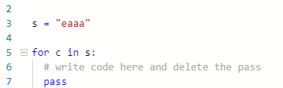

* The **ord()** function transforms a character into an integer: $ord\left(\text{"a"}\right)=97$
* Subtract 96 from the value returned by **ord()**, this will make a= 1, b =2, etc
* Convert the integers to a string with the **str()** function: $str\left("1"\right)=1$
* Combine strings with the concatenation operator **+**:

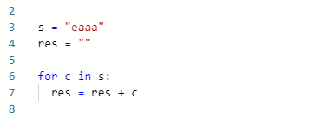

Solution (Please paste code below):