Name:

ID:

M3 Challenge 02B

Submit here: <https://docs.google.com/forms/d/e/1FAIpQLScBOJyIqz_-rF86dobH7vpeV6ysxxu87SNaEJZ4XEmJNdvICQ/viewform>

<https://repl.it/@enaard/Python-3>

Part 1:

1). The program should ask the user to enter two points p1 = (x1,y1) and p2 = (x2,y2). The program should output the distance between the points and the midpoint between the points.

*Distance = sqrt((x2-x1)^2+(y2-y1)^2)*

*Midpoint = (x1+x2)/2,(y1+y2)/2*

2) Write a program that asks the user to enter the number of moles of 3 different gases inside a container. Given that the total pressure inside a container is 200 Pascal, output the partial pressure of each gas in the container:

*Mole fraction A = (moles of gas A)/ total moles*

*Partial pressure of gas A = (Mole fraction A)\*Total pressure*

3) Consider the following:

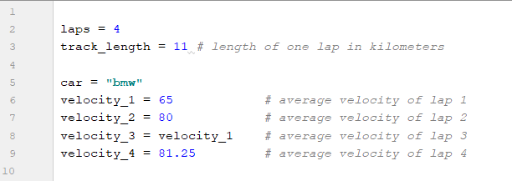

*Average Velocity = total distance/ total time*

* What is the average velocity of the car after completing 4 laps around the track?