Name:

ID:

M3 Review 2

<https://repl.it/@enaard/Python-3>

Part 1:

1) Which of the following is a float?

|  |  |
| --- | --- |
| z = lambda a,b: a + b | (1,12.8) |
| [1.0] | True |
| 1.1e8 | 8+1.1j |

2) What is the output: 3*”a” + “b”*2?

|  |  |
| --- | --- |
| 3a+b2 | ab |
| aaab2 | 3ab2 |
| 32 | 6ab |
| aaabb | ab6 |

3) Which of the following best describes the ** operator?

|  |  |
| --- | --- |
| exponentiation | Remainder from division |
| Divides integers | multiplication |
| Gives decimals of a number | Percentage |

4) What is the last element of range(5) plus the first element of range(100)?

|  |  |
| --- | --- |
| range(0,5) | ‘e’ |
| 0 | 5 |
| 4 | 1 |

5) What is the data type of a+b?

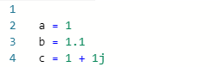

|  |  |
| --- | --- |
| complex | float |
| list | boolean |
| dictionary | number |

6) Find values of A,B, and C so the output is “A”:

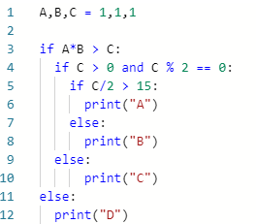

|  |  |
| --- | --- |
| A = 1, B = 1, C = 1 | A = 1, B = 1, C = 33 |
| A = 5, B = 5, C = 100 | A = 1, B = 1, C = 34 |
| A = -1.5, B = 1, C = 1.1 | A = 25, B = 20, C = 910 |
| A = 20, B = 20, C = 300 | A = 1, B = -1, C = 1 |

7) Consider the following function:

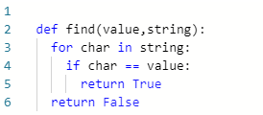

* What is the output of **find(“a”,”aslhgfjfvkjsdfkfsddfhhbjbhjsdf”)**?

|  |  |
| --- | --- |
| “a” | ”aslhgfjfvkjsdfkfsddfhhbjbhjsdf” |
| True | 1 |
| char | False |
| find(“a”, ”aaslhgfjfvkjsdfkfsddfhhbjbhjsdf”) | ”aaslhgfjfvkjsdfkfsddfhhbjbhjsdf” |

8) Consider the following:

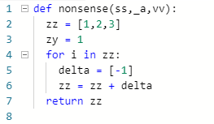

What is the name of the function and how many parameters does it have?

|  |  |
| --- | --- |
| zz, 5 | def, 4 |
| def, 3 | nonsense, 7 |
| def nonsense(ss,_a,vv), 3 | for, 1 |
| nonsense, 3 | ss, 2 |

9) Consider the following:



What is the value of **l – z**?

|  |  |
| --- | --- |
| 14 | -14 |
| .1 | .001 |
| -.001 | 0 |

10) Complete the table:

|  |  |
| --- | --- |
| Data Type | Example |
|  | [1.0] |
|  | {“apple”:[{“apple”:{“red”: 1}]} |
|  | 1 > 2 and not 2 < -1 |

Part 2:

11) Create a function name greeting with 2 parameters: fname, lname. The procedure should print a greeting + the parameters.

12) Create a fruitful function with 1 parameter (list data type). The function should return the maximum value of the list.