Name:

ID:

Version 1

Part 1:

1) Which of the following is a tuple?

|  |  |
| --- | --- |
| z = lambda a,b: a + b | (1,12.8) |
| [1.0] | True |
| 1.1e8 | 8+1.1j |

2) What is the output: 2*”aa” + “”*2?

|  |  |
| --- | --- |
| 2a+”” | aa |
| aaab2 | 2a |
| 22 | 2aa |
| aaabb | aa”””” |

3) Which of the following best describes the % operator?

|  |  |
| --- | --- |
| exponentiation | Remainder from division |
| Divides integers | multiplication |
| Gives decimals of a number | Percentage |

4) What is the last element of range(6) plus the first element of range(1)?

|  |  |
| --- | --- |
| range(0,5) | 7 |
| 0 | 5 |
| 4 | 6 |

5) What is the data type of c+b?

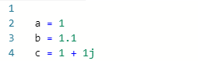

|  |  |
| --- | --- |
| complex | float |
| list | boolean |
| dictionary | number |

6) Find values of A,B, and C so the output is “D”:

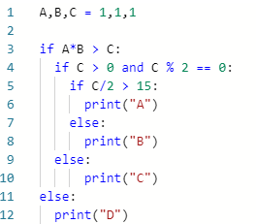

|  |  |
| --- | --- |
| A = 1, B = 1, C = 1 | A = 20, B = 20, C = 301 |
| A = 20, B = 20, C =-300 | A = 22, B = 22, C = 300 |
| A = 20, B = 20, C = 100 | A = 23, B = 20, C = 200 |
| A = 20, B = 20, C = 300 | A = 20.999, B = 31, C = 100 |

7) Consider the following function:

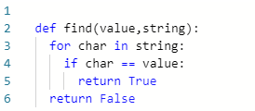

* What is the output of **find(“b”,”aslhgfjfvkjsdfkfsddfhhbjbhjsdf”)**?

|  |  |
| --- | --- |
| “a” | ”aslhgfjfvkjsdfkfsddfhhbjbhjsdf” |
| True | 1 |
| char | False |
| find(“a”, ”aaslhgfjfvkjsdfkfsddfhhbjbhjsdf”) | ”aaslhgfjfvkjsdfkfsddfhhbjbhjsdf” |

8) Consider the following:

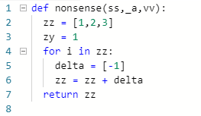

What is the name of the lists and parameters?

|  |  |
| --- | --- |
| Lists:ss, _a, vv parameters: zz, zy, delta | Lists:ss, _a, vv parameters: zz, zy, delta |
| Lists:ss, _a, vv parameters: 1,2,3 | Lists: zz, delta parameters: ss, _a, vv |
| Lists:ss, _a, vv parameters: nonsense | Lists:ss, _a, vv parameters: def, for, return |
| Lists: nonsense parameters: zz, zy, delta | Lists: zz, zy, delta parameters: ss, _a, vv |

9) Consider the following:



What is the value of **max([l+l,z*2,z,l+l+l-20])**?

|  |  |
| --- | --- |
| 28 | 28.001 |
| 22 | 42 |
| 28.002 | 62 |

10) Complete the table:

|  |  |
| --- | --- |
| Data Type | Example |
|  | 1 ** 3 + 3/5.0 |
|  | [1]*3 |
|  | {“a18”:18} |

Part 2:

11) Create a function named multiply with 3 parameters. The function is a procedure that should print the product of the parameters.

12) Create a fruitful function with 1 parameter (list data type). The function should return the minimum value of the list.