Name:

ID:

<https://repl.it/@enaard/Python-3>

Part 1:

1) Which of the following is a string?

|  |  |
| --- | --- |
| z = lambda a,b: a + b | (1,12.8) |
| [“apple”] | 2*”1” |
| 1.1e8 | {“sam”: 33} |

2) What is the output: “np”*len(“a”) + “ck”[1]?

|  |  |
| --- | --- |
| npack | nplenck |
| nplenack1 | nplenack |
| npck | npk |
| npc | npk1 |

3) Which of the following best describes the **and** operator?

|  |  |
| --- | --- |
| exponentiation | Remainder from division |
| Boolean operation where only one condition needs to be true for the result to be true | Boolean operation that inverts the truth value |
| Gives decimals of a number | Boolean operation where both conditions need to be true for the result to be true |

4) What is the last element of range(1) plus the first element of range(1,10)?

|  |  |
| --- | --- |
| range(1,10) | 12 |
| 2 | 0 |
| 11 | 1 |

5) What is the data type of a+b+c?

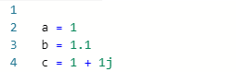

|  |  |
| --- | --- |
| complex | float |
| list | boolean |
| dictionary | number |

6) Find values of A,B, and C so the output is “A”:

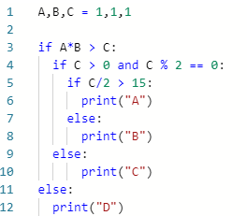

|  |  |
| --- | --- |
| A = 1, B = 1, C = 1 | A = 1, B = 1, C = 33 |
| A = 5, B = 5, C = 100 | A = 1, B = 1, C = 34 |
| A = -1.5, B = 1, C = 1.1 | A = 25, B = 20, C = 910 |
| A = 20, B = 20, C = 300 | A = 1, B = -1, C = 1 |

7) Consider the following function:

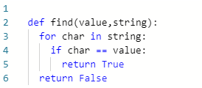

* What is the output of **find(“ax”,”aslhgfjfvkjsdfkfsddfhhbjbhjsdf”)**?

|  |  |
| --- | --- |
| “a” | ”aslhgfjfvkjsdfkfsddfhhbjbhjsdf” |
| True | 1 |
| char | False |
| find(“a”, ”aaslhgfjfvkjsdfkfsddfhhbjbhjsdf”) | ”aaslhgfjfvkjsdfkfsddfhhbjbhjsdf” |

8) Consider the following:

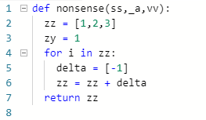

What is the name of the function and how many parameters does it have?

|  |  |
| --- | --- |
| zz, 5 | def, 4 |
| def, 3 | nonsense, 7 |
| def nonsense(ss,_a,vv), 3 | for, 1 |
| nonsense, 3 | ss, 2 |

9) Consider the following:



What is the value of **l – z**?

|  |  |
| --- | --- |
| 14 | -14 |
| .1 | .001 |
| -.001 | 0 |

10) Complete the table:

|  |  |
| --- | --- |
| Data Type | Example |
|  | (1 + 2.0j) + 1.0 |
|  | “a”*3 |
|  | 1 == 1 |

Part 2:

11) Create a function nameLength with 2 paramters: lname and fname. This fruitful function should return the sum of the lengths of lname and fname.

12) Create a procedure function with 0 parameter. The function should print something.