**Name:**

**ID:**

**M5 Assignment 04A**

Submit completed assignment here: <https://docs.google.com/forms/d/e/1FAIpQLScBBGgxQ3diOYkV4uhKr2WrhT1RfRErgAnEWXodGjqc0SX7hA/viewform>

Use the following book as a reference to answer the following questions:

<https://runestone.academy/runestone/books/published/thinkcspy/PythonTurtle/toctree.html>

Online Python3 Editor:

<https://repl.it/@enaard/Python-3>

Part 1)

1. Consider the following code (**4.2**):

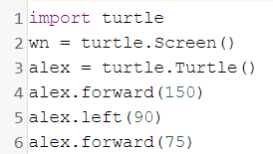

1. Explain the code in line 1?
2. Explain the code in line 2?
3. Explain the code in line 3?
4. Explain the code in line 4?
5. Explain the code in line 5?
6. Consider the following turtle code **(4.2)**:

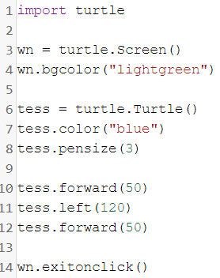

1. Which line changes the background color?
2. Which line will change how thick the line is?
3. Which line will turn Tess left 120 degrees?
4. How can you turn Tess right by 35 degrees?
5. What does line 14 do?
6. Consider the following code **(4.4)**:

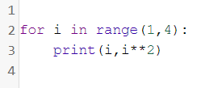

* What is the output?
* Change **range(1,4)** to **range(2,8)**, what is the output?
* What is the difference between **i** and **i**2**?

1. Consider the following code **(4.6)**:

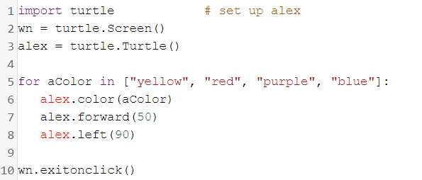

* On line 4 use the .speed() function to change the turtle’s speed to 15, what is the effect
* Every time the turtle change’s color, reduce the distance traveled by 5 units. Paste the output below
* Make the turtle color only blue and pink.

Part 2)

1. Draw the first letter of your first name using the turtle module and python3:

Example: “Nick”

