**Name:**

**ID:**

**M5 Assignment 04B**

Submit completed assignment here: <https://docs.google.com/forms/d/e/1FAIpQLSexHXBV0lbML7gA-KpYfN4GKgvzhsCjrJTlRMjd8-CilTXb3A/viewform>

Use the following book as a reference to answer the following questions:

<https://runestone.academy/runestone/books/published/thinkcspy/PythonTurtle/toctree.html>

Online Python3 Editor:

<https://repl.it/@enaard/Python-3>

**Part 1)**

1. Consider the following code (**4.2**):

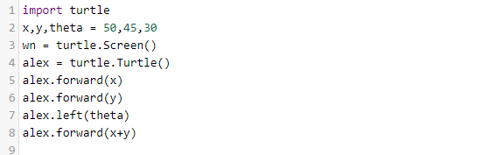

1. Explain the code in line 1?
2. Explain the code in line 2?
3. Which line generates the screen?
4. Which of the following makes alex travel the furthest?

|  |
| --- |
| alex.forward(x*2) |
| alex.forward(x+y) |
| alex.forward(x)  alex.forward(y) |
| alex.forward(theta) |

1. Consider the following turtle code **(4.2)**:

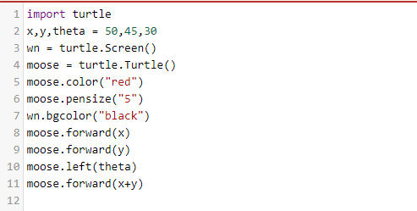

1. Which line changes the background color?
2. Which line will change how thick the line is?
3. Which line will turn Tess left 30 degrees?
4. How can you turn Tess right by 65 degrees?
5. Change the background color to yellow and the color to blue. Paste a screenshot of the result below?
6. Consider the following code **(4.6)**:

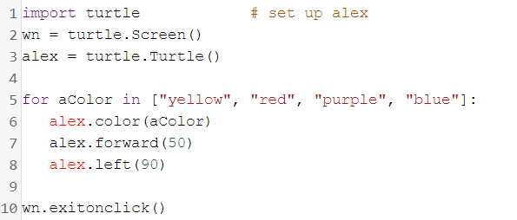

* How many elements are in the list?
* What will happen if you change the name *alex* on line 3 to *tom*?
* Does the **forward** function move the turtle or change the orientation?
* Does the **left** function move the turtle or change the orientation?
* Change the code so the turtle will only be red and purple:

1. Consider the following **(4.7)**:

Which of the following generates the sequence: 17, 19, 21

|  |  |
| --- | --- |
| range(17,21) | range(17,2,21) |
| range(17,20) | range(17,3,22) |
| range(17,22,2) | range(17,21,2) |
| range(17,22,3) | range(17,22) |

What is the answer?

Part 2)

1. Create the following using Python3 and the turtle module:

