Name:

ID:

M5 Challenge 01

<https://repl.it/@enaard/Python-3>

Part 1:

1). The program should ask the user to input the lengths of two sides of a right triangle. The program should output the length of the hypotenuse & the perimeter of the triangle.

Hints:

* Use the input function to get information into your program
* Store the input in a variable
* Convert to a number data type (int, float, complex): int(“1”) = 1
* Pythagoreans Theorem: $C^{2}=A^{2}+B^{2}$
* Square root in python: 4**0.5 = 2
* The perimeter equation for a square is: $Perimeter=A+B+C$

Solution (Please paste code below):

2) Write a program that creates a username for an Assumption student. The username will be the uppercase first two letters of the surname + the lowercase last two letters of the surname + the sum of the digits in your ID number.

Example:

First name: “Nick”

Last Name: “Sebasco”

ID: 510445

Username: “NIco19”

Hints:

* Store the last name input and first name input in variables
* To get a substring from a string use the slice operator: $"\text{alpha"}\left[0:2\right]="al"$
* The .upper() function makes a string upper case: $\text{"smack"}.upper()="SMACK"$
* The .lower() function makes a string lower case: $\text{"}SMACK\text{"}.lower()="\text{smack}"$
* To join strings use the + operator ”1” + “1” $="\text{11}"$
* To sum the digits in your id, convert id to a string : $\text{id}=str(id)$

510445 -> “510445”

* Transform the string into a list: $\text{id}=list(id)$

“510445” -> [“5”,”1”,”0”,”4”,”4”,”5”]

* Transform the list of strings into a list of integers: $id= \text{[int(i) for i in id]}$

[“5”,”1”,”0”,”4”,”4”,”5”] -> [5,1,0,4,4,5]

* Sum the integers in the list: $idSum=sum(id)$

idSum = 5+1+0+4+4+5 = 19

Solution (Please paste code below):

3) Transform a string of letters into a string of numbers. “apple” -> “1 16 16 12 5”

Hints:

* You will need to loop through the characters in the string:

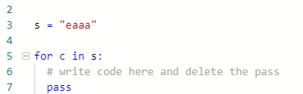

* The **ord()** function transforms a character into an integer: $ord\left(\text{"a"}\right)=97$
* Subtract 96 from the value returned by **ord()**, this will make a= 1, b =2, etc
* Convert the integers to a string with the **str()** function: $str\left("1"\right)=1$
* Combine strings with the concatenation operator **+**:

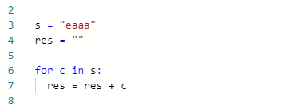

Solution (Please paste code below):