Name:

ID:

M5 Challenge 1 ADVANCED

1. Consider the following:

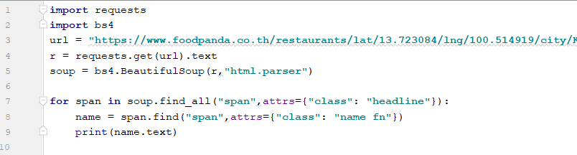

*** The *requests* and *bs4* modules must be installed for this question ***

url = **"https://www.foodpanda.co.th/restaurants/lat/13.723084/lng/100.514919/city/Krung%20Thep%20Maha%20Nakhon/address/Assumption%2520Cathedral%252C%2520Bangkok%252C%252057%2520Oriental%2520Ave%252C%2520Khwaeng%2520Bang%2520Rak%252C%2520Khet%2520Bang%2520Rak%252C%2520Krung%2520Thep%2520Maha%2520Nakhon%252010500%252C%2520Thailand/Oriental%2520Avenue%2520Alley/Assumption%2520Cathedral%252C%2520Bangkok%252057?postcode=Khwaeng+Bang+Rak"**

* What does this code do?
* What code will get the ratings (r) for each restaurant?
* What code will get the count (c) for each restaurant?
* Which restaurant has the highest count (hc)?
* Which restaurant has the highest rating (hr)?
* Give restaurants a special rating (S) according to the following equation: $S=3*\left(\frac{c}{hc}\right)+7*(r/hr)$. Tim wants to eat at the restaurants with the 3 highest special ratings. Which restaurants should he eat at?
* Use the csv module to store the following data for each restaurant: **name**, **count**, **rating**, **special rating**. The csv file should be name **food_data.csv.** The csv file should be ordered from highest special rating to lowest special rating.

1. Read the data from the **food_data.csv** file, download the **scipy** module and use the **stats.linregress** function to generate an equation that predicts the count (c) given the rating (r).

|  |  |
| --- | --- |
| predict(4.3) | 535 |
| predict(4.9) | 615 |
| predict(1.25) | ? |
| predict(3.33) | ? |
| predict(3.8) | ? |

* How good is the prediction equation that you created? (Hint look at the r_value)

1. Use a **dictionary comprehension** and the **enumerate** function to transform a list *L* (of length *n*) of strings into a dictionary with integer keys: *0,1, ..., n-1* and values that are elements of the list such that {0: L[n-1], 1:L[n-2], ..., n-1: L[0]}. Your answer should be a 1 line python expression.